**Name: Michael Kincel**

**Supervisor: Dr Luis Mejias Alvarez**

**Project Title: Autonomous Helicopter Navigation System – Platform Subsystem**

**Year: 2010**

**Volume: 1 of 1**

This project report was submitted as part of the requirements for the award of the

**BACHELOR OF ENGINEERING (Aerospace Avionics)**

in the

SCHOOL OF ENGINEERING SYSTEMS

FACULTY OF BUILT ENVIRONMENT AND ENGINEERING

at the

QUEENSLAND UNIVERSITY OF TECHNOLOGY

BRISBANE, AUSTRALIA

Signature of Candidate

...............................................................

`

"Any intelligent fool can make things bigger, more complex and more violent. It takes a touch of genius - and a lot of courage - to move in the opposite direction"

- Albert Einstein

Executive Summary

The Autonomous Helicopter Navigation System 2010 focused on developing a helicopter system capable of autonomous control, navigation and localising within a GPS denied environment. This document formally presents the development of the hardware for this system, including the project outline and the system architecture. The process of design solution development is initiated with consideration of the system requirements, both derived and baseline, for each subsystem.

The project was completed by a team of four students, and was managed using the systems engineering methodology. This follows the five stages: definition and research, design and develop, component testing, integration and testing, finally, delivery.

The author was responsible for the development of the hardware for the system. This followed a six step process of; initial concept, detailed concept, design, manufacture, integration and testing. An autopilot design was conceived from scratch and developed over the course of the project to meet the projects changing requirements. Once a design was finalised it was realised and implemented on the platform.

Once hardware system was developed, software integration and testing was commenced. A total of 14 flight test sessions were used to log a total flight time of 530 minutes or 8 hours and 50 minutes.

Most states could be estimated with a great deal of accuracy and certainty, this meant that stable attitude hold could be achieved. All states that could not be measured could be obtained from the Vicon motion capture system.

The project did not achieve position hold as onboard localisation data was not obtained by the onboard camera system.

Statement of Authorship

The work contained in this project report has not been previously submitted for a degree or diploma at any other tertiary educational institution. To the best of my knowledge and belief, the project report contains no material previously published or written by another person except where due reference is made.

Signed ……………………..……………………..

Date ……………………..

Acknowledgements

I would like express my deep gratitude to my supervisor, Dr Luis Mejias, and the rest of the AHNS team, without whom the project would not be possible.

I would also like to thank the many lectures and academic staff who have helped me acquire the skills and knowledge used throughout the course of this project.

Thank you to my parents and entire family, who have been extremely understanding and supportive during this final year of university. Thank you also to Alina for her support, advice and endless motivation during this stressful period.

Finally, thank you to all my close friends who have made this final year of university more enjoyable and relaxing.

Table of Contents

Executive Summary ii

Statement of Authorship iii

Acknowledgements iv

Table of Contents v

List of Tables viii

List of Figures ix

Definitions xi

Chapter 1 Project Introduction 12

1.1 Background 12

1.2 Autonomous Helicopter Navigation System 2009 13

1.2.1 Aims and Objectives 13

1.2.1.1 HLO-1 Platform 13

1.2.1.2 HLO-2 Localisation 13

1.2.1.3 HLO-3 State Estimation 13

1.2.1.4 HLO-4 Autonomous Hovering Flight 13

1.2.1.5 HLO-5 Ground Control Station 13

1.2.1.6 HLO-6 Communications 13

1.3 Importance of Work and Aim of Thesis 14

1.4 Thesis Outline 14

Chapter 2 Project Management 15

2.1 Systems Engineering Methodology 15

2.2 Work Packages 16

2.2.1 WP-PL-01 – Airframe Trade Study 17

2.2.2 WP-SY-04 – Preliminary Design Document 17

2.2.3 WP-PL-02 – Acquire and Construct Airframe 17

2.2.4 WP-PL-03 – Acquire Platform Electronics 17

2.2.5 WP-PL-04 – Airframe RC Test Report 17

2.2.6 WP-PL-05 – Electronics Test Report 17

2.2.7 WP-PL-06 – Integrate Onboard Hardware into Enclosure 17

2.2.8 WP-PL-07 – Integrate Electronics Enclosure into Airframe 17

2.2.9 WP-SY-05 – Augmented Flight Test Report 18

2.2.10 WP-SY-06 – Station Keeping Test Report 18

2.2.11 WP-SY-07 – Complete all Test Reports 18

2.2.12 WP-SY-08 – Complete Operation Manual 18

2.2.13 WP-SY-09 – Verification of Success 18

2.2.14 WP-SY-10 – Demonstration 18

2.2.15 WP-SY-11 – Presentation 18

2.3 Document Numbering 18

2.3.1 Subsystem Codes 19

2.3.1.1 Document Code and Number 19

Chapter 3 Subsystem Development 21

3.1 System Requirements 21

3.2 Design and Development 21

3.2.1 Airframe 21

3.2.2 Power System 23

3.2.2.1 High Voltage Power System 24

3.2.2.1.1 High Voltage Harness 24

3.2.2.1.2 Voltage Divider 27

3.2.2.1.3 Main Power Switch 28

3.2.2.2 Low Voltage Power System 29

3.2.3 Autopilot Hardware Design 30

3.2.3.1 MAX3001 Breakout Board 31

3.2.3.2 Schematic and Bill of Materials 32

3.2.3.3 Circuit Board Design and Manufacture 35

3.2.4 Altitude Sensor 37

3.2.5 Heat Considerations 38

3.2.6 Vibration Dampening and Mounting 40

Chapter 4 Integration and Testing 41

4.1 Integration 41

4.2 Testing 42

4.2.1 Airframe Test 42

4.2.2 Electronics Test 46

4.2.2.1 Main Board and MCU 48

4.2.2.2 Flight Computer 49

4.2.2.3 Arduino 50

4.2.2.4 Inertial Measurement Unit 51

4.2.2.5 Compass 52

4.2.2.6 Logic Shifter 53

Chapter 5 Conformance Matrix 56

5.1 Platform 56

Chapter 6 Conclusions 57

6.1 Recommendations 57

References 59

Associated Websites 59

List of Appendices 60

List of Tables

Table 2‑1 - Project stages 15

Table 2‑2 - Subsystem Codes 19

Table 2‑3 - Document Codes 20

Table 3‑1 – System Requirements for the Platform Subsystem 21

Table 3‑2 - Autopilot Bill of Materials 32

Table 4‑1 - Flight Test Objectives 43

Table 4‑2 - Platform Configuration 43

Table 4‑3 - Transmitter Configuration 44

Table 4‑4 - Flight Test Results 45

Table 4‑5 - Test Objectives 46

Table 5‑1 - Conformance matrix legend 56

Table 5‑2 - Platform conformance matrix 56

List of Figures

Figure 2‑1 - Work Breakdown Structure 16

Figure 3‑1 - Core MK40 Airframe 22

Figure 3‑2 – Platform Conponent Placement 23

Figure 3‑3 – LF50A Voltage Regulators on ESC 24

Figure 3‑4 - High Voltage Distribution System Schematic 25

Figure 3‑5 - High Voltage Power Harness 26

Figure 3‑6 - Voltage Divider Connected to ADC Harness 27

Figure 3‑7 - Main Power Switch 28

Figure 3‑8 - Low Voltage Power System 29

Figure 3‑9 - PCB Markings for Pin 1 30

Figure 3‑10 - MAX3001 Breakout Board 31

Figure 3‑11 - Final Autopilot Schematic 34

Figure 3‑12 - Final PCB Layout 35

Figure 3‑13 - Final Assembled Autopilot 36

Figure 3‑14 - Maxbotix EZ0 Ultrasonic Altimeter 37

Figure 3‑15 - ESC FETs With and Without Heatsink 38

Figure 3‑16 - Mounting of Heat Emitting Components 39

Figure 3‑17 - Autopilot Mounting 40

Figure 4‑1 - PCB Mounting Hole Dimensions 41

Figure 4‑2 - RC Flight Test 42

Figure 4‑3 – Five Volt Power Rail of Autopilot Board and MCU 48

Figure 4‑4 - Power Rail of Flight Computer 49

Figure 4‑5 - Power Rail of Arduino 50

Figure 4‑6 - Power Rail and Data Line of the IMU 51

Figure 4‑7 - Power Rail and Data Line of the Compass 52

Figure 4‑8 - Power Rails of the Logic Shifter 53

Figure 4‑9 - Logic Shifter Functionality Test (downshift) 54

Figure 4‑10 - Logic Shifter Functionality Test (upshift) 54

Definitions

|  |  |
| --- | --- |
| AHNS | Autonomous Helicopter Navigation System |
| COTS | Commercial, Off The Shelf |
| CoG | Centre of Gravity |
| ESC | Electronic Speed Controller |
| EMI | Electromagnetic Interference |
| HLO | High Level Objective |
| ADC | Analogue to Digital Converter |
| IMU | Inertial Measurement Unit |
| MCU | Mode Control Unit |
| IC | Integrated Circuit |
| SMD | Surface Mounted Device |
| FET | Field Effect Transistor |
| LED | Light Emitting Diode |
| QUT | Queensland University of Technology |
| RC | Remote Control |
| svn | Subversion – a source code version control system |
| GPS | Global Position System |
|  |  |

# Project Introduction

The Autonomous Helicopter Navigation System (AHNS) project was a final year undergraduate project at the Queensland University of Technology (QUT), completed as a requirement for a Bachelor of Engineering – Aerospace Avionics degree. The project involved the development of an indoor helicopter autopilot system. This means that the system would need to perform localisation and navigation within a GPS denied environment. Four members are part of the AHNS team in 2010, Michael Hamilton who is the project leader, Tim Molloy is responsible for control and ground station development, Liam O’Sullivan is responsible for state estimation and the author who is responsible for the hardware developement.

## Background

Uninhabited aerial vehicle (UAV) development is an area of research that QUT has invested much and resource into. These aerial robots are not widely used due to issues of safety and integration with civilian air traffic. For this reason the development of system to facilitate safe integration are of high value to QUT and the greater aviation community.

Limited research has been carried out in the area of indoor helicopter. Small groups of undergraduate students have made attempts to develop such a system. These have usually had small success and a project of this type requires more than a single year of development. This limited experience, by the 2010 team and QUT make this project unexplored territory.

The project in 2010 aims to develop a system using a small budget ($2000) and commercially available components in an integrated autopilot system.

## Autonomous Helicopter Navigation System 2009

### Aims and Objectives

The primary aim of the AHNS 2010 project was to develop a helicopter capable of autonomous flight within a GPS denied environment. The AHNS project had six HLOs as defined in Appendix Aiii and are presented below.

#### HLO-1 Platform

*A platform should be developed and maintained to facilitate flight and on board hardware integration.*

#### HLO-2 Localisation

*The system should be capable of determining its position with the aid of image processing within an indoor environment to an appropriate time resolution.*

#### HLO-3 State Estimation

*A method of estimating the states of the helicopter system should be designed and implemented. The resolution of the estimations should facilitate their employment in the control system design.*

#### HLO-4 Autonomous Hovering Flight

*An autopilot system should be developed to enable sustained indoor autonomous hovering flight. The control system should be designed to enable future ingress and egress manoeuvre to longitudinal and hovering flight.*

#### HLO-5 Ground Control Station

*A ground control station that supports appropriate command and system setting inputs and data display and logging should be developed. The design should be derived from previous AHNS developments and enable future ground station developments.*

#### HLO-6 Communications

*The communications system should enable transfer of control, state and localisation data to the ground control station. It should provide with a flexible wireless data link available on consumer-electronic devices.*

## Importance of Work and Aim of Thesis

This project is of great importance to the Queensland University of Technology as there has been limited research carried out in the field of indoor helicopters. A small undergraduate team with a small budget is a good way for researchers and postgraduate students to develop a scope for this type of project. All lessons learnt within this small team can be projected to larger, better funded projects.

This project is equally valuable to the author. It can be used as a platform to develop the system engineering skills and technical knowledge of the author. Additionally the gain in hardware development experience is also very important.

## Thesis Outline

This thesis begins with a description of the systems engineering methodology used in order to guide the development of the project both within subsystems and at the system level. This section also describes the work breakdown structure of the author’s subsystems in the project, and other management techniques used by the author.

Chapter 3 discusses the design and development of the author’s subsystems, and describes how each subsystem works.

Chapter 4 describes the integration and testing of the system, including the integration process, subsystem interfaces and flight-testing.

Chapter 5 contains the conformance matrix, which describes which functional requirements have been met, and which have not, as well as referring to the supporting test reports.

Finally, Chapter 6 concludes the thesis with a summary of what was done and recommendations for future progress.

# Project Management

## Systems Engineering Methodology

Large engineering projects are broken up into five primary phase. These are applied to all subsystem but are not necessarily completed in parallel within the subsystem. Some system will be completed sooner than others. These phases are described below as found in Appendix Aiv.

Stage one consists of defining the objectives and system requirements for the project. Initial research is also carried out within each sub-system which can including overview of previous years documents and performing trade studies.

Stage two outlines the chosen design that will achieve the HLO’s SR’s prepared in a preliminary design document. Once the design has been finalised, the individual components are acquired and constructed.

Stage three outlines the individual components testing, which ensures that each component achieves its own purpose before integration with the system.

Stage four consists of integration of all the individual components into the whole system. The system is then tested to ensure that it achieves the HLO’s and SR’s.

Finally stage five involved the delivery of the product to the customer, which in tales demonstration and presentations. Table 2‑1 illustrates the work breakdown structure for the 2010 AHNS project utilising the five primary stages as a guideline.



Table ‑ - Project stages

## Work Packages

Work packages are used to define all the tasks that must be carried out to achieve all system requirements. These can be seen in **Error! Reference source not found.**



Figure ‑ - Work Breakdown Structure

The work packages associated with the author’s subsystem are detailed below:

### WP-PL-01 – Airframe Trade Study

This work package was to research the information that is required to achieve the System Requirements for the airframe. Produce a Trade study from this research, and recommend the best option for the project..

### WP-SY-04 – Preliminary Design Document

This work package was to produce a preliminary design document, with the information gathered from the system requirements and the trade studies.

### WP-PL-02 – Acquire and Construct Airframe

This work package was to purchase the Airframe from the supplier, and assemble the platform to a RC flight level.

### WP-PL-03 – Acquire Platform Electronics

This work package was to purchase all the platform electronics from the Supplier, such as the Coulomb counter, enclosure, temperature sensor, necessary wires and connectors.

### WP-PL-04 – Airframe RC Test Report

This work package was to test the RC airframe for flight characteristics to confirm successful construction. Also test for maximum endurance and total payload.

### WP-PL-05 – Electronics Test Report

This work package was to test the onboard electronics to ensure they function correctly before integrating it with the other major components.

### WP-PL-06 – Integrate Onboard Hardware into Enclosure

This work package was to integrate all the hardware that is to be mounted inside the enclosure and test to ensure that it is all operational. Ensure that the results appear normal before integrating with platform and flight testing.

### WP-PL-07 – Integrate Electronics Enclosure into Airframe

This work package was to integrate the enclosure containing all onboard electronics into the airframe and test that all aspects are operational. Ensure that the results appear normal during RC tests before testing in flight modes.

### WP-SY-05 – Augmented Flight Test Report

This work package was to test the completed platform for its performance of augmented flight.

### WP-SY-06 – Station Keeping Test Report

This work package was to test the completed platform for its performance of station keeping flight.

### WP-SY-07 – Complete all Test Reports

This work package was to complete all Test Reports for each subsystem, and the system as a whole. This includes any test reports compiled from flight testing.

### WP-SY-08 – Complete Operation Manual

This work package was to compile an operations manual that explains to a new user how to operate every component within the project. This will allow easy hand over to future students working on the project.

### WP-SY-09 – Verification of Success

This work package was to verify that all high level objectives and all system requirements are completed.

### WP-SY-10 – Demonstration

This work package was to demonstrate to the supervisor that all high level objectives and system requirements are completed and were successful.

### WP-SY-11 – Presentation

This work package was to produce a presentation of the AHNS 2010 system to the client, industry representatives and peers.

## Document Numbering

As outlined in Appendix Aiv all documentation within the AHNS project must follow strict naming convention to ensure that system identification and traceability can be maintained. The naming convention for all official AHNS documentation is as follows.

*<Project Name>-<Project Year>-<Subsystem Code>-<Document Code>-<Document Number>*

An example for this is the project management plan, under the system level sub-system, AHNS-2010-SY-PM-001

### Subsystem Codes

As outlined in Appendix Aiv To differentiate between each sub-system within the AHNS project, a code is assigned to indentify the document to belonging to that system. Table 2‑2 outlines the corresponding codes for each sub-system.

Table ‑ - Subsystem Codes

|  |  |
| --- | --- |
| Subsystem | Code |
| System Level | SY |
| Platform | PL |
| Autopilot | AP |
| Localisation | LO |
| State Estimation | SE |
| Ground Control Station | GC |
| Communication | CO |

#### Document Code and Number

As outlined in Appendix Aiv all sub-systems will have many different types of documents associated with them. An additional document code will also be included into the name to aid in categorising the reports. Table 2‑3 outlines the all the codes against the type of document that is within the report. Also attached to each document code is a three digit ascending number, which differentiates between multiple documents of the same document code.

Table ‑ - Document Codes

|  |  |
| --- | --- |
| Document | Code |
| High Level Objectives | HL |
| System Requirements | SR |
| Project Management Plan | PM |
| Trade Study | TS |
| Design Document | DD |
| Test Report | TR |
| Detailed Drawing | DR |
| Traceability Matrix | TM |
| Operations Manual | OM |
| Minutes of Meeting | MM |

# Subsystem Development

The author’s main responsibility in this project was the design, development, testing and validation of platform subsystem. Although this project is primarily a software project, the platform is used to realise and validate all functional autopilot and control code. The platform therefore forms a foundation for the various other subsystems on the project.

## System Requirements

The system requirements pertaining to the platform subsystem were developed during the initial planning phase of the project and are presented in below.

Table ‑ – System Requirements for the Platform Subsystem

|  |  |  |
| --- | --- | --- |
| HLO | Requirement | Definition |
| HLO-1  Platform | **SR-B-01** | The platform shall have the ability to be manually manoeuvred with a radio controller. |
| **SR-D-01** | The platform shall be capable of maintaining controlled flight with a total payload of 400 grams. |
| **SR-D-02** | A maintenance document shall be used to log airframe flight time, battery cycles and aircraft repairs. |

## Design and Development

### Airframe

Initially, it was proposed that a custom airframe would be constructed for the project. Due to time constraints and the availability to spare parts, it was decided that a COTS airframe would be more suitable. Through the use of a trade study, found in Appendix Bi, the MikroKopter MK40 airframe was selected. This was due to its ready availability, lightweight yet durable construction, low maintenance requirements and its ability to satisfy SR-D-01. Figure 3‑1 shows the core MikroKopter airframe after directly after assembly.

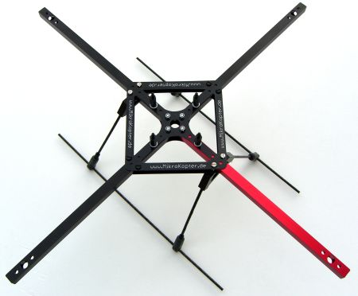

Figure ‑ - Core MK40 Airframe

Many of the other airframes considered for the project, both conventional helicopter design and quad-copter design, are made of many small plastic piece. This means that if one of the pieces break, a partial or complete disassembly is required to replace the broken piece. The MK40’s simple design and strong materials meant that repairs were seldom necessary. As can be seen in Figure 3‑1 the entire airframe consists of four pieces of aluminium connected by two pieces of fibreglass.

Once the airframe was selected, an initial concept was drawn to determine the best places to mount the various components to the airframe. This consisted of an RC flight test to determine the optimum position for the centre of gravity. This report can be found in Appendix Biv. The test concluded that the ideal place for the CoG is high up between the engines. This reduces the pendulum effect caused by the difference between the CoG and the aerodynamic centre. To facilitate this, it was decided that the battery would be mounted atop the airframe. Figure 3‑2 shows the projected placement of the battery and the autopilot. The autopilot is mounted beneath the airframe as there are mounting provisions made for this by the airframe manufacturer. The ESCs are mounted underneath the engines as to minimise EMI and improve heat dissipation.

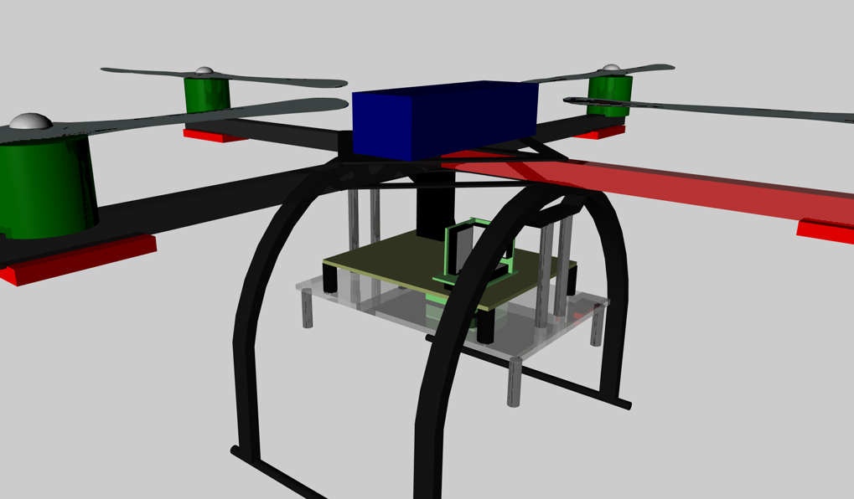

Figure ‑ – Platform Conponent Placement

### Power System

The autopilot power system is a fundamental component in ensuring project success. The entire system requires a constant 5 volt regulated power supply to function correctly. In 2009, a standalone voltage regulator was added to the system to provide the necessary power. This was not required in 2010 as the ESCs chosen were able to perform this role. It was observed that the ESCs were fitted with two 5 volt regulators. The LF50A regulators, shown in , are each capable of delivering 1 amp each. This means that when they are configured in parallel, as they are on the board, they are capable of supplying 2 Amps. As these are already fitted to the ESCs, and will be mounted to the airframe regardless of use, it was decided that these would be used as the source of 5 volt power. Within this section, the 5 Volt power distribution will be known as the “low voltage power system” and the 12 Volt power distribution system will be known as the “high voltage power system”.

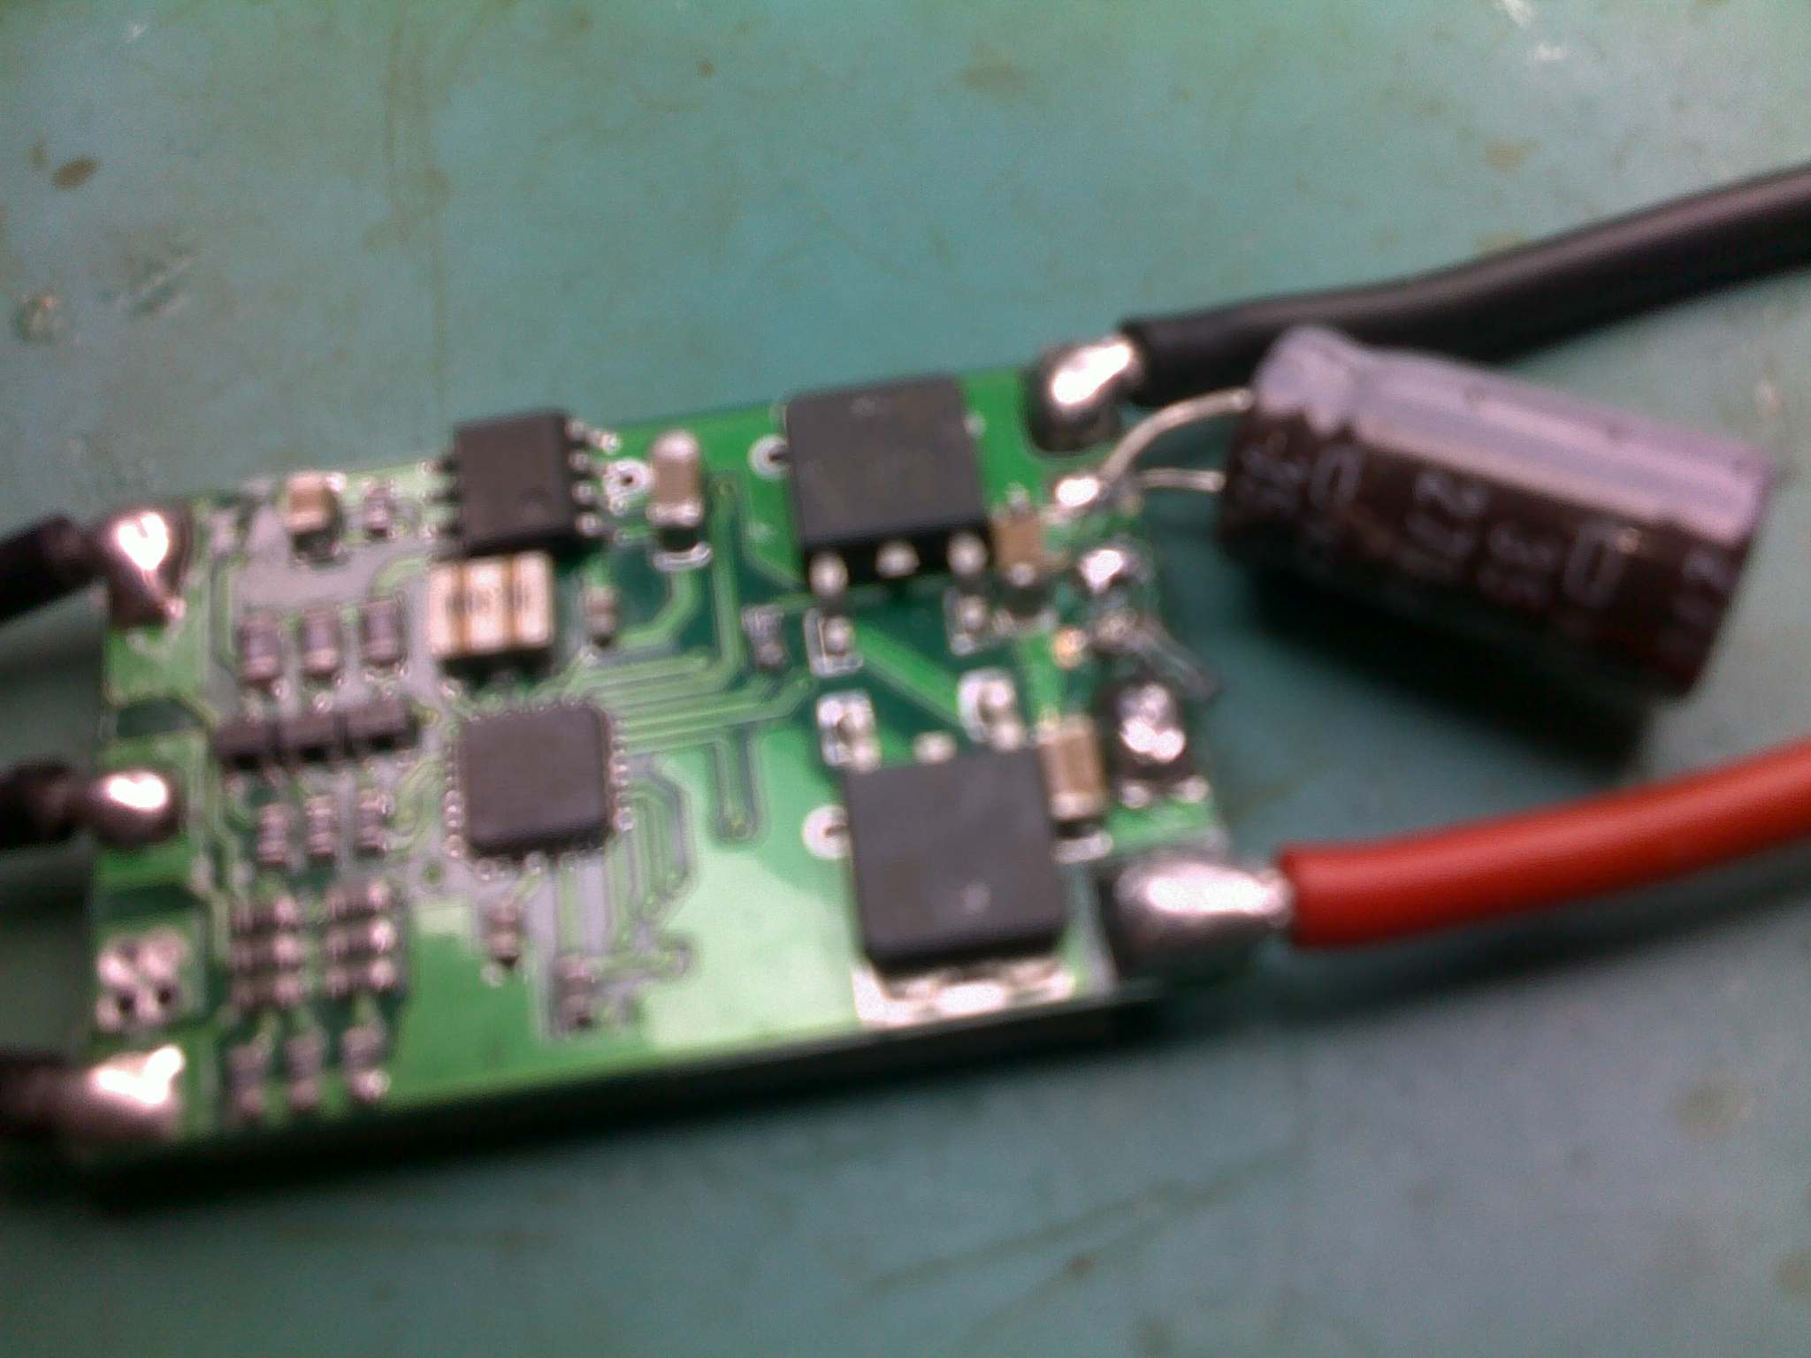

Figure ‑ – LF50A Voltage Regulators on ESC

#### High Voltage Power System

The high voltage power system refers to the distribution of all 12 Volt power throughout the airframe. The source for the power is the flight battery and needs to breakout to the four ESCs. In addition to this, a line needs to be tapped off this to measure the battery voltage. **Error! Reference source not found.** shows a functional diagram of the high voltage power distribution system. It includes the voltage divider resistors that are required for measuring the battery voltage. This is discussed in more detail in the next section.

##### High Voltage Harness

The high voltage power distribution harness, shown in Figure 3‑4, is divided into two major but similar sections. These are the positive side of the system and the negative side. These sections were made in parallel as duplicates of each other. A red wire is soldered to the positive side and a black wire to the negative side to mark each appropriately. These are soldered to a single plug and placed into the final layout as seen in Figure 3‑5.



Figure ‑ - High Voltage Distribution System Schematic

The power harness for the positive and negative side were made using 14 gauge wire. This thickness of wire has a maximum current rating of 32 Amperes. As each of the ESCs has a maximum current draw of 18 Amperes, is can be seen that this is well with the limit of the wire. In addition to this, all high current applications suffer from voltage drop through wires, This is a result of the voltage drop being a function of the fixed resistance of the wire and the current flowing through it. As either of these values is increased so too is the voltage loss. The voltage lost in the wire can be quantified using the following relationship:

Where V is the voltage loss, I is the current flowing through the wire and R is the resistance of the wire for that given length. There is a total of 0.3 metres of wire between the flight battery and each ESC. The resistance of 14 gauge wire is 0.0082 Ohms per metre. The total voltage loss through the system at 18 Amperes is therefore:

This is seen as a negligible amount within the 12 Volt power system and is therefore deemed acceptable.

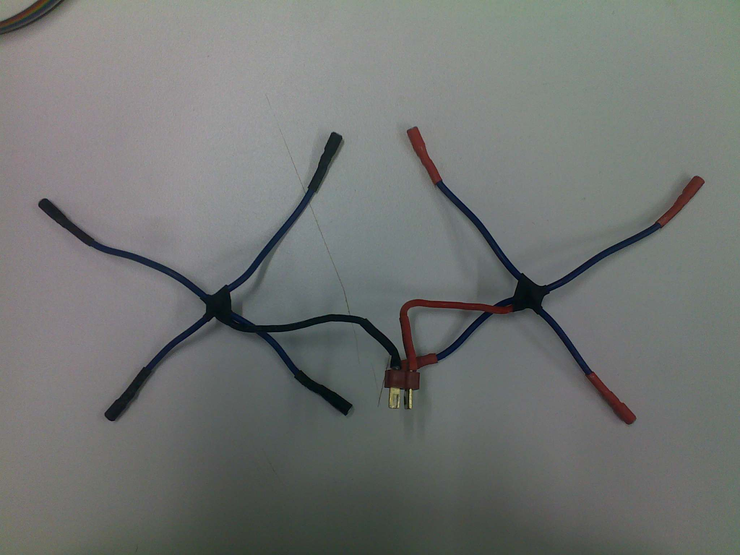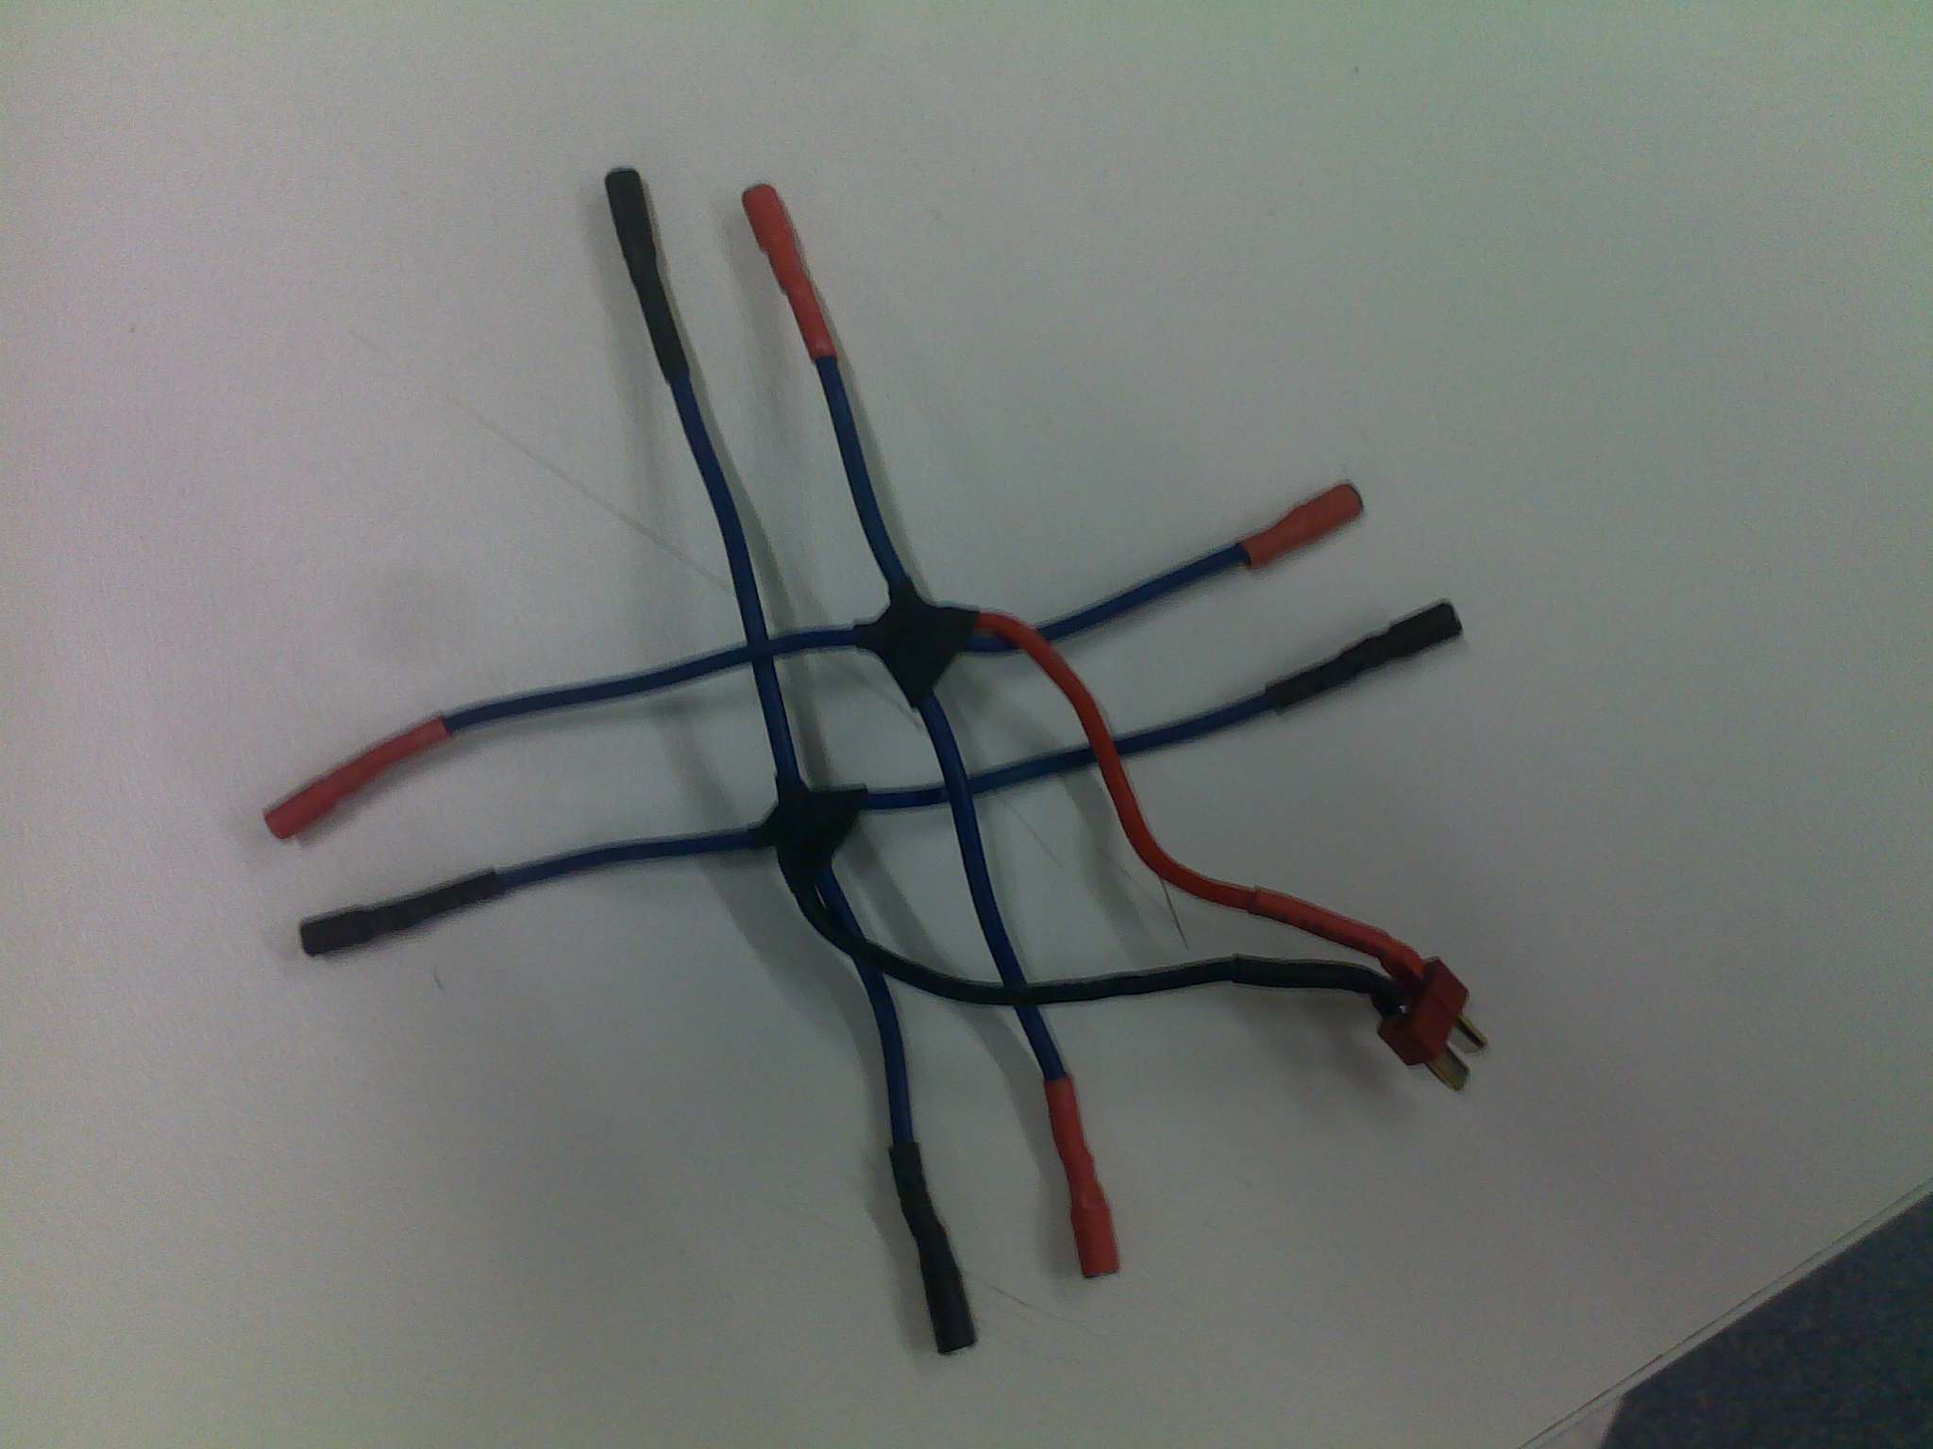

Figure ‑ - High Voltage Power Harness

##### Voltage Divider

The voltage dividing resistors were made as a separate modular piece to allow for easy access during repair and maintenance. In addition to this, they are integrated into the ADC harness which also connects to the ultrasonic altimeter. The voltage divider was designed with the assumption that the maximum voltage reached on the high voltage side would be 14 Volts. The values were chosen such that they would be high enough to ensure there is negligible current through resistors, while being low enough to ensure they are not affected by the input resistance of the ADC. The final resistor values were 56,000 Ohms and 100,000 Ohms as can be seen in Figure 3‑4. The divider can be seen in the bottom left of connected to the ADC harness.

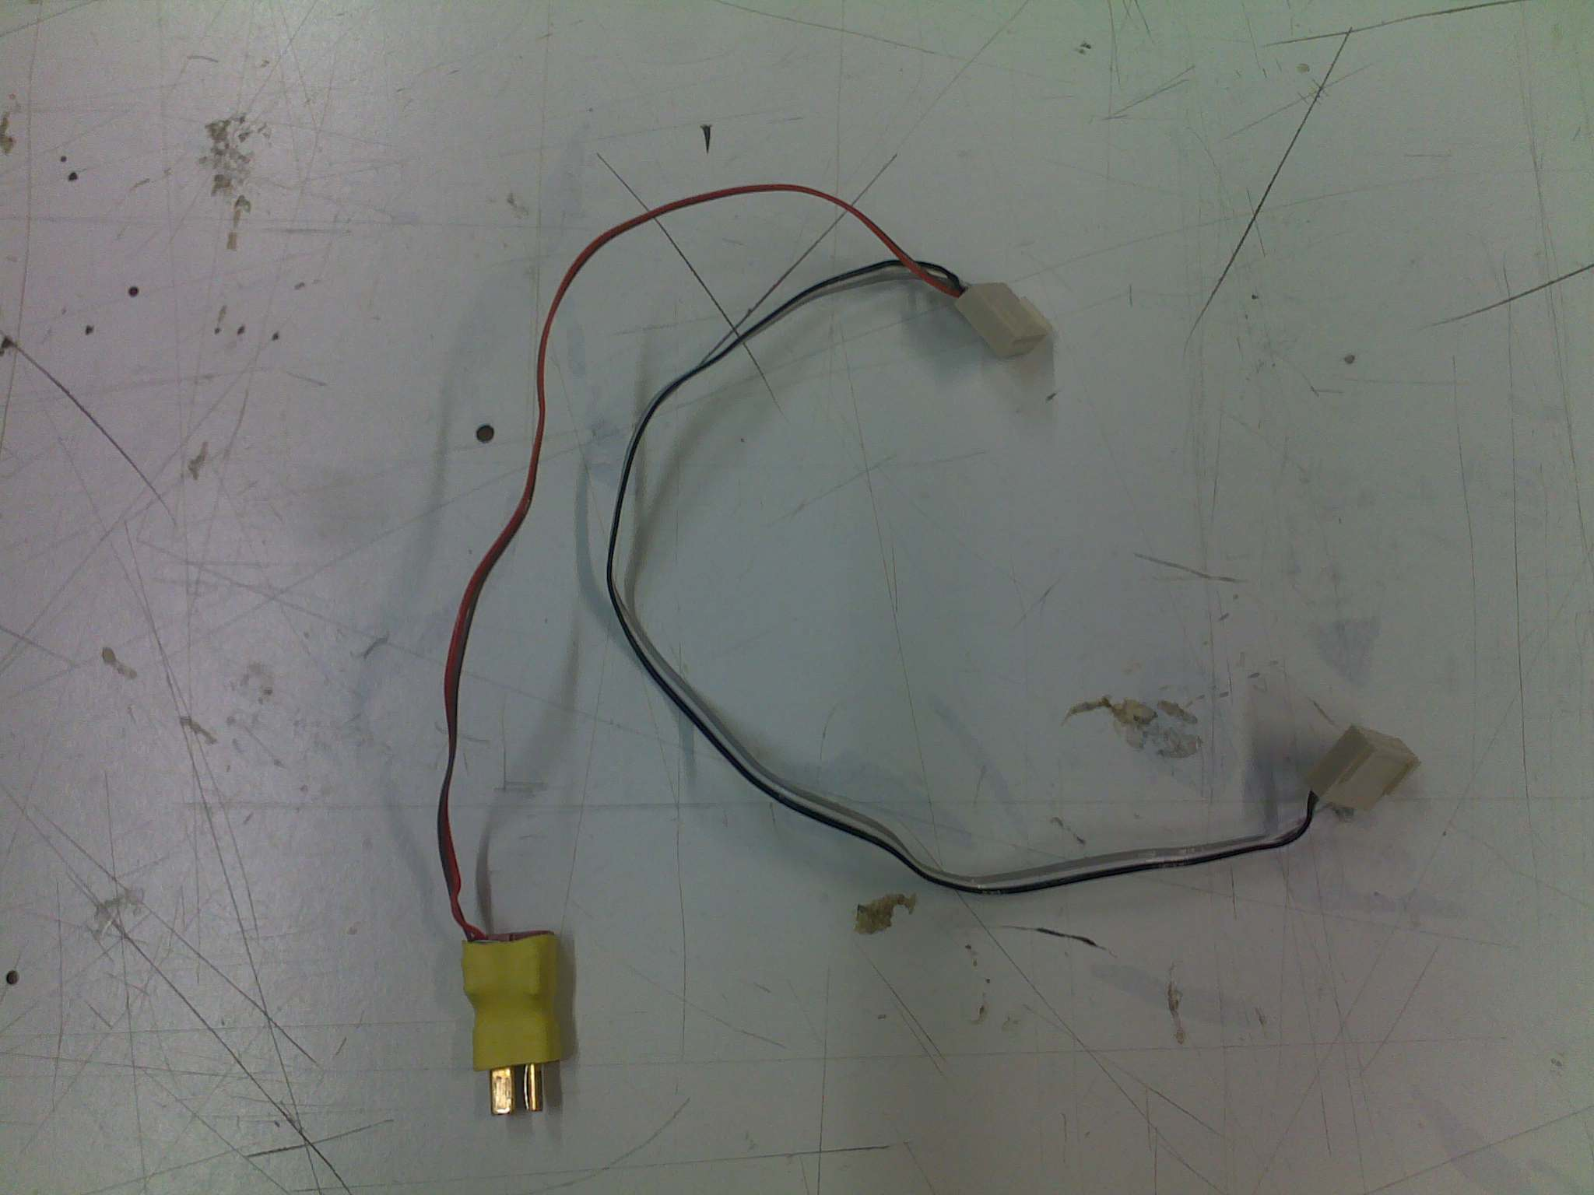

Figure ‑ - Voltage Divider Connected to ADC Harness

##### Main Power Switch

The main power switch that was selected is rated at 20 AMPS. As a result is was large and difficult to mount. As with the voltage divider, it was made as a separate module that could be detached during repairs and maintenance. As the switch is illuminated, it requires the system ground to be connected to it. This can be seen in **Error! Reference source not found.**. The switch controls the entire system. That is, if it is switched off, all electronic components are turned off. This includes the ESCs.

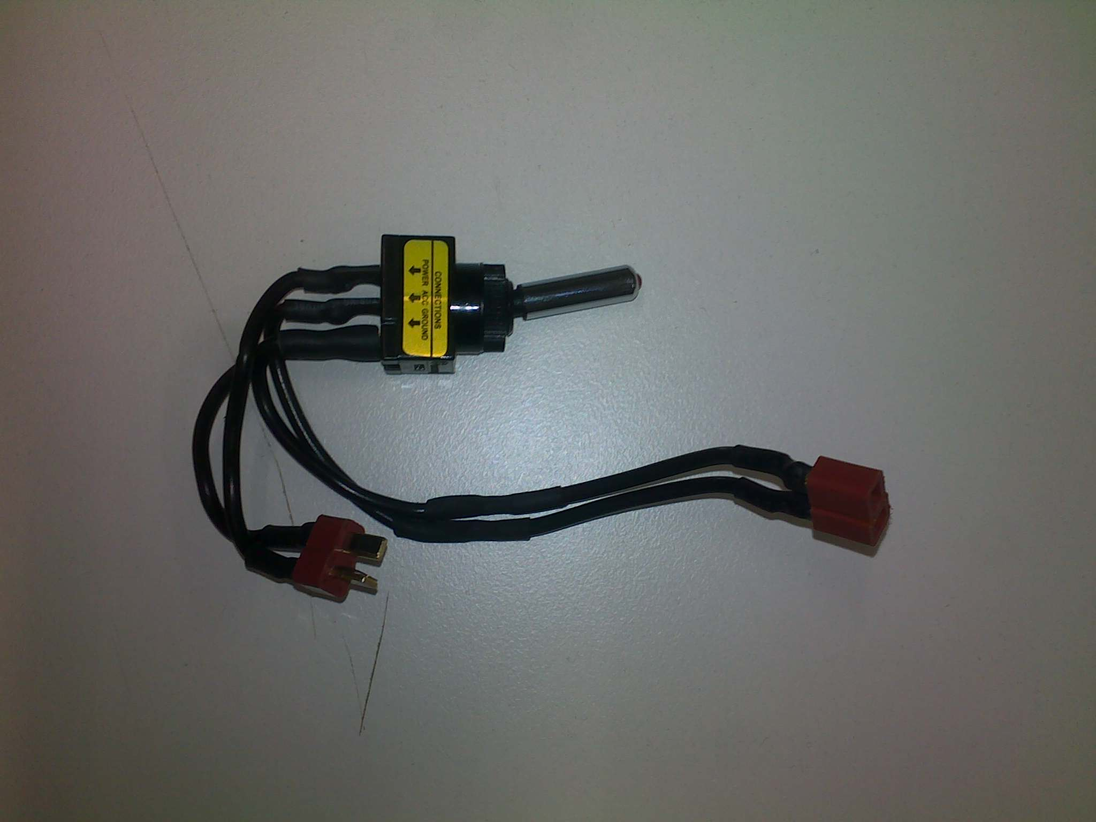

Figure ‑ - Main Power Switch

#### Low Voltage Power System

The low voltage power systems refers to all parts of the platform that operate at 5 Volts. As mentioned previously, the 5 Volt regulation is carried out by the regulators fitted to the ESCs. The LF50A regulators are fitted with short circuit and over temperature protections. This means that if either of these two conditions is met, the device shuts down to recover. Under normal circumstances, this would lead to a complete power failure. In this case, however, as there are four ESCs connected, each with two regulators, the system is powered by eight regulars. As such, if any single regulator reaches a shut down conditions, the remaining seven will be able to continue powering the system. As each individual regulator is capable of powering the entire system, up to seven failures can occur on any one flight. Alternatively if any of the malfunctions during a flight test, the offending ESC’s power line can be disconnected and flight testing can resume with the remaining six regulators.



Figure ‑ - Low Voltage Power System

The low voltage power is connected directly to the autopilot board and is decoupled by a 100uF capacitor. The Autopilot board distributes the power to all other systems on the platform.

### Autopilot Hardware Design

The autopilot PCB is an essential component of the AHNS project. The project uses a single PCB design which acts to minimise complexity and reduce wire count. As there are external sensors and devices, the use of wires in unavoidable. By reducing the number of wires and using a ground plane on the PCB, both emitted and received EMI can be reduced. Another risk commonly found on undergraduate projects is the risk of not plugging connecters into their appropriate sockets or reverse polarising the connector. This often leads to a complete failure of one or more devices in the system. To mitigate this risk, the AHNS design has separate headers on the PCB for each individual component. Where possible, the amount of similar connectors has been reduced. This makes the chance of connecting a plug into a wrong socked very unlikely. In addition to this, where possible, polarity checked connectors have been utilised. Finally, to ensure all DIP sockets have PIN 1 clearly marked with an offset connector. This has been highlighted in Figure 3‑9 and can be seen clearly in Figure 3‑12.

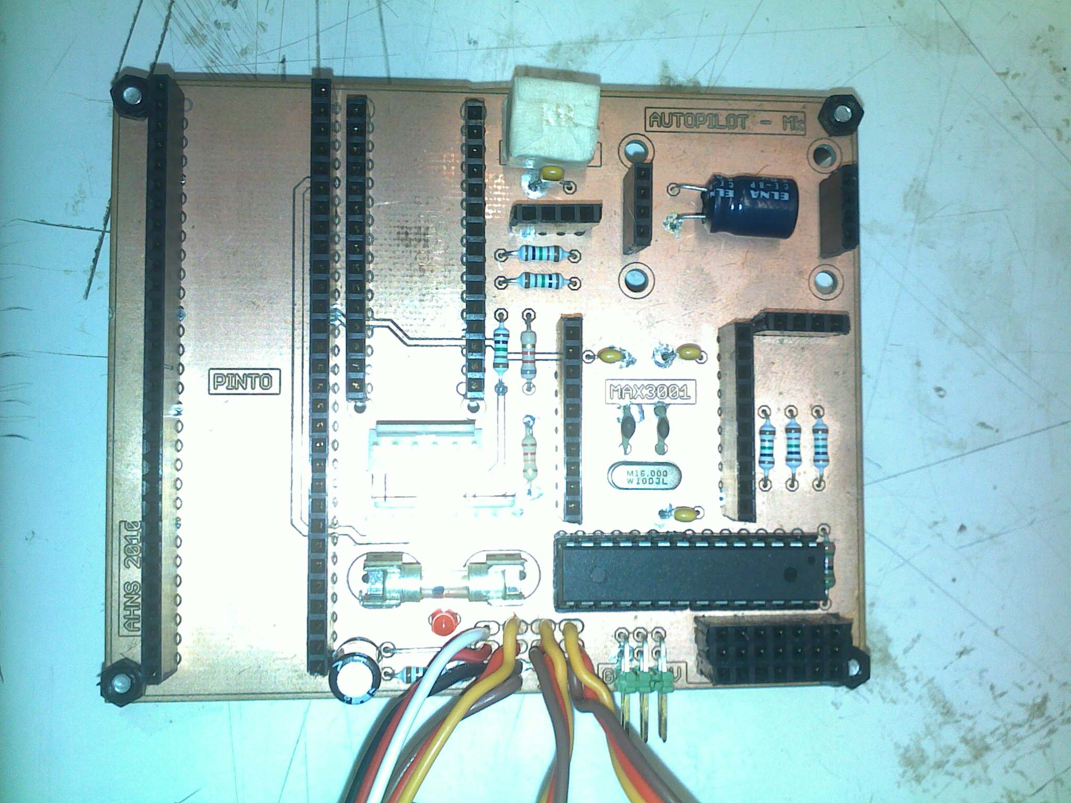

Figure ‑ - PCB Markings for Pin 1

#### MAX3001 Breakout Board

One significant problem that was encountered during the early phases of development was the difference in logic levels between the flight computer and all other external devices. To minimise EMI, the flight computer operates at a 1.8Volt logic level. In the final design only two devices need to communicate with it. This is the IMU and the MCU. Both of these devices operate at a 5Volt logic level. To enable compatibility between these two devices, this logic level needs to be shifted. As the two links are full duplex serial links, there are two data lines that need to be shifted up and two that need to be shifted down. A logic shifter IC often carries out the task of logic shifting. There are not many commercial logic shifters available which offer bi-directional shifting between 5Volts and 1.8Volts. One device that is capable of performing this task is the MAX3001. The drawback of this device is that it is only available in an SMD package. This makes soldering of the device much more difficult than regular through hole devices. As it is expected that there will be several revisions of the autopilot, it was decided that a breakout board would be made for this IC. This breakout board will act as an adaptor to convert the SMD device into a though hole device. The result of this will be a module that can be plugged and unplugged from a socket on the PCB. This limits the amount of SMD solder in the project to one IC. Figure 3‑10 shows the latest revision of the MAX3001 breakout board

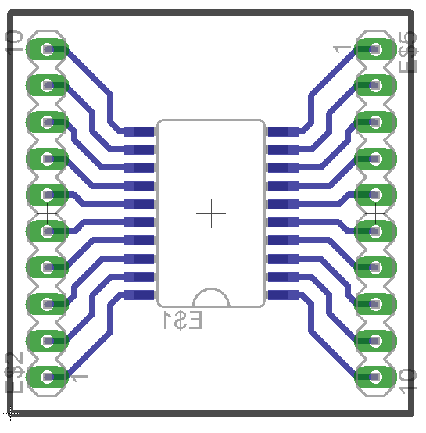

Figure ‑ - MAX3001 Breakout Board

#### Schematic and Bill of Materials

As mentioned previously, the autopilot underwent many revisions before a design was ultimately finalised. Figure 12 shows the final autopilot schematic with all components and modules laid out. To make the diagram is less cluttered nodes have been used extensively. This can be slightly difficult to read on paper. The original Eagle file is available on the SVN and is best read in the Eagle editor as it highlights selected nodes. The only connection not marked on the diagram is the USB cable that links the Arduino Nano with the FC. Table 3‑2**Error! Reference source not found.** shows the Bill of Materials for the complete Autopilot. It shows all the components and modules necessary for building the autopilot.

Table ‑ - Autopilot Bill of Materials

|  |  |  |
| --- | --- | --- |
|  | Component | QTY |
| Passive  Components | Resistor - 1/2W - 1k | 8 |
| Resistor - 1/2W - 10k | 2 |
| Resistor - 1/2W - 12k | 1 |
| Capacitor - 22p | 2 |
| Capacitor - 100n | 5 |
| Capacitor - 100u | 1 |
| Diode – 1N5819 | 1 |
| Active  Components | LED - TriColour - 5mm | 1 |
| LED - Red - 3mm | 1 |
| MAX3001 (on breakout board) | 1 |
| ATMEGA328 DIP28 | 1 |
| Crystal - 16MHz | 1 |
| Modules | PINTO DIP for OVERO COM | 1 |
| Arduino Nano | 1 |
| Sensor Dynamics - Inertial Measurement Unit | 1 |
| OS4000 Compass Module | 1 |
| Hardware | Header, Locking - 6PIN - Male | 1 |
| Header, Locking - 8PIN - Male | 1 |
| Header, Terminal - 3PIN - Male | 4 |
| Header, Terminal - 4PIN - Female | 3 |
| Header, Terminal - 7PIN - Female | 3 |
| Header, Terminal - 10PIN - Female | 2 |
| Header, Terminal - 15PIN - Female | 2 |
| Header, Terminal - 30PIN - Female | 2 |
| Header, IDC - 6PIN - Male | 1 |
| M205 PCB Fuse Holder | 2 |
| M205 Fuse - 1Amp | 1 |
| IC Socket - 14PIN - Narrow | 2 |

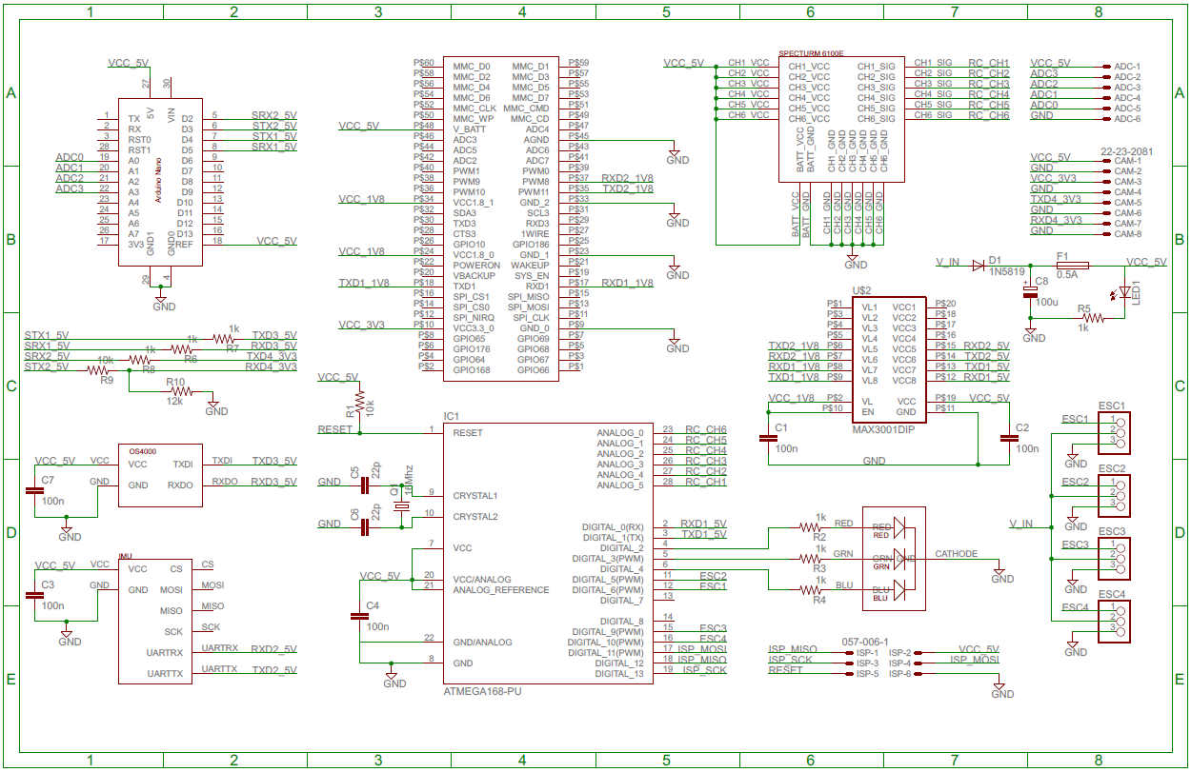

Figure ‑ - Final Autopilot Schematic

#### Circuit Board Design and Manufacture

Figure 3‑12 shows the final PCB layout that was used for the autopilot. The drawing also shows the placement of each components and module. To create a duplicate board, the original Eagle file is available in the SVN. All previous versions are available here as well.

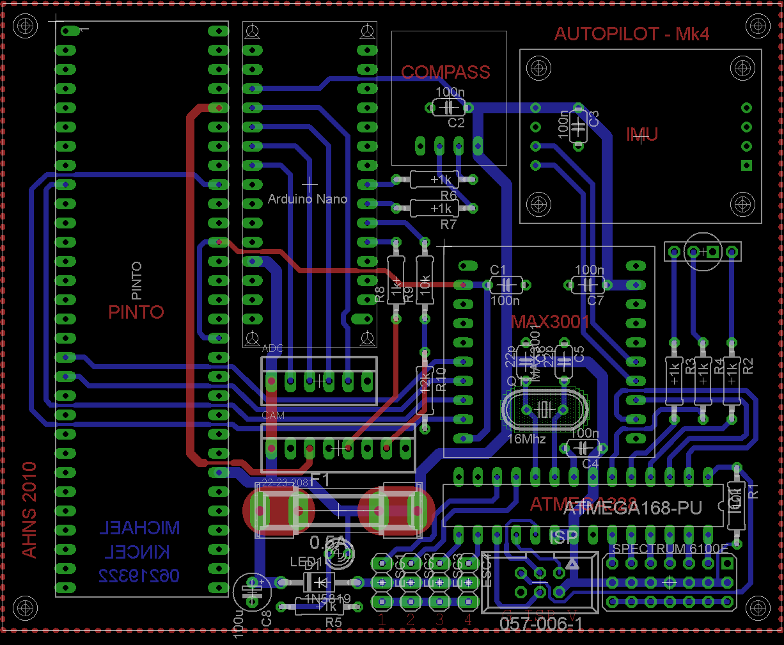

Figure ‑ - Final PCB Layout

The RC Rx module inserts into the bottom right corner of the board, beside this is the programming port for the MCU and the four ESC connections. Above the fuse are the ADC and Camera connections. Both of these have a 5 Volt pin and the Camera connection has a 3.3 volt pin a well. Pin assignment can be seen on the schematic in Figure 3‑11.

Figure 3‑13 shows the final assembled autopilot with all components mounted in their final location. This picture can be used as a reference for future duplicates.

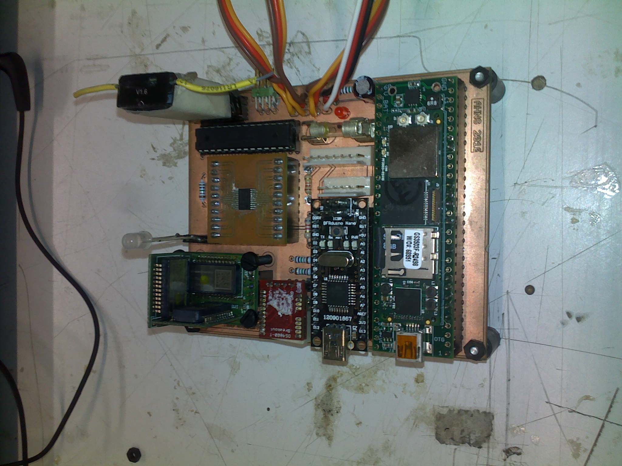

Figure ‑ - Final Assembled Autopilot

### Altitude Sensor

In order to determine the altitude of the helicopter a Maxbotix ultrasonic altimeter was used, as shown in Figure 3‑14. This type of sensor emits a brief ultrasonic pressure wave and measures the time delay from transmission to receiving it again. In principle, half the measured time multiplied by the speed of sound can determine an approximate distance. This sensor was mounted on the lowest electronics tray to have an unobstructed view of the ground. By contrast, an IR sensor was going to be used. This was later replaced with the ultrasonic sensor due to the potential of interference with the Vicon system. The sensor has a useable range of 15cm to 6 metres. This is inside the operating altitude of the aircraft.

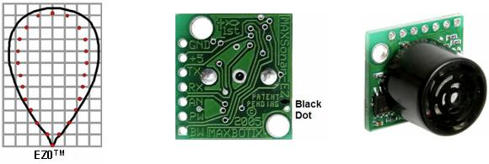

Figure ‑ - Maxbotix EZ0 Ultrasonic Altimeter

The output of the sensor is provided as an analogue voltage that changes depending on the distance. This sensor is connected to one of the analogue inputs of the Arduino. The voltage output response was characterised, and a function implemented in flight computer. This function gives accurate altitude measurements to the state estimation system. The physical connection is achieved through the analogue harness shown earlier in Figure 3‑6.

### Heat Considerations

There are a total of five major heat emitting components on the AHNS platform. These are the four ESCs and the actual flight computer itself. Several special considerations had to be made to ensure these devices received adequate cooling.

The ESCs have two sources of heat on them, the first are the voltage regulators, as seen in **Error! Reference source not found.**. The second are the FETs on the other side. These FETs are shown with and without their heatsink attached in Figure 3‑15. This heatsink increases the ESCs ability to keep the FETs cool. To further assist in this cooling process, the ESCs have been attached to the airframe underneath the propellers, as seen in Figure 3‑16. This means that the ESCs are using the entire airframe as a large heatsink. This effect is observable by touching the airframe after running the autopilot for a few minutes. The airframe becomes considerably warmer. Another advantage of this mounting regime is that as the engines are running they pass air over those parts of the airframe. Air is also passed over the actual ESCs themselves, leading to an even greater increase in cooling efficiency.

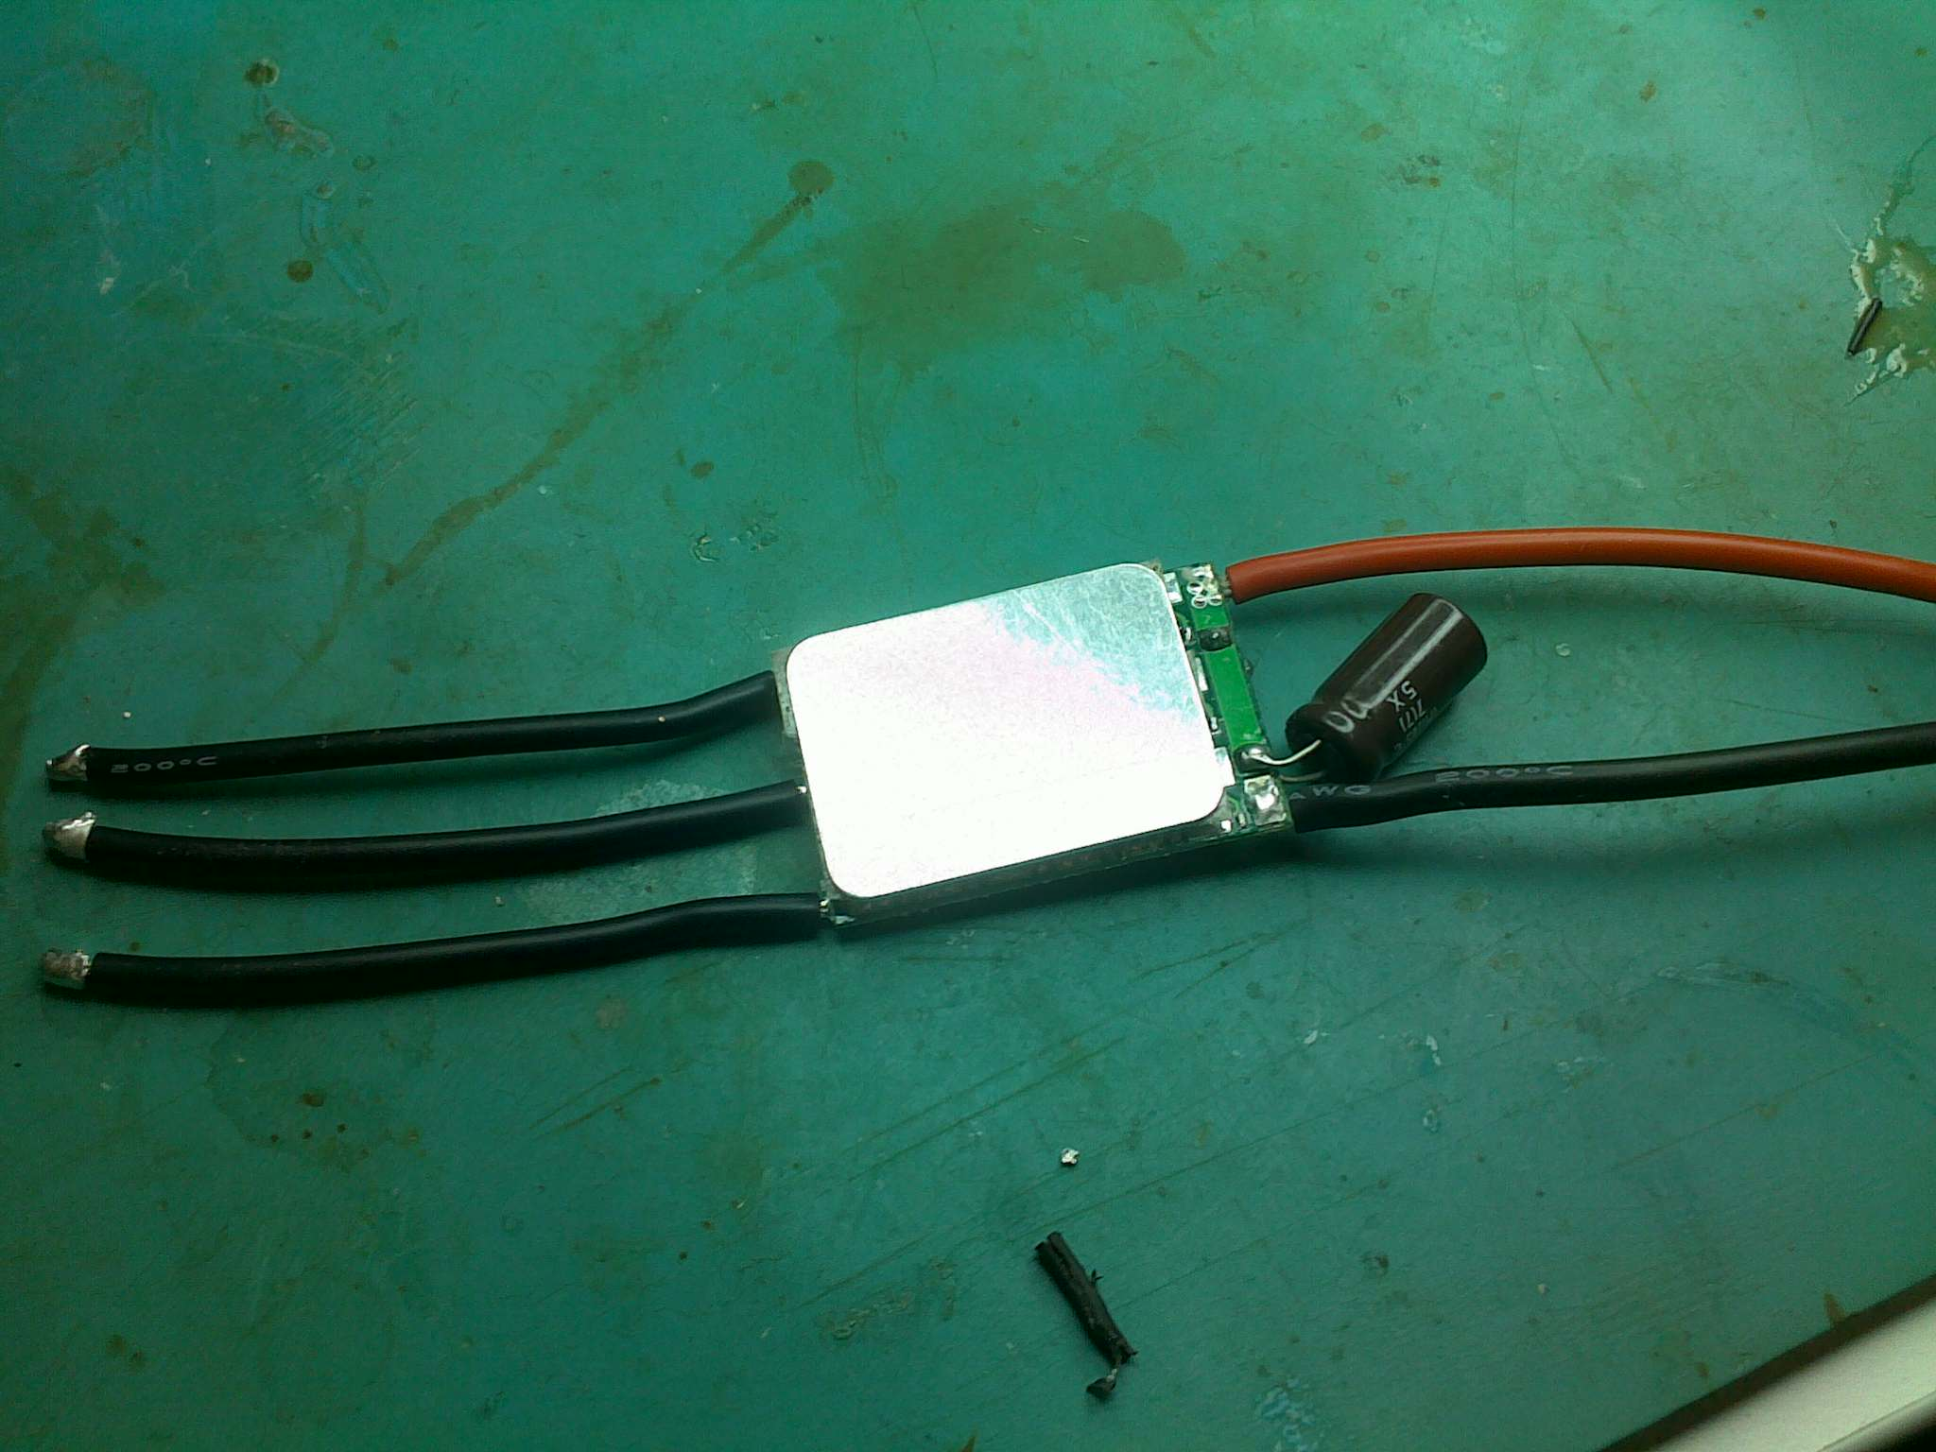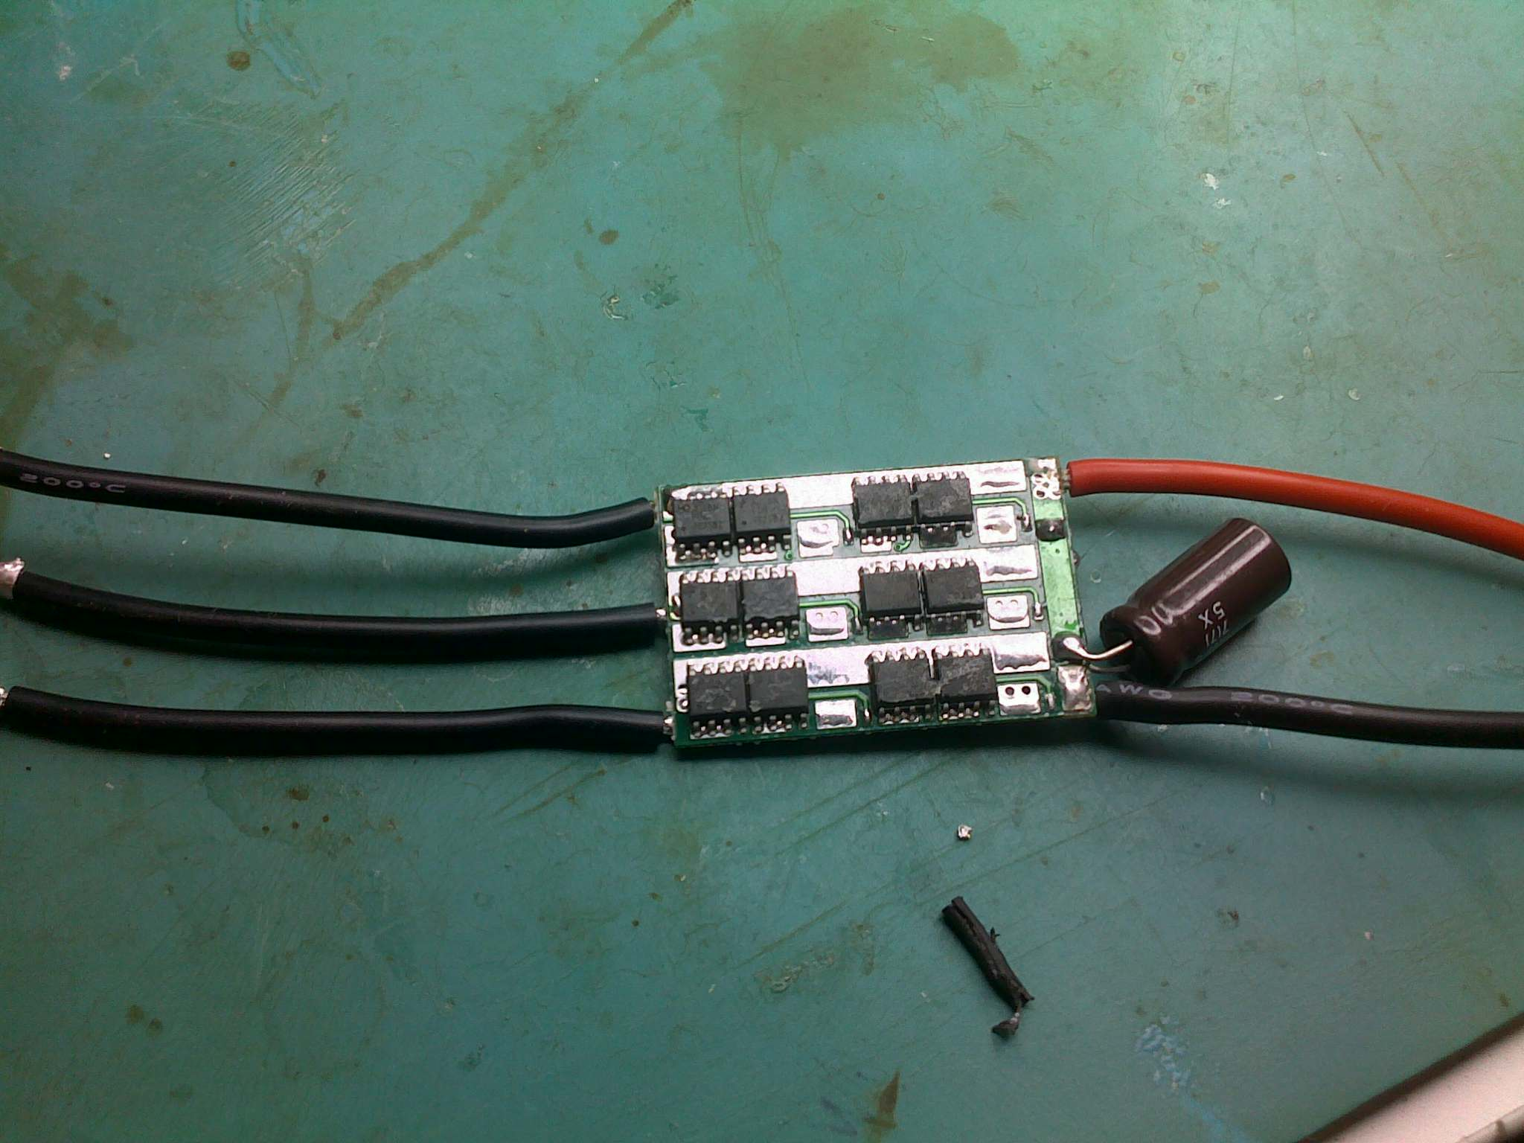

Figure ‑ - ESC FETs With and Without Heatsink

The other element that requires special heat considerations is the flight computer. To ensure this does not overheat, it was decided that the mounting would not be done inside an enclosure. If this design was continued, the FC would be confined within a small area with no possibility of air passing over it. By mounting it on an open air tray, the heat generated by the FC is free to radiate away from the device. In addition to this, as the engines are running, air is able to pass over the FC, further enhancing the cooling effect. Figure 3‑16 shows the FC mounted on the open air electronics tray in the middle of the platform.

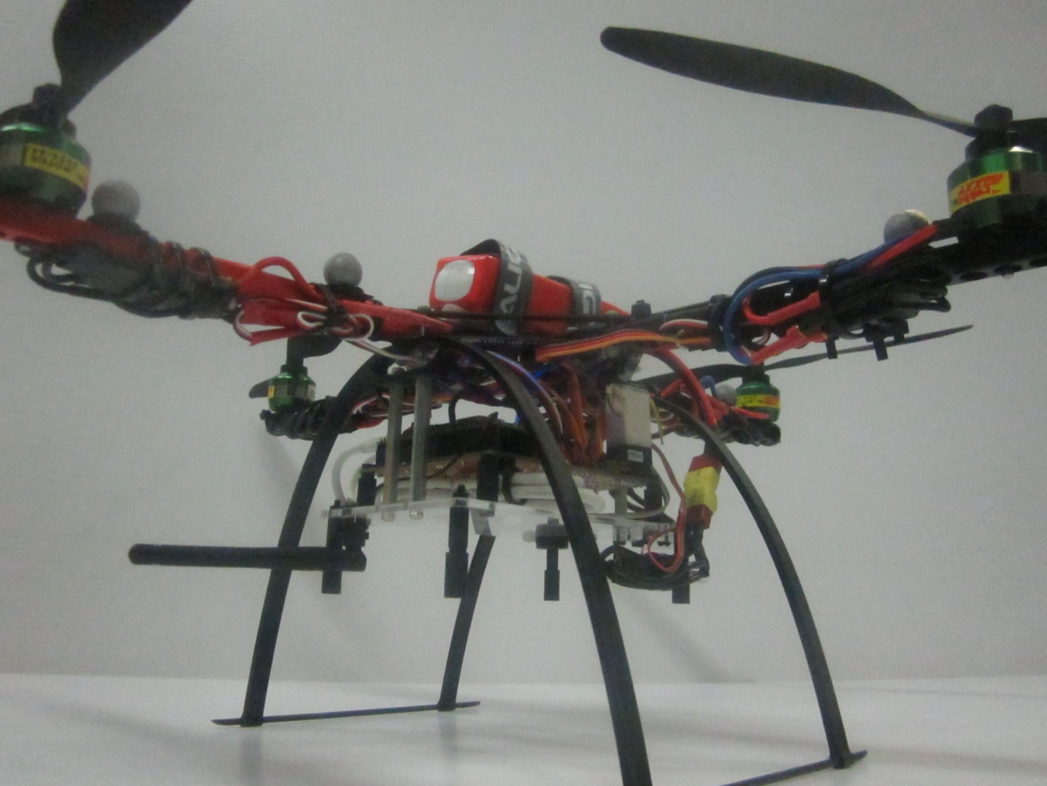

Figure ‑ - Mounting of Heat Emitting Components

### Vibration Dampening and Mounting

Helicopter platforms are prone to vibrations. There are four main rotors attached to the platform. As these are not perfectly balanced, they will induce a vibration with a frequency equal to the period of rotation. Also each propeller spins at a slightly different speed. This means there is a total of four fundamental frequencies of vibration, each with varying amplitude. A harmonic of each is also induced at twice the fundamental frequency. This is a result of the propeller passing over the frame. Isolation of the delicate sensors and processing hardware from vibration is an important consideration in the design of the mounting systems. The airframe was acquired from MikroKopter. The company sells an RTF autopilot for use in GPS environments. This is mounted on the company’s proprietary vibration dampening. These have been proven to work successfully on their autopilot, which has similar sensors. It was therefore decided that these would be acquired and adapted to mount the AHNS 2010 autopilot.

The autopilot is mounted onto to electronics tray by four of these vibration dampeners. Three of these vibration dampeners have been mounted in Figure 3‑17.

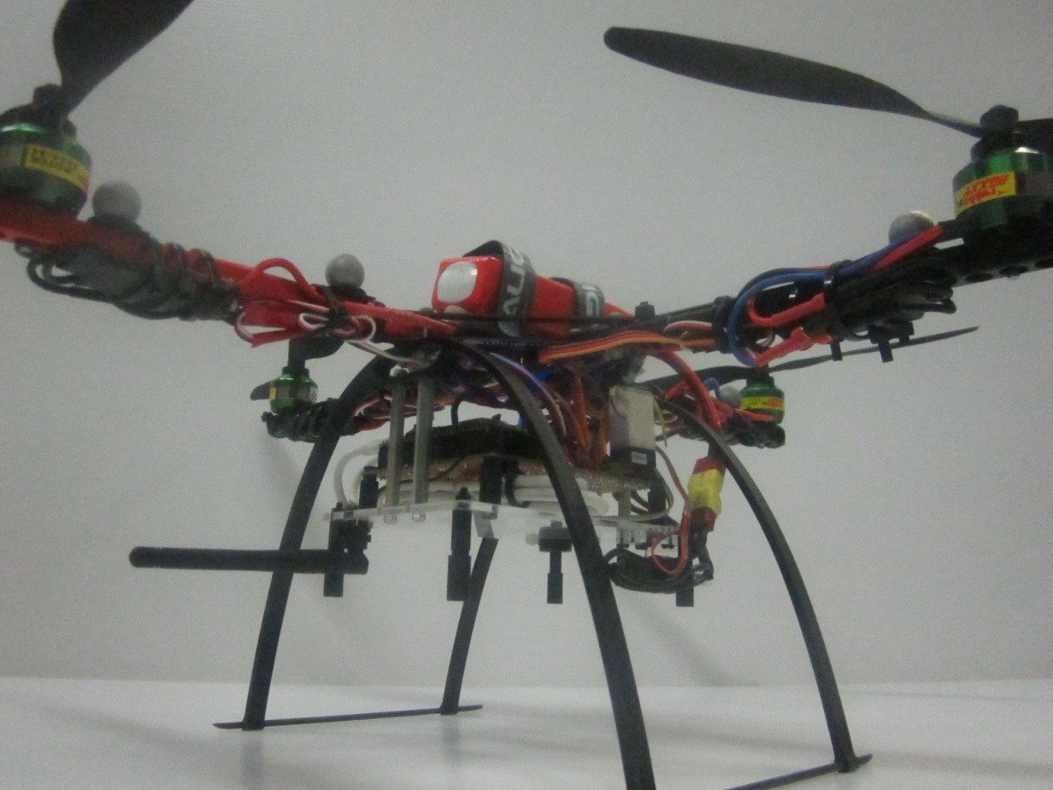

Figure ‑ - Autopilot Mounting

# Integration and Testing

## Integration

The hardware integration stage was generally seamless and suffered few setbacks. This is primarily because all hardware was developed within a single sub system. Less attention needs to be given when a single person is developing all hardware interfaces. One interface that was developed and maintained was the dimensions of the mounting holes on the autopilot. The electronics mounting tray was being developed by a different group member and a misalignment of mounting holes can potentially cause a delay to the project. Figure 4‑1 shows the dimensions of the mounting holes on the autopilot. This was used as a control for the interface.

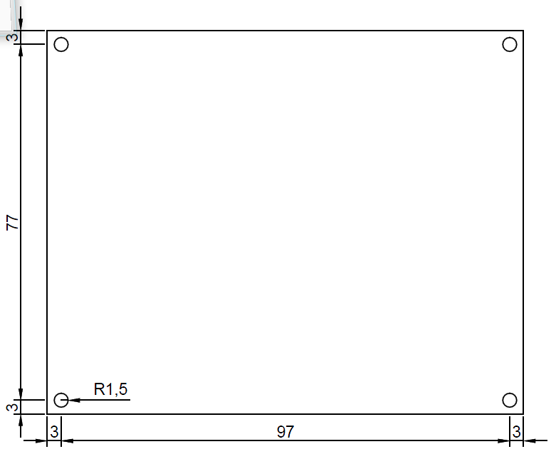

Figure ‑ - PCB Mounting Hole Dimensions

## Testing

### Airframe Test

It was necessary to perform two tests before any of the hardware was designed or implemented. The first is to ensure that it is possible to control the airframe manually using remote control. Having this ability is considered vital as it was planned that the pilot can perform a recovery manoeuvre should the autopilot ever place the platform into an undesired attitude or location.

To test this, the airframe was stripped down to only its essential components. A Gaui quad-copter mixing gyro was attached to the platform to handle stability augmentation and channel mixing. The airframe was tested in two configurations. The first was in a low CoG configuration. This is where the battery was mounted as low as possible in the airframe. The second was a high CoG configuration in which the battery was mounted as high as possible. Individual test flights were carried out and pilot feedback was used to compare performance of the two configurations.

Also during this same flight session it was necessary to test the maximum payload capability for the platform. To test this, the platform was loaded up with 400grams of dummy weight. As with the previous tests, the airframe was flown in both low and high CoG configurations. Similarly, pilot feedback was used to assess the performance of the airframe.

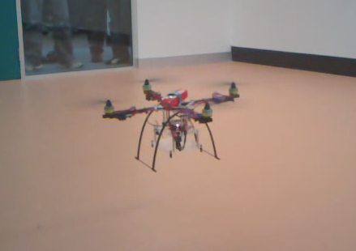

Figure ‑ - RC Flight Test

This RC test season had four major objectives. The objectives and their tests are designed to test the suitability, optimal configuration, and stability of the airframe. They have been summarised in Table 4‑1 below.

Table ‑ - Flight Test Objectives

|  |  |  |
| --- | --- | --- |
| Objective | | Criteria |
| 1 | Ensure the platform behaves normally at minimum flying weight with battery mounted below airframe. | The platform performance must behave as expected by the pilot; no unexpected movements are to be produced. |
| 2 | Ensure the platform behaves normally at minimum flying weight with battery mounted above airframe. | The platform performance must behave as expected by the pilot; no unexpected movements are to be produced. |
| 3 | Ensure the platform behaves normally at maximum flying weight with battery mounted below airframe. | The platform performance must behave as expected by the pilot; no unexpected movements are to be produced. |
| 4 | Ensure the platform behaves normally at maximum flying weight with battery mounted above airframe. | The platform performance must behave as expected by the pilot; no unexpected movements are to be produced. |

Before the commencement of the actual test flight, the platform and transmitter were configured to optimal parameters. These parameters were chosen before the flight test and refined during the actual testing, the final values are shown in Table 4‑2 and Table 4‑3.

Table ‑ - Platform Configuration

|  |  |  |
| --- | --- | --- |
| Configuration | | RC Rx – Gyro – ESCs (no autopilot) |
| Gyro settings | Orientation | “+” |
| Mode | (RC controlled) |

Table ‑ - Transmitter Configuration

|  |  |  |
| --- | --- | --- |
| Channel directions | Throttle | Normal |
| Roll | Reversed |
| Pitch | Reversed |
| Yaw | Reversed |
| Gear | Normal |
| Aux/Gyro | Normal |
| Travel adjust | All | 100% |
| Gyro Gain | | 30% |
| Dual Rate and Exponential | Throttle | N/A |
| Roll | D/R = 60%; EXPO = 40% |
| Pitch | D/R = 60%; EXPO = 40% |
| Yaw | D/R = 60%; EXPO = 40% |
| Gear | N/A |
| Aux | N/A |
| Throttle Curve | | Linear |

Once the test was performed and all objectives, the results shown in Table 4‑4 were obtained from pilot feedback.

Table ‑ - Flight Test Results

|  |  |  |  |
| --- | --- | --- | --- |
| Objectives | | Criteria | Results |
| 1 | Ensure the platform behaves normally at minimum flying weight with battery mounted below airframe. | The platform performance must behave as expected by the pilot; no unexpected movements are to be produced. | **FAIL**  (Slow and oscillatory response) |
| 2 | Ensure the platform behaves normally at minimum flying weight with battery mounted above airframe. | The platform performance must behave as expected by the pilot; no unexpected movements are to be produced. | **PASS** |
| 3 | Ensure the platform behaves normally at maximum flying weight with battery mounted below airframe. | The platform performance must behave as expected by the pilot; no unexpected movements are to be produced. | **FAIL**  (Slow and oscillatory response) |
| 4 | Ensure the platform behaves normally at maximum flying weight with battery mounted above airframe. | The platform performance must behave as expected by the pilot; no unexpected movements are to be produced. | **PASS** |

The first and second tests were performed with the minimum take-off weight. This means that only the battery, RC receiver, and gyro are fitted. This was done to form a benchmark for aircraft performance and to test the effect of moving the CoG up and down.

The third and forth tests were performed with the full 400g payload fitted. During this test the effect of moving the CoG up and down was accessed. In addition to this, a comparison was made to the first two tests.

It was apparent that having a low CoG lead to undesirable flight characteristics. A low CoG made the aircraft really slow to respond to commands. In addition to this, a pendulum effect was really clear as the airframe had a tendency to oscillate. The platform was deemed unsuitable to fly with the low CoG configuration.

With the mass of the electronics added, similar results were observed to above. With a low CoG configuration the platform exhibited undesirable flying characteristics. With a high CoG the platform fly as it did with a high CoG with no added weight. The only difference that was noticed between a more weight and less weight was that more throttle was required to sustain flight. This will ultimately lead to a reduction in flying time.

One observation that is consistent with all four flight tests is that the indoor environment makes flying much more difficult due to the wash form the propellers bouncing off the walls. Despite this, the platform is still flyable and can be operated safely.

The flight test was very successful. It showed that a high CoG is the desirable configuration for flying. The addition mass of a full payload had little adverse effect on the flying characteristics, with only an increase in required thrust being observed. A full copy of the flight test, including procedures, is available in Appendix Biv.

### Electronics Test

The AHNS autopilot system has a hardware layer integral to its operation. Without a functional hardware platform, no system control code can be tested or progress made. The electronics test revolves around connecting the autopilot to a bench to a power supply and ensuring all components are functioning correctly. This includes all logic devices and sensors.

The first set of testing that was carried out was initial power testing. Most of the modules connected used on the autopilot include power LEDs. This means that for initial power testing, each module can be inserted individually and powered on and the power LED is observed. In addition to this, The voltage rail would be testing to ensure there is no emitted noise by the module onto the power rail. As not all devices have power LEDs, those devices will have the data line connected to the oscilloscope to ensure they are emitting data.

Table ‑ - Test Objectives

|  |  |
| --- | --- |
| Objective | Criteria |
| Main Power On | Main power LED illuminated. No disturbances on power rail. |
| Overo Power On | All power related LEDs on the Overo are illuminated. No disturbances on power rail. |
| Arduino Power On | All power related LEDs on the Arduino are illuminated. No disturbances on power rail. |
| IMU Power On | Data observed on the oscilloscope. No disturbances on power rail. |
| MCU Power On | Mode Indicator illuminates. No disturbances on power rail. |
| Compass Power On | Data observed on the oscilloscope. No disturbances on power rail. |
| Level Shifter Power On | Data observed on the oscilloscope. No disturbances on power rail. |
| Overo Communication and Function | Communication can be established with the Overo and response to commands are observed. |
| Arduino Communication and Function | Communication can be established with the Arduino and response to commands are observed. |
| IMU Communication and Function | Communication can be established with the IMU and measurements can be observed. |
| MCU Communication and Function | Communication can be established with the MCU, pulse captures and outputs all observed. |
| Compass Communication and Function | Communication can be established with the Compass and measurements can be observed. |

#### Main Board and MCU

The main power board has a power LED that illuminated when power was applied to the board. The MCU has the mode indicator led that illuminates when power is applied to it, this too illuminated. Figure 4‑3 shows there are no abnormalities on the 5 Volt power rail.

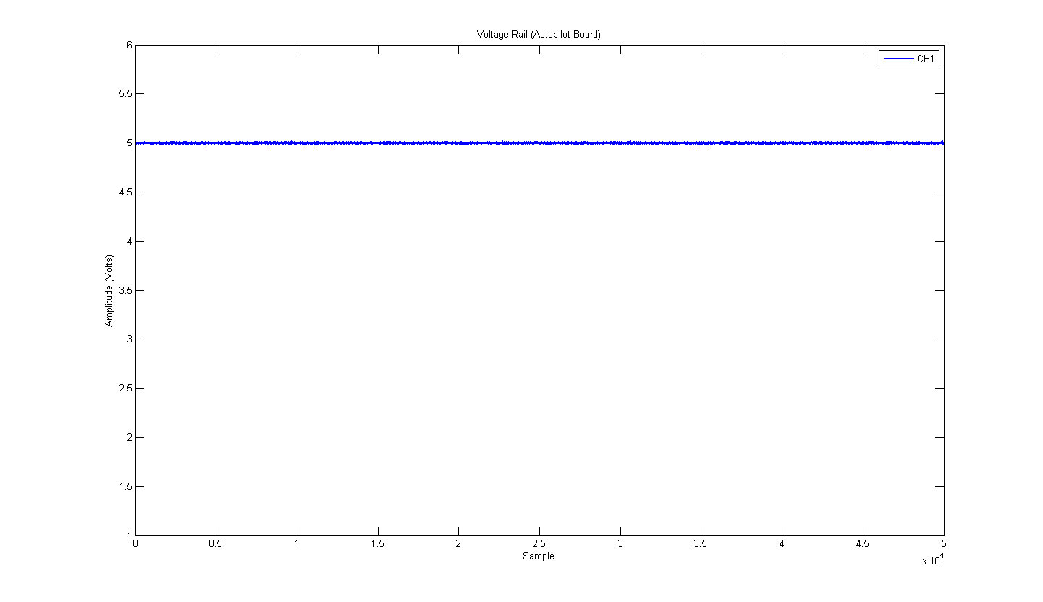

Figure ‑ – Five Volt Power Rail of Autopilot Board and MCU

#### Flight Computer

The flight computer contains several LEDs that indicate which indicate that power is applied to the system. All these illuminated when the flight computer was connected to the autopilot board. It can be seen in Figure 4‑4 that no abnormalities were observed on the 5 Volt power rail connected to the flight computer.

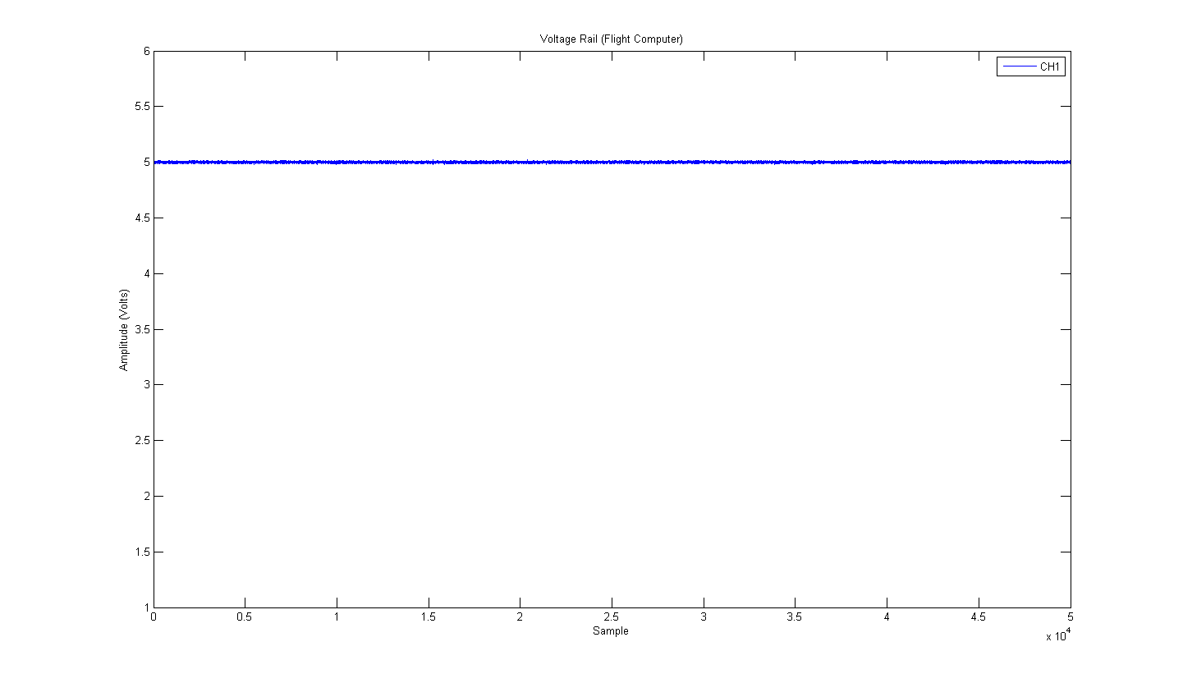

Figure ‑ - Power Rail of Flight Computer

#### Arduino

As with the flight computer, the Arduino has several power LEDs that can be used to verify that it is received sufficient power. It can be seen in Figure 4‑4 that no abnormalities were observed on the 5 Volt power rail connected to the Arduino.

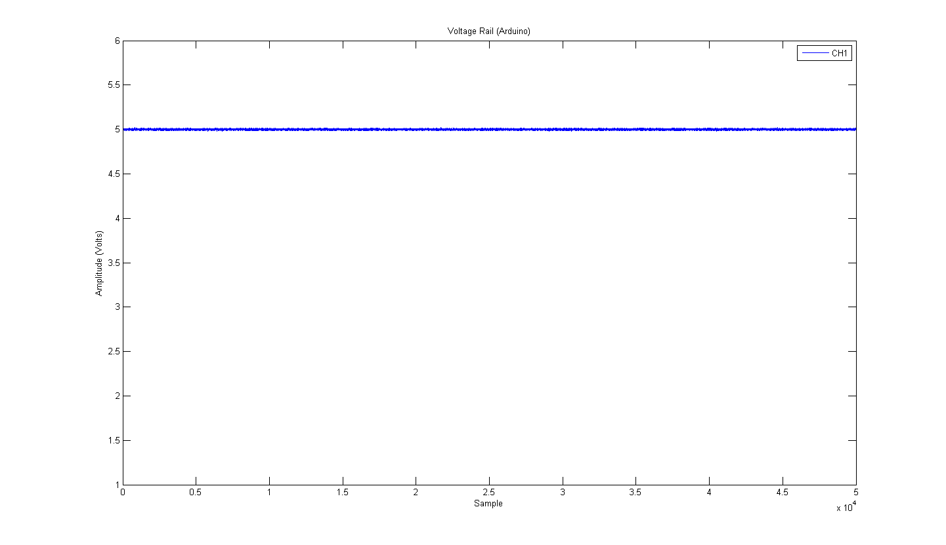

Figure ‑ - Power Rail of Arduino

#### Inertial Measurement Unit

The inertial measurement unit does not have any power LEDs on it or any other directly observable way of determining if the system has powered on. Therefore, to ensure the system is powered on, the data out line will be probed with the oscilloscope to ensure a bit sequence is present. It can be seen in Figure 4‑6 that no abnormalities were observed on the 5 Volt power rail connected to the IMU and that a bit sequence is present. Channel 1 shows the data line at the output while channel 2 shows the power rail.

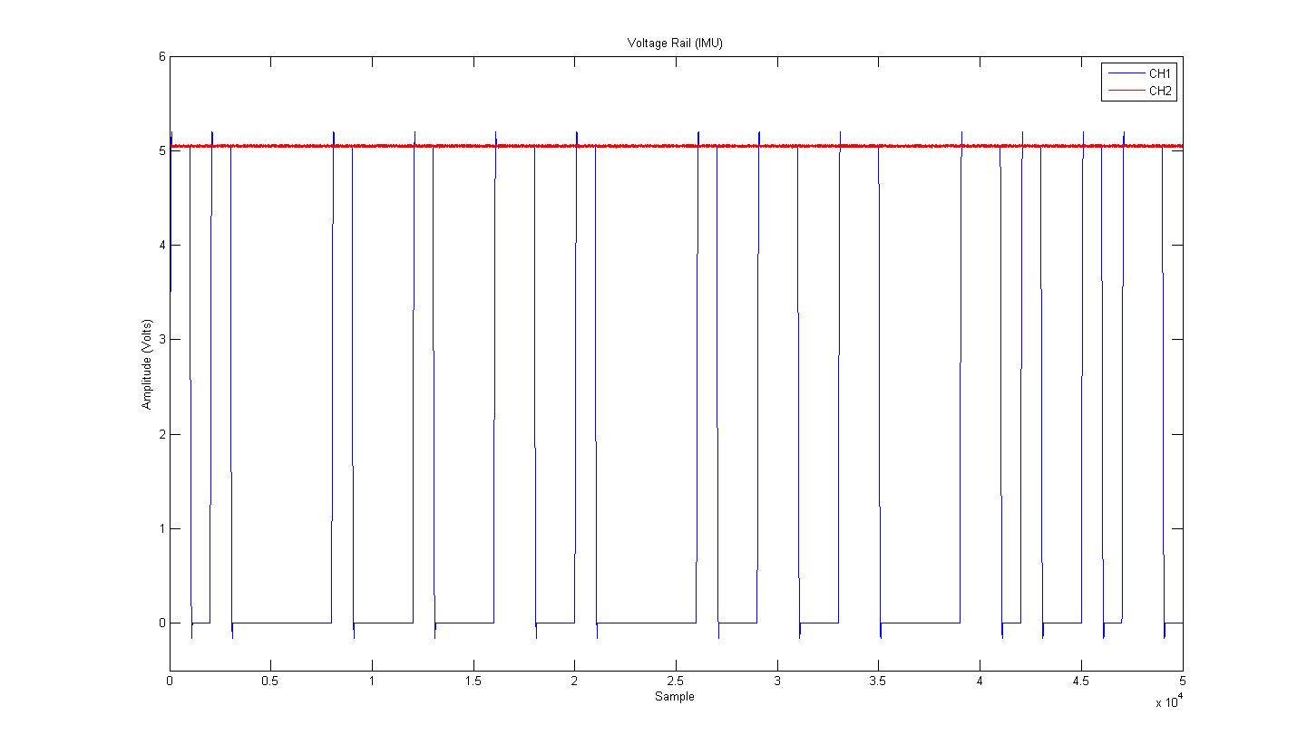

Figure ‑ - Power Rail and Data Line of the IMU

#### Compass

Similar to the inertial measurement unit, the compass does not have any power LEDs on it or any other directly observable way of determining if the system has powered on. Therefore, to ensure the system is powered on, the data out line will be probed with the oscilloscope to ensure a bit sequence is present. It can be seen in Figure 4‑7 that no abnormalities were observed on the 5 Volt power rail connected to the compass and that a bit sequence is present. Channel 1 shows the data line at the output while channel 2 shows the power rail.

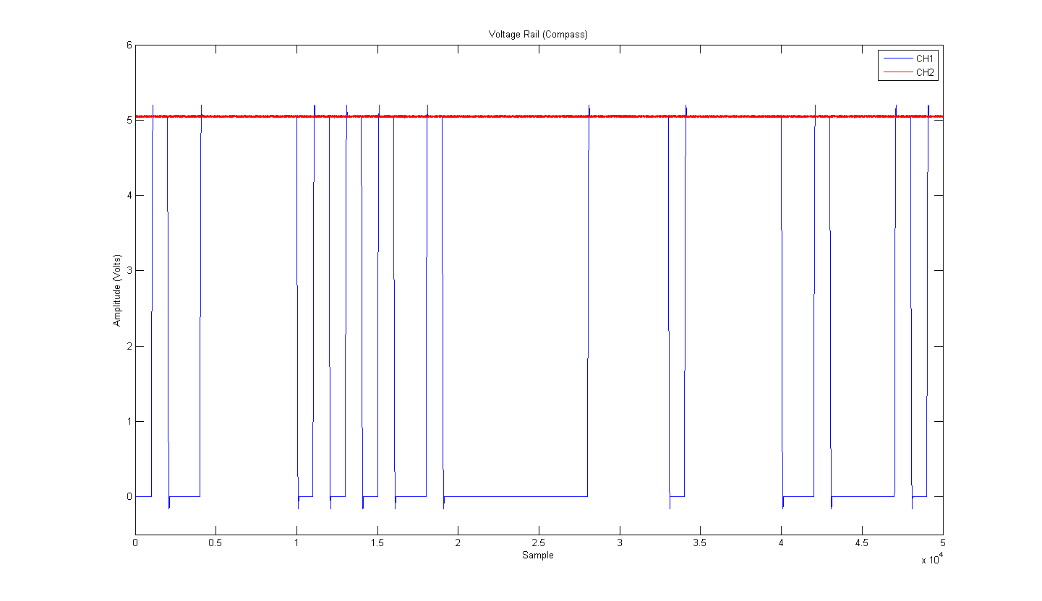

Figure ‑ - Power Rail and Data Line of the Compass

#### Logic Shifter

As mentioned previously, the logic shifter converts between 1.8 Volt logic levels and 5 Volt logic levels. As this is a bi-directional device, it can perform an up shift or a downshift. As this is a single IC, there are no power LEDs to indicate if power is connected. In addition to this, the logic shifter requires a 5 Volt power input as well as a 1.8 Volt power input to drive the 1.8 Volt side of the IC. To ensure the logic shifter is functioning correctly, both the 5 Volt and 1.8 Volt rails were checked for abnormalities. This is shown in Figure 4‑8.

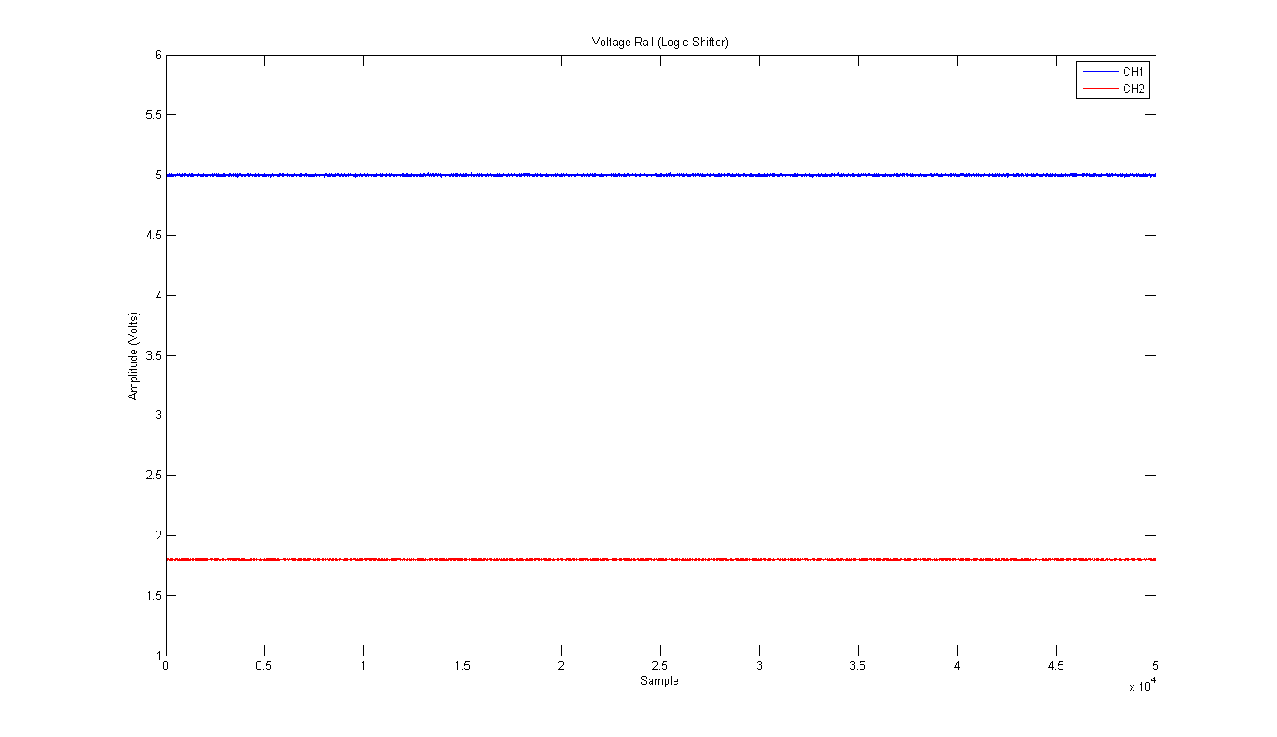

Figure ‑ - Power Rails of the Logic Shifter

To test functionality, a 5 volt signal was applied to one side of the level shifter and the other side was measured. An in phase version of the signal was obverted at the output that had been scaled to 1.8 Volts. Similarly a 1.8 Volt signal was applied to the other side of the logic shifter and a 5 Volt replica of the signal was observed on the other side. These results can be seen in respectively.

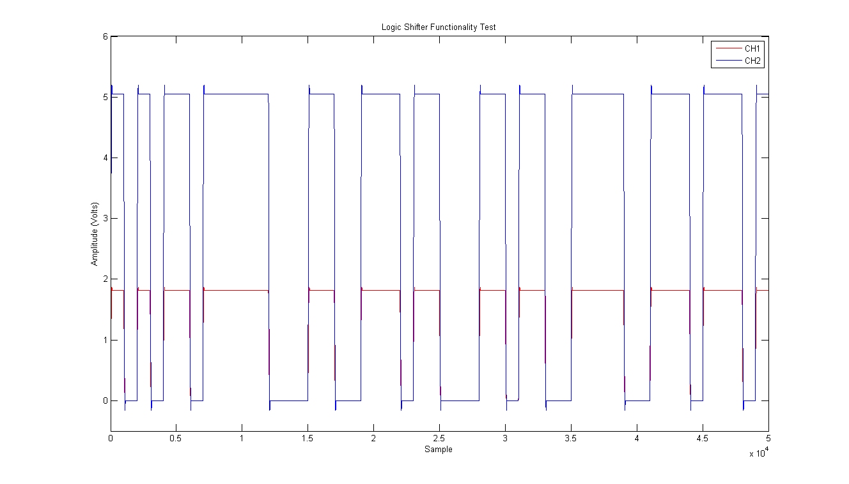

Figure ‑ - Logic Shifter Functionality Test (downshift)

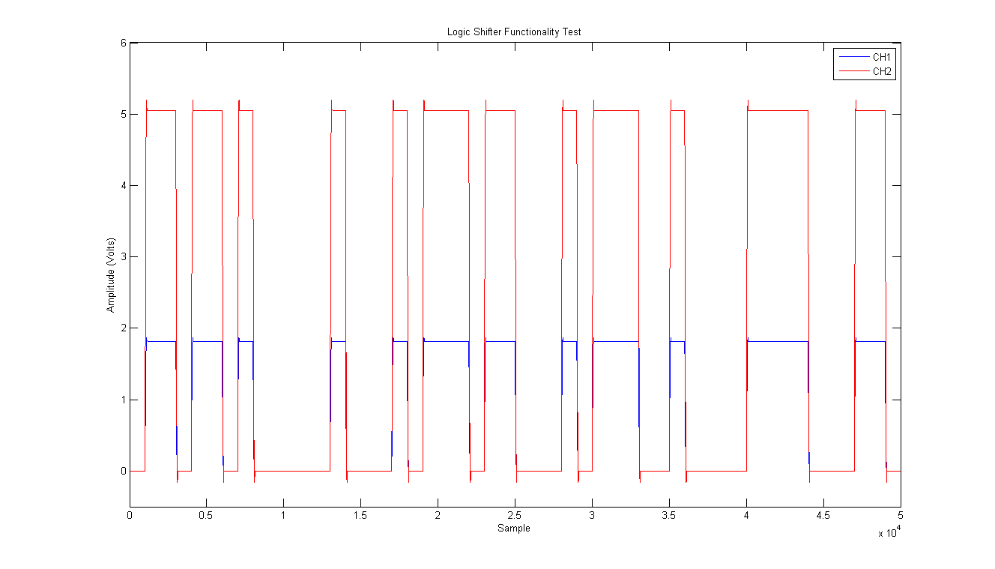

Figure ‑ - Logic Shifter Functionality Test (upshift)

Once these tests were completed, the entire autopilot was assembled with all modules fitted and a communication test was carried out. This is where the data was sent to its appropriate device and read. The test was deemed successful is the data being read was as expected. A summary of all testing performed in this section is seen in below.

|  |  |  |
| --- | --- | --- |
| Objective | Criteria | Results |
| Main Power On | Main power LED illuminated. No disturbances on power rail. | **Pass** |
| Overo Power On | All power related LEDs on the Overo are illuminated. No disturbances on power rail. | **Pass** |
| Arduino Power On | All power related LEDs on the Arduino are illuminated. No disturbances on power rail. | **Pass** |
| IMU Power On | Data observed on the oscilloscope. No disturbances on power rail. | **Pass** |
| MCU Power On | Mode Indicator illuminates. No disturbances on power rail. | **Pass** |
| Compass Power On | Data observed on the oscilloscope. No disturbances on power rail. | **Pass** |
| Level Shifter Power On | Data observed on the oscilloscope. No disturbances on power rail. | **Pass** |
| Overo Communication and Function | Communication can be established with the Overo and response to commands are observed. | **Pass** |
| Arduino Communication and Function | Communication can be established with the Arduino and response to commands are observed. | **Pass** |
| IMU Communication and Function | Communication can be established with the IMU and measurements can be observed. | **Pass** |
| MCU Communication and Function | Communication can be established with the MCU, pulse captures and outputs all observed. | **Pass** |
| Compass Communication and Function | Communication can be established with the Compass and measurements can be observed. | **Pass** |

It can be seen that all tests passed and hence it was deemed that the electronics worked successfully.

# Conformance Matrix

This section details which system requirements were met by the author’s subsystems, and refers to the test reports in which the requirements were tested. These test reports can be found in Appendix B.

|  |  |
| --- | --- |
| Status | Explanation |
| ACHIEVED | This function requirement was met. |
| NOT TESTED | This functional requirement could not be tested due to dependencies on other subsystems. |
| NOT ACHIEVED | This functional requirement was not met. |

Table ‑ - Conformance matrix legend

## Platform

|  |  |  |  |  |
| --- | --- | --- | --- | --- |
| HLO | Requirement | Definition | Status | Test reports |
| HLO-1  Platform | **SR-B-01** | Groundpulse shall receive data through a connection from the autopilot | **ACHIEVED** | AHNS-2010-PL-TR-002 |
| **SR-D-01** | Each data packet shall include values adequate to control each of the helicopter control surfaces | **ACHIEVED** | AHNS-2010-PL-TR-002 |
| **SR-D-02** | The packet shall include a CRC-8 checksum and use parity checking | **ACHIEVED** | AHNS-2010-PL-TR-001 |

Table ‑ - Platform conformance matrix

It can be seen that system requirements were achieved within the Platform Subsystem.

# Conclusions

The project was able to achieve almost all system requirements and hence almost all of its high level objectives. Due to time constraints, a camera was never implemented and hence localisation could not be achieved. As a matter of safety, and given the unpredictable and unstable nature of the quad-copter design. Position hold was never implemented. Other than these two requirements, all other requirements and objects were met.

Unlike previous years, sate estimation was not an issue for the project in terms of control. Although most states were measured to a great deal of accuracy and reliability, the Vicon system could be used to measure them exactly. The Vicon system was able to measure position in all three axes as well as roll angle and roll rate.

The project was left in good condition for future adaptation. The system is complete and functioning. A revised PCB design should be adopted to ensure connectors are managed more efficiently. The system is able to maintain a stable hover with pilot input. It should not take long for a position hold system to be implemented with the help of Vicon

Due to the strong materials and simple design of the airframe, it is completely undamaged despite the crashes is sustained.

## Recommendations

The scope of the project needs to be considered carefully to ensure too much work is not being expected. There is limited time to develop a system within an undergraduate course. If the objective of a project is to simply develop hardware than this is all that should be achieved. If the objective of the project is to achieve any form of waypoint navigation or station keeping, hardware should be acquired by other means. That is, all hardware components should be adopted from tested, open source projects or commercial systems. Given the limited time and resources available during an undergraduate degree there is simply insufficient time to develop and test a low level hardware system and develop high levels functionality.

The development of an autopilot hardware system is a complex undertaking. Given, this, a minimum of two people should be assigned to this system. Two hardware oriented people would ensure all designs are double check more efficiently. It would also mean that designs can be broken up between two people and developed in parallel. Additionally two people could be used to speed up the manufacturing and testing process associated with hardware development.

Another recommendation to be made is to allow more time for the hardware development stage. In this project, the time taken for development of hardware by a single person was underestimated. The development stage should be started sooner and time should be allocated to allow the process to end later. In addition to this considerations should be made to facilitate parallel development of software and hardware. This created a bottleneck as software development was held up, waiting for the hardware to be completed.

As a final note, considerations should be made to establish a standalone project for the hardware development This would allow the entire year to develop the system and ensure the best possible design decisions are made.

References

[1] MikroKopter, "Wiki: MikroKopter.de" Internet: <http://www.mikrokopter.de/ucwiki/en/MikroKopter>, 2010 [Nov. 3, 2010]

Associated Websites

[A1] AHNS Source code repository: <http://ahns10.googlecode.com/svn/>

List of Appendices

1. System Documentation
   1. AHNS-2010-SY-DD-001 Preliminary Design Document
   2. AHNS-2010-SY-SR-001 System Requirements Document
   3. AHNS-2010-SY-HL-001 High Level Objectives Document
   4. AHNS-2010-SY-PM-001 Project Management Plan
   5. AHNS-2010-SY-PM-002 Risk Management Plan
2. Subsystem Documentation
   1. AHNS-2010-PL-TS-001 Airframe Trade Study
   2. AHNS-2010-PL-DD-001 Platform Electronics Design Document
   3. AHNS-2010-PL-TR-001 Flight Log
   4. AHNS-2010-PL-TR-002 Airframe Radio Control Test Report
   5. AHNS-2010-PL-TR-003 Platform Electronics Test Report