|  |  |  |
| --- | --- | --- |
| RD/1 | Design and Control of an Indoor Micro Quadrotor | Bouabdallah, S, P Murrieri and R Siegwart. 2007. "Design and Control of an Indoor Micro Quadrotor." In Advances in unmanned aerial vehicles: state of the art and the road to autonomy, ed. K. P. Valavanis: Springer Verlag. |
| RD/2 | IEEE Design and control of an indoor micro quadrotor | Bouabdallah, S., P. Murrieri and R. Siegwart. 2004. "Design and control of an indoor micro quadrotor." In IEEE INTERNATIONAL CONFERENCE ON ROBOTICS AND AUTOMATION: IEEE. |
| RD/3 | Overo Fire COM | Gumstix 2010. Overo Fire COM. Available: <http://www.gumstix.com/store/catalog/product_info.php?products_id=227>  (accessed March 7 2010) |
|  |  |  |
|  |  |  |

# Autopilot Control

The autopilot control has been described in SR-B-10 as taking the form of a cascaded proportional, integral and derivative controller. That is, the autopilot will consist of cascaded guidance and control PID control loops. At a preliminary level these cascaded elements may be position control and attitude control [RD/1]. In stability augmentation mode the attitude controller is to maintain the quadrotor at a level attitude, without considering the altitude of the aircraft or its position. This mode is primarily to be used as a means of tuning the autopilot’s attitude control loops. In autonomous station keeping the position control will use the information from the localisation subsystem to drive the attitude control loops.

The quadrotor arrangement means regardless of the control implementation the outputs will be reference signals for the four engines as shown in Figure 1.1. Vertical motion can be controlled by simultaneously increasing or decreasing the motor speeds. To vary pitch or roll, asymmetric engine thrust is produced between engines 1 and 3 or 2 and 4. Pitch and roll variations also lead to longitudinal and lateral motion respectively [RD/1; RD2]. Although these effects are well understood gain tuning of the controller will still be achieved during on-line flight testing. Provisions have been included in the design of the software and hardware systems to log all state and control data for facilitation of linear system model development.

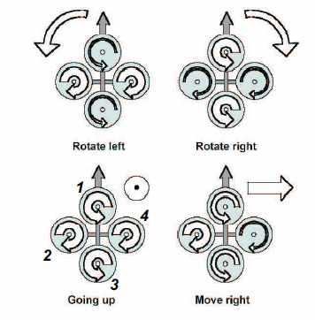

Figure . - Quadrotor motor control input effects [RD/2]

# Flight Computer

To enable autonomous operation of the AHNS platform considerable airborne computing power and hardware interfacing is required. This was decided to be achieved with a single-board flight computer. A trade study was therefore undertaken to consider the precise system requirements and high level objects of the system. The Gumstix Overo Fire COM was selected from a field of four single-board computer alternatives based on its processor type and power, mass, operating system support, memory, hardware interfaces and cost. Its processor support for digital image processing and computations proved its suitability. To expand its hardware interfacing options two expansion boards, the Pinto-TH and the Summit were also selected.

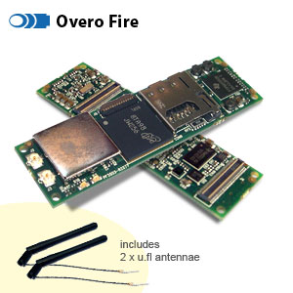

Figure . – Gumstix Overo Fire COM [RD/3]