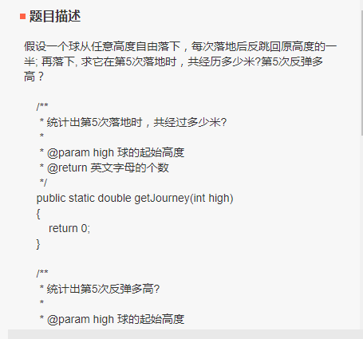

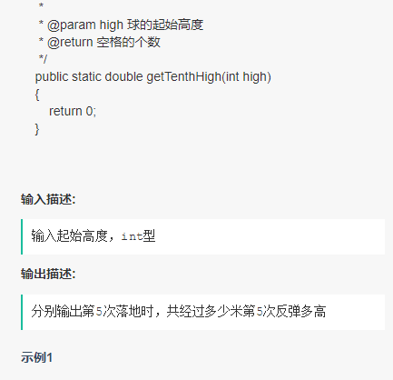

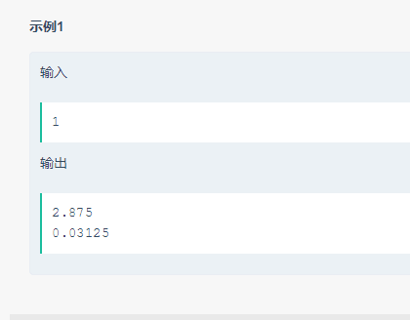

#include<iostream>

using namespace std;

int main(){

    int data;

    while(cin >> data){

        double sum = data;

        double height = data;

        for(int i = 2; i <= 5; ++i){

            height /= 2;

            sum += height \* 2;

        }

        cout << sum << endl << height/2 << endl;

    }

    return 0;

}

通过100%