Introduction

Sedapp: a new non-linear open-source R code for Forward Stratigraphy Modelling (FSM). This code uses an integrated depth-distance related function as the expression of the transport coefficient to underpin the FSM with more along-shore details. All parameters were implemented in a non-linear manner. The version number here is v2021.

Support

For more details about Sedapp, please contact Jingzhe Li via email [lijingzhe@qust.edu.cn](mailto:(lijingzhe@qust.edu.cn)).

Installation

Sedapp is a model written in R. The R scripts could be run directly in your PCs provide an R environment is available.

Note:

R packages listed below are needed before the running:

"smoothr", "Matrix", "stats", "graphics", "grDevices" "utils", "datasets", "methods", "base", "Rcpp".

RStudio of Windows is a preferable IDE since Package ‘rstudioapi’ is also used in Sedapp_v2021.

License information

The current version of Sedapp (Sedapp_v2021) is available from the project doi: 10.5281/zenodo.4556868 under the Creative Commons Attribution 4.0 International License.

An example

Taking a continental fault basin as an example, Sedapp_v2021 can conduct a simplified 2D case study. The basic geological background is as follows:

During the deposition period of this set of strata, the normal fault tectonic movement in the north of the sag was active, which was the main controlling factor leading to the increase of accommodation space. At the same time, the terrigenous clasts came from the north is sufficient, and the basin was in a balanced state.

According to the geological background, a simplified reconstruction model was designed, which assumed that the subsidence rate of the boundary fault and sediment supply rate is constant, neglected the effect of isostasy, and considered the effect of sediment compaction.

Run the ‘Example.r’ can get the figures like below:

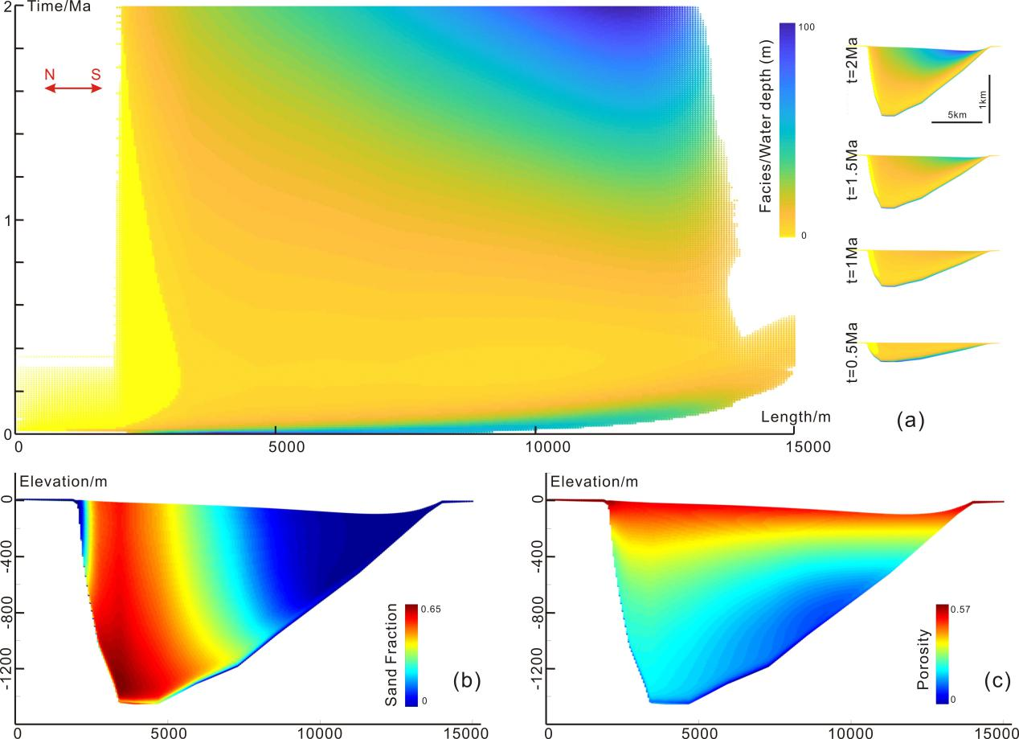

**A continental fault basin example simulated by Sedapp_v2021**

See the file ‘Example.r’ for detailed input parameters and their meanings.

A brief explanation of some input parameters in the ‘Example.r’:

1. **sl.series**: a vector showing the change of the sea level over time. The length of the vector should be the number of the steps.
2. **isostasy**: Isostasy is the state of gravitational equilibrium between Earth's crust (or lithosphere) and mantle such that the crust "floats" at an elevation that depends on its thickness and density. The value of this parameter is logic. TRUE means the isostasy process is activated in the simulation, and FALSE means the isostasy is disabled.
3. **overlying.layer.thickness**: an imaginary thickness of the overlying layer. The default value is 0, which means a normal situation. The non-zero positive values could only be used when you hope to see the enhanced effect of the compaction process.

Other input parameters can see: https://gmd.copernicus.org/preprints/gmd-2020-256/