爱创课堂前端培训

jquery第四天

班级：爱创课堂十八期

讲师：彭帅伟

日期：2018年11月4日

# 间歇模型



我们的编程思路是使用定时器来完成， 我们让图片每2000ms更换一次， 完成动画的事件是600ms， 定时器的间隔时间应该是它们的加和， 所以应该是2600ms

|  |
| --- |
| var idx = 0;  setInterval(function(){  idx++;  $("#unit").animate({"top":-90 * idx},500);  },2600); |

拉动的策略就是右按钮的策略：

|  |
| --- |
| setInterval(function(){  idx ++;  $unit.animate({"top": -90 * idx} , 500,function(){  // 验证  if(idx > **$unit.children().length / 3 - 2**){  idx = 0;  $unit.css("top",0);  }  });  }, 2500); |

# 手风琴效果

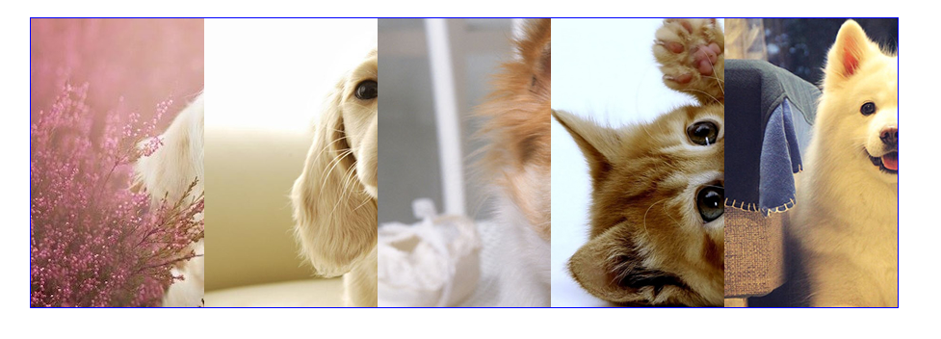

分析：

我们将整体图片宽定为900， 里面存放5张图片，每一张所占的位置应该是180，当鼠标移入某张图片， 当前图片延展开（560）， 其它图片要压缩， 由4张图片压缩之后应该是85的位置

|  |
| --- |
|  |

|  |
| --- |
|  |

|  |
| --- |
|  |

|  |
| --- |
|  |

|  |
| --- |
|  |

|  |
| --- |
|  |

|  |
| --- |
|  |

|  |
| --- |
|  |

|  |
| --- |
|  |

|  |
| --- |
|  |

|  |
| --- |
|  |

|  |
| --- |
|  |

|  |
| --- |
|  |

|  |
| --- |
|  |

|  |
| --- |
|  |

|  |
| --- |
|  |

|  |
| --- |
|  |

|  |
| --- |
|  |

|  |
| --- |
|  |

|  |
| --- |
|  |

|  |
| --- |
|  |

|  |
| --- |
|  |

|  |
| --- |
|  |

|  |
| --- |
|  |

|  |
| --- |
|  |

|  |
| --- |
|  |

|  |
| --- |
|  |

|  |
| --- |
|  |

|  |
| --- |
|  |

|  |
| --- |
|  |

|  |
| --- |
|  |

|  |
| --- |
|  |

|  |
| --- |
|  |

|  |
| --- |
|  |

|  |
| --- |
|  |

|  |
| --- |
|  |

|  |
| --- |
|  |

|  |
| --- |
|  |

|  |
| --- |
|  |

|  |
| --- |
|  |

|  |
| --- |
|  |

|  |
| --- |
|  |

|  |
| --- |
|  |

|  |
| --- |
|  |

|  |
| --- |
|  |

|  |
| --- |
|  |

|  |
| --- |
|  |

|  |
| --- |
|  |

|  |
| --- |
|  |

|  |
| --- |
|  |