爱创课堂前端培训

# 微信小程序

第4天课堂笔记（本课程共4天）

班级：北京前端训练营19期

讲师：李兰波

日期：2019年2月25日

爱创课堂官网 ：[www.icketang.com](http://www.icketang.com)

# 上线

第一步：设置APPID

第二步：点击上线按钮 菜单栏工具 => 上传

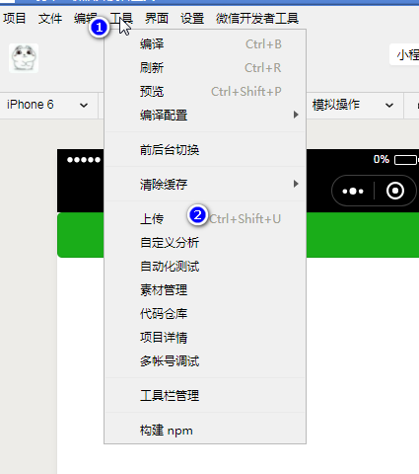

第三步：在弹出的对话框中输入版本和说明

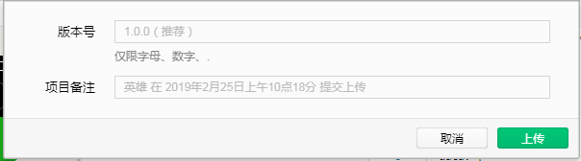

第四步：登录微信公众平台 进入后台管理 设置为体验版本

第五步：等待审核

第六步：审核通过之后点击发布 就发布到线上了。

|  |
| --- |
|  |

|  |
| --- |
|  |

|  |
| --- |
|  |

|  |
| --- |
|  |

|  |
| --- |
|  |

|  |
| --- |
|  |

|  |
| --- |
|  |

|  |
| --- |
|  |

|  |
| --- |
|  |

|  |
| --- |
|  |

|  |
| --- |
|  |

|  |
| --- |
|  |

|  |
| --- |
|  |

|  |
| --- |
|  |

|  |
| --- |
|  |

|  |
| --- |
|  |

|  |
| --- |
|  |

|  |
| --- |
|  |

|  |
| --- |
|  |

|  |
| --- |
|  |

|  |
| --- |
|  |

|  |
| --- |
|  |

|  |
| --- |
|  |

|  |
| --- |
|  |

|  |
| --- |
|  |

|  |
| --- |
|  |

|  |
| --- |
|  |

|  |
| --- |
|  |

|  |
| --- |
|  |

|  |
| --- |
|  |

|  |
| --- |
|  |

|  |
| --- |
|  |

|  |
| --- |
|  |

|  |
| --- |
|  |

|  |
| --- |
|  |

|  |
| --- |
|  |

|  |
| --- |
|  |

|  |
| --- |
|  |

|  |
| --- |
|  |

|  |
| --- |
|  |

|  |
| --- |
|  |

|  |
| --- |
|  |

|  |
| --- |
|  |

|  |
| --- |
|  |

|  |
| --- |
|  |

|  |
| --- |
|  |

|  |
| --- |
|  |

|  |
| --- |
|  |

|  |
| --- |
|  |

|  |
| --- |
|  |

|  |
| --- |
|  |

|  |
| --- |
|  |

|  |
| --- |
|  |

|  |
| --- |
|  |

|  |
| --- |
|  |

|  |
| --- |
|  |

|  |
| --- |
|  |

|  |
| --- |
|  |

|  |
| --- |
|  |

|  |
| --- |
|  |

|  |
| --- |
|  |

|  |
| --- |
|  |

|  |
| --- |
|  |

|  |
| --- |
|  |

|  |
| --- |
|  |

|  |
| --- |
|  |

|  |
| --- |
|  |

|  |
| --- |
|  |

|  |
| --- |
|  |

|  |
| --- |
|  |

|  |
| --- |
|  |

|  |
| --- |
|  |

|  |
| --- |
|  |

|  |
| --- |
|  |

|  |
| --- |
|  |

|  |
| --- |
|  |

|  |
| --- |
|  |

|  |
| --- |
|  |

|  |
| --- |
|  |

|  |
| --- |
|  |

|  |
| --- |
|  |

|  |
| --- |
|  |

|  |
| --- |
|  |

|  |
| --- |
|  |

|  |
| --- |
|  |

|  |
| --- |
|  |

|  |
| --- |
|  |

|  |
| --- |
|  |

|  |
| --- |
|  |

|  |
| --- |
|  |

|  |
| --- |
|  |

|  |
| --- |
|  |

|  |
| --- |
|  |

|  |
| --- |
|  |

|  |
| --- |
|  |

|  |
| --- |
|  |

|  |
| --- |
|  |

|  |
| --- |
|  |

|  |
| --- |
|  |

|  |
| --- |
|  |

|  |
| --- |
|  |

|  |
| --- |
|  |

|  |
| --- |
|  |

|  |
| --- |
|  |

|  |
| --- |
|  |

|  |
| --- |
|  |

|  |
| --- |
|  |

|  |
| --- |
|  |

|  |
| --- |
|  |

|  |
| --- |
|  |

|  |
| --- |
|  |

|  |
| --- |
|  |

|  |
| --- |
|  |

|  |
| --- |
|  |

|  |
| --- |
|  |

|  |
| --- |
|  |