第一次作业

1.#include<iostream.h>

int main()

{

int c0,c1,c2,c3,c4,c5,c6,k;

int c66,c55,c44,c33,c22; //钱分别找了100,50,20,10,5,2剩下的

cout<<"你要支付多少元："<<endl;

cin>>k;

if(k%100==0)

c6=k/100;

else

{

c6=k/100;

c66=k%100;

if(c66%50==0)

c5=c66/50;

else

{

c5=c66/50;

c55=c66%50;

if(c55%20==0)

c4=c55/20;

else

{

c4=c55/20;

c44=c55%20;

if(c44%10==0)

c3=c44/10;

else

{

c3=c44/10;

c33=c44%10;

if(c33%5==0)

c2=c33/5;

else

{

c2=c33/5;

c22=c33%5;

if(c22%2==0)

c1=c22/2;

else

{

c1=c22/2;

c0=c22%2;

}

}

}

}

}

}

cout<<"需要支付的100，50,20,10,5,2,1纸币分别为："<<c6<<" "<<c5<<" "<<c4<<" "<<c3<<" "<<c2<<" "<<c1<<" "<<c0<<endl;

cout<<"总共需要的纸币为:"<<c6+c5+c4+c3+c2+c1+c0<<endl;

return 0;

}

运行结果

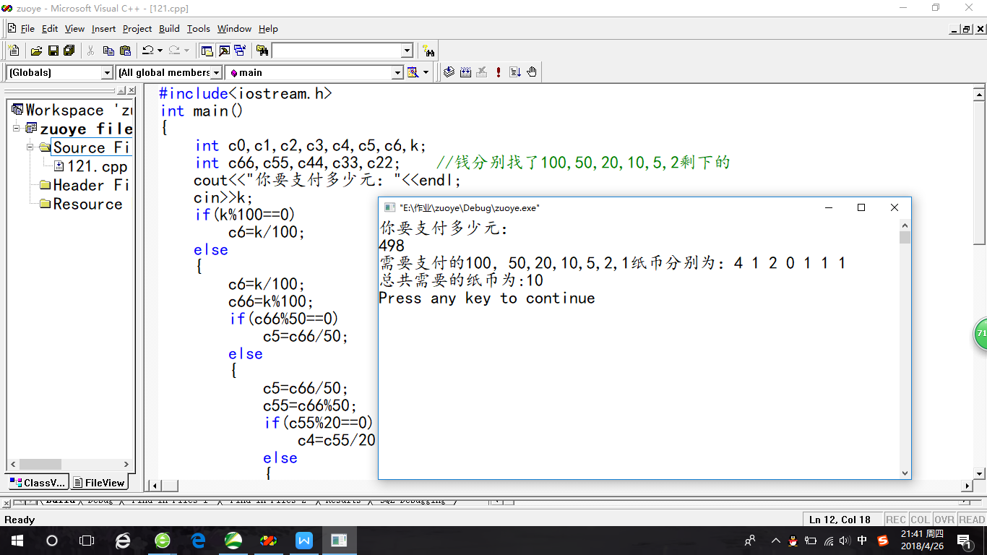

安装liunix系统：

