Aws文档地址：https://docs.aws.amazon.com/iot/latest/developerguide/iot-jobs.html?icmpid=docs_iot_hp_manage_jobs
https://docs.aws.amazon.com/zh_cn/iot/latest/developerguide/iot-jobs.html

Aws管理后台设置job的地址：
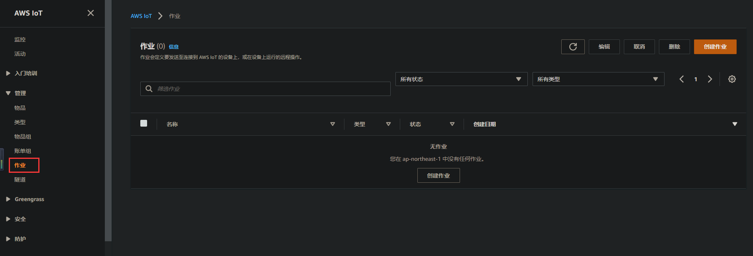

一共可分为三种类型，按需求选择：