Aws文档地址：https://docs.aws.amazon.com/iot/latest/developerguide/iot-rules.html

Aws管理后台设置规则引擎地址：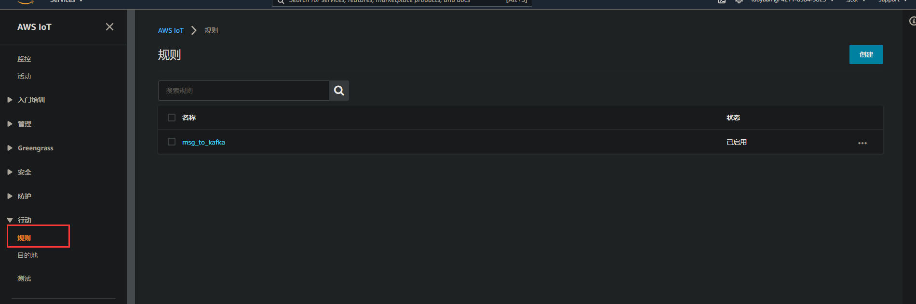

- 设置规则名称和描述：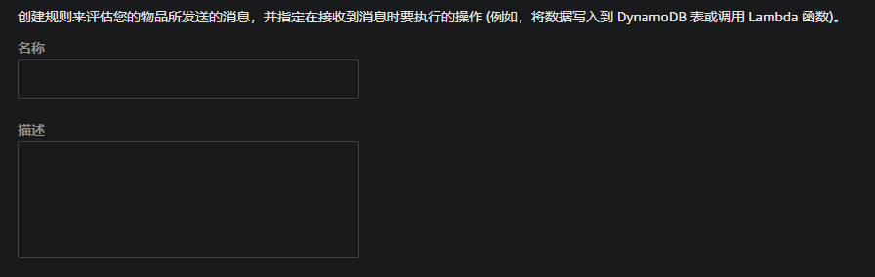
- 根据aws-iot-sql筛选特定规则的topic下的mqtt消息：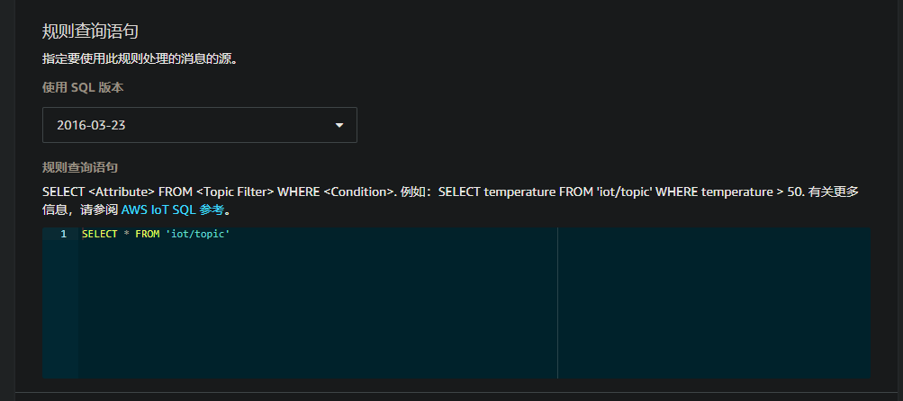
- 设置步骤2的消息的操作：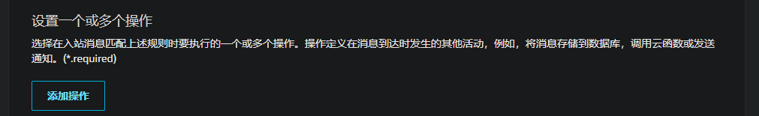
- 设置出错时的操作：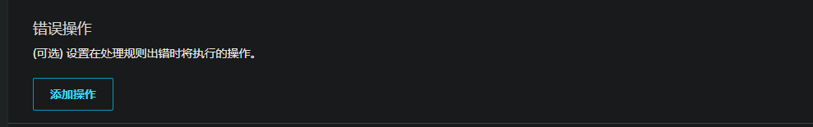

iot规则引擎配置kafka教程：https://aws.amazon.com/cn/getting-started/hands-on/deliver-data-at-scale-to-amazon-msk-with-iot-core/

规则引擎sql语句:
https://docs.aws.amazon.com/zh_cn/iot/latest/developerguide/iot-sql-reference.html?icmpid=docs_iot_console
https://docs.aws.amazon.com/zh_cn/iot/latest/developerguide/iot-create-rule.html
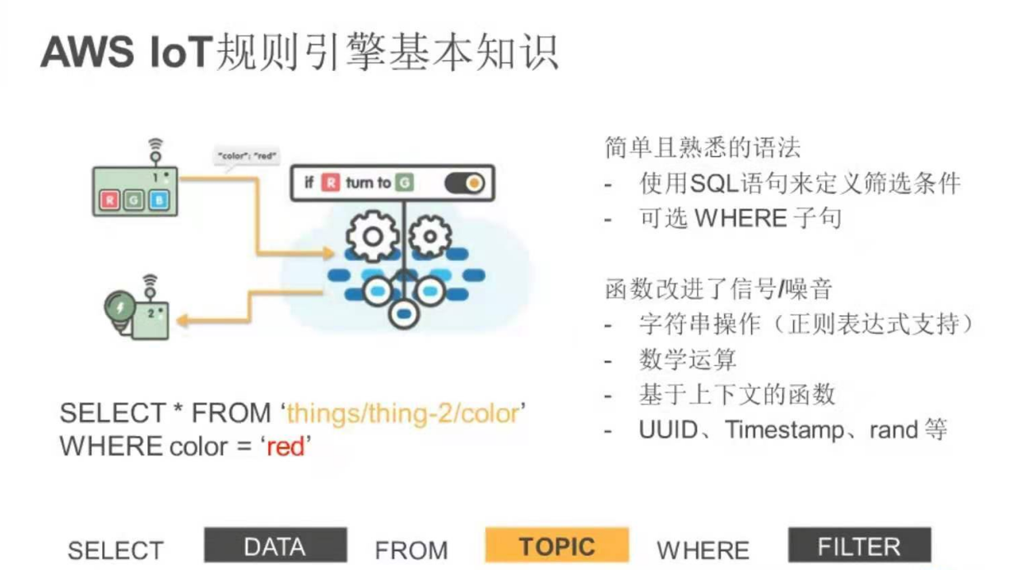
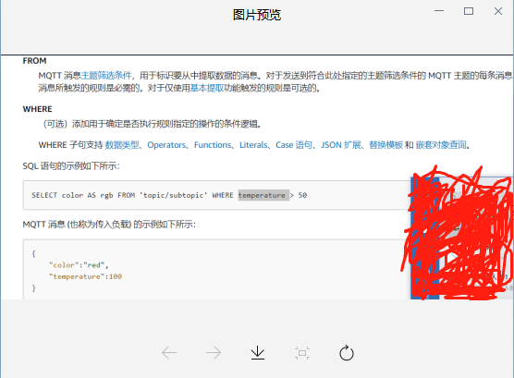

插座基础
