- 安装go
wget https://dl.google.com/go/go1.xx.linux-amd64.tar.gz
官网下载最新版本即可
tar -xvf go1.xx.linux-amd64.tar.gz -C /usr/local/
/usr/local/go/bin路径添加到环境变量PATH中

- 安装etcd
github clone 即可
将解压后bin下的etcd和etcdctl可执行文件移动到$GOPATH/bin目录下

- 安装vpp-agent
git clone https://github.com/ligato/vpp-agent.git
分别执行make agent agnentctl install cmd
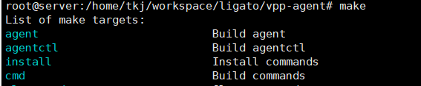
另外需要看下vpp-agent支不支持vpp版本
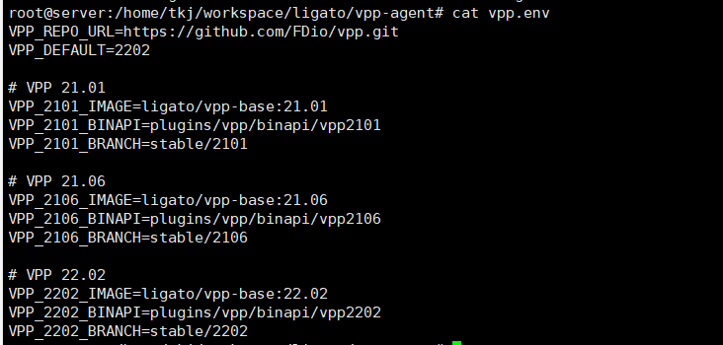

还需要修改vpp配置文件
socksvr {
socket-name /var/run/vpp/api.sock
}

需要改成api.sock

- 测试
分别运行 vpp etcd vpp-client

获取vpp中interfaces信息
root@server:/home/tkj/workspace/ligato# curl -X GET http://localhost:9191/dump/vpp/v2/interfaces
{
"0": {
"interface": {
"name": "UNTAGGED-local0",
"type": 2,
"phys_address": "00:00:00:00:00:00",
"Link": null
},
"interface_meta": {
"sw_if_index": 0,
"sub_sw_if_index": 0,
"l2_address": "AAAAAAAA",
"internal_name": "local0",
"dev_type": "local",
"is_admin_state_up": false,
"is_link_state_up": false,
"link_duplex": 0,
"link_mtu": 0,
"mtu": [
0,
0,
0,
0
],
"link_speed": 0,
"sub_id": 0,
"tag": "",
"dhcp": null,
"vrf_ipv4": 0,
"vrf_ipv6": 0,
"pci": 0
}
},
"1": {
"interface": {
"name": "GigabitEthernet2/5/0",
"type": 3,
"enabled": true,
"phys_address": "00:0c:29:96:5f:eb",
"ip_addresses": [
"192.168.10.3/24"
],
"mtu": 8996,
"rx_modes": [
{
"mode": 1
}
],
"rx_placements": [
{}
],
"Link": null
},
"interface_meta": {
"sw_if_index": 1,
"sub_sw_if_index": 1,
"l2_address": "AAwpll/r",
"internal_name": "GigabitEthernet2/5/0",
"dev_type": "dpdk",
"is_admin_state_up": true,
"is_link_state_up": true,
"link_duplex": 2,
"link_mtu": 8996,
"mtu": [
8996,
0,
0,
0
],
"link_speed": 1000000,
"sub_id": 0,
"tag": "",
"dhcp": null,
"vrf_ipv4": 0,
"vrf_ipv6": 0,
"pci": 0
}
}
}

root@server:/home/tkj/workspace/ligato# curl -X PUT -H "Content-Type: application/json" --data-binary @loop1.json http://localhost:9191/configuration
{}
root@server:/home/tkj/workspace/ligato# curl -X GET http://localhost:9191/dump/vpp/v2/interfaces
{
"0": {
"interface": {
"name": "UNTAGGED-local0",
"type": 2,
"phys_address": "00:00:00:00:00:00",
"Link": null
},
"interface_meta": {
"sw_if_index": 0,
"sub_sw_if_index": 0,
"l2_address": "AAAAAAAA",
"internal_name": "local0",
"dev_type": "local",
"is_admin_state_up": false,
"is_link_state_up": false,
"link_duplex": 0,
"link_mtu": 0,
"mtu": [
0,
0,
0,
0
],
"link_speed": 0,
"sub_id": 0,
"tag": "",
"dhcp": null,
"vrf_ipv4": 0,
"vrf_ipv6": 0,
"pci": 0
}
},
"1": {
"interface": {
"name": "GigabitEthernet2/5/0",
"type": 3,
"enabled": true,
"phys_address": "00:0c:29:96:5f:eb",
"ip_addresses": [
"192.168.10.3/24"
],
"mtu": 8996,
"rx_modes": [
{
"mode": 1
}
],
"rx_placements": [
{}
],
"Link": null
},
"interface_meta": {
"sw_if_index": 1,
"sub_sw_if_index": 1,
"l2_address": "AAwpll/r",
"internal_name": "GigabitEthernet2/5/0",
"dev_type": "dpdk",
"is_admin_state_up": true,
"is_link_state_up": true,
"link_duplex": 2,
"link_mtu": 8996,
"mtu": [
8996,
0,
0,
0
],
"link_speed": 1000000,
"sub_id": 0,
"tag": "",
"dhcp": null,
"vrf_ipv4": 0,
"vrf_ipv6": 0,
"pci": 0
}
},
"2": {
"interface": {
"name": "loop1",
"type": 2,
"enabled": true,
"phys_address": "de:ad:00:00:00:00",
"ip_addresses": [
"192.168.1.1/24"
],
"mtu": 9000,
"Link": null
},
"interface_meta": {
"sw_if_index": 2,
"sub_sw_if_index": 2,
"l2_address": "3q0AAAAA",
"internal_name": "loop0",
"dev_type": "Loopback",
"is_admin_state_up": true,
"is_link_state_up": true,
"link_duplex": 0,
"link_mtu": 9000,
"mtu": [
9000,
0,
0,
0
],
"link_speed": 0,
"sub_id": 0,
"tag": "loop1",
"dhcp": null,
"vrf_ipv4": 0,
"vrf_ipv6": 0,
"pci": 0
}
}
}

