Jeremy Li
March 1, 2012

Credit: Citrix Tech Exchange Q1 2012

Virtual Desktop Infrastructure (VDI) Deployment Issues:

1. Boot and Log-on Storm
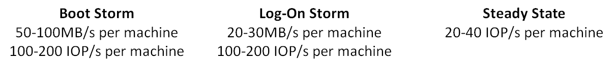

2. Attended one session from Atlantis Computing (An Excellent Session)

The following excerpts come from Windows 7 IOPS for VDI: Deep Div –
http://jimmoyle.com/wordpress/wp-content/uploads/downloads/2011/05/Windows_7_IOPS_for_VDI_a_Deep_Dive_1_0.pdf

Summary
Windows 7 and IOPS is the most challenging, least understood and most frequently encountered resource bottleneck that stalls todays desktop virtualization projects. Many of these projects are Windows 7 migrations which are one of the key IT initiatives which are driving VDI adoption today. However, many IT organizations planning a Windows 7 migration with VDI are unaware that the combination of Windows 7 and Anti-virus more than doubles the amount of memory and IOPS required per desktop compared to Windows XP, which will significantly decrease virtual desktop density per server and will degrade virtual desktop performance. As a result, the storage architecture is often undersized for Windows 7. This leads to desktop performance and budgeting issues when more storage is required to fix the IOPS bottleneck.

IOPS and Scaling VDI for Production
Many IT organizations have delivered successful VDI pilot projects, only to fail as they scale the production rollout. During the pilot, the shared storage infrastructure delivers more than adequate throughput, providing excellent desktop performance. However, as the pilot transitions to production, storage infrastructure IO performance degrades as each virtual desktop makes requests of the shared storage infrastructure as if it were dedicated storage. The result is poor desktop and application performance and increasing user dissatisfaction with the virtual desktop infrastructure. With conventional VDI environments, the only way to address this degraded performance is to spread the virtual desktop load over more and more drives and storage controllers. This either increases the cost of VDI beyond the original budget or dooms the project to failure.

(Jeremy’s comments: I knew that many VDI users, especially in graphic intensive units, tried and requested to go back to their 5-year old desktops in order to return their daily normal productivities in many Government Agencies. As a result, a few new EMC VNX or other vendors’ storages must be purchased in order to boost IOPS requirements in order to support VDI users in a production environment. This is very expensive method to deploy VDI at Government Agencies since hundreds or thousands of HDDs must be purchased in order to meet the VDI IOPS requirements. Therefore, Atlantis Computing software agent was born to address the IOPS issue from Windows XP and Windows 7 issues.

However, please be cautious. A third party solution often generates a compatibility issue. It may work for a while, but stops work after other vendors may some changes through a service pack upgrade or OS version changes etc.

Competing for shared resources

Windows 7 was designed with a local and dedicated disk and requires constant access to the hard drive even when it is idle. In addition, Windows 7 will consume as much disk IO or throughput to the hard drive as is possible. This means that Windows isn’t a good community member, it is very selfish. As a result, when you virtualize thousands of Windows 7 desktops and have them share storage (SAN or NAS), they all compete to use as much disk IO as possible to maximize their own performance without any knowledge of the needs of the other desktops that are sharing that same hardware resource. If a Windows 7 desktop doesn’t have access to the IO that it requires, desktop performance will degrade and users will see it in the form of long boot/logon times, slow application launching and generally poor desktop performance. Also, organizations will be limited in how they can boot their virtual desktops, when and how they can patch the operating system and applications and when they can run Anti-Virus scans.
Each disk can provide 65-200 IOPS per spindle depending on its type (SATA, SAS). This figure cannot be increased at the moment. Essentially, to cover the amount of IOPS required by VDI by using traditional methods, huge amounts of HDDs and controllers need to be purchased.

Virtualization is meant to save us space, power and cooling in the datacenter. If you have to add racks of HDDs to the datacenter, you essentially lose the benefits of virtualization. This means your CAPEX/OPEX costs and the complexity of the VDI deployment goes up considerably.

From Citrix’s recommendation for IOPS:
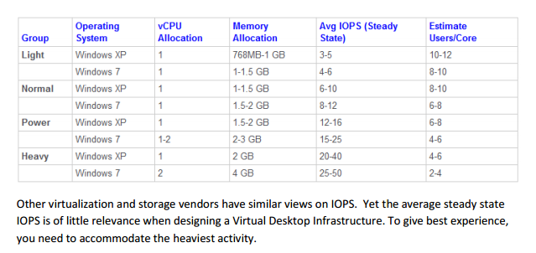

The Luncheon Keynote from Microsoft MVP Brian Madden at

Q1 2012 LA Citrix Tech Exchange – Brian Madden

http://www.lacitrix.com/q1-2012-la-citrix-user-group-brian-madden-keynote-more/

http://www.lacitrix.com/la-tech-exchange-q1-2012-presentations/

- 4 ways Microsoft is screwing the desktop virtualization industry, and why I'm quitting the MVP program

Click on the link below for details:

http://www.brianmadden.com/blogs/brianmadden/archive/2012/03/01/4-ways-microsoft-is-screwing-the-desktop-virtualization-industry-and-why-i-m-quitting-the-mvp-program.aspx

- Click http://www.brianmadden.com/ for details

It looks like Microsoft does not want to support VDI but would like to promote its own terminal services technology since many VDI deployments started since 2006. The former Microsoft MVP Brian Madden quit the MVP program to protest Microsoft …

4. Case Study One: Defense Customer

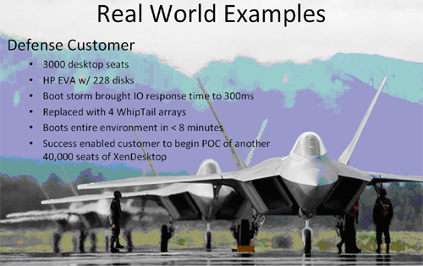
Whiptail all-flash array

Case Study Two: Government Organization

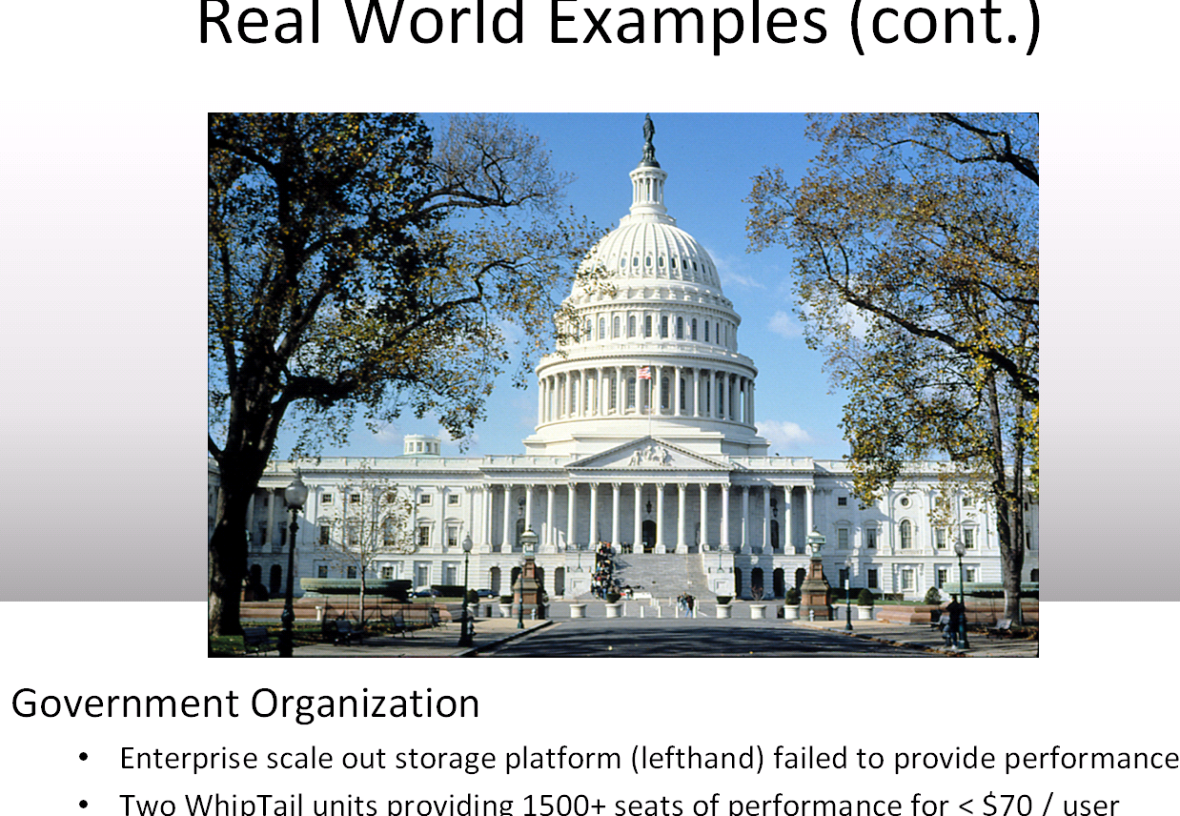

5. Windows 7 OS requires nearly two (2) times more IOPS than Windows XP.

That’s one of the main reasons why most companies to put XP on VDI (VM) instead of Windows 7 OS in order to boost VDI client numbers

Jeremy’s comments: We need to balance a high technology in a right way. A customer should not implement one high-tech device in one end, while implement another obsolete technology (In this case, it is Windows XP, which is an 11 years old technology) on the other end for a combination of a single deployment (In this case, it is a VDI deployment) with relying on hundreds or thousands of HDDs to support a large VDI deployment.

The VDI implementation started in 2006. In 2012, we talked about more VDI implementation. But one VM from VDI implementation is always expensive than a $400 to $500 desktop. In my opinion, most Government Agencies should ‘pause’ a large VDI deployment for the time being until the solid state drives (SSDs) are in a mass production, therefore, the pricing of SSD will go down dramatically since the SSD is the ultimate solution for a successful large VDI deployment due to high IOPS per drive, as shown in the table below. Buying hundreds or thousands of SAS (HDDs) drives costs too much to boost the IOPS in order to support a large VDI deployment.

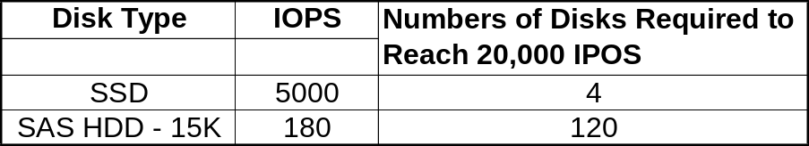

Government Agencies should take a priority on data center consolidation via virtualization (Definition of a Private Cloud: Data Center Consolidation via Virtualization through Applications, which manage the data center). Eliminate hundreds or thousands of data centers as much as possible since it does not require spending a lot of dollars in compare with the VDI large deployment implementation.

On the other hand, if the large VDI deployment must continue, take a look at XIO storage (http://xiostorage.com/), Nimble Storage (http://www.nimblestore.com/) and other SSD-technology solutions for alternative choices to reduce the cost.

Be cautious: Since the SSD solution from many large storage vendors is new, it may take some times to prove its reliability in a production environment, especially through auto-tiering technique.

Recommended Reading:

http://www.desktone.com/product/why_desktone

