Jeremy Li
March, 2012

Credit: Cloud Intelligence Technology Conferences -
http://www.intelligence-conferences.com/

1. Microsoft Pre-Validated Private Cloud Configuration:

Microsoft has been purchasing PB storages through multi-vendor approach method, listed in the screen shot below, and validated the following storage vendors’ products. Microsoft wants its customers worry free when it is a time buying storage for a private cloud.

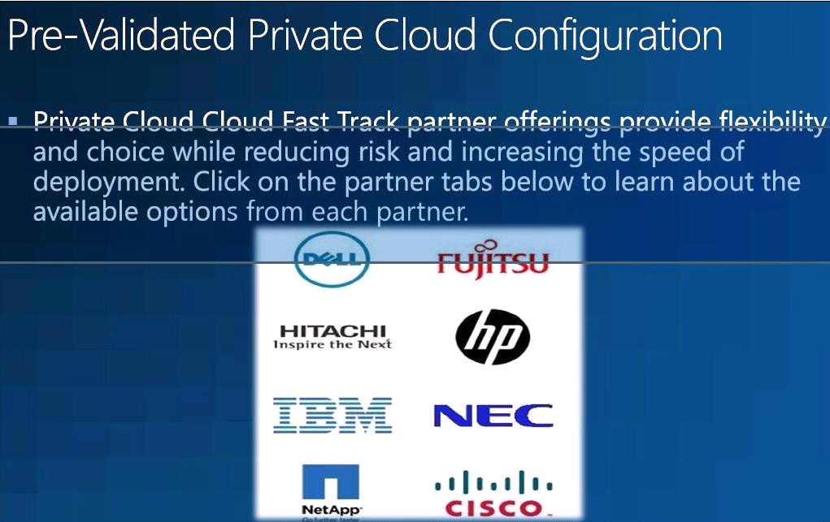

2. IDC predicts that 2012 will be VMware's last year as king of the hill

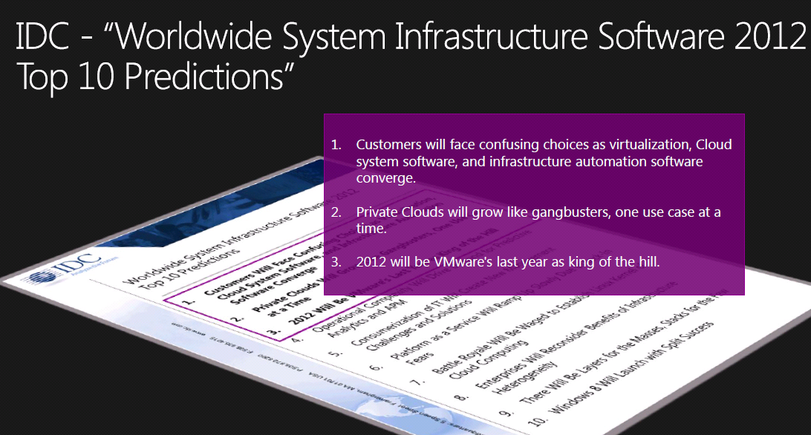
Figure 1 Source: IDC, Dec 2011, “IDC Worldwide System Infrastructure Software 2012 Top Predictions Report”
3. The Evolution of Hyper-V Continues with Hyper-V 3.0

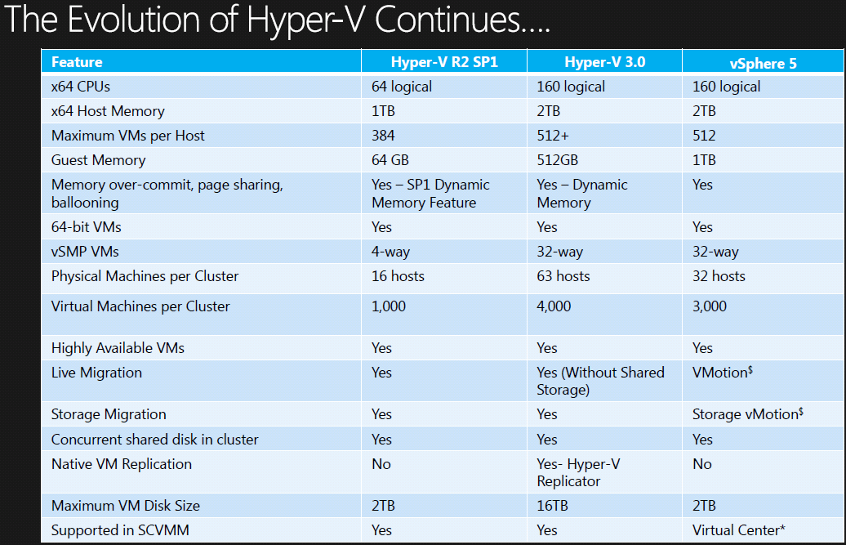
Figure 2 Note: Windows 8 will come with Hyper-V 3.0

4. Microsoft Continues as the Value Leader

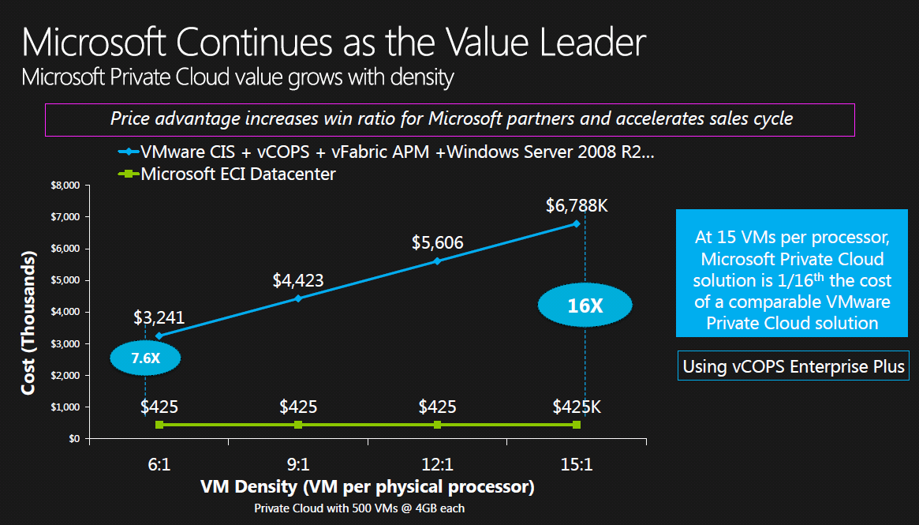
Figure 3 Microsoft Hyper-V License vs. VMware Enterprise Plus License

5. Microsoft Top 10 Data Centers –

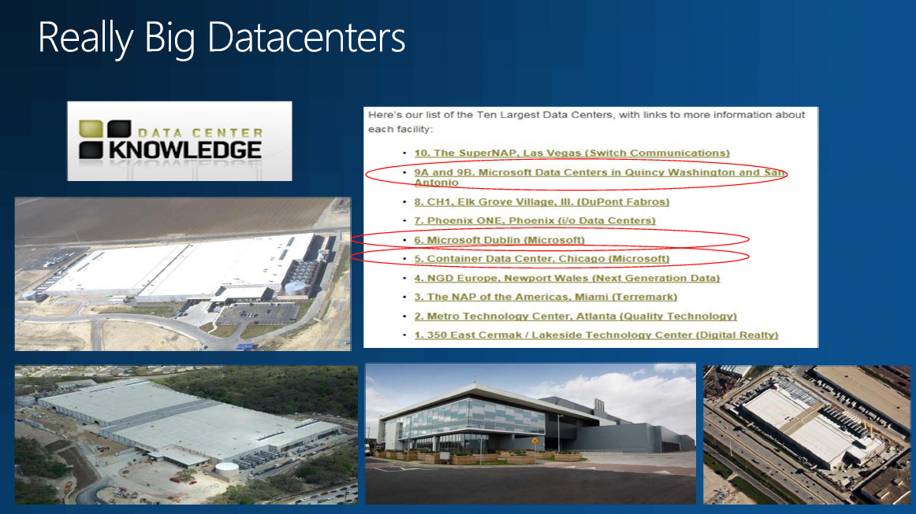

6. Microsoft Azure – Public Cloud

http://www.windowsazure.com/en-us/home/features/overview/

7. Microsoft upcoming System Center 2010 Capabilities Overview

http://www.microsoft.com/en-us/server-cloud/system-center/datacenter-management-capabilities.aspx

