EMC VNX 5300 vs. Nimble CS220 (CS-Series)

Jeremy Li
April 2012

Executive summary

In the past three years, the Office of Information Technology for the County of Los Angeles requested each department to move each physical server into a virtualization environment whenever possible. The deadline for the server virtualization project is year 2014.

Since the Auditor Controller (A-C), one of 37 departments at the County of Los Angeles, has no virtualization Infrastrure in its current IT data centers, a storage area network (SAN) is considered to be purchased to build a virtualization Infrastrure in order to complete the task.

With a fully virtualized IT Infrastrure beyond using only server virtualization to deal with server sprawl and wasted power consumption in data centers in mind, purchasing a unified storage, which can run and manage files [file-level access, e.g. Common Internet File System (CIFS) and Network File System (NFS)] and applications (block–level access, e.g. Internet Small Computer System Interface (iSCSI)] from a single device, is recommended.

Since the A-C has no single fiber channel component at its IT data centers, only IP-based SAN (iSCSI) storage with solid-state drives (SSDs) feature will be considered to avoid a forklift upgrade in the future. Read Top 3 Reasons Why You Can’t Build a Cloud with Fibre Channel for additional reasons - http://san.coraid.com/rs/coraid/images/Coraid_Brief_Top3ReasonsWhyYou.pdf? (Source: CORAID). Embedded advanced storage efficiency capabilities such as thin provisioning, file deduplication, and compression will also be considered.

This comparison report is not about being ‘for” or ‘against’ one storage vendor but merely a call for equal consideration of each vendor’s storage solution to maximize a long-term investment on a storage system.

Several storage vendors were contacted for this project. A few quotes were presented by Dell Compellent, EMC, StoneFly (www.StoneFly.com), XIO (www.xiostorage.com), Nimble Storage (http://www.nimblestore.com/), NexSAN (http://www.nexsan.com/) and HP. To meet the criteria of the combination of the SSD and iSCSI capability, six vendors, Dell Compellent, EMC, StoneFly, Nimble Storage and NexSAN were selected for the consideration.

Last October, the eCloud project, a private cloud hosted by ISD (Los Angeles County Internal Services Department), was discussed and will be considered first by the A-C.
Since the evaluation of the storage area network (SAN) and virtualization project had already been started before the eCloud project was introduced, we decided to continue to select a storage vendor for the virtualization project for the A-C, as an alternative solution, in case the eCloud project might not work for the A-C.

The goal to select new storage is to reduce costs, reduce complexity and increase performance.

The following information is an initial analysis of a comparison between EMC VNX 5300 and Nimble CS220.

1. Application and Management Interface

- EMC Unisphere Application Interface looks better than Nimble Storage Application Interface by delivering a single, integrated and simplified user view panes, as shown below. It can navigate all common tasks through an easy dashboard, such as highly automated provisioning, system interfaces, data replication, viewing detailed reports of how resources are being used and visually drilling down to individual components. The simple and intuitive application-aware management interface can help administrators easily create a storage pool that is optimized for an important deployed application such as Exchange 2010, advanced efficiency features including file deduplication, and compression, which can reduce disk space used by up-to 50 percent.
- Nimble management interface may be as simple as the VNX Series.

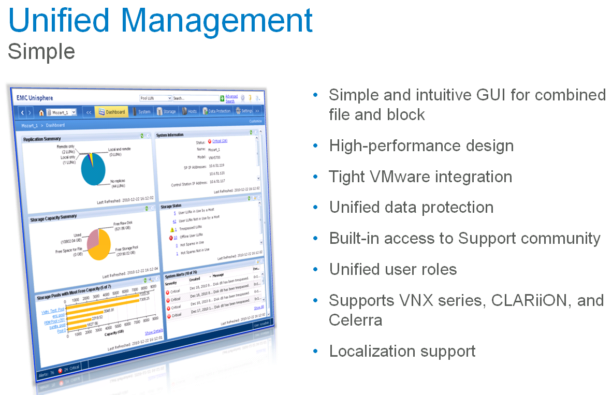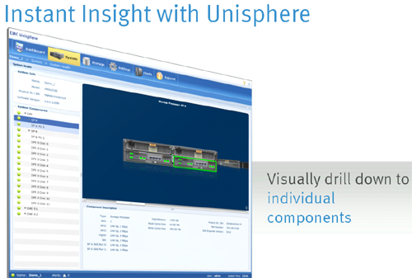
Source: EMC

Who won in this category?

2. Avoid Forklift Upgrade and Scale-out and Scale-up

Nimble Storage CS-Series (http://www.nimblestore.com/Nimble-CS-Series.asp) VS. VNX Series:

EMC VNX Series has a better scale-out/scale deep and scale-up technology than Nimble CS-Series. You can add more disks to disk shelves to achieve scale deep until the unit is full. Then, a second unit must be purchased, and is linked with first unit when the scale out or scale deep is required. But there is a catch:

EMC:

- EMC can add more disks to a pre-defined unit such as VNX5300 to achieve a better IOPS and higher storage capacity via adding more disks into shelves, as shown in a chart below:
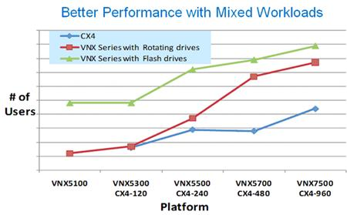
Source: EMC

- EMC has multiple VNX array models: VNX 5100, VNX 5300, VNX 5500 and VNX 7500 and VNXe, which is designed for small and medium business (SMBs) markets.

- EMC customers must require a customer to purchase a second identical unit and link them tighter in order to increase its capacity (Scale out or scale deep) and performance (e.g., when VNX5300 reaches its current capacity, a customer must either purchase second unit or replace the existing header with a higher capacity header in order to increase the storage capacity, as shown in the screenshot below.)

- Replace the existing header with a higher capacity header, which requires a downtime of the entire unit, can also increase the capacity (e.g., replacing a VNX 5300 head with a VNX 5700 head, then, using existing disks from VNX 5300 and link the unit with the new VNX 5700 unit.

Note: VNX7500, the highest capacity in the Series can hold 1000 disks (CX4-960 can hold up to 960 disks).
- According to the result from Microsoft Exchange 2010 Jetstress benchmark testing -
(http://technet.microsoft.com/en-us/exchange/ff182054.aspx), two VNX 5300 arrays are able to host 20,000 mailboxes (Each array has 68 disks and 8GB Flash Cache installed. A primary DAG was located on one array while the secondary DAG was located on a second array. Read page 14 from
http://www.emc.com/collateral/hardware/white-papers/h8849-esrp-vnx5300-20k-1-5gb-exchange-2010.pdf for your reference.)

Nimble Storage:

- Storage CS220 can not be scaled beyond 12 disks, 4 SSDs as of today without forcing customers to buy a second identical unit or upgrade to a higher capacity unit, as shown in the screenshot below. It forces a customer to foresee future scalability requirement, years ahead of actual needs, and acquire controller assets to match those predictions.

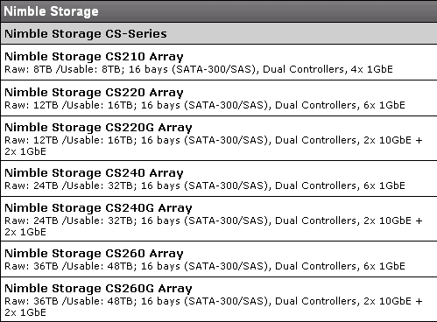

- Currently, Nimble uses VMware Vmotion to move VM’s from one array to another to scale out the capacity.
- One CS240 with 12 disks and 1.3 TB of Usable Flash Cache, which is used for primary Exchange 2010 Database Availability Group (DAG), is able to support 20,000 mailboxes, while the 2nd array is used for the copy of DAG.
CS-240 Storage:

- Nimble Storage CS-240 array
- Dual Storage Controllers
- (2) 10 Gbps Ethernet ports per controller with Jumbo Frames
- Nimble Operating System 1.1
- 32 TB of Usable Storage Capacity
- 1.3 TB of Usable Flash Cache

Reference:

- EMC VNX5300 Unified Storage 20,000 users with 1.5GB mailboxes Microsoft Exchange 2010 Mailbox Resiliency Storage Solution (Aug 2, 2011) – Click on the link below for your reference:

http://www.emc.com/collateral/hardware/white-papers/h8849-esrp-vnx5300-20k-1-5gb-exchange-2010.pdf
- EMC VNXe3300 1000 mailbox Microsoft Exchange Server 2010 Mailbox Resiliency Storage Solution (Jun 27, 2011) – Click on the link below for your reference:

http://www.emc.com/collateral/hardware/technical-documentation/h8259-esrp-vnxe-1000-user-exchange.pdf

- Nimble Storage CS240G 20,000 Mailbox Microsoft Exchange Server 2010 Mailbox Resiliency Storage Solution (Mar 17, 2012) – Click on the link below for your reference:

http://info.nimblestorage.com/rs/nimblestorage/images/Nimble_Storage-CS240G-ESRP_20000_Mailbox_Solution.pdf

Fixed block Architecture: (Source: Nimble Storage)

1. Eight (8) blocks grouped & compressed
2. Group placed into N fixed size slots
3. Entire group read & uncompressed
4. Block updated with new data
5. New group compressed & re-written

Cost of fixed block architecture relative to CASL file system architecture:

1. Additional M blocks read from disk
2. Additional CPU cycles for decompression & recompression of all N Blocks
3. Additional M-1 blocks written to disk

RAW Flash vs. SSDs – click on the link below for more info:

http://thessdreview.com/latest-buzz/raw-flash-versus-ssds-in-enterprise-applications-a-very-interesting-exchange/

Who is the winner in this category?

3. NAS and Block Level Integration

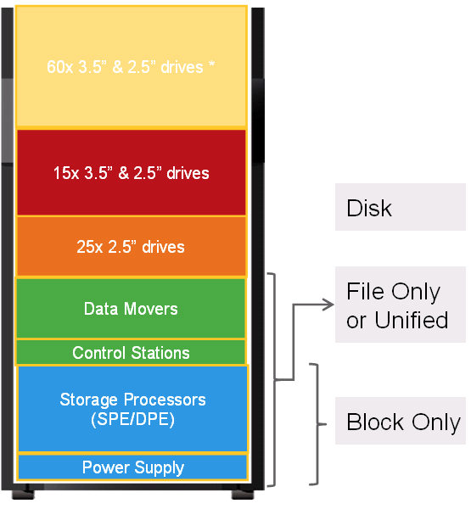
EMC Data Moves, Network Attached Storage (NAS), for CIFS, is integrated within the VNX Series enclosure so that the VNX 5300 provides flexibility for supporting both block and file-based access, while Nimble Storage must rely on two external NASs for CIFS via Window Storage Server (WSS) gateways.

EMC won in this category.

However, it does not matter at our environment in my opinion due to the following reasons:

Source: EMC

- Author will recommend using P2V to move our existing departmental file server to virtual machine (VM) for simplicity without worrying about third party compatibility (Additional $500.00 Windows OS license fee is required).
- No learning curve to use EMC integrated tools.
- No need to perform any trouble-shooting for a shared folder or permission issue due to additional layer of the EMC licensed CIFS integration with Microsoft native CIFS. (Ex: During a live demo on Feb. 15, 2012, two new shared folders were created on the VNX5500, but Microsoft native MMC for shared folders could not see them).
- EMC still recommends using Microsoft native MMC to manage its folder and file permissions, even though Microsoft licensed the CIFS to EMC for its integration.
- Quicker to upgrade Microsoft OS, service packs or patches on existing VM without waiting for EMC to certify the compatibility with all new updates, mentioned here.
- Do not need to worry about the Microsoft and EMC relationship at all. If Microsoft stops renewal of newer version of the CIFS license to EMC one day, our department will not be affected. For example, Symantec (formerly VERITAS) stop giving Microsoft VERITAS Backup Exec Light license for its use in Windows Server 2008. As a result, Microsoft had to rewrite all its built-in backup utility from scratch. The new built-in backup utility from the Windows Server 2008 does not support tape backup etc.

However, one advantage for using EMC built-in NAS, instead of P2V, is that no one needs to worry about OS patches anymore since it does not use Windows OS.
Snapshots Comparison for Historical Point-in-Time Copies

A traditional daily backup has only one recovery point (RP) in every 24 hours. By relying on local snapshots, read/write snapshots (e.g., clonesnap), a customer can increase the RP from every 24 hours to 1 hour or even every 15 minutes, depending on the needs.

•Recovery-point objective (RPO): How recent is the point in time for the recovery
•Recovery-time objective (RTO): How fast can you restart a failed application?
•Backup Retention (BR): How long do you need to restore the point in copy?

A major advantage of snapshots over backup software is that they scale very well and there is no data movement involved, but pointer. This means you will get near instant application recoveries based on whether the snapshot can support both file-level and block level. Most vendors’ snapshots only support file-level, including from VMware vSphere 5.0. Therefore, a third party backup/recovery application will be used to recover block-level applications such as Exchange and SQL servers.

Unlike traditional copy-on-write (COW) snapshots in EMC VNX series - the historical data is relocated to reserved space prior to the new inbound write overwriting the original data, Nimble Storage snapshots use a fine granular snapshot with redirect-on-write with compression technique. Thus, it has no performance impact and consumes least disk space, as shown in the screenshot below:

Traditional Array Snapshot Granular Snapshot
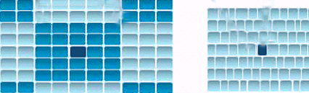

A traditional array snapshot creates large pages and extents, while a granular snapshot creates an individual variable block

Each vendor uses different pages and extents, as shown below:
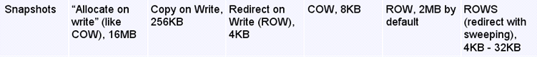
Source: Nimble
A Granular Snapshot is the most efferent snapshot and consumes the least disk space. The larger the pages and extents, the more disk space will be consumed.

Nimble CS220:

- Highly efficient snapshot is accomplished via a redirect-on- write with real-time compression, whereby no production performance will be impacted for establishing and maintaining historical point in time copies.
- Over 10,000 snapshots per array can create historical point-in-time copies or snapshots without impacting storage performance. It provides for the ability to easily maintain hundreds of high frequency (every five minutes) near term recovery points in combination with long term (hours, days, or months) recovery points.
- Snapshots can be set as read-only or read-writeable and can be mounted directly.

Therefore, a third party disk-to-disk backup system, including its snapshots and a backup/restore program, might be eliminated due to its highly efficient snapshot technology, which takes minimal disk space, only changes to the active file system are written. With CS Series, data is protected by Snapshot copies without purchasing excessive amounts of disk storage.

Note:

- All snapshots must be stored on the same host. Therefore, snapshots can not be redirected from one host to another host in a real time.
- A third party application, such as Quantum vmPRO 4000, can move the snapshots created by VMware native snapshot from one VMWare host to its DXi Disk-to-Disk backup system with deduplication turned on via variable block inline compression.

Click on the link http://www.nimblestore.com/Nimble-Solutions-VMware.asp for reference.

In VNX Series:

- Traditional copy-on-write (COW) snapshots have been used for many years and have huge performance impact due to disk spindle contention for concurrent reads.
- The COW causes poor RPOs and very limited retention capability.
- 96 Read-Only (RO) snapshots and 16 Read/Write (R/W) snapshots are supported due to the COW reason.

Nimble won in this category.
A Zero-copy Clone from a Snapshot (Writeable Snapshot)

Usually, a clone snapshot (by creating instant, space-efficient data replicas that shorten design cycles and improve service levels) will be used to create a testing and development environment for testing applications.

An efficient zero-copy clone is a copy of a volume that shares all common data blocks with its parent. Therefore, it should only consume disk space when new blocks are written to the clone or existing blocks are changed.

Space-efficient snapshot and clone (writeable snapshot) technologies are excellent tools to help reduce the need for thick copies of data while retaining the ability to use and protect data.

However, each vendor might implement clone method differently. As a result, an inefficient clone copy will consume large disk space.

Nimble:

Nimble Storage has capability to create zero-copy clones from a snapshot up to 255 volumes or clones on a single appliance. By leveraging 4k variable blocks with high speed inline compression systems administrators can create dozens of clones of a volume without consuming massive amounts of disk capacity

- In CS220, Read-only and Read/Write copies of snapshots are supported The demo on April 9, 2012 used an offline snapshot method, then, a Zero-Copy clone was created to show that zero space was consumed. Unfortunately, the VM host went unresponsive. Therefore, a presenter will not be able to mount the snapshots to display a success for creating a testing and development environment.
- Read/Writable Snap and Zero-Copy clone demo was performed again on April 16, 2012. It was a success. A presenter performed two kinds of clone snapshots by checking “online checkbox” and “Read/Write checkbox” prior to the creation of the clonesnap. The demo showed that clonesnap does not consume any disk space.

Environment Setup: Lab-FS01 is a Windows 2008 R2 Enterprise OS with file services configured. Server image is in a VMDK thin provisioned for 40GB.

- iSCSI mounted volume (NTFS) from the Nimble array for 100GB (39GB+ data when written to Nimble compressed to 32.9 GB, many ISO files)
- The above referenced iSCSI mounted volume is using the F drive letter and shared for file services.
- The data volume which makes up the F drive is using a protection policy that takes a snapshot every hour and keeps 30 snapshots as well as daily and keeps 30 days of snapshots.
Testing process:

Method One (Snapshot):

- Took a manual snapshot of the F drive volume (Lab-fs01Data), selected options to set it “online” and make it “read/writeable”.
- Mounted this volume via iSCSI to Lab-fs01 as the H drive (A testing environment)

  - Verified that data in both F drive and H drive were identical.
  - Edited a text file in the H drive and validated that the same text file in the H drive was not modified.
  - Delete a text file in the H drive and validated that the same text file in the H drive was still there.

Method Two (Zero-copy Clone, a recommended method):

- Took a zero-copy clone of the last scheduled snapshot, manually.
- Presented this to the lab-fs01 server as the G drive via iSCSI initiator.

  - Verified that data in both F drive and G drive were identical.
  - Verified that the G drive clone occupied no additional space.
  - Copied 2.9 GB of new data to the G drive and validated that the volume of the G drive now showed space consumption of 2.7 GB due to inline compression.
  - Deleted all data in G drive/verified that all data were still in the F drive.
  - Performed a snapshot recovery and verified that the volume was recovered successfully.

EMC:

Clone is Physical Point-in-Time (PIT) Copy - Physically independent point-in-time copies of source volume:

- A clone is a full image copy.
  - Require the same space as the source data
  - Available after initial copy
  - No performance impact on source data
  - Can be used to replace source after hardware or software error
- EMC successfully performed the clone via a read/write snapshot. Therefore, the clone copy will consume large disk space.
- In VNX Series, 96 Read-Only (RO) snapshots and 16 Read/Write (R/W) snapshots are supported. You can easily create a real world testing or development environment (Staging environment) quickly without touching a production environment.

Of Note:

NetApp FlexClone (read/write snapshot): Create Exact Disk Copies – Virtually (Instant replication without additional storage space) – Click on the link http://media.netapp.com/documents/ds-2837-flexclone.pdf for details.

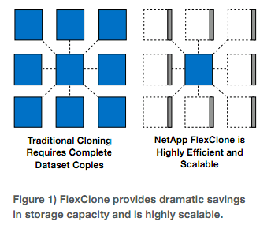
Who won in this category?

- Snapshots Comparison – The Initial Snapshot Size (Delta)?

The first time snapshot should be also very small, while most vendors’ first time snapshot will consume large disk space as a baseline because a traditional copy-on-write (COW) snapshot is used and the performance will also be affected.

- EMC did a demo to show the file size of the first copy of snapshot. EMC acknowledged that the result of the demo was misleading. Per EMC, regardless of 1TB or 100TB, the file size of the first copy of snapshot is based on the percentage of the original data size. Therefore, it only consumes a small disk space.
- Nimble performed a live demo on April 9, 2012 to show its superior and efficient snapshot technology with compression. Nimble shows its snapshot does not consume disk space in the first time unless there will be a change. The 2008R2Ent-Gold image size is at 9.612GB. When it was written or moved to Nimble storage, the image size was reduced to 6.11GB with a compression ratio at 1.49. When an initial single manual snapshot of the volume was created, it consumes only 112.13MB in size, as shown in the screenshot below:

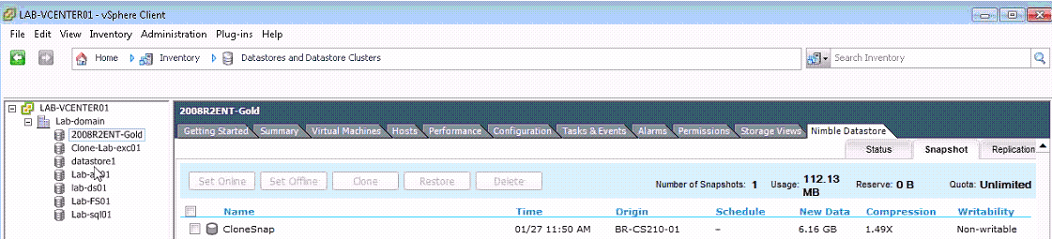
2008R2Ent-Gold image with an initial snapshot via CloneSnap method

Note: Microsoft Date Protection Manager (DPM) from System Center 2010 supports snapshots. However, the first-time snapshot size is very big, at least 70% of the original size, depending on the deduplication and compression per Microsoft IT evangelist at Microsoft Cloud Conference Session, March 14, 2012.

Nimble won in this category.

- Storage Tiering (Automated Data Movement) and RAID Implementation

The storage tiering in conjunction with thin provisioning, a technique of maximum effective use of the physical storage capacity actually deployed, makes IT organizations easier to manage and use primary storage (RAID-10 for fast write access) as well as secondary or third tiering storage (RAID-5 for large volumes and long-term archiving) efficiently and economically.

- RAID-5 is acceptable in “read” access, which is no difference with RAID-10. It requires one disk IO operation for each read access (1 IO operation for 1 read)
- RAID-5 is not very good on “written” access because one-write changed operation requires four (4) disk IO operations (2 reads + 2 writes = 4 IOs). That’s the reason almost all vendors use RAID controller’s cache to speed up the “write” operation. In many scenarios, an add-on Flash Cache will speed up the write and read operations significantly. Item 13 will discuss the topic of Flash Cache Module from EMC.

- EMC did not show the automated tiering feature during the demo. Per EMC, VNX 5300 has an auto-tiering storage feature via statistics collection, analysis and relocation operational processes.
- Nimble Storage does not use auto-tiering. Per Nimble, Microsoft does not recommend to use auto-tiering on Exchange Server at all.

EMC Automated Tiering Process:

You must purchase FAST Cache, which uses 64KB extents (16x less granular than Nimble’s 4KB extents) and Fast Suite option in order to perform the auto-tiering:
- FAST Cache operates at a 64KB granularity for increased efficiency. If a 64KB block is referenced 3 times in a given period of time (the time will depend on the IO activity of the system), the block will be promoted into FAST Cache.
- As the data ages and becomes less active, it will fall out of FAST Cache to be replaced by a more active chunk of data.
- EMC VNX new feature comes with a Fully Automated Storage Tiering for Virtual Pools (FAST VP). It allows a single LUN to leverage the advantages of Flash, serial-attached SCSI (SAS), and Near-line SAS drives through the use of pools. FAST solves theses issues by providing automated sub-LUN-level tiering.
- 3X performance gain if Microsoft SQL server, VMware and Citrix VDI boot time and refresh time; Oracle’s number of users and transactions.

Nimble:

The Nimble Storage Array does not use auto-tiering design. Instead, it uses patented high-efficiency Cache-Accelerated Sequential Layout (CASL) storage architecture to seamlessly integrate four (4) Intel NAND-Flash Multi Layer Cell (MLC) SSDs configured as RAID-0 with 12 high-capacity low-rpm serial advanced technology attachment (SATA) drives or NL-SAS drives configured as RAID-6, plus one spare drive to provide attractive $/GB, as shown in the screenshot below:

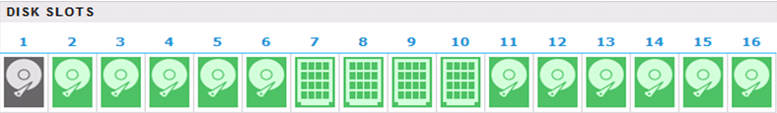
Spare 4 MLC SSDs
Drive
Source: Nimble

The SSDs contain only a copy of all of the hot blocks of data from the RAID 6+1 storage, and are much cheaper than Single Layer Cell (SLC) SSDs. Per Intel, MLC SSD has a five-year lifespan.

The CASL design takes random data and lay out sequentially. This dramatically reduces the wear and tear on the SSD cache and drastically increases the performance of high-density SATA/SAS disk.

Writes:

- Data written to the array is committed directly to 1GB mirrored and battery backed nonvolatile RAM (NVRAM) in variable sized blocks ranging from 4K – 32K. Once data is written to NVRAM, the system can respond to the host/application with an acknowledgement. This dramatically increases the performance.
- As a watermark is reached in NVRAM, a shadow copy of the data is made to 12GB synchronous dynamic random-access memory (SDRAM). The SDRAM is, then, used as the workspace to coalesce and compress the data in to a single sequential RAID stripe.
- The sequential full RAID stripe, currently 4.5 MB in size, is sized exactly for a single write operation to each of the 11 disks that make-up the RAID 6 set. Due to a single write operation, six (6) IOs do not apply to a RAID-6 storage in Nimble for a changed write access.

Note 1: The striping size 4.5 MB comes from 12 disks with RAID-6, plus one spare drive (12-2-1=9 HDs: 9x 512KB = 4.5 MB, 512KB is sector size)

Note 2: As data is written to the RAID 6 drives, a copy of certain blocks may be written to SSD (Adaptive Flash) if it is found to be random in nature or has a high probability of being read.

Reads:

1. If the data exists in NVRAM, then, the data will be fetched from NVRAM.
2. If the data is not in NVRAM, then, the data will be pulled from SSD.
3. If the data is not in SSD, a sequential read occur from SATA for those blocks. At the same time, populate the SSD cache with the same blocks for future reads. Therefore, read performance is greatly accelerated via cache sequential.

The CASL algorithms yield over 900 IOPS per NL-SAS (near online SAS) drive for a fully random, write-only load of 4KB blocks.
The variable–size blocks can be tuned to fit for different applications to get a better performance.

Click on the link http://www.nimblestorage.com/products/architecture/ for details.

Special Note: Per Microsoft, any Exchange database(s) should not be stored on any storage with auto-tiering. Click on the links below http://technet.microsoft.com/en-us/exchange/ff182054 for details, since both EMC and Dell Compellent uses SAS spindles to store database(s) and log(s), do not use auto-tiering during the test(s).

Of note:

Compellent Automated Tiering Process:

- Data will always write to tier-1 (RAID-10, striped data across mirrored
storage disks) first.
- Every 24 hours, inactive or aged data will be moved from tier 1 (either SSD or SAS HDD) to tier2 (RAID-5, SAS HDDs).
- Every 12 days, inactive or aged data will be moved from tier 2 to tier 3 (RAID-5, near-line SAS HDDs).
- When an active data is detected from tier 2 or tier 3, that data will be automatically moved back from tier 2 to tier 1 or tire 3 to tire 2.

No one wins in this category since Nimble does not use Auto-Tiering.

- VMware Integration

EMC:

EMC has a tight integration with VMware OS – vSphere 5, as shown in the screenshot below:

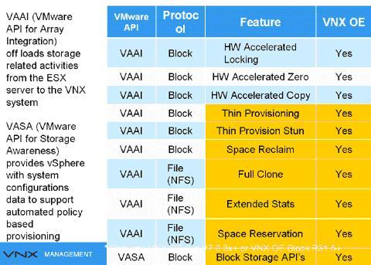
Source: EMC

Please note EMC owns 80% of VMware. Traditionally, EMC should have the best integration with VMware.

Nimble:

- vCenter Plug-in allows all storage related activities to be performed from within vCenter console.
- Storage Replication Adaptor (SRA) for VMware Site Recovery Manager (SRM) – allows full integration with VMware SRM for automated failover and failback between primary and DR sites.

- VAAI Primitives – Natively we don’t write zero data blocks and this is true with VMware. The HW accelerated locking, copying and thin provisioning stun are scheduled for later this year. Currently space reclamation is disabled in VMware 5.0 due to performance issues with the process. Therefore, no vendor, currently, can provide this VAAI primitive.

The author was impressed with Nimble’s VMware live demo on April 9, 2012. Nimble was able to delete SQL database and use the latest snapshot to recover the database.

EMC should win in this category?

Note: The author has no time to watch any VMware demos from EMC.

- Embedded Advanced Storage Efficiency Capabilities (Thin Provision, Deduplication and Compression)

- EMC VNX Series’ embedded advanced storage efficiency capabilities including thin provisioning, file deduplication and compression reduce disk space used by up-to 50 percent.
- Nimble Storage CS220 does not provide file deduplication, but provide block-level inline compression, and advanced thin provisioning.
- No chance to view EMC demo on the thin provisioning.

Who wins in this category?

- Mixed Drives Types in a Virtual Pool

EMC Method:

EMC successfully demonstrated three types of disks (SSD, SAS and SATA) in a Virtual Storage Pool (VP), as shown in a screenshot below:
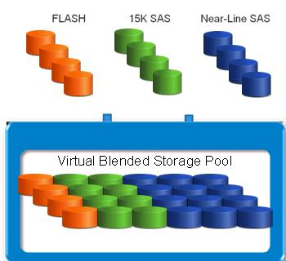

- EMC encourages its customers to move from its traditional RAID Group to VP, because Pool LUNs are more flexible besides certain features require using VP. The VP is available to both VNX series and VMAXe series.

- The VP seamlessly allows addition and removal of physical capacity easier.

However, within one Virtual Pool with mixed drives type:

- The VP can only support one RAID type (Raid 0/1, 5 and 6). In other words, RAID10 and RAID 5 can not be mixed together.
- RAID-10 is 4X faster than RAID-5 for each changed “written” operation, while RAID-5 is a good choice for each “read” operation.
- Most customers can not afford to use RAID-10 in the VP due to much higher cost of storage.

Of note:

Dell Compellet Method:

Dell does not think the Mixed Drives Virtual Pool is good.
- Prefers to use RAID-10 in first tiering storage (striped data across mirrored storage disks).
- Prefers to use RAID-5 in second tiering storage to efficiently use the disk space.
- Via automated data movement (Read item 7 for details) to increase the disk efficient usage.

Both EMC and Nimble can mix drive types together in one enclosure.

- Unified Snapshots and Remote Replication

Both vendors support both synchronous and asynchronous replication. Generally speaking, synchronous replication is used for Local Area Network (LAN) and Metro Area Network (MAN) for the best data protection (e.g., where no single transaction can be lost in case of a DR), while asynchronous replication is used for a long distance replication (e.g., Los Angeles to New York) for a highest possible performance purpose.

EMC

A customer has to purchase local snapshot as well as remote replication snapshot (Replication Manager) from EMC.

  - VNXe supports the following types of storage resources for iSCSI replication:
  - Microsoft Exchange, VMware VMFS, Microsoft Hyper-V and Generic iSCSI
  - No native (Unisphere) replication
  - iSCSI replication on VNXe requires EMC Replication Manager to create, schedule, and manage the replication. (Additional cost is required)
  - Requires EMC Replication Manager (RM)
  - Provides UI for managing replication & snapshots of iSCSI LUNs.
  - Controls the creation of snapshots, marks the snapshots for replication, and initiates the copy job from the source to the destination.
  - During a snapshot or replication job, RM ensures applications are in a consistent state by quiescing data reads and writes, including flushing the cache.

Nimble:

  - The CS220 appliance will include a complimentary Bi-Directional Replication application, based on IP technology, if second unit will be planed to be purchased, in order to avoid a single point of failure of a SAN.

  - Nimble creates efficient redirect-on-write snapshots (instant backup capabilities) with real-time 4K variable block compression; WAN-efficient replication and fast failover enable quick, cost effective disaster recovery. Therefore, it significantly reduces the replication bandwidth required for off-site backup protection.

  - The entire failover process can be automated via management tools such as VMware Site Recovery Manager (SRM), which leverages a Nimble SRA to control the storage level failover capabilities. Rapid failover ensures business continuity in case of disaster.

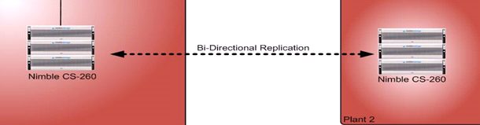

  - Replication can take place between any Nimble array regardless of the model.

  - “Scale Out” solution in the near future: You can cluster any Nimble array in a single group up to 4 arrays. The only requirement is that all arrays must have the same firmware versions. Disparate versions of firmware are only supported for short periods of time to allow for the upgrade of all arrays in the group to be completed.

Special Note:

In an extremely rare situation, the data and snapshot will be completely lost on primary and secondary sites, if there was a corruption in the metadata of the volume that was transferred to the second array via the replication, although two storage arrays are installed for a DR purpose – avoid a single point of failure of one SAN implementation approach.
In order to avoid this extremely rare scenario, an organization might consider deploying a secondary D2D storage, which can keep one copy of the data (primary data) on the primary storage, while copying a second copy of the data to a D2D appliance such as Data Domain. They are a completely separate copy of the data. Therefore any corruption of the metadata on the SAN does not affect data copied to the D2D appliance at all.

The problem with this solution is not only “complexity” - add additional layer of storage and its backup application, but also increase the cost dramatically, besides labor cost.

An alternative solution is to use a popular concept – cloud - to address any corruption in the metadata of the volume on any two arrays (one acts as a DR array).

One storage vendor, for example, cloud-integrated enterprise storage (http://www.storsimple.com/) can completely eliminate tradition storage products:

- Backup Media Server & Software
- Disk backup with deduplication
- Tape backup Infrastrure
- Storage system for Disaster Recovery Time Objective (RTO)]

- Support Virtual Desktop Infrastructure (VDI)

Both storage systems will support VDI deployment due to capability of SSD present. How much VDI devices can be supported by both storage systems? It is beyond the scope of this report.

However, the author would like to share his view learned from Citrix Tech Exchange Q1, 2012. Click on the link below for details:

http://www.lacaaea.com/aaeapdf/san/A-Partial-Note-from-Citrix-Tech-Exchange-Q1-2012.pdf

- Flash Cache:

EMC:

EMC uses FAST Cahce, as described below:

- FAST Cache can optimize both Read/Write operations. Applications, such as random small block like exchange, databases (OLTP), etc. have been proven to work well with Fast Cache, as shown in the screenshot below. However, applications such as large block sequential will not work well with FAST Cache because there is no locality of reference.

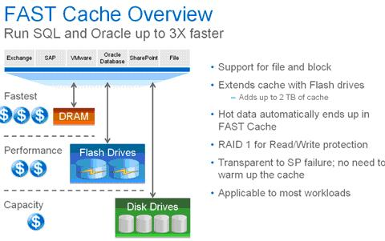
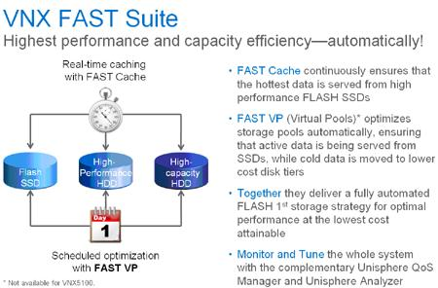
Source: EMC

- Adding Fast Cache will boost the performance in a large VDI deployment.
- Adding Flash drives as FAST Cache will improve cache hit rates from the traditional 20-30% up to 60-70%.

Nimble Storage:

Nimble storage uses patented high-efficiency Cache-Accelerated Sequential Layout (CASL) storage architecture by relying on NVRAM, DRAM and SSD cache (Read-only). Read the section under item 7 for details.

Of Note: NetApp Flash Cache (http://www.netapp.com/us/products/storage-systems/flash-cache/), formerly called PAM (Performance Accelerator Module), can only optimize Read operation. However, if you exam the NetApp OS File System (Hole Filling, e.g., WAFL - Write Anywhere File Layout) carefully, each changed written operation is not subject to the RAID-5’s 4-disk-IO operations for each write (2R + 2W) for panelizing the write operation because NetAPP file system uses a dedicated parity drive and has a good random write performance until disk fills up. This means that each write will stripe across all data drives without putting any parity on data drives in NetApp storage. In other words, the 4-disk-IO operations for each changed written access in RAID-5 do not apply to NetApp OS file system. That might be the reason NetApp Flash Cache does not need to optimize the write mode.

File System (NetApp) | Pro | Cons
Hole filling (e.g., WAFL)  (Source: Nimble) | - Good random write performance until disk  fills up  - More efficient redirect-  on-write snapshots | - Performance degrades over time  - Slow, high overhead compression
Note: Click http://en.wikipedia.org/wiki/Write_Anywhere_File_Layout for more.

Who won in this category?

14. How Much Performance Will be Affected after a Failover

Both Nimble CS220 and EMC VNX Series can offer two controllers (maximum) per storage system. If one controller fails, the surviving controller in a pair will take over via a failover process in Write-Through Mode, which disabled the cache memory on the surviving controller to avoid data corruption. That change may occur for a short time during the failover but once all the volumes are back on line, the surviving controller will resume in Write-Back mode (normal mode).

Good array management includes trying to keep the peak load on each controller under 50% to keep post-failover performance from being an issue. Otherwise, the surviving controller may not have enough CPU resources to meet the host requirements after a failover.

The EMC Clariion, VNX series, Dell EqualLogic, Nimble Storage, LSI/Engenio, Network Appliance, HP and XIO solutions all have a limit of two controllers in a single storage system, except for EMC’s VMAXe and HP 3PAR, which can support up to either (8) controllers per system.

Almost all storage arrays from vendors mentioned above can run in some form of Active/Active mode but one controller manages the Write cache and performs all data writes for a volume; the other controller can read data but doesn’t handle writes.
Therefore, we need to look at each vendor’s tool to verify how each vendor manages volume presentation either manually or automatically in order to balance workload on the two controllers (e.g., HP EVA/P6000 has some load balancing capability, and the P4000 and P10000/3PAR stripe all volumes across all controllers so they don’t have the issue of load balancing).
Due to time constraints, author does not have a chance to compare:

- A performance on disk arrays
- Both Vendors’ application (tool) to manage the array storage controllers.

It is beyond the scope of this report.

Of note: Only EMC VMXe and HP 3PAR storage system can offer up to eight (8) controllers per storage system.

EMC VMAXe:

- A host LUN (Volume) will be served by as many disk controllers (up to 8 physical controllers) as the virtual storage pool is configured for.
- One engine contains two physical controllers.
- Each controller (a PCI hardware-based board), has one major function – a connectivity to host(s) and connectivity to disk(s) etc.
- Both the physical board and SW functions were called directors.
- Each director has a matching adapter for physical connectivity (e.g., fibre adapter (FA) and disk adapter (DA) etc). Per EMC, this is not true anymore today.
- Today, a director has two meanings:
  - A director, in HW context, refers to boards,
  - A director, In SW context, refers to functions (FA, DA etc).
- Therefore, a director has multiple functions (HW and SW functions).
- In summary, one VMAXe engine contains 2 HW director boards; each director board contains 4 FAs and 4 DAs, thus, each engine has a total of 8 FAs and 8 DAs.
- VMAXe is the top of the line in EMC.

HP 3PAR:

- 3PAP storage system can support many disk controllers (up to 8 physical controllers).
- Controllers with four (4) controllers or more installed will avoid the Write-Through Mode. Therefore, the performance after a failover with four or more controllers installed will have much less issue since the workload on the failed controller will be evenly distributed to three or more remaining controllers.
- The 3PAR system creates host volumes by combining logical volumes hosted by each controller, so that every volume in a four-controller system should have 25% of its data managed by each controller (and volumes fail over between node pairs). When a single controller fails, the array runs with 75% or higher performance, instead of 50% performance.
- 3PAR uses legacy Fiber Channel (FC) drives at this moment. HP will be moving to SAS drives in the future in order to reduce the cost.
- HP will continue to use FC to connect to their drive cages. The reason is flexibility, using FC connections the drive shelves can be up to 100m away from the controllers, while SAS only goes about 4m.

15. Exchange 2010 Mailbox Recovery via Snapshot

Both vendors have not yet performed a live demo. EMC is willing to perform a live demo via a web conferencing.

Please be aware of the fact that any organization must purchase either Application Protection Suite or Total Protection Pack, which consists of Local Protection Suite, Remote Protection Suite and Application Protection Suite, in order to be able restore a mailbox from Exchange 2010. A Local Protection Suite (Snapshot) is only designed for recovering files, folders and volumes.

On the other hand, if an organization has already relied on a third party product, such as Symantec NetBackup or Backup Exec, to handle a mailbox recovery, you may consider not purchasing the Application Protection Suite or Total Protection Pack to save the acquisition cost. It all depends on the environment.

Note: A comparison between a third party Backup and Restore application and EMC’s Total Protection Pack or its individual component is beyond the scope of this report.

16. Microsoft Exchange 2010 Solution Reviewed Program (ESRP)
(http://technet.microsoft.com/en-us/exchange/ff182054.aspx)

Each vendor uses two arrays. A primary DAG was located on one array while the secondary DAG was located on a second array.
With 20,000 mailboxes in the ESRP report, the following items were used:

- Nimble CS240G: 24 SATA disks, 8 SSD for Read-only Adaptive Flash
- EMC VNX 5300: 136 NL-SAS disks (7200 RPM), 8GB Flash Cache on each controller

Of Note:

- Dell Compellent Model 30: 144 SAS 15K RPM, 3.5 Flash Cache.

Reference:

- EMC VNX5300 Unified Storage 20,000 users with 1.5GB mailboxes Microsoft Exchange 2010 Mailbox Resiliency Storage Solution (Aug 2, 2011) – Click on the link below for your reference:

http://www.emc.com/collateral/hardware/white-papers/h8849-esrp-vnx5300-20k-1-5gb-exchange-2010.pdf

- EMC VNXe3300 1000 mailbox Microsoft Exchange Server 2010 Mailbox Resiliency Storage Solution (Jun 27, 2011) - Click on the link below for your reference:

http://www.emc.com/collateral/hardware/technical-documentation/h8259-esrp-vnxe-1000-user-exchange.pdf

17. Eliminating the Need for a Separate Disk-based Backup.

Nimble Storage uses an entirely new approach to data storage which combines primary and backup storage into one array, dramatically cutting costs and complexity due to its high efficient redirect-on-write snapshot with inline compression technology.

Nimble CS-series - all in a single device, enables, intelligent data optimization leveraging flash memory and high-capacity SATA or NL-SAS disk, instant optimized backups based on efficient snapshots mentioned above, and WAN-efficient replication. Therefore, a separate, disk-based backup storage system is not required to achieve a fast recovery (Recovery Point Ojectives).

EMC uses the Copy-On-Write (COW) snapshots and limits 96 read-only snapshots and 16 read/write snapshots per system. Therefore, a separate, disk-based backup is required to achieve a fast recovery.

Nimble won in this category

18. Software RAID vs. Hardware RAID

Nimble:

Nimble and other small appliance vendors are, in fact, uses software-based RAID dual controllers, and supports active/passive mode. Having active/passive controllers also allows you to do firmware upgrades without any downtime and with less errors.

When one controller fails, the standby controller will resume the failed controller’s same workload automatically.

According to Nimble, the SW RAID is a highly optimized with RAID 6, plus a hot spare. Nimble went this route because the performance is getting better than any hardware RAID solution due to its unique CASL architecture. This provides greater performance and reliability than anyone can get.

At this writing, a single multi-core Intel Nehalem E5504 processor with the 2nd CPU socket empty on all model arrays. With the DMA architecture of the Nehalem chipset, it would also entail populating the memory DIMMs for the 2nd socket. According to Nimble, it is nothing to do with the SW RAID not supporting two physical CPU’s, and it is completely independent.

Note: Rebuild time from a failed spindle might take long time due to the nature of SW RAID.

EMC:

VNX Series uses hardware-based RAID dual controllers and supports active/active mode. When one controller fails, the surviving controller will resume the failed controller’s workload automatically.

- Active/Active vs. Active/Passive

Nimble:

Note: the following information is supplied by Nimble.

- The Nimble arrays are built with Active/Standby controller architecture
- An Active/Standby controller configuration is within a single array group. In a 4-array group, 4 x Active controllers and 4 x Standby controllers will work together as a single SAN, but each is responsible for the handling of its own data.
- Active/Standby controller design was done purposefully and in our opinion, it provides a better performance guarantee in the event of a controller failover. In an active/active controller design, the end user must make careful considerations to balance the load between the controller targets without loading either controller beyond 50% capacity. The reason is that if one controller fails, the remaining controller must now handle the entire load.

20. Software Bundle

- Per Nimble Storage, a customer will not pay any software bundle except for 24x7 Phone/Online Support, 4hr OnSite Support.
- EMC will charge an application such as Local Protection, 24x7 Phone/Online Support and 4hr OnSite Support

Nimble won in this category

Conclusion

EMC VNX Series storage system combined its CLARiiON (block level only) and Celerra series (block level and file level) into one physical system, and is capable of scale disk from 16 disks to 1000 disks (VNX 7500), while VNXe can scale disks from 12 disks to 120 disks. It provides a unified storage with Unisphere management console - a simple, integrated experience for managing EMC VNX Family, EMC CLARiiON, and EMC Celerra storage systems through both a storage and virtualization. It provides simplicity, flexibility.

On the other hand, a fork lift upgrade might be needed. For example, if a customer bought VNX5300, which can support up to 125 disks, its disk capacity reaches to the max capacity, the customer either has to buy a second VNX 5300 system or replace its current header within VNX 5300 with a header for VNX 5500 in order to be able to support additional disks beyond the 125 disks limitation.

Its Copy-on-Write snapshot limits its capability for backup and restore without relying on a D2D system.

However, Nimble Storage has no scale up (scale deep) scalability at this time. When any customers run out of disk capacity, another CS-Series unit must be purchased. Customers must rely on VMware V-Motion to scale out the disk capacity by moving some volumes from one storage CS-Series iSCSI array to another to achieve the scale-out objective.

Nimble storage is very attractive and can act as a primary storage, backup & restore secondary storage (D2D) and disaster recovery storage due to its superior and efficient redirect-on-write snapshot with inline 4K variable blocks compression, as shown in the screenshot below:
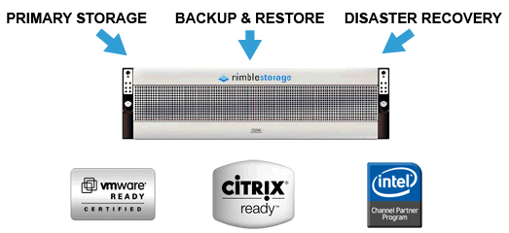
Source: Nimble

Therefore, it allows enterprises to significantly cut costs, reduce complexity, and implement a complete disaster recovery solution, while eliminating design of a traditional RAID levels implementation to tradeoff performance and capacity utilization of specific applications through the use of Performance Policies.

Please note that the A-C does not need to have high capacity storage such as VNX series due to higher cost. Therefore, both EMC VNXe 3300 [designed for departments and remote offices in the enterprise as well as small and midsized businesses (SMBs) market] and Nimble CS-220 can be considered and might be a good fit to the A-C environment for the following reasons:

EMC:

EMC VNXe 3300 has unified storage capability, supporting both file-level and block-level access in a single 3U box.

Click on the link below for details:
http://www.emc.com/microsites/unified/smb.htm?CMP=KNC-unified_smb-VNX&activity_id=62225&division=core

- It is optimized for the virtualization environment.
- It can scale from 9 disks to 120 disks with a capacity up to 300TB.
- A forklift upgrade should be avoided at the A-C environment due to the built-in feature of SSD (100 GB Flash) and two (2) 10Gb/s Ethernet and four (4) 1Gb/s Ethernet as optional components.
- Get 50 percent more disk capacity without additional cost due to deduplication and compression feature.
- The Unisphere management is also integrated with VMware vCenter management.
- Ease of configuration.

Nimble:

There is no doubt that Nimble has highly efficient redirect-on-write with an inline compression and variable block snapshots technology, plus its CS-Series storage has its patented Cache Accelerated Sequential Layout (CASL™) storage architecture with integrated NVRAM, SSDs and high-capacity disks to deliver affordable performance, integrated backup and disaster recovery.

Nimble Storage CS-Series -
http://www.nimblestore.com/Nimble-CS-Series.asp?gclid=CLv704uQqK8CFSMHRQodoxzRXw is based on the concept of converged storage, backup, and disaster recovery. Its solution can be possible to replace an enterprise's expensive FC and SAS drives with a hybrid architecture that combines high-performance SSD drives with low-cost, near online and high-capacity SAS or SATA drives and eliminate the secondary disk-to-disk backup storage.

Challenge:

EMC:

- With VNXe or VNX series, an organization should still need to purchase a disk-to-disk backup as a secondary storage system due to limited copy-on-write (COW) snapshots.

  - Traditional copy-on-write (COW) snapshots have huge performance impact due to disk spindle contention for concurrent reads.
  - The COW triples the I/O required for every write, thus reducing I/O performance by 66%.
  - The COW causes poor Recovery Point Objectives (RPOs).
  - The 96-read-only COW snapshots will have very limited retention capability.
  - Snapshot schedule limitations - Minimum RPO of 4 hours (A minimum interval of four hours must exist between snapshot operations.)
  - Maximum number of daily snapshots is two.
2. Both VNX series and VNXe are based on two different storage systems.

VNX is based on block-level:

- LUNs are simply built from the Virtual Pool.
- LUNs can be shared to block connected Hosts (FC, iSCSI, FCoE).
- File services added.

The file system is much faster if it is based on block-level for many block-level applications such as Exchange and SQL servers.

VNXe is based on file-level:

Read the chart below to find out that array based remote replication is only supported on CIFS/NFS.

- Block-level is added on top of file-level system (NAS) (Need to verify with EMC).
- If block protocols (e.g., FC, FCoE and iSCSI) are emulated on top of the file system, the overall performance might be affected since the file system has to emulate block and thus, add overhead for performing block level functionality. This could lead to slower response and latencies issues because each time a block request is made, it must be emulated through the file system versus just being able to respond natively.
- Read the chart below to find out that array based remote replication is only supported on CIFS/NFS.

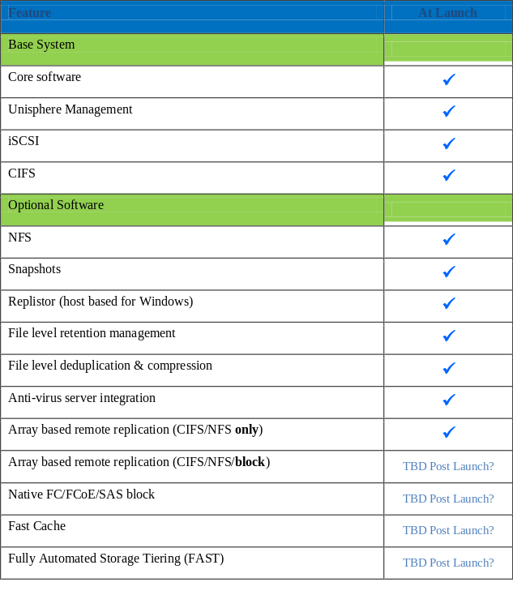
Nimble:

- Nimble Storage has no scale up (scale deep) scalability at this time. When any customers run out of disk capacity, another CS-Series unit must be purchased. Customers must rely on VMware V-Motion to scale out the disk capacity by moving some volumes from one storage CS-Series iSCSI array to another to achieve the scale-out objective.

Due to no scale up (scale deep) capability, Nimble storage is most suitable for mid-range (depend on storage capacity need) and SMBs market.

- Needs to find a way to replicate its metadata from its array to any storage for protecting the entire data in the event of its metadata corruption.

- Since Nimble is a startup company, it must convince most organizations that its product is solid, reliable and has enough resources to support its products at enterprise environment because most IT professionals never heard of its name.

A quote from “Magic Quadrant for Midrange and High-End Modular Disk Arrays” – “Some large organizations are reluctant to do business with privately held vendors that lack financial transparency, particularly when there may be alternatives that are available from large established vendors”. Click the following link for details:

http://www.storagenewsletter.com/news/marketreport/gartner-magic-quadrant

Nimble’s response:

A few factors to consider:

- We do not typically compete against the VNXe- the VNXe is a SMB product. We would typically compete against the VNX- but the cost point will be much higher for the VNX.
- With the VNXe you would never be able to scale to do VDI or major applications. The VNXe just wasn’t built for those scenarios.
- With Nimble you have the performance and scalability built in. if you want to do VDI or add more VM Ware the performance is already built in and you would not need to purchase additional
Disk or have to forklift and upgrade just for performance. Out of the box the Nimble is about 4-5x the performance of the VNXe. The 2 don’t even compare.
- The integration with snap shots and true replication, inline compression. These are all products the VNXe does not do well, but they are included with Nimble.
- Your TCO with Nimble is built in: no need to add disk for performance, scalability, snap shots ( ability to remove additional HW/ SW costs- other products removed, etc )

Since a virtualization relies heavily on either SAN or a unified storage (e.g., put all eggs in one basket), it is very important that we must consider all facts, as shown below:

- Meeting your business objectives (e.g., 10 GbE, instead of FC, might be able to meet 95 percent of all business objectives, plus 40 GbE is coming soon!)
- Vendor’s reputation
- Vendor’s storage price, including total cost of ownership (TCO)
- Resources, including consulting services
- Customers’ installed base
- Technical support
- Customers’ satisfaction
- Available Technical Training
- How quickly replacement of a storage administrator when a turnover occurs

In summary, make an award in the best interests of the organization after all factors have been evaluated.

About EMC (http://www.emc.com/about/index.htm)

CRN Names EMC "Company of the Year" in Three ARC Award Categories -
http://www.emc.com/about/news/press/2011/20110812-01.htm

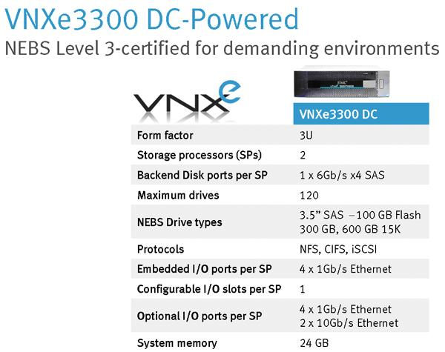
Source: EMC

About Nimble Storage (http://www.nimblestore.com/)

CRN Names Nimble Storage "Product of the Year" in 2010 for Developer of the First Converged Storage and Backup Solution -
http://www.nimblestorage.com/news-events/crn-product-of-the-year/

Nimble Storage CS220 Array
Raw: 12TB /Usable: 16TB; 16 bays (SATA-300/SAS), Dual Controllers, 6x 1GbE

Overview – Nimble Storage (45 min)
http://info.nimblestorage.com/nimble-webinar-7-13-11.html

Additional Reading from Government Technology

Real Value from the Cloud: Moving beyond personal productivity
Both government and industry have been fascinated by the concept of cloud computing since its inception. Now that the dust has settled and some early adopters have started to see successes – especially in the area of personal productivity applications like email, word processing and spreadsheets – government leaders are asking “What’s next?” To answer that question, the Center for Digital Government has reviewed a new landscape of more complex, enterprise-class applications that are powered by the cloud. This white paper discusses this new class of cloud solutions that is emerging, and the great promise it holds for government. Click on the line below for details:

http://www.govtech.com/library/papers/Real-Value-from-the-Cloud-Moving-beyond-personal-productivity.html

