Dell Compellent Model 40 vs. EMC VNX 5300

Jeremy Li
February 2012

Executive summary

In the past three years, the Office of Information Technology for the County of Los Angeles requested each department to move each physical server into a virtualization environment whenever possible. The deadline for the server virtualization project is year 2014.

Since the Auditor Controller (A-C), one of 37 departments at the County of Los Angeles, has no virtualization Infrastrure in its current IT data centers, a storage area network (SAN) is considered to be purchased to build a virtualization Infrastrure in order to complete the task.

With a fully virtualized IT Infrastrure beyond using only server virtualization to deal with server sprawl and wasted power consumption in data centers in mind, purchasing a unified storage, which can run and manage files [file-level access, e.g. Common Internet File System (CIFS) and Network File System (NFS)] and applications (block–level access, e.g. Internet Small Computer System Interface (iSCSI)] from a single device, is recommended.

Since the A-C has no single fiber channel component at its IT data centers, only IP-based SAN (iSCSI) storage with solid-state drives (SSDs) feature will be considered to avoid a forklift upgrade in the future. Read Top 3 Reasons Why You Can’t Build a Cloud with Fibre Channel for additional reasons - http://san.coraid.com/rs/coraid/images/Coraid_Brief_Top3ReasonsWhyYou.pdf? (Source: CORAID). Embedded advanced storage efficiency capabilities such as thin provisioning, file deduplication, and compression will also be considered.

This comparison report is not about being ‘for” or ‘against’ one storage vendor but merely a call for equal consideration of each vendor’s storage solution to maximize a long-term investment on a storage system.

Several storage vendors were contacted for this project. A few quotes were presented by Dell Compellent, EMC, StoneFly (www.StoneFly.com), XIO (www.xiostorage.com), Nimble Storage (http://www.nimblestore.com/), NexSAN (http://www.nexsan.com/) and HP. To meet the criteria of the combination of the SSD and iSCSI capability, five vendors, Dell Compellent, EMC, StoneFly, Nimble Storage and XIO were selected for the consideration.

Last October, the eCloud project, a private cloud hosted by ISD (Los Angeles County Internal Services Department), was discussed and will be considered first by the A-C.

Since the evaluation of the storage area network (SAN) and virtualization project had already been started before the eCloud project was introduced, we decided to continue to select a storage vendor for the virtualization project for the A-C, as an alternative solution, in case the eCloud project might not work for the A-C.

The goal to select new storage is to reduce costs, reduce complexity and increase performance.

The following information is an initial analysis of a comparison between Dell / Compellent Model 40 and EMC VNX 5300.

1. Application and Management Interface

- EMC Unisphere Application Interface looks better than Dell Compellent Application Interface by delivering a single, integrated and simplified user view panes, as shown below. It can navigate all common tasks through an easy dashboard, such as highly automated provisioning, system interfaces, data replication, viewing detailed reports of how resources are being used and visually drilling down to individual components. The simple and intuitive application-aware management interface can help administrators easily create a storage pool that is optimized for an important deployed application such as Exchange 2010, advanced efficiency features including file deduplication, and compression, which can reduce disk space used by up-to 50 percent.
- Dell management interface is not as simple as the VNX Series, but it is good enough for most IT professionals to manage its storages, pools and other tasks without a big learning curve.

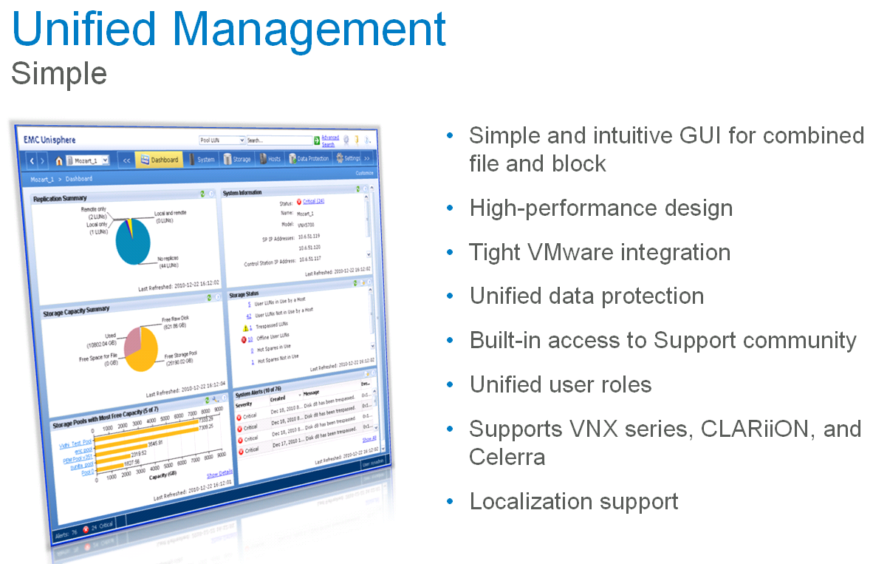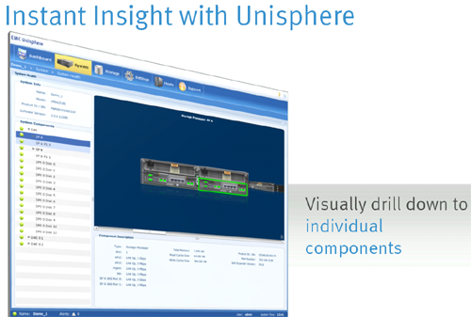

Source: EMC

- Dell Compellent can only manage its own Compellent storage and will not be able to manage Dell EqualLogic storage or Dell PowerVault.

EMC won in this category.
2. Avoid Forklift Upgrade – Scale Up and Scale Out

Dell Compellent:

- Dell Compellent Model 40 can be scaled from 12 disks to 960 disks without forcing customers to buy a second identical unit or upgrade to a higher capacity unit – you can’t buy the wrong sized array from Compellent. Other manufactures force a customer to foresee future scalability requirement, years ahead of actual needs, and acquire controller assets to match those predictions. For example, EMC has multiple VNX array models: VNX 5100, VNX 5300, VNX 5500 and VNX 7500 versus Compellent’s Model 40.

Compellent Storage Center Gen4 | Traditional Modular Storage | Comments
Vertical and horizontal scalability | Vertical scalability by model with limited horizontal scalability | Compellent performance growth is based on a bounded vertical & unbounded horizontal scalability. Storage performance linearly scales compute, backplane, capacity, and connectivity assets without degradation in business application storage response time. Growth beyond the bounded vertical limits occurs via horizontal clustering of multiple pairs of fault tolerant controller pairs providing additional compute, backplane, capacity and connectivity capabilities to the aggregated cluster of controller pairs. Traditional modular arrays provide vertical scaling by model, but typically limit horizontal scalability.
Extended depreciation terms | Traditional depreciation terms | Compellent’s component modularity architecture allows for extended product lifecycle within the datacenter as compared to traditional arrays – Individual components within a Compellent solution can be enhanced, or simply replaced due to wear, via exchange or addition of the newest variant of the part. Traditional arrays typically provide upgrade capabilities, but adopting newer core components usually is not an option (e.g., an EMC CX3 generation array cannot adopt CX4 based technology without performing a forklift upgrade of the CX3 to a CX4.

The model 40 separates the head unit from the disks; therefore, you can buy one unit and scale out or scale deep by adding more disks, or scale up by changing the head unit. With EMC VNX Series, a second unit must be purchased and is linked with first unit, when the scale out or scale deep is required.
EMC:

- EMC customers must require a customer to purchase a second identical unit and link them tighter in order to increase its capacity (Scale out or scale deep) and performance (e.g., when VNX5300 reaches its current capacity, a customer must either purchase second unit or replace the existing header with a higher capacity header in order to increase the storage capacity, as shown in the screenshot below.)
- Replace the existing header with a higher capacity header, which requires a downtime of the entire unit, can also increase the capacity (e.g., replacing a VNX 5300 head with a VNX 5700 head, then, using existing disks from VNX 5300 and link the unit with the new VNX 5700 unit.
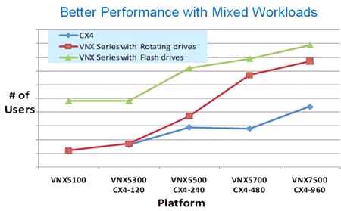
Source: EMC

Note: VNX7500, the highest capacity in the Series can hold 1000 disks (CX4-960 can hold up to 960 disks).

Author did a research and found that a pair of controllers from Compellent’s quote will not support 960 disks. Therefore, simply replacing the current pair of controllers with more powerful pair of controllers must take place, in order to support more disks beyond the current controller can handle, when any customers must add more disks to its systems.

In this case, there is no difference between EMC and Dell Compellent’s methods to address the storage capacity expansion. However, a customer can choose the most powerful pair of controllers in Compellent Model 40 in the first place to avoid the Forklift upgrade, as data volumes grow – capacity is added just in time and performance scales linearly.

Dell Compellent won in this category in a thin margin

3. NAS and Block Level Integration
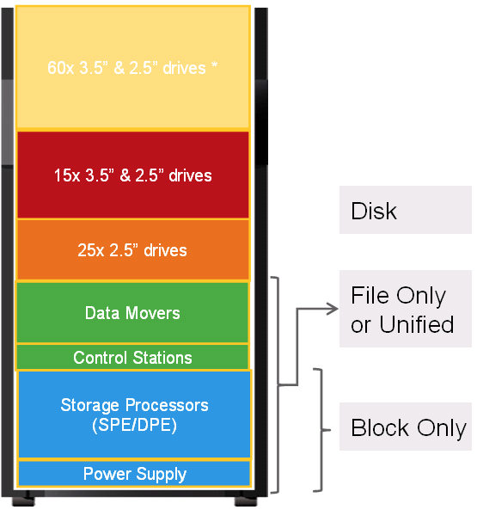
EMC Data Moves, Network Attached Storage (NAS), for CIFS, is integrated within the VNX Series enclosure so that the VNX 5300 provides flexibility for supporting both block and file-based access, while Dell Compellent must rely on two external NASs for CIFS via Window Storage Server (WSS) gateways.

Reference from Dell:

Network attached storage (CIFS/NFS/NDMP) is supported via Window Storage Server (WSS) gateways. Dell's current solution is NX3000 models
based on Windows 2008 R2 Windows Storage Server edition. Solution supports from one to eight gateways and enables high-availability, deduplication, and native AD integration. iSCSI, FCoE, and FC are all natively supported protocols NOT requiring gateways. Our gateways would be similar to EMC Data Movers – the Data Movers are EMC gateways enabling CIFS, NFS, and NDMP functionality.

EMC won in this category.

However, it does not matter at our environment in my opinion due to the following reasons:

- Author will recommend using P2V to move our existing departmental file server to virtual machine (VM) for simplicity without worrying about third party compatibility (Additional $500.00 Windows OS license fee is required).
- No learning curve to use EMC integrated tools.
- No need to perform any trouble-shooting for a shared folder or permission issue due to additional layer of the EMC licensed CIFS integration with Microsoft native CIFS. (Ex: During a live demo on Feb. 15, 2012, two new shared folders were created on the VNX5500, but Microsoft native MMC for shared folders could not see them).
- EMC still recommends using Microsoft native MMC to manage its folder and file permissions, even though Microsoft licensed the CIFS to EMC for its integration.
- Quicker to upgrade Microsoft OS, service packs or patches on existing VM without waiting for EMC to certify the compatibility with all new updates, mentioned here.
- Do not need to worry about the Microsoft and EMC relationship at all. If Microsoft stops renewal of newer version of the CIFS license to EMC one day, our department will not be affected. For example, Symantec (formerly VERITAS) stop giving Microsoft VERITAS Backup Exec Light license for its use in Windows Server 2008. As a result, Microsoft had to rewrite all its built-in backup utility from scratch. The new built-in backup utility from the Windows Server 2008 does not support tape backup etc.

However, one advantage for using EMC built-in NAS, instead of P2V, is that no one needs to worry about OS patches anymore since it does not use Windows OS.

- Snapshots Comparison for Historical Point-in-Time Copies

A traditional daily backup has only one recovery point (RP) in every 24 hours. By relying on local snapshots, read/write snapshots (e.g., clonesnap), a customer can increase the RP from every 24 hours to 1 hour or even every 15 minutes, depending on the needs.

•Recovery-point objective (RPO): How recent is the point in time for the recovery
•Recovery-time objective (RTO): How fast can you restart a failed application?
•Backup Retention (BR): How long do you need to restore the point in copy?

A major advantage of snapshots over backup software is that they scale very well and there is no data movement involved, but pointer. This means you will get near instant application recoveries based on whether the snapshot can support both file-level and block level. Most vendors’ snapshots only support file-level, including from VMware vSphere 5.0. Therefore, a third party backup/recovery application will be used to recover block-level applications such as Exchange and SQL servers.

Unlike traditional copy-on-write (COW) snapshots in EMC VNX series - the historical data is relocated to reserved space prior to the new inbound write overwriting the original data, Nimble Storage snapshots use a fine granular snapshot with redirect-on-write with compression technique. Thus, it has no performance impact and consumes least disk space, as shown in the screenshot below:

Traditional Array Snapshot Granular Snapshot
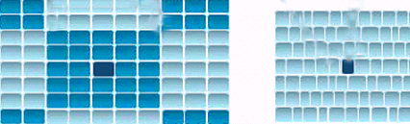

A traditional array snapshot creates large pages and extents, while a granular snapshot creates an individual variable block

Each vendor uses different pages and extents, as shown below:
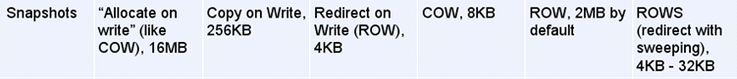
Source: Nimble

A Granular Snapshot is the most efferent snapshot and consumes the least disk space. The larger the pages and extents, the more disk space will be consumed.

Compellent uses 2MB pages and extends because it has to deal with auto- Tiering. Therefore, Compellent’s snapshot size should be larger than EMC VNX’s COW with 8KB.

The first time snapshot should be also very small, while most vendors’s first time snapshot will consume large disk space as a baseline because a traditional copy-on-write (COW) snapshot is used and the performance will be affected.

In Model 40:

- A near unlimited number of historical point-in-time copies or snapshots can be performed per volume (LUN). It provides for the ability to easily maintain hundreds of high frequency (every five minutes) near term recovery points in combination with long term (hours, days, or months) recovery point.

- Granular snapshots can be configured not to expire providing historical retention of hourly, daily or monthly recovery point.

- Compellent's snapshot functionality is accomplished via a redirect on write, whereby no production performance impact is suffered for establishing and maintaining historical point in time copies - redirect on write provides for the maintaining of historical point in time copies by ingesting and mapping new writes to new blocks preserving the original blocks and not having to copy those historical blocks. (Source: Above info comes from Compellent Comparative Analysis Matrix)

Therefore, a third party disk-to-disk backup system, including its snapshots and a backup/restore program, might be eliminated due to its efficient ROW snapshot technology, which takes minimal disk space, only changes to the active file system are written. With the Model 40, data is protected by Snapshot copies without purchasing excessive amounts of disk storage.

In VNX Series:

- Traditional copy-on-write (COW) snapshots have been used for many years and have huge performance impact due to disk spindle contention for concurrent reads.
- The COW causes poor RPOs and very limited retention capability.
- 96 Read-Only (RO) snapshots and 16 Read/Write (R/W) snapshots are supported due to the COW reason.

Of Note: A more efficient snapshot is accomplished via a redirect on write with inline or post process compression. No production performance impact occurs and historical point- in-time copies are maintained, while consuming the least disk space.

Compellent won in this category.

- A Zero-copy Clone from a Snapshot (Writeable Snapshot)

Usually, a clone snapshot (by creating instant, space-efficient data replicas that shorten design cycles and improve service levels) will be used to create a testing and development environment for testing applications.

An efficient zero-copy clone is a copy of a volume that shares all common data blocks with its parent. Therefore, it should only consume disk space when new blocks are written to the clone or existing blocks are changed.

Space-efficient snapshot and clone (writeable snapshot) technologies are excellent tools to help reduce the need for thick copies of data while retaining the ability to use and protect data.

However, each vendor might implement clone method differently. As a result, an inefficient clone copy will consume large disk space.

In Model 40: (Read/Write snapshots - Replays - are supported)

Dell Compellent did a live demo on April 23, 2012

- Two LUNs created (LUN ID 1 and 2), one LUN presented as F volume.
- Performed a snapshot on ( F) volume, associated with LUN ID 1.
- Used the newly created snapshot to mount a new volume as G:, associated with LUN ID 2.
- Copied a few folders to G:.
- Verified the original volume F: and found the newly copied folders were not there.

Therefore, the replays (snaphosts) are read/write and can be used as a testing and development environment

In VNX Series:

Clone is Physical Point-in-Time (PIT) Copy - Physically independent point-in-time copies of source volume:

- A clone is a full image copy.
  - Require the same space as the source data
  - Available after initial copy
  - No performance impact on source data
  - Can be used to replace source after hardware or software error
- EMC successfully performed the clone via a read/write snapshot. Therefore, the clone copy will consume large disk space.
- In VNX Series, 96 Read-Only (RO) snapshots and 16 Read/Write (R/W) snapshots are supported. You can easily create a real world testing or development environment (Staging environment) quickly without touching a production environment.

Here’s Dell’s response regarding snapshots:

Snapshots of Snapshots –

This is something very unique to Compellent because of the way we do it, and again its important to know how legacy systems do snapshots.

In a legacy system, you have an active volume, and to take a snapshot you either allocate disk space to keep ‘original data’ that has been overwritten by new data, from a given point in time. By selecting a snapshot and overlaying its data to the active volume, you are able to view data the way it was when you took the snapshot. In these systems you can mount the snapshot, utilize it, or roll it back to the main volume (for a total volume recovery, not recommended). A snapshot is a VERY simple implementation.

A Replay is much different.
In a Compellent environment, similar to snapshots, we create an empty page buffer that starts empty. When an original page is overwritten, that original data gets FROZEN as read only, migrated to RAID-5 (redundant array of independent disks) and the new data is presented over it. What is unique to Compellent is that snapshots look no different than base data, and snapshots of snapshots or snapshots of a snapshot's snapshot can be taken, as deep as desired. This implementation is called a view and is identical to the end user as a volume on the array. It behaves the same, writes and progresses data the same, but uses common blocks (from the base) instead of its own dedicated blocks. A great implementation of this would be a virtual desktop. Imagine allocating 10GB of disk space for a base, image, and creating 5 views (engineering, hr, sales, finance, and executive). Engineering hires 10 people and their ‘view’ (which uses common blocks from the base) is used as the base to make 25 more views. Each of these views is r/w but utilizing the data from the base image. A windows image doesn’t change often, so there is no reason to have 25 copies of it, but the actual view would hold unqiue profile information like desktop, passwords etc.

The alternative for this is the legacy model, where you would take a snapshot of a base volume, and mount, unmounts, read or write from it, but that’s it… In a Compellent world, a view turns any volume into a template.

Of Note:

NetApp FlexClone (read/write snapshot): Create Exact Disk Copies – Virtually (Instant replication without additional storage space) – Click on the link http://media.netapp.com/documents/ds-2837-flexclone.pdf for details.

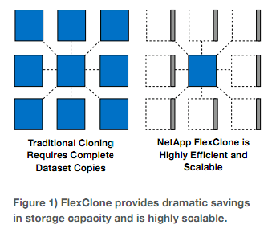
Who won in this category?

- Snapshots Comparison – The Initial Snapshot Size (Delta)?

- EMC did a demo to show the file size of the first copy of snapshot. EMC acknowledged that the result of the demo was misleading. Per EMC, regardless of 1TB or 100TB, the file size of the first copy of snapshot is based on the percentage of the original data size. Therefore, it only consumes a small disk space.
- Dell will perform a short live demo via a web conferencing to show the initial size of the first snapshot in the future.

Note: Microsoft Date Protection Manager (DPM) from System Center 2010 supports snapshots. However, the first-time snapshot size is very big, at least 70% of the original size, depending on the deduplication and compression per Microsoft IT evangelist at Microsoft Cloud Conference Session, March 14, 2012.

Here’s Dell’s response regarding snapshots:

In Compellent, a snapshot is a replay. In traditional systems, snapshots are disk or memory constructs that ‘hold changes’. In a Compellent system, replays are a key motivator for how we do data progression. When we take a snapshot, it consumes ZERO space. As a new page is written, that new page is written to the active replay, and the page PRIOR to it gets converted from RAID-10 to RAID-5, and later progressed to RAID-6. Therefore, not only are replays a mechanism for point-in-time recovery, but by taking one, you are physically freeing up space to be reallocated to the pool.

In legacy architectures, replays have ONE function, for point-in time recovery. For a Compellent, you WILL regain disk space every time you take one AND we encourage you to take them often. Others will recommend taking replays just for backup.

TBD

- Storage Tiering (Automated Data Movement) and RAID Implementation

The storage tiering in conjunction with thin provisioning, a technique of maximum effective use of the physical storage capacity actually deployed, makes IT organizations easier to manage and use primary storage (RAID-10 for fast write access) as well as secondary or third tiering storage (RAID-5 for large volumes and long-term archiving) efficiently and economically.

- RAID-5 is acceptable in “read” access, which is no difference with RAID-10. It requires one disk IO operation for each read access (1 IO operation for 1 read)
- RAID-5 is not very good on “written” access because one-write changed operation requires four (4) disk IO operations (2 reads + 2 writes = 4 IOs). That’s the reason almost all vendors use RAID controller’s cache to speed up the “write” operation. In many scenarios, an add-on Flash Cache will speed up the write and read operations significantly. Item 13 will discuss the topic of Flash Cache Module from EMC.
- Dell Compellent showed the automated tiering storage migration from tier 1 (RAID-10) to tier 2 (RAID-5) successfully during the demo.
- EMC did not show the automated tiering feature during the demo. Per EMC, VNX 5300 has an auto-tiering storage feature via statistics collection, analysis and relocation operational processes.

Compellent Automated Tiering Process:

- Data will always write to tier-1 (RAID-10, striped data across mirrored
storage disks) first.
- Every 24 hours, inactive or aged data will be moved from tier 1 (either SSD or serial-attached SCSI (SAS) HDD to tier2 (RAID-5, SAS HDDs).
- Every 12 days, inactive or aged data will be moved from tier 2 to tier 3 (RAID-5, near-line SAS HDDs).
- When an active data is detected from tier 2 or tier 3, that data will be automatically moved back from tier 2 to tier 1 or tire 3 to tire 2.

EMC Automated Tiering Process:

You must purchase FAST Cache, which uses 64KB extents and Fast Suite option in order to perform the auto-tiering:

(Source: EMC)

- FAST Cache operates at a 64KB granularity for increased efficiency. If a 64KB block is referenced 3 times in a given period of time (the time will depend on the IO activity of the system), the block will be promoted into FAST Cache.

- As the data ages and becomes less active, it will fall out of FAST Cache to be replaced by a more active chunk of data.

- EMC VNX new feature comes with a Fully Automated Storage Tiering for Virtual Pools (FAST VP). It allows a single LUN to leverage the advantages of Flash, SAS, and Near-line SAS drives through the use of pools. FAST solves theses issues by providing automated sub-LUN-level tiering.

- 3X performance gain if Microsoft SQL server, VMware and Citrix VDI boot time and refresh time; Oracle’s number of users and transactions.

Of Note: Nimble Storage does not use any auto-tiering method. Instead, it uses the high-efficiency technique called Cache-Accelerated Sequential Layout (CASL) listed below.

Writes:

- An application writes random data in a bucket of 1GB nonvolatile RAM (NVRAM).
- Once NVRAM is full, data will be moved to 12GB dynamic random-access memory (DRAM), where data is compressed into variable–size blocks and coalesced into a full stripe.
- A 4.5MB sequential full write stripe is written to disks.

Reads:

1. If the data exists in NVRAM, then, the data will be fetched from NVRAM.
2. If the data is not in NVRAM, then, the data will be pulled from SSD.
3. If the data is not in SSD, a sequential read occur from serial advanced technology attachment (SATA) drives for those blocks. At the same time, populate the SSD cache with the same blocks for future reads. Therefore, read performance is greatly accelerated via cache sequential.

The CASL algorithms yield over 900 IOPS per NL-SAS drive for a fully random, write-only load of 4KB blocks.

The variable–size blocks can be tuned to fit for different applications to get a better performance.
Click on the link http://www.nimblestorage.com/products/architecture/ for details.

Special Note: Per Microsoft, any Exchange database(s) should not be stored on any storage with auto-tiering. Click on the link below http://technet.microsoft.com/en-us/exchange/ff182054 for details, since both EMC and Dell Compellent uses SAS spindles to store database(s) and log(s), do not use auto-tiering during the test(s).

Here’s Dell’s response regarding RAID Implementation:

Compellent RAID implementation is very simple, but makes sense when you understand the inadequacy of a non Compellent system. In legacy architectures, you define an IOP and bandwidth requirement for a given ecosystem or application. Using certain types of drives, you scale for the performance requirement on speed and type of drives, and then apply penalties or advantages for the raid architecture. When you have that volume created, you assign it to an application, and that application lives on that construct.

In a Compellent system, you also size for IOPS and bandwidth, and then allow the system to self heals. That is where the similarities end. Data on Compellent is broken up into pages, and pages are frequently evaluated regarding access. Data that is written always goes to RAID-10 on the fastest drives possible. As replays are taken, data is automatically converted to a lower performing write RAID level (raid-5) since it has become a candidate only for reads. Subsequent writes will go to RAID-10 directly. As data ages, and becomes less frequently accessed it will eventually live on RAID-6 which is an even more cost effective read protection scheme, freeing up space, and allowing much LESS RAID-Penalty overhead than other systems.

No one wins in this category (Due to complicated algorithms, it is very difficult to judge the result without a real-world experience and additional researches).

- VMware Integration

The Model 40 is tightly integrated with VMware OS. It won the Finalist Award at the BEST OF VMworld 2010, as shown below:

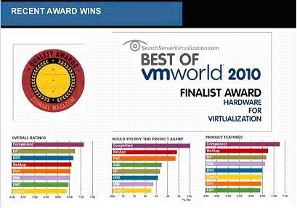
Source: Dell

On the other hand, EMC also has a tight integration with VMware OS – vSphere 5, as shown in the screenshot below:

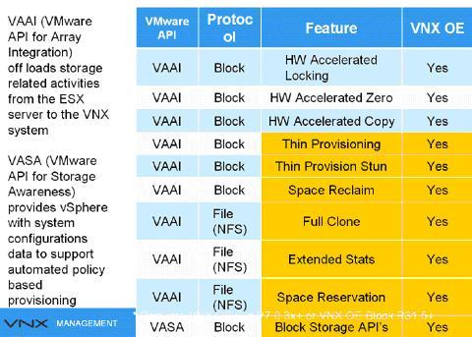
Source: EMC

Dell Compellent ties with EMC in this category

Note: The author has no time to watch any VMware demos with either EMC or Dell Compellent. Therefore, more researches will be needed to make the conclusion.

- Embedded Advanced Storage Efficiency Capabilities (Thin Provision, Deduplication and Compression)

- EMC VNX Series’ embedded advanced storage efficiency capabilities including thin provisioning, file deduplication and compression reduce disk space used by up-to 50 percent.
- Dell Compellent Model 40 does not provide file deduplication and compression at this time, although it provides advanced thin provisioning.
- Dell Compellent bought a company, who is specialized for file deduplication and compression a few months ago. The Model 40 will support the feature of file deduplication and compression in the future.
- Dell Compellent can delivery a true thin provisioning, as shown in this demo (http://www.compellent.com/popups/D2TP/D2TP.html). It is simple and clear.
- No chance to view EMC demo on the thin provisioning.

Here’s Dell’s response regarding pre- deduplication, up to 40% disk space reduction:

As we import or ingest data, we actually read the data. If we are sensing whitespace, we acknowledge transfer of the data but do not allocate space. On the initial ingest from existing assets, Compellent will typically reduce the total amount of data by approximately 40%. Deduplication is a different implementation (which is coming in a future release), that will allow data segments that are redundant to be deduplicated (written once, referenced many), lowering disk consumption for repetitive data. Note that deduplication is VERY CPU intensive. For in-line deduplication, performance can be constrained by bandwidth, memory and CPU, while ‘post process’, will require a considerable amount of ‘staging’ area and time, as it is done post-process. One must also consider the cost basis when evaluating dedupe (cost of software and higher end hardware vs. buying more low cost drives). However, deduplication, as a feature with is on the Dell-Compellent roadmap.

EMC won in this category, but will check with EMC for the pre-deduplication subject.

- Mixed Drives Types in a Virtual Pool

EMC Method:

EMC successfully demonstrated three types of disks (SSD, SAS and SATA) in a Virtual Storage Pool (VP), as shown in a screenshot below:
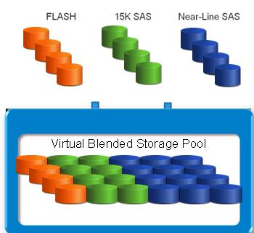
- EMC encourages its customers to move from its traditional RAID Group to VP, because Pool LUNs are more flexible besides certain features require using VP. The VP is available to both VNX series and VMAXe series.

- The VP seamlessly allows addition and removal of physical capacity easier.

However, within one Virtual Pool with mixed drives type:

- The VP can only support one RAID type (Raid 0/1, 5 and 6). In other words, RAID10 and RAID 5 can not be mixed together.
- RAID-10 is 4X faster than RAID-5 for each changed “written” operation, while RAID-5 is a good choice for each “read” operation.
- Most customers can not afford to use RAID-10 in the VP due to much higher cost of storage.

Dell Compellet Method:

Dell does not think the Mixed Drives Virtual Pool is good.

- Prefers to use RAID-10 in first tiering storage (striped data across mirrored storage disks).
- Prefers to use RAID-5 in second tiering storage to efficiently use the disk space.
- Via automated data movement (Read item 7 for details) to increase the disk efficient usage.

Both EMC and Dell can mix drive types together in one enclosure.

Here’s Dell’s response regarding Mixed Drives Types in a Virtual Pool

In other (competitive) systems, drivers are resources that are allocated to volumes and are the fundamental building block of performance and capacity to a given volume. With drive sizes increasing, it is very difficult to assign small volumes to end users that need higher requirements (ie. A 1 TB footprint with 3000 IOPS). To complicate things even more, creating static volumes, with specific drive speeds, raid types and interfaces prove better in LIMITING performance rather than MAXIMIZING it.
In a Compellent system, all drives, regardless of type, size and speed are aggregated into a single pool, that is the resource end users will allocate volumes against. This allows you to use the performance, capacity and pathing from ALL drives in the array rather than creating groups and sub groups which everyone else has to deal with. We then use RAID, as a software construct, rather than something that is applied directly to spindles. As user data access changes, we can dynamically change the raid level on pages, rather than the entire drive. This is important as with our research, we have seen that up to 80% of data at rest only gets touched once in its lifetime, and unlike competition, we can automatically demote those ‘stale’ pages, to larger expanses of lower cost storage, and provide the same read performance. Everyone else will keep an entire volume on disks equivalent to what its top performance requirement is. If 80% of that data is low access, that is 80% of that performance profile is wasted. Not on a Compellent.

- Unified Snapshots and Remote Replication

Both vendors support both synchronous and asynchronous replication. Generally speaking, synchronous replication is used for Local Area Network (LAN) and Metro Area Network (MAN) for the best data protection (e.g., where no single transaction can be lost in case of a DR), while asynchronous replication is used for a long distance replication (e.g., Los Angeles to New York) for a highest possible performance purpose.

EMC

A customer has to purchase local snapshot as well as remote replication snapshot (Replication Manager) from EMC.

  - VNXe supports the following types of storage resources for iSCSI replication:
  - Microsoft Exchange, VMware VMFS, Microsoft Hyper-V and Generic iSCSI
  - No native (Unisphere) replication
  - iSCSI replication on VNXe requires EMC Replication Manager to create, schedule, and manage the replication. (Additional cost is required)
  - Requires EMC Replication Manager (RM)
  - Provides UI for managing replication & snapshots of iSCSI LUNs.
  - Controls the creation of snapshots, marks the snapshots for replication, and initiates the copy job from the source to the destination.
  - During a snapshot or replication job, RM ensures applications are in a consistent state by quiescing data reads and writes, including flushing the cache.

Dell Compellent:

Compellent’s remote replication capability is fully integrated and unified with the snapshot capability providing for the ability to leverage the space-efficient snapshots between local and remote sites for cost-effective disaster recovery and business continuity. Synchronous and asynchronous replication capability are providing including full quality of service throttling allowing for the prioritization of replication based on time of day and importance or significance as compared to other LUNs. Traditional modular arrays provide replication, but not competitors have unified their local data protection and remote data protection functionality.

Here’s Dell’s response regarding Sync & Async Replication:
Compellent has two methods to do replication in addition to our Live-Volume

a. Synchronous is the traditional “remote mirroring” implementation, where we write remotely, write locally and then respond to the server that a write has been committed. It is traditionally purposed in environments where no single transaction can be lost in case of a DR but tends to be a bit more latency sensitive at longer distances. For that reason, Asynch is often used.
b. Asynchronous, which we call ‘remote instant replay’ is our functionality where we use our replay technology to creates ‘points in time’ which can then be synchronized to a remote site based on a scheduler. Writes are accumulated in a replay, and the replay is exported to a remote system which can then be used as a recovery volume or instantly activated as a useable production volume.
c. Live Volume acts as a storage hypervisor, actively mapping one volume to two Dell Compellent arrays at the same time. This allows organizations to shift volumes between systems for high availability and continuous access to data. With Live Volume, data is not physically bound to any particular array or data center. Instead, all volumes can be accessed and shared from multiple locations, making Live Volume a key enabler for virtualization and the cloud.

Special Note:

In an extremely rare situation, the data and snapshot will be completely lost on primary and secondary sites, if there was a corruption in the metadata of the volume that was transferred to the second array via the replication, although two storage arrays are installed for a DR purpose – avoid a single point of failure of one SAN implementation approach.

In order to avoid this extremely rare scenario, an organization might consider deploying a secondary D2D storage, which can keep one copy of the data (primary data) on the primary storage, while copying a second copy of the data to a D2D appliance such as Data Domain. They are a completely separate copy of the data. Therefore any corruption of the metadata on the SAN does not affect data copied to the D2D appliance at all.

The problem with this solution is not only “complexity” - add additional layer of storage and its backup application, but also increase the cost dramatically, besides labor cost.

An alternative solution is to use a popular concept – cloud - to address any corruption in the metadata of the volume on any two arrays (one acts as a DR array).

One storage vendor, for example, cloud-integrated enterprise storage (http://www.storsimple.com/) can completely eliminate tradition storage products:

- Backup Media Server & Software
- Disk backup with deduplication
- Tape backup Infrastrure
- Storage system for Disaster Recovery Time Objective (RTO)]

- Support Virtual Desktop Infrastructure (VDI)

Both storage systems will support VDI deployment due to capability of SSD present. How much VDI devices can be supported by both storage systems? It is beyond the scope of this report.

However, the author would like to share his view learned from Citrix Tech Exchange Q1, 2012. Click on the link below for details http://www.lacaaea.com/aaeapdf/san/A-Partial-Note-from-Citrix-Tech-Exchange-Q1-2012.pdf

- Flash Cache Module:

EMC:

- FAST Cache can optimize both Read/Write operations. Applications, such as random small block like exchange, databases (OLTP), etc. have been proven to work well with Fast Cache, as shown in the screenshot below. However, applications such as large block sequential will not work well with FAST Cache because there is no locality of reference.

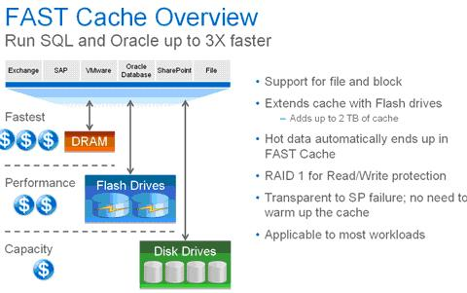
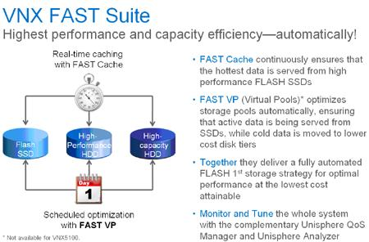
Source: EMC

- Adding Fast Cache will boost the performance in a large VDI deployment.
- Adding Flash drives as FAST Cache will improve cache hit rates from the traditional 20-30% up to 60-70%.

Dell Compellent:

- Compellent has the Model 30 controller with 3.5GB cache (battery backup) and the Model 40 with 4GB cache (backed up with flash).
- A 2-controller array has 8GB of flash total.
- Since both Model 30 and 40 uses 32-bit OS, it can only support 4GB physical memory. That’s the reason why both arrays can not offer more than 4GB flash cache to speed up the performance.

Note: The upcoming new model under Dell name will use 64-bit OS. Therefore, Dell might be able to increase the flash cache to increase the performance.

Of Note: NetApp Flash Cache
(http://www.netapp.com/us/products/storage-systems/flash-cache/), formerly called PAM (Performance Accelerator Module), can only optimize Read operation. However, if you exam the NetApp OS File System (Hole Filling, e.g., WAFL - Write Anywhere File Layout) carefully, each changed written operation is not subject to the RAID-5’s 4-disk-IO operations for each write (2R + 2W) for panelizing the write operation because NetAPP file system uses a dedicated parity drive and has a good random write performance until disk fills up. This means that each write will stripe across all data drives without putting any parity on data drives in NetApp storage. In other words, the 4-disk-IO operations for each changed written access in RAID-5 do not apply to NetApp OS file system. That might be the reason NetApp Flash Cache does not need to optimize the write mode.

File System (NetApp) | Pro | Cons
Hole filling (e.g., WAFL)  (Source: Nimble) | - Good random write performance until disk  fills up  - More efficient redirect-  on-write snapshots | - Performance degrades over time  - Slow, high overhead compression
Note: Click http://en.wikipedia.org/wiki/Write_Anywhere_File_Layout for more.

EMC won in this category

14. Active/Active vs. Active/Passive Controllers

Both Dell Compellet Model 40 and EMC VNX Series can offer two controllers (maximum) per storage system. If one controller fails, the surviving controller in a pair will take over via a failover process in Write-Through Mode, which disabled the cache memory on the surviving controller to avoid data corruption. That change may occur for a short time during the failover but once all the volumes are back on line, the surviving controller will resume in Write-Back mode (normal mode).

Good array management includes trying to keep the peak load on each controller under 50% to keep post-failover performance from being an issue. Otherwise, the surviving controller may not have enough CPU resources to meet the host requirements after a failover.

The EMC Clariion, VNX series, Dell EqualLogic, Dell Compellent, LSI/Engenio, Network Appliance, HP and XIO solutions all have a limit of two controllers in a single storage system, except for EMC’s VMAXe and HP 3PAR, which can support up to either (8) controllers per system.

Many storage arrays from vendors mentioned above can run in some form of Active/Active mode but one controller manages the Write cache and performs all data writes for a volume; the other controller can read data but doesn’t handle writes except EMC VNX series, which can only support Active/Passive mode.

The following excerpt came from “Magic Quadrant for Midrange and High-End Modular Disk Arrays” (Source: Gartner (November 2011)
http://www.storagenewsletter.com/news/marketreport/gartner-magic-quadrant

“The VNX system is a dual-controller design that lacks the automatic load balancing and scalability available with some competitive products. VNX controller-based block services have limited snapshot functionality (eight per volume), which can cause operational complexity, especially in virtualized environments that require short recovery point objectives or that use snapshots to boot virtual machines.”

Therefore, we need to look at each vendor’s tool to verify how each vendor manages volume presentation either manually or automatically in order to balance workload on the two controllers (e.g., HP EVA/P6000 has some load balancing capability, and the P4000 and P10000/3PAR stripe all volumes across all controllers so they don’t have the issue of load balancing).

Due to time constraints, author does not have a chance to compare:

- A performance on disk arrays
- Both Vendors’ application (tool) to manage the array storage controllers.

It is beyond the scope of this report.

Of note: Only EMC VMXe and HP 3PAR storage system can offer up to eight (8) controllers per storage system.

EMC VMAXe:

- A host LUN (Volume) will be served by as many disk controllers (up to 8 physical controllers) as the virtual storage pool is configured for.
- One engine contains two physical controllers.
- Each controller (a PCI hardware-based board), has one major function – a connectivity to host(s) and connectivity to disk(s) etc.
- Both the physical board and SW functions were called directors.
- Each director has a matching adapter for physical connectivity (e.g., fibre adapter (FA) and disk adapter (DA) etc). Per EMC, this is not true anymore today.
- Today, a director has two meanings:
  - A director, in HW context, refers to boards,
  - A director, In SW context, refers to functions (FA, DA etc).
- Therefore, a director has multiple functions (HW and SW functions).
- In summary, one VMAXe engine contains 2 HW director boards; each director board contains 4 FAs and 4 DAs, thus, each engine has a total of 8 FAs and 8 DAs.
- VMAXe is the top of the line in EMC.

HP 3PAR:

- 3PAP storage system can support many disk controllers (up to 8 physical controllers).
- Controllers with four (4) controllers or more installed will avoid the Write-Through Mode. Therefore, the performance after a failover with four or more controllers installed will have much less issue since the workload on the failed controller will be evenly distributed to three or more remaining controllers.
- The 3PAR system creates host volumes by combining logical volumes hosted by each controller, so that every volume in a four-controller system should have 25% of its data managed by each controller (and volumes fail over between node pairs). When a single controller fails, the array runs with 75% or higher performance, instead of 50% performance.
- 3PAR uses legacy Fiber Channel (FC) drives at this moment. HP will be moving to SAS drives in the future in order to reduce the cost.
- HP will continue to use FC to connect to their drive cages. The reason is flexibility, using FC connections the drive shelves can be up to 100m away from the controllers, while SAS only goes about 4m.

15. Exchange 2010 Mailbox Recovery via Snapshot

Both vendors have not yet performed a live demo. EMC is willing to perform a live demo via a web conferencing.

Please be aware of the fact that any organization must purchase either Application Protection Suite or Total Protection Pack, which consists of Local Protection Suite, Remote Protection Suite and Application Protection Suite, in order to be able restore a mailbox from Exchange 2010. A Local Protection Suite (Snapshot) is only designed for recovering files, folders and volumes.

On the other hand, if an organization has already relied on a third party product, such as Symantec NetBackup or Backup Exec, to handle a mailbox recovery, you may consider not purchasing the Application Protection Suite or Total Protection Pack to save the acquisition cost. It all depends on the environment.

Note: A comparison between a third party Backup and Restore application and EMC’s Total Protection Pack or its individual component is beyond the scope of this report.

16. Microsoft Exchange 2010 Solution Reviewed Program (ESRP)
(http://technet.microsoft.com/en-us/exchange/ff182054.aspx)

Each vendor uses two arrays. A primary DAG was located on one array while the secondary DAG was located on a second array.

With 20,000 mailboxes in the ESRP report, the following items were used:

- Nimble CS240G: 24 SATA disks, 8 SSD for Read-only Adaptive Flash
- EMC VNX 5300: 136 NL-SAS disks (7200 RPM), 8GB Flash Cache on each controller

Of Note:

- Dell Compellent Model 30: 144 SAS 15K RPM, 3.5 Flash Cache.

Reference:
- EMC VNX5300 Unified Storage 20,000 users with 1.5GB mailboxes Microsoft Exchange 2010 Mailbox Resiliency Storage Solution (Aug 2, 2011) – Click on the link below for your reference:

http://www.emc.com/collateral/hardware/white-papers/h8849-esrp-vnx5300-20k-1-5gb-exchange-2010.pdf

- EMC VNXe3300 1000 mailbox Microsoft Exchange Server 2010 Mailbox Resiliency Storage Solution (Jun 27, 2011) - Click on the link below for your reference:

http://www.emc.com/collateral/hardware/technical-documentation/h8259-esrp-vnxe-1000-user-exchange.pdf

- Compellent Storage Center 5.3 20,000 Mailbox Microsoft Exchange Server 2010 Mailbox Resiliency Storage Solution (Jan 25, 2011) - ) - Click on the link below for your reference:

http://technet.microsoft.com/en-us/exchange/ff182054.aspx

Of Note:

Nimble Storage CS240G 20,000 Mailbox Microsoft Exchange Server 2010 Mailbox Resiliency Storage Solution (Mar 17, 2012) – Click on the link below for your reference:

http://info.nimblestorage.com/rs/nimblestorage/images/Nimble_Storage-CS240G-ESRP_20000_Mailbox_Solution.pdf

17. Eliminating the Need for a Separate Disk-based Backup.

Dell Compellent Model 40 uses its efficient redirect-on-write snapshot technology. It can provide upto 8,196 snapshots per array. Therefore, a separate, disk-based backup storage system might be avoided to achieve a fast recovery (Recovery Point Ojectives) for a long term archiving purpose.

EMC uses the Copy-On-Write (COW) snapshots and limits 96 read-only snapshots and 16 read/write snapshots per system. Therefore, a separate, disk-based backup is required to achieve a fast recovery.

18. Software License

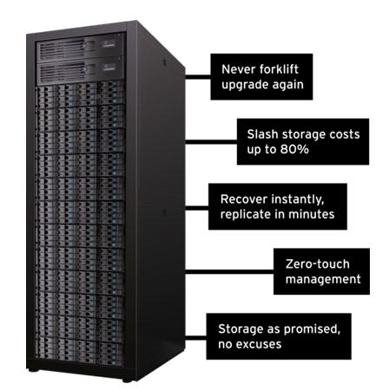
- Per Dell Compellent, a customer only buys controller software once and will not pay any additional software license beyond 96 disks. It is called “Perpetual software licensing model”.
- Non-disruptive controller software upgrade

- EMC charges the software license with every disk enclosure a customer has to buy. More details will come soon from EMC.

Source: Dell

Conclusion

In summary, both vendors’ storage systems are very good, and capable of scale disk from 12 up to 960 disks (Model 40) and 1000 disk (VNX 7500), respectively, without performing a forklift upgrade except for VNX series, which is required to replace a header (A Storage Controller) to move the capacity up to next level (Refer to the diagram on page 3).

For example, if a customer bought VNX5300, which can support up to 125 disks, and runs out of the capacity of disk space, the customers either have to buy a second VNX 5300 or replace its current header within VNX 5300 with a header for VNX 5500 in order to be able to support additional disks beyond the 125 disks limitation.

However, it is imperative that organizations must be aware of the fact that Dell Compellent’s claim that you can’t buy the wrong sized array from Compellent. A customer will go through a similar process to replace a pair of array controllers in order to support more disks, if the initial pair of controllers is not designed to support 960 disks.

Challenge:

EMC:

With VNXe or VNX series, an organization should still need to purchase a disk-to-disk backup as a secondary storage system due to limited copy-on-write (COW) snapshots.

- Traditional copy-on-write (COW) snapshots have huge performance impact due to disk spindle contention for concurrent reads.
- The COW triples the I/O required for every write, thus reducing I/O performance by 66%.
- The COW causes poor Recovery Point Objectives (RPOs).
- The 96-read-only COW snapshots will have very limited retention capability.
- Snapshot schedule limitations - Minimum RPO of 4 hours (A minimum interval of four hours must exist between snapshot operations.)
- Maximum number of daily snapshots is two.

Dell Compellent:

Both Model 30 and 40 has only 3.5GB and 4.0GB flash cache, respectively. This is not enough to speed up the performance and reduce HDDs in many scenarios. For example, with NetApp’s Flash Module installed, the followings can be achieved:

- FC configuration: Reduce 50% disk drives and improved response times 35%
- SATA configuration: Reduce 50% disk drives and increased capacity 75%
- Both FC and SATA configurations: Reduced purchase price 27%, provided 44% space savings, and reduced power usage by 47% and 54%, respectively.

Recommendation:

On the other hand, the A-C does not need to have this high capacity storage. Therefore, EMC VNXe 3300, designed for departments and remote offices in the enterprise as well as small and midsized businesses (SMBs) market, can be considered and might be a good fit to the A-C environment for the following reasons:

- EMC EMC VNXe 3300 has unified storage capability, supporting both file-level and block-level access in a single 3U box. Click on the link below for details:
http://www.emc.com/microsites/unified/smb.htm?CMP=KNC-unified_smb-VNX&activity_id=62225&division=core
- It is optimized for the virtualization environment.
- It can scale from 9 disks to 120 disks with a capacity up to 300TB.
- A forklift upgrade should be avoided at the A-C environment due to the built-in feature of SSD (100 GB Flash) and two (2) 10Gb/s Ethernet and four (4) 1Gb/s Ethernet as optional components.
- Get 50 percent more disk capacity without additional cost due to deduplication and compression feature.
- The Unisphere management is also integrated with VMware vCenter management.
- Ease of configuration.

Special Note:

VNXe is based on file-level:

- Block-level is added on top of file-level system (NAS) (Need to verify with EMC).
- If block protocols (e.g., FC, FCoE and iSCSI) are emulated on top of the file system, the overall performance might be affected since the file system has to emulate block and thus, add overhead for performing block level functionality. This could lead to slower response and latencies issues because each time a block request is made, it must be emulated through the file system versus just being able to respond natively.
- Read the chart below to find out that array based remote replication is only supported on CIFS/NFS.

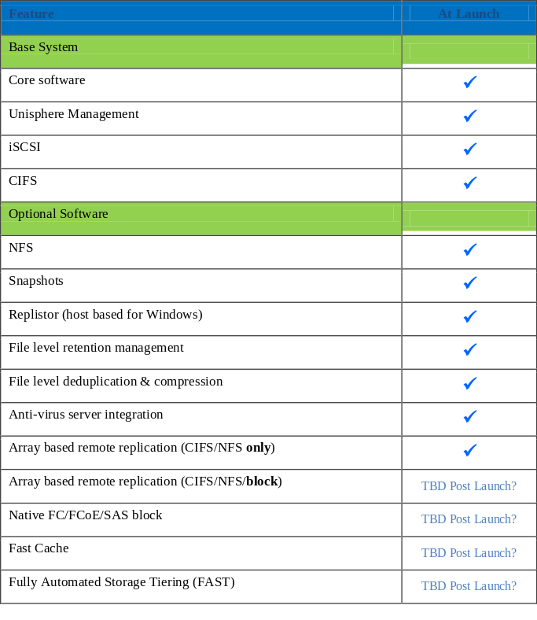
Please note Dell Compellent Model 40 was very competitive with EMC VNX 5300 prior to the arrival of EMC VNXe 3300 in 2011. If Dell Compellent has a similar model with EMC VNXe 3300, we should look at it again.

Please note that there are other SAN manufactures offering a storage system similar to EMC and Dell Compellent (e.g., StoneFly’s Voyager-6GS Scalable IP SAN appliance, and Nimble Storage, as shown below)

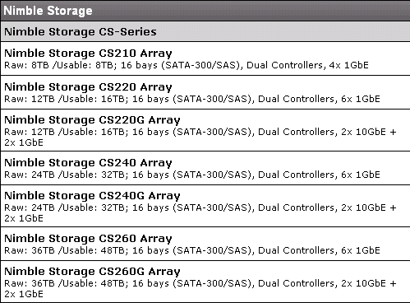

Since a virtualization relies heavily on either SAN or a unified storage (e.g., put all eggs in one basket), it is very important that we must consider all facts, as shown below:

- Meeting your business objectives (e.g., 10 GbE, instead of FC, might be able to meet 95 percent of all business objectives, plus 40 GbE is coming soon!)
- Vendor’s reputation
- Vendor’s storage price, including total cost of ownership (TCO)
- Resources, including consulting services
- Customers’ installed base
- Technical support
- Customers’ satisfaction
- Available Technical Training
- How quickly replacement of a storage administrator when a turnover occurs

In summary, make an award in the best interests of the organization after all factors have been evaluated.

Additional Readings:

- How New York City is going to Consolidate 50 Data Centers from 40 City Agencies into One Location:
http://www.informationweek.com/news/government/state-local/229219575

About Compellent
Dell Compellent Model 40 provides Fluid Data storage solutions that automate the movement and management of data at a granular level, enabling organizations to constantly adapt to change, reduce costs and secure information against downtime and disaster. This patented storage automation and built-in intelligence provides significant efficiency, scalability and ease of use.

Dell Compellent STORAGE CENTER TECHNICAL SPECIFICATIONS
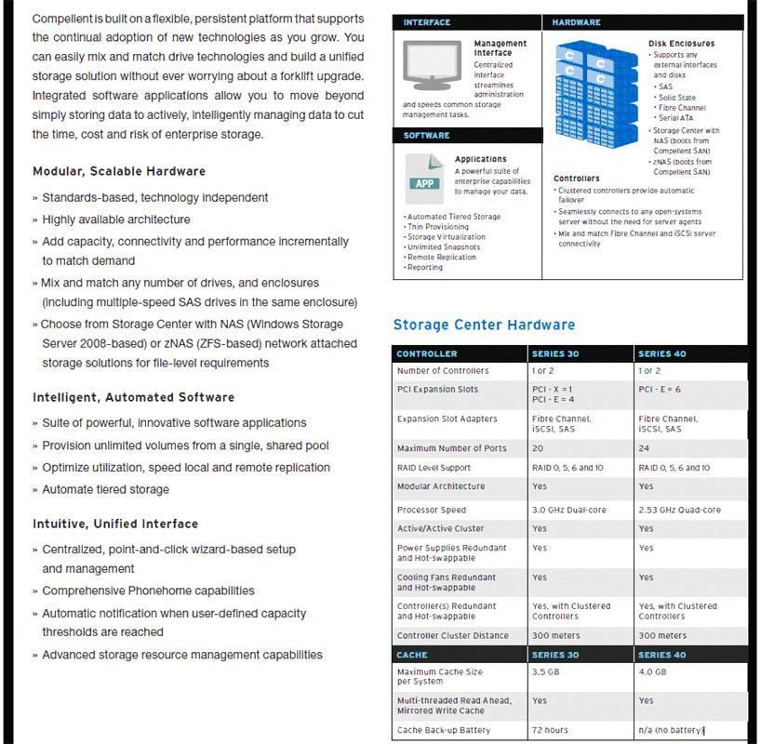
Source: Dell
About EMC (http://www.emc.com/about/index.htm)

CRN Names EMC "Company of the Year" in Three ARC Award Categories -
http://www.emc.com/about/news/press/2011/20110812-01.htm

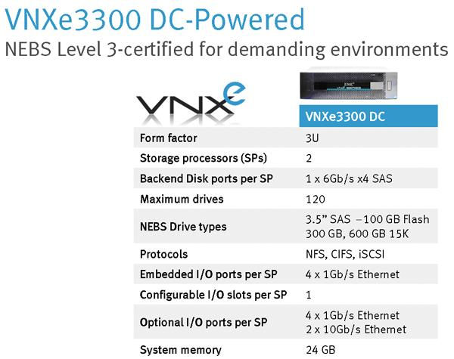
Source: EMC
Additional Reading from Government Technology

Real Value from the Cloud: Moving beyond personal productivity
Both government and industry have been fascinated by the concept of cloud computing since its inception. Now that the dust has settled and some early adopters have started to see successes – especially in the area of personal productivity applications like email, word processing and spreadsheets – government leaders are asking “What’s next?” To answer that question, the Center for Digital Government has reviewed a new landscape of more complex, enterprise-class applications that are powered by the cloud. This white paper discusses this new class of cloud solutions that is emerging, and the great promise it holds for government. Click on the link below for details:

http://www.govtech.com/library/papers/Real-Value-from-the-Cloud-Moving-beyond-personal-productivity.html

