July 8, 2012
Jeremy Li
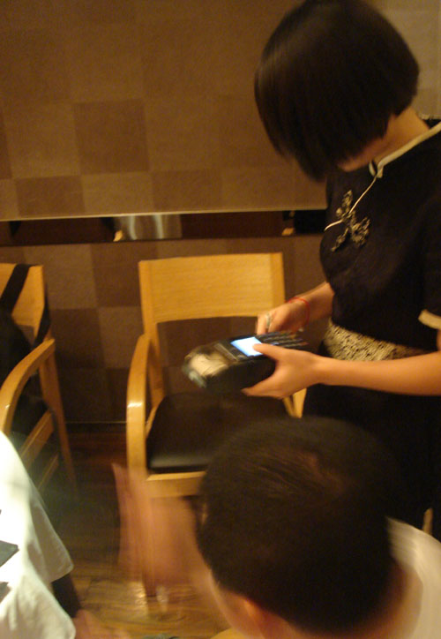
I had a dinner with my relatives and friends on Sunday, July 8, 2012 in Shanghai, China. I was impressed with an antiflaw technique used everywhere in a restaurant or other shopping places on how to pay a bill with an efficient verification process.

Here are the processes:

- A waitress came to a dinner table and swiped for a credit card.
- A customer must enter a 6-digit code to confirm the transaction.
- A small credit card device printed a receipt for a customer.
- A customer was receiving a transaction confirmation email on his/her smartphone serving as verification purpose, while a receipt was being printed.
This method will greatly reduce a flaw because a cardholder will immediately notify a bank, if a transaction is not authorized. Therefore, a bank will stop a payment to a merchant. As a result, a merchant usually will pay more attention and ask for verification during a transaction period.

You can view three pictures, as shown in this page for details.
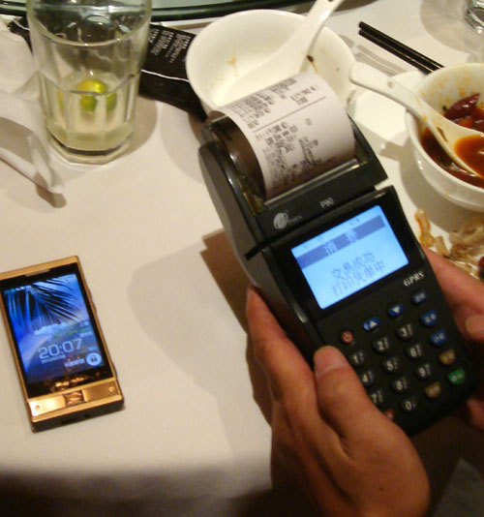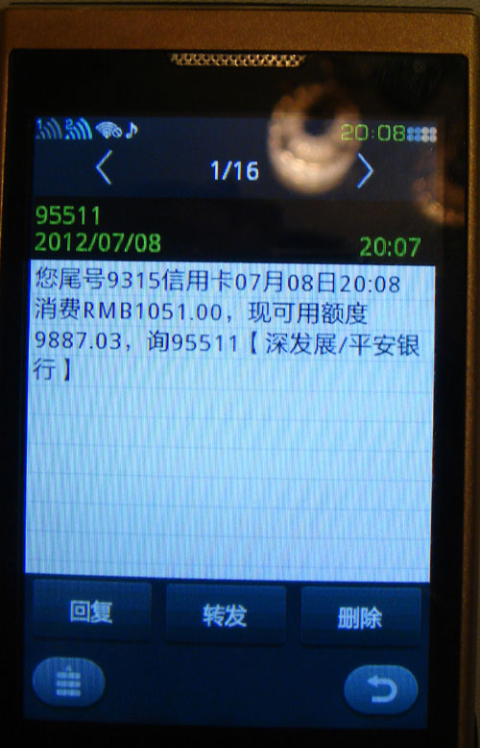
While a receipt is being printed, a customer is receiving a confirmation email on his/her smartphone serving as verification purpose.

