Jan. 09, 2013
Jeremy Li

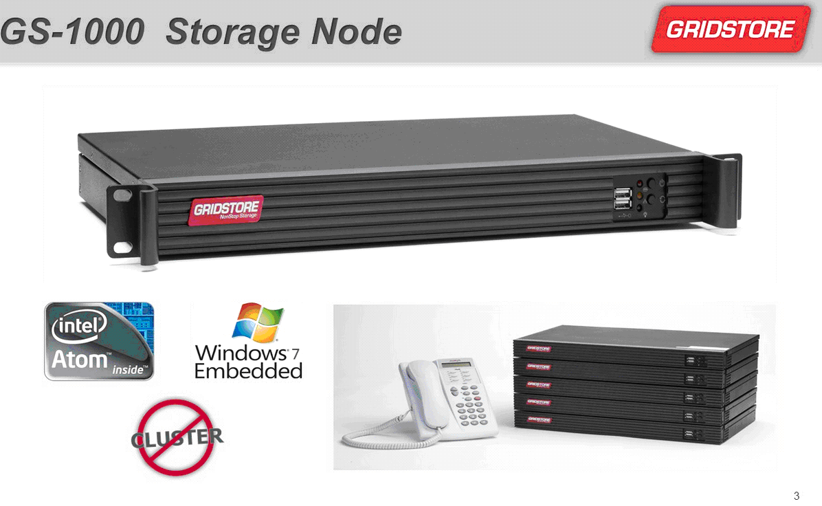
Note: Each 1U node (appliance) consumes only 25 watts with one 1GbE port.

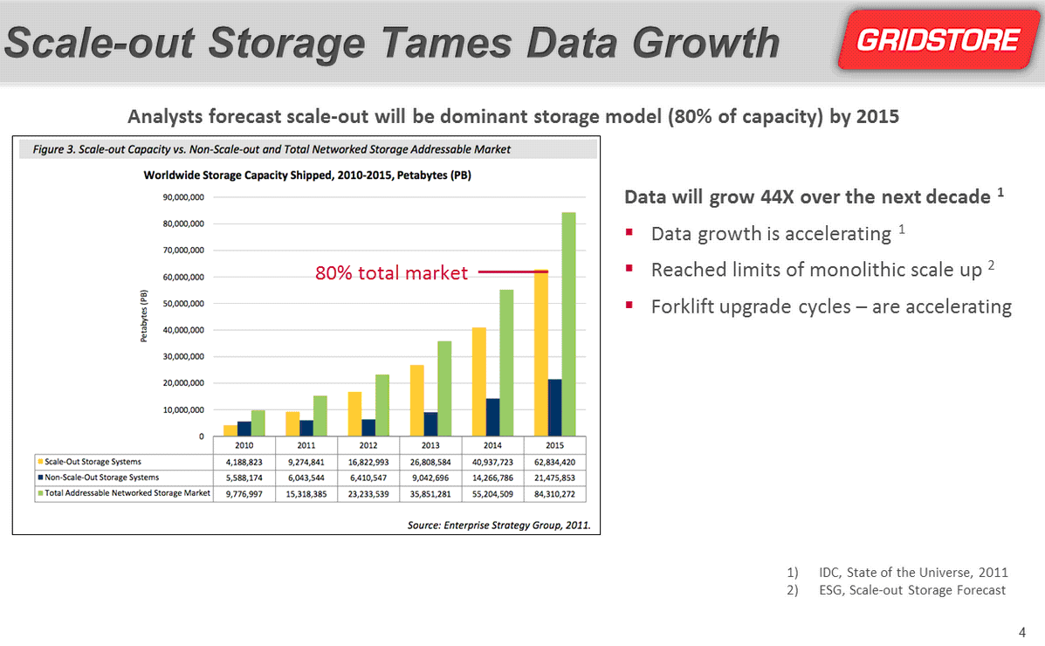

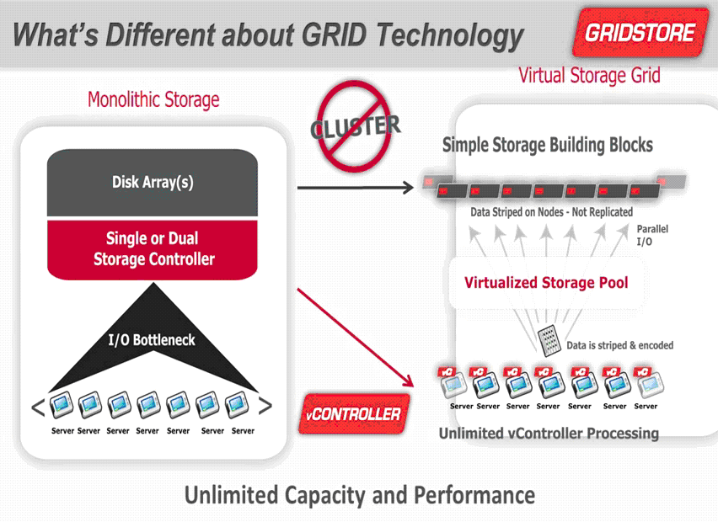
Note: Gridstore’s vController (agent) must be installed on every client (server) - a physical server and virtual machine (VM). That server connects to the storage nodes within a storage pool via its agent. Therefore, it eliminates the need for a physical controller.

Gridstore will release a newer version of the application, which will install one agent on a VMware ESXi OS once, thus eliminate the need to install an agent on each client.

Gridstore is based on Windows 7 OS and offers two models: 2TB and 4TB, as illustrated in a picture below:

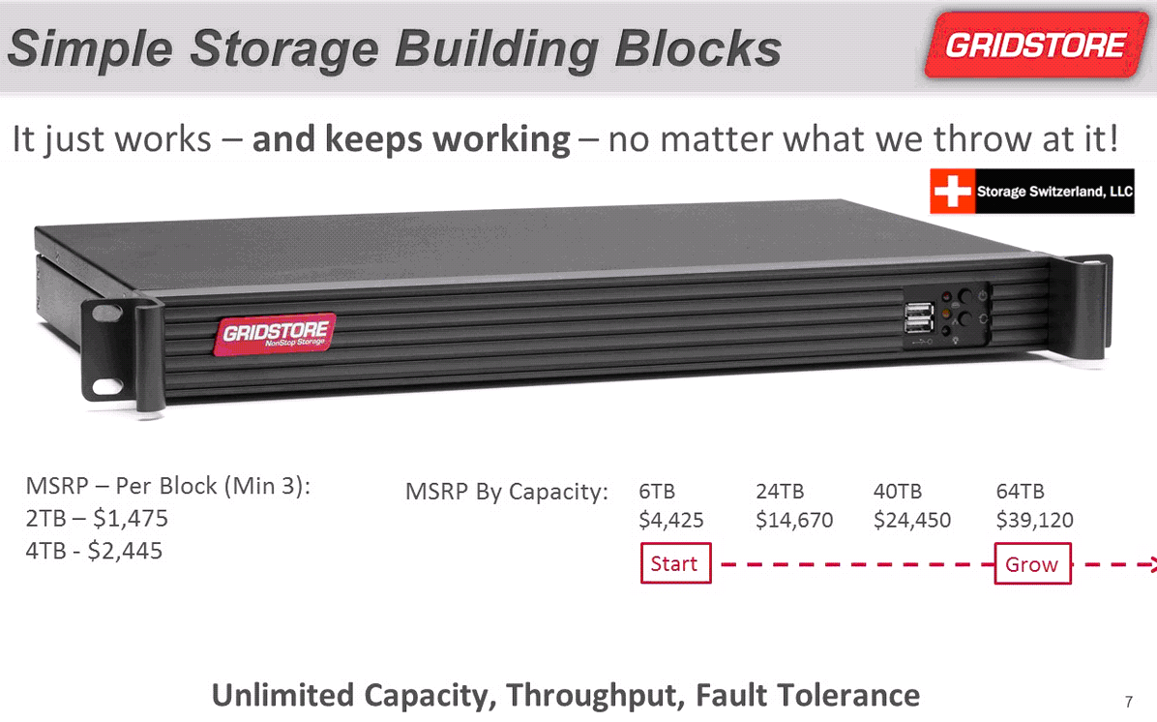

For fault tolerance, it uses a formula N/2 -1. For example, if a 12-node system is purchased, a policy can be configured to allow five (5) nodes to be down without affecting the entire system’s uptime (e.g., 12/2 – 1 = 5).

Currently, the Grid supports file level access data only, but will support block level access in the future.

It has about 40 customers in January, 2013.

Therefore, Gridstore claims that it has resolved a tradition problem with Monolithic Storage by using a technique called “storage without limits”, as illustrated in the picture below:
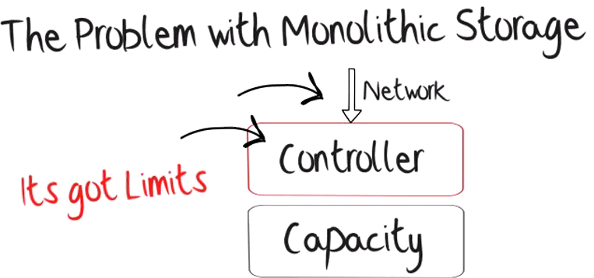

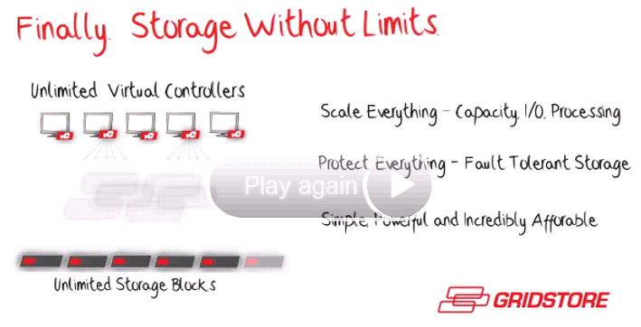

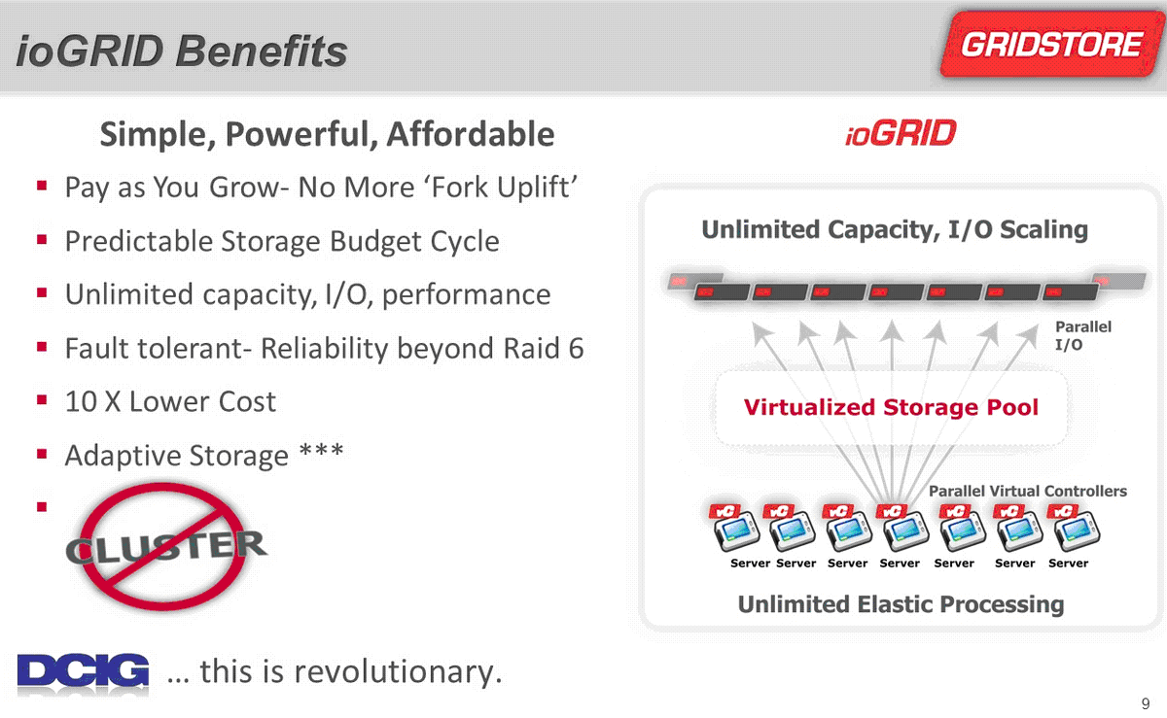



The entire grid system is based on Network Share connection, as shown in the picture below:
