July, 2012
Updated in Nov. 2013
Jeremy Li

Shanghai’s Metro – Subway Lines: (Notes Taken from Metro Line 8 and Line 4 on July 4, 2012)

SHANGHAI’S METRO is world's largest and longest metro system in terms of track mileage, and will continue to grow quickly from current 12 Metro lines (Metro 1 to Metro 12) in production to 25 Metro lines within next 5 to 10 years. Metro Line 1, designed and built by Germany, is the main north-south line of the Shanghai Metro and was the first Metro line to open, in 1995. Click here for Shanghai at a glance.

The permanent resident population in Shanghai is 23 million, which exceeds that of Australia, with a large population of working poor deserving an efficient, convenient and comfortable network of frequently scheduled buses in every 5 to 10 minutes to mesh with current 12 Metro lines (Subway lines), high-speed rail and highways. Click on the link http://www.urbanrail.net/as/cn/shan/shanghai.htm for a subway map and each subway line information.

Anyone can make a phone call; read & send emails via smartphone or tablet and text message while riding a subway or waiting at a subway station. Many Executives and managers in China can sign a document via smartphone or tablet as an official signature.

The $32.5 billion Shanghai-Beijing high-speed 819 miles long rail link (bullet trains), which was in production in 2011, marked a significant milestone to improve intercity rail systems – click on the link for details:

Note: The original plan for the Beijing-Shanghai high-speed rail link would continue using German Maglev Train after the world’s first public commercial Shanghai Maglev Train was in service on January 1, 2004. The construction of the line began on March 1, 2001. However, a negotiation between China and German failed due to German’s technology transfer refusal. As a result, China decided to use bullet trains, instead of the expensive German Maglev Trains.

The line 13 was in operation during the World Expo 2010 in Shanghai, but it was shut down for an extension at this time.
Many Metro lines have 30 stations on average. The sign in each station is very clear, while the Los Angeles MetroLink signs at Union Station (http://www.metrolinktrains.com/) are confusing, as illustrated in the picture below.
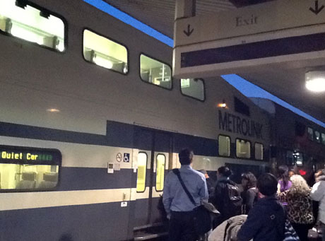
The Red Line subway sign from each station at Los Angeles is better than the sign at Metrolink Union Station (left picture), but is not as clear as a sign in Shanghai subway station, as shown in the picture below:

Next Station Current Station Last Station
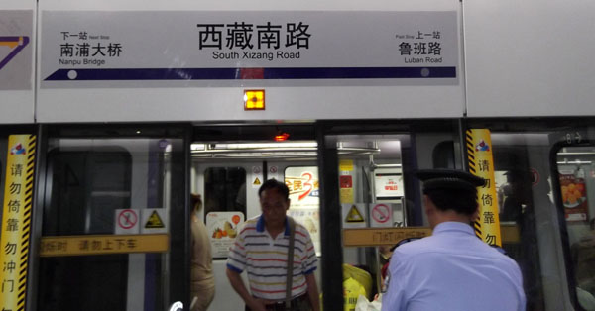
Signs are very clear at each station

At Los Angeles Metrolink Union Station Platform

It is almost impossible to have a suicide accident occurring again at each subway station in Shanghai because either full or half safety barriers are installed at each station, as illustrated below:
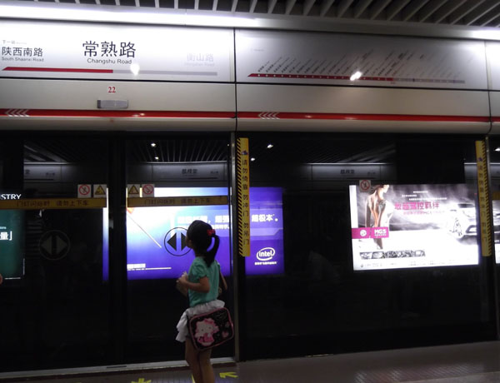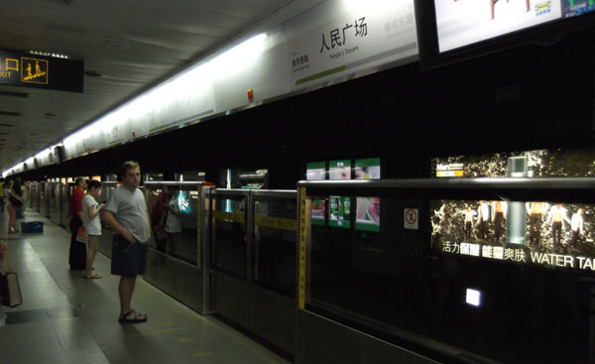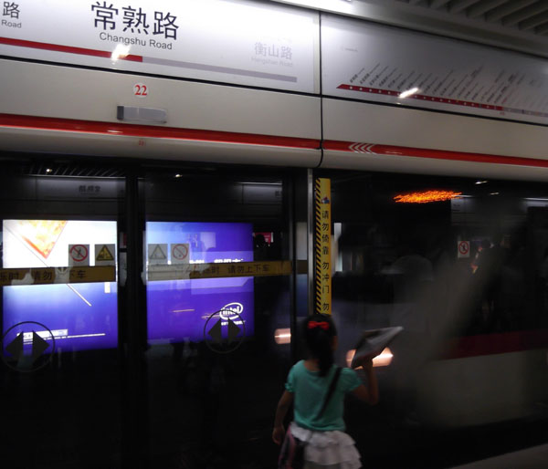
Most Metro Lines have a closed barrier Metro line 8 has an open safety barrier A train is arriving inside a barrier

- Until a train is at a full stop, a sliding door attached to the safety barrier on the platforms will not open.
- To generate revenue for the public transportation agency, many advertising signs are placed on every station

Unfortunately, there are no safety barriers separating the trains from the people on most U.S. City's subway platforms (e.g., in New York City, the largest city in the U.S. and Los Angeles City, the second largest city in the U.S.), and many people fall or jump to their deaths in front of rushing trains each year. As a result, more than 100 people are hit by New York City subways every year.
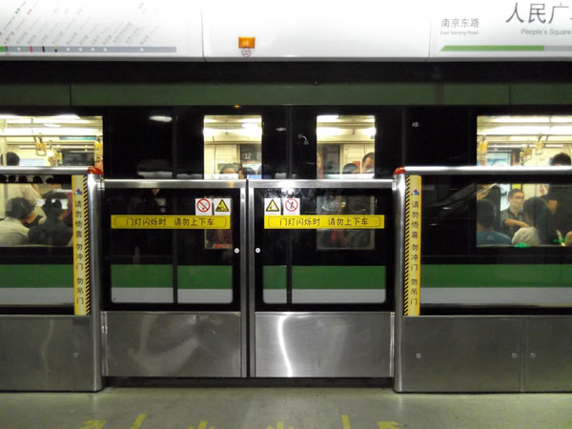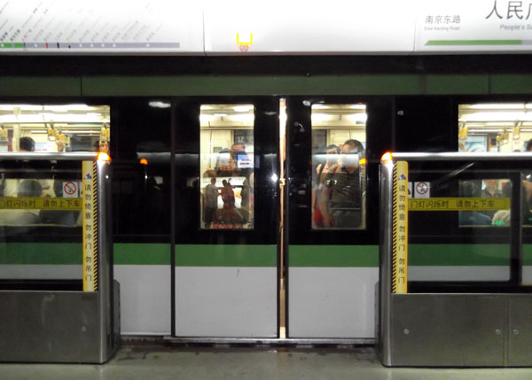
A barrier sliding door is closed until a train is at a full stop A barrier sliding door is open after a train is at a full stop

- The safety barrier, also called platform screen doors, is generally transparent walls or barriers. The sliding screen doors or gates are aligned with the train’s doors.

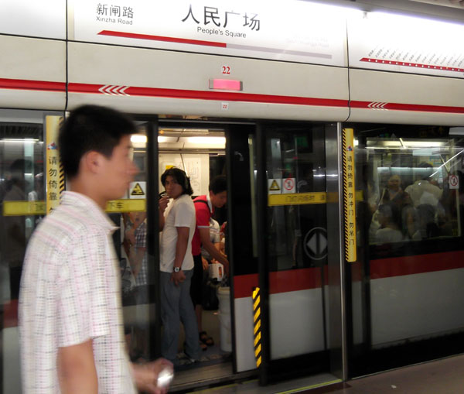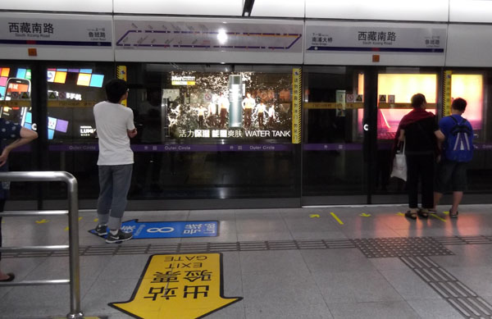
Both a subway carriage and barrier doors are closing More Signs are placed on the floor for additional directions
A Metro Map is displayed on top of every entrance door (e.g., a sign for Subway Line 8, a sign for EXIT GATE etc.)

You can go many places easily (e.g., the Huangpu River or Shanghai World Financial Center, as illustrated in three pictures below) with subway systems by using a subway map.

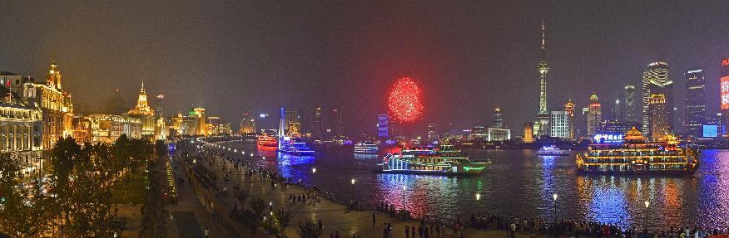
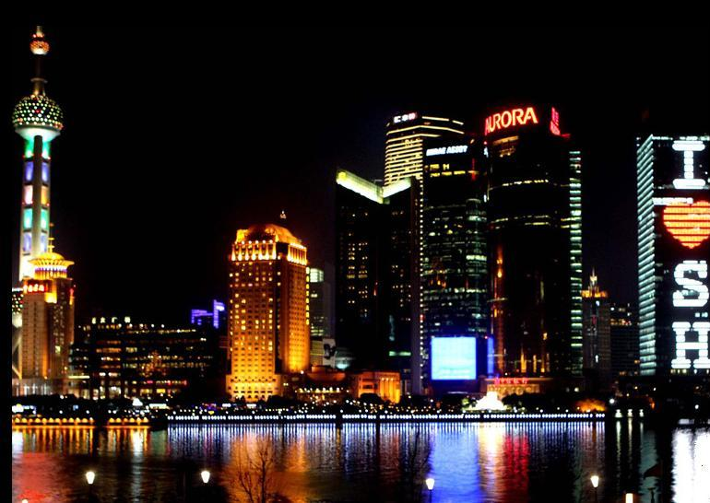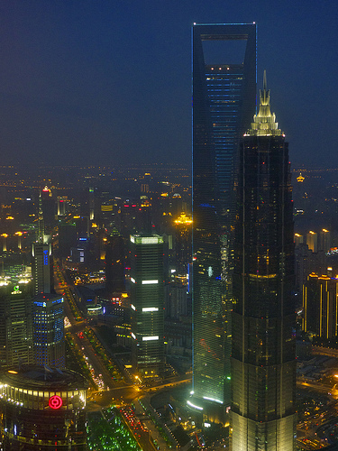
Huangpu River Shanghai World Financial Center

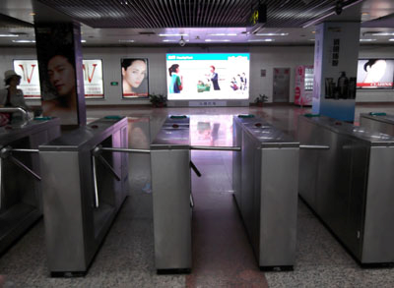
The TAP systems are installed at each station, shown in the picture (left)
When entering the TAP system, you tap the ticket against a scanner above the turnstile. When you exit the TAP system, you tap the ticket against a scanner again to get the actual fare deducted from the TAP ticket (card).

The Tap Systems in Shanghai
- A LED Map is placed inside a subway carriage, shown in the picture below:

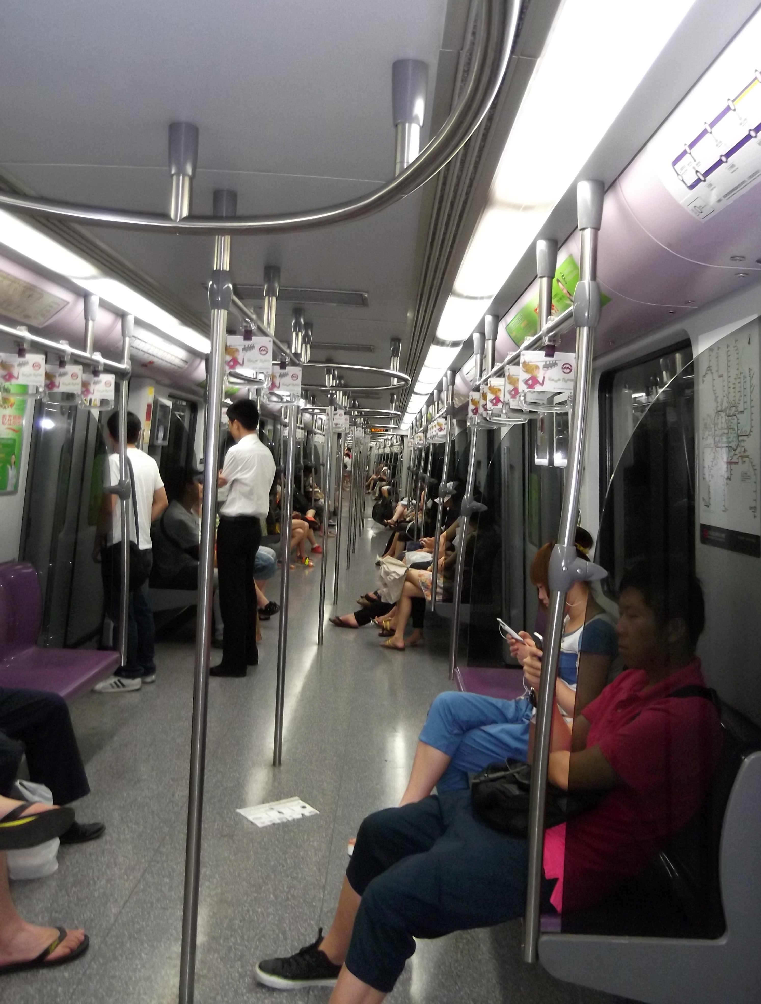  Inside a subway carriage on Metro Line 8, July 4, 2012 | 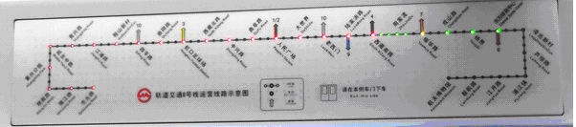  A LED Map is displayed inside a subway carriage  Note: A red dot color represents a past station. An amber dot color represents the forthcoming next station. The flashing and growing green color of moving dots (e.g., in this case, four green dots) between a red dot color and amber dot color represent “A train is moving toward next station”, and will be disappeared when a train stops.
Additional info can be obtained by clicking on the link.

China's high-speed railway will exceed 10,000 kilometers that is nearly half of the global total by the end of 2013 and is expected to hit 18,000 km by 2020.

Appendix (Beijing Metro – Subway Lines):

Beijing, capital of China, will put four subway lines into operation by the end of 2012 as part of the city's efforts to expand rail transit to ease severe traffic congestion. This will make Beijing the longest subway system in the world. The new lines will bring the number of subway lines in the city to 16, with a total length of 275 miles. That will add the city's total subway transport capacity to over 9 million passengers per day, while the city’s public transport system carried an average of 20.6 million people per day in 2012. By 2015, the number of subway lines in the city will reach 19, with a combined length of 349 miles. Most importantly, the new four subway lines will be completed within two to four years or by the end of 2012 (e.g., a $32.5 billion Beijing-Shanghai high-speed rail link took only three years to put the bullet train rail into operation after construction began), while most western countries often spend decades of times conducting an environment study and going through multiple lawsuits to prevent a new subway line from starting construction. Checks and balances are good for modern governments, but too much unreasonable fighting for reasons such as environmental damage or inconvenience for a small group has generated additional expenses that have far exceeded the original estimated cost for building a public transit. If this public transit were built, it would have reduced traffic congestions for most citizens and daily commuters, and saved hundreds of hours of productivity each year.

Note: In Oct., 2013, there are 17 subway lines running in Beijing with a total length of 456 km. The city's subway system carries approximately 10 million passengers daily on workdays.

The six lines, with a total length of more than 90 km, are expected to be operational by the end of 2016, bringing the city's total track length to more than 600 km, and reach 1,000 km by the end of 2020, according to the Beijing City Subway Construction Management Company.

In 2002, Beijing had only two lines with a track length of 54 km.

Leisure Reading:

36 Hours in Shanghai by the N.Y. Times where a traveler can take subway lines to any places mentioned in the Times.

