March 19, 2013
Jeremy Li

Credit: Aruba Presentation on Competitive Advantages, Clearpass and Airwave

Aruba Networks, (http://arubanetworks.com/) has about 2,000 employees and over 27,000 customers worldwide with 500 million revenue in 2012, and projects having 700 million revenue in 2013 due to massive Bring-Your-Own-Device (BYOD) explosion. It provides wireless (Wi-Fi) solutions at the access (edge) of the enterprise network and listed as a leader in Gartner’s Magic Quadrant for the Wireless LAN Access Infrastructure in 2011 and Magic Quadrant for the Wired and Wireless LAN Access Infrastructure in 2012.

Aruba Networks claims that New York School District, the largest Unified School District in the nation has successfully implemented AirWave (Centralized Monitoring and Management) to manage its Cisco network. The entire Calif. State University System (except San Jose campus) which is the largest public university system in the nation has successfully implemented its AirWave and Aruba Networks wireless on all campuses.

Recently, Aruba Networks was selected for management and BYOD using AirWave and ClearPass (Multivendor Identity-based Access Management) in one of the largest school districts in the nation with over 1100 schools supporting over 750,000 students.

Note: San Jose, Calif., Launches Fast Public Wi-Fi (Source: GovTech)
http://www.digitalcommunities.com/articles/San-Jose-Calif-Launches-Fast-Public-Wi-Fi.html

AirWave has the following features:

- Network-wide visibility
- Root-cause analysis and reporting
- RAPIDS rogue Access Point (AP)/client detection
- Easy-to-use interface
- Real-time wireless heat maps and location tracking

ClearPass offers a comprehensive workflow by following three steps:

- Onboarding the device
- Invoking a Policy
- Enforcing Policy via switches or WiFi devices

ClearPass with WorkSpace can deliver “One place to mange all things BYOD” and applies contextual data – user roles, device type and ownership, app usage and location – to policies that extend across the network to devices and app. Click on the link below for more details about ClearPass that supports 40 Mobile Apps (e.g., Box) as of today:
http://www.arubanetworks.com/solutions/bring-your-own-device

With more than 85% of the worlds companies having an imbedded Microsoft Infrastructure and utilizing Exchange Servers, Aruba is the only vendor that was certified by Microsoft for Lync integration.

Many cutting edge technology companies in the world like Google, Facebook, Yahoo, Microsoft and SAP have chosen Aruba wireless networks due to its reliability, security and flexible architecture, although money is not the primary factor for them in selecting a wireless vendor. They tested Aruba WiFi network against Cisco and all of them decided to choose Aruba Networks for mobility.

Note: Aruba can query and monitor Cisco and HP on Airwave for reporting and monitoring, but no vendor can support another vendors’ AP with its controller. Therefore, a single vendor solution will be applied for a wireless network within a building in most scenarios.

A formal presentation comprises of many subjects listed below:

Aruba Controller vs. Cisco Controller:

Aruba Controller comprises of a firewall (FW), VPN Concentrator and Wireless Controller components while a Cisco equivalent requires two devices: 1) Cisco Controller, and 2) ASA Series Next Generation Firewall and VPN. A customer must purchase two separate Cisco devices in order to manage the wireless network in the same capacity as a single Aruba Controller that, in turn, leads not only to reduced power and rack space consumption, but also less complexity in wireless deployment in data centers.

Aruba’s marketing message is “Aruba Networks MOVE architecture is all you need for mobility initiatives at lower costs including labor and equipment.”

In addition, Aruba’s Instant WiFi AP’s includes Wireless Intrusion Prevention System (WIPS), which has no additional cost in licenses. On the other hand, Cisco needs another box called Mobility Service Engine (MSE) acting as WiFi controller.

- Aruba One Manager vs. Cisco Five Managers

Aruba’s approach is to get rid of multiple complexities by combining five networks (and their respective device managers) into one role based access network to centrally manage the mobile devices. As a result, this approach dramatically reduces the Total Cost of Ownership (TCO), while Cisco’s solution comprises of many individual equipments with dedicated IT professionals for each area in order to manage each field, as illustrated in the screenshot above.

The following slide was displayed during the presentation:

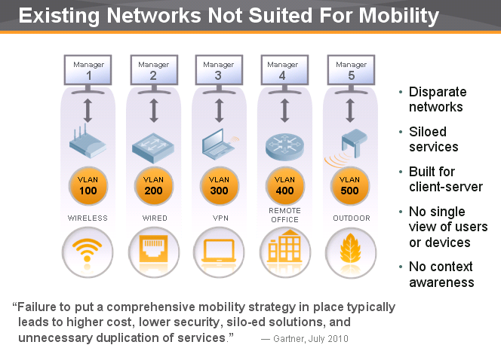
Courtesy of Aruba Networks

Gartner introduced the idea of "Total Cost of Ownership" (TCO) in 1986, and realized that acquisition costs of hardware and software products are only part of the total costs that comprise of the sum of all costs related to the usage of specific product that has to be taken into account, as illustrated in the pie chart from left:
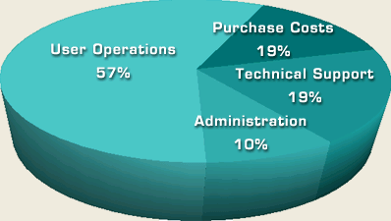
Source: http://www.alligatorsql.com/solutions/tco/index.jsp

Aruba claims that it can achieve 70% reduction in WiFi Access Network in term of the TCO.

- MOVE Mobility-Centric Access Architecture
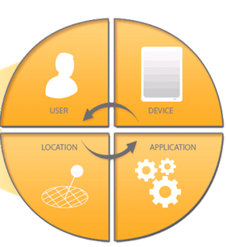
With Aruba’s Mobility Controller, AirWave and ClearPass can manage any device by enabling enterprise IT organizations to easily roll out mobility services for different group of users without having to create different networks for different user groups.

Aruba Move Architecture comprises of

- Open BYOD Framework Strategy
- Enforcement Across Any Network Type
- Device Profiling
- Multi-point Access Visibility
- Secure and Highly Scalable

- Quality of Services (QoS)

Cisco uses a traditional approach (VLAN and Port number) for QoS:

- Only provisions one class of service (e.g., Video, VoiP, VDI and data) per device at a time
- QoS is designed on wired LAN access only, but not really on wireless LAN access because it can only support one class of service, thus, the QoS is blind to applications, as illustrated in the screenshot below:

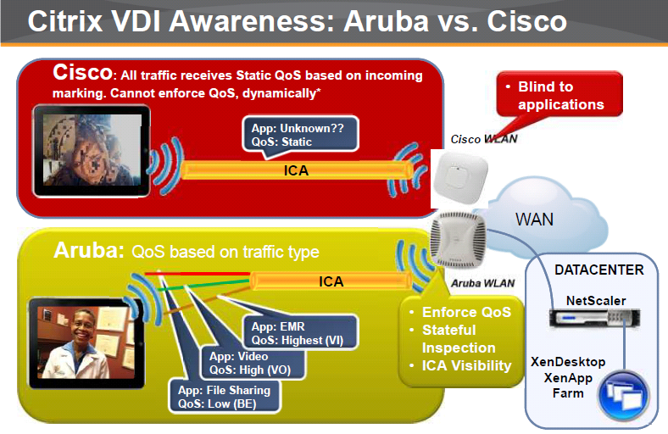
Courtesy of Aruba Networks

- Can not enforce different QoS settings on one device for different applications at once. As a result, it treats all applications and class of services in the same way, and thus, leads to no QoS
- VLAN assignment for access control performed per SSID
- Each network access policy is manually configured per VLAN
- Different network configuration for different user groups

Today, the world is facing converged devices. That's the real problem for Cisco that must use multiple SSIDs to deal with multiple applications. Instead of VLAN and SSID configuration for each type of user group, Aruba allows the role of the users within the organization to automatically define the access policies assigned to them as they access the network.
- The Largest WiFi Deployment in the Department of Defense (DoD)

Aruba Centralized Encryption Architecture is simply the most secure in the industry according to Aruba’s presentation. For example, the primary reason why the DoD has chosen Aruba is due to its better security and openness.

Wireless LAN access uses the shared media and most traffic should be encrypted in the format of WPA or WAP2.

Cisco: Uses a proprietary version of a standard protocol Lightweight Access Point Protocol (LWAPP) as a tunnel mechanism. It is less secure than IPSec method.

If a payload (data) is transmitted via WPA or WPA2 format (both formats are encrypted), the payload sending from the AP to a controller via LWAPP is still encrypted via WiFi Tunnel. As a result, using the LWAPP should be still okay for data moving from an AP to a controller in most scenarios.

However, the management and control frame is not preserved if LWAPP is used as it is decrypted at the AP and then forwarded via LWAPP. Cisco does not support centralized encryption.

Note: Lightweight Access Point Protocol (LWAPP) is the name of a protocol that can control multiple Wi-Fi wireless access points at once. This can reduce the amount of time spent on configuring, monitoring or troubleshooting a large network. The system will also allow network administrators to closely analyze the network (Source: Wikipedia)

Many enterprises are considering or have been discontinued the IPSec VPN Network by switching to SSL VPN. SSL VPN provides enhanced security and privacy capabilities, functionality, and is their preferred technology for providing secure remote access.

Aruba: Uses a standard IPSec, instead of LWAPP. The IPSec method encrypts everything or more secured. All traffic between an AP and a controller are not decrypted until the data reaches the controller with a centralized encryption model. Therefore, tap is not possible.

As a result, the DoD has chosen Aruba due to its IPSec used for its wireless network deployment. This is because the DoD environment requires everything should be encrypted and the highest level of security is demanded.

- Controller Capacity vs. Power and Rack Space Savings

New Cisco Controller 5760 supports about 1000 APs, but can not support multiple applications on a single device, while Aruba 7240 Controller supports 2048 APs and is able to support multiple applications on a single device.
Note: A customer needs to buy four Cisco older model of WiFi controller 5508 in order to meet the capacity of one Aruba 7240.

- Role Based Support (One Controller vs. Two Controllers)

Aruba one controller can support role-based enforcement, while Cisco needs to rely on a second device called the Cisco Identity Services Engine (ISE) in order to support the role based enforcement that governs network with central policy enforcement. Therefore, two Cisco solutions must be purchased.

As a result, the second device (ISE) will add another layer of complexity and support cost. In addition, it creates additional single point of failure unless a clustering method will be implemented. That, in turn, will add additional complexity, support cost and training cost besides more power and rack space will be consumed.

Take one user for example: there is only one (1) SSID required to control the user’s access in Wi-Fi LAN. Aruba role-based policy enforcement for mobility is based on a user’s logon account (who he/she is). Based on a given user’s role, the QoS, security access, etc can be determined without relying on multiple separate VLAN’s. Aruba can also do it even on a device, location or application.

Below is a summary of Policy Enforcement for Mobility from Aruba solution:

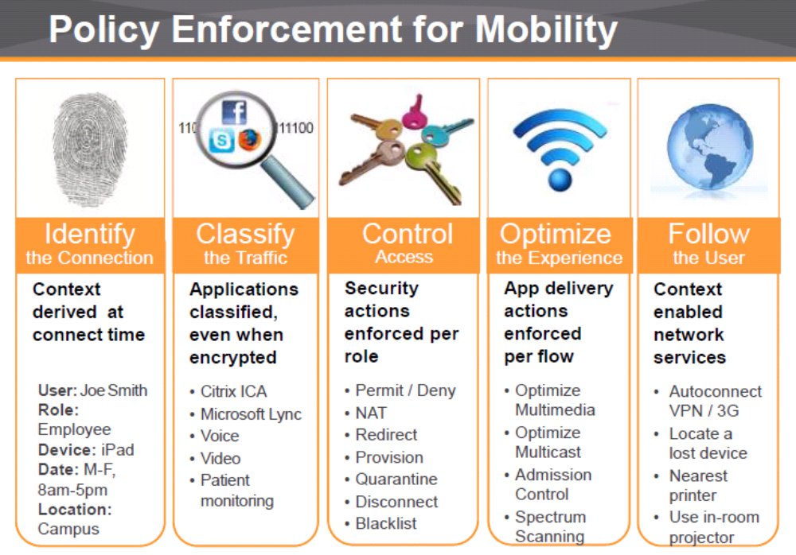
Courtesy of Aruba Networks
- Virtual Controller (Instant AP)

Each Aruba AP can act both AP and a controller (virtual). Instant AP is a Virtual Controller (VC). You configure one AP per subnet, and then, use the 1st AP (VC) configuration file and software to be pushed to all remaining APs on the same subnet. This greatly reduces the deployment and ongoing maintenance costs. There are no subscription fees and all licensing is built into the AP thus reducing cost and complexity exponentially. Also all Instant AP’s can be converted into CAP’s (controller based AP’s) with one command.

- Tracking Where Is the Mobile Device

A live demo showed that the AirWave network management application is able to quickly identify where the mobile device located, as illustrated in the screenshot below, including where the device was traveling in the last four or eight hours etc.

An example was given by using USC as a showcase: how USC police was able to find a stolen laptop quickly in a dorm by using its AirWave application to pin point the location of the stolen device. USC has deployed Aruba wireless over its entire campus which translates into approximately 6000 Aruba APs on its campus.

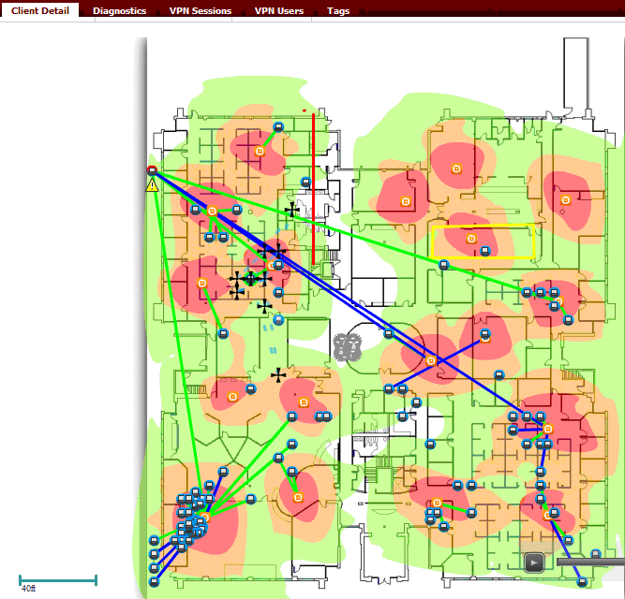

- Cisco Clean Air vs. Aruba Spectrum

Cisco calls the name as Clean Air, while Aruba calls it as Spectrum. Both are the same to recognize WiFi interference (e.g., home microwave will interfere with WiFi access)

- 2.4GHz vs. 5GHz
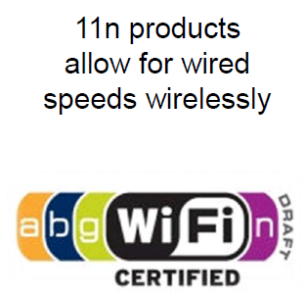
- 2.4GHz will be only used for legacy applications.

- The 5GHz APs are highly recommended for 802.11n deployment due to larger spectrum with 11 channels as well as allowing for wired speeds wirelessly, as illustrated in the screenshot from left and below:

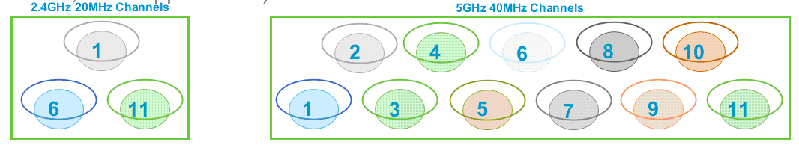

- Redundancy (N+1) and Active/Active Support

In terms of redundancy, Cisco does not support either Active Active or N+1 design on their controllers. Therefore, most customers have no choice to buy an additional controller appliance for each controller that gets very expensive once a large wireless deployment takes place.

Aruba supports Active/Active and uses N+1 for redundancy.

- 802.11ac vs 802.11n

The next-generation 802.11ac architecture is the first Wi-Fi technology that can really allow for wired speeds wirelessly and has a throughput at 1.3Gbps vs. 802.11n at 456 Mbps. That is 3X performance gain over 802.11n. Thus, users can enjoy faster performance with higher client density per AP.

The new comer Ubiquiti Networks, Inc. (www.ubnt.com/) with the first 802.11ac technology (UniFi-AP AC) beats three leading 802.11n vendors (Cisco, Aruba and Ruckus) in performance test within 15 feet. However, the wired performance can be only retained within 15 feet per Aruba. When the distance between a Wi-Fi client and an AP exceeds more than 15 feet, the performance will drop significantly. As a result, the first generation 802.11ac does not have a great advantage (e.g., 3X performance gain) than the current 802.11n competitive technology between 24 feet and 50 feet, although it can deliver up to 46% faster upstream throughput, and up to 48% downstream throughput with single client on average, using 802.11ac, than offerings tested from Aruba, Cisco and Ruckus - Source: Tolly Report #213122 titled “Ubiquiti Networks UniFi-AP AC 802.11n & 802.11ac Rate/Range Comparative Performance Evaluation vs. Aruba Networks, Cisco Systems & Ruckus Wireless“dated March, 2013.

Note: The first generation of the 802.11ac acts like a hub while the second generation 80211ac will act like a switch, but it is 2 or 3 years away from today.

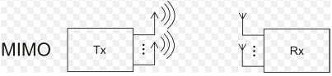
The second-generation of the 802.11ac will have Multi-user MIMO (MU-MIMO) in comparison with the first-generation of the 802.11ac that only supports MIMO (multiple-input and multiple-output), as illustrated in the screenshot on the left:

Source: http://commons.wikimedia.org/wiki/File:Prinzip_MIMO.png

- Multiple Windows Domain and Single Sign On (SSO) Support

Multiple Windows Domain Support:

Aruba supports it while Cisco does not.

SSO Support:

Aruba supports SSO while Cisco does not.

Note: Aruba can support SQL Database with Authentication (Who are you) and Authorization (What right do you have) - Aruba can talk to SQL DB directly and bypass Active Directory authentication while Cisco controller can not talk to SQL DB directly.

Conclusion and Recommendations

Aruba has a robust AirWave network management application that supports multi-vendors wired and wireless network platform, and ClearPass that supports multivendor identity-based access management devices.

Aruba Controller comprises a clear set of an ICSA (Inter-Collegiate Sailing Association) certified stateful firewall (FW), VPN Concentrator and Wireless (WiFi) Controller component including Wireless Intrusion Prevention System (WIPS) at no additional cost in licenses.

Aruba MOVE Architecture comprises of Mobility Controller, AirWave Network Management and ClearPass Multivendor Identity-based Access Management. Any mobile devices can be controlled via its thin access on-ramps (Wireless, Wired, VPN, Remote Office and Outdoor.)

In order to deploy a large amount of APs in the public sector, Aruba may need to consider partnering with an IT organization from the private sector that has successfully deployed and been managing a large amount of APs in order to ensure that there would be no chance of human error or misconfiguration of its Wi-Fi products.

Often, CIOs in any organization(s) are being asked to do more with fewer resources, less time and less funding, and transform and guide an enterprise into a lean organization. Therefore, carefully examining its internal IT operations and efficiency, including using available technology in new efficient ways, often leads to trim many hidden costs and yields greater flexibility to focus on core business and pursue the innovation.

Challenge

Cisco is still number one incumbent market share leader in the enterprise based on both wired and wireless platforms. Cisco’s new marketing theme is “One Policy, One Management and One network”. With Cisco network in majority enterprises, it is very difficult to convince IT decision makers to select an alternative solution unless Aruba can win the price war over Cisco and show customers that its solution has the lower total cost of ownership than Cisco’s.

The estimate for Cisco’s WiFi market share is between 55% and 60%, Aruba 13% and15%, Motorola 8% and 9%; Ruckus at about 4% and the remaining small WiFi vendors at 10%.

Per Aruba, the percentage is changing constantly. Aruba has been eating at Cisco’s market share and reached #2 position in the market share due to its simplicity and affordable licensing price.

Recommended Reading

1. New York Gov. Andrew Cuomo says the state will consolidate about 50 data centers at the State University of New York. (Source: GovTech)

http://www.govtech.com/e-government/New-York-State-SUNY-Partner-Data-Center-Consolidation.html

2. Android and iOS Combine for 91.1% of the Worldwide Smartphone OS Market in 4Q12 and 87.6% for the Year, (Source: IDC)

http://www.idc.com/getdoc.jsp?containerId=prUS23946013#.UVHuGxcpLE0

- Android Tablet Shipments Predicted to Surpass iPad Shipments in 2013

http://www.iclarified.com/28154/android-tablet-shipments-predicted-to-surpass-ipad-shipments-in-2013

- State of Texas Moves More Than 100,000 State Employees to Microsoft Cloud

The State of Texas is moving more than 100,000 employees onto Office 365 at a cost of about $3.50 per user, per month, making it the largest statewide deployment of email and collaboration services in the U.S.

http://www.microsoft.com/en-us/news/Press/2013/Feb13/02-15TexasO365PR.aspx

- How New York City is going to Consolidate 50 Data Centers from 40 City Agencies into One Location

http://www.datacenterknowledge.com/archives/2011/03/01/nyc-opens-consolidated-data-center/

- The Android Boom? (INFOGRAPHIC)

http://www.govtech.com/infographics/The-Android-Boom.html (Source: GovTech)

Acknowledgement - Thank Loc Ta for his time to present an Aruba Overview, and Dave Stoddard for performing a live demo of AirWave.

