Oct 30, 2013
Jeremy Li

Evaluation of HP3PAR 7400

HP introduced a newer model of 3PAR StoreServ 7000 Series for Enterprise Storage: 7200, 7400 and 7450 arrays in November, 2012.

According to the DCIG 2014 ENTERPRISE MIDRANGE ARRAY BUYER'S GUIDE, HP earned the "Best-In-Class" Ranking among enterprise midrange arrays, while EMC VNX earned the ““Recommended” Ranking. It has replaced many competitors' high-end storage arrays at a lower acquisition price.

HP is a Fortune 500 company and has nearly 350,000 employees globally and delivered the HP 3PAR StoreServ 7000 Series in December, 2012.

HP 3PAR 7400 is the best new technology in the storage market today because it was designed for today’s virtualized environments and is optimized for cloud deployments. However, ease of use, performance, and cost savings features are valuable to all customers. Below are a few highlights:

- 3PAR Thin Provisioning - Industry leading technology to maximize storage utilization

- Via Thin Guarantee. HP guarantees that 3PAR StoreServ 7000 customers can double VM density in VMware environments.

- 3PAR Autonomic Storage Tiering – Automatically optimizes using multiple classes of storage

- 3PAR Virtual Domains – Multi-tenancy for service providers and private clouds

- 3PAR Dynamic Optimization – Workload management and load balancing

- 3PAR Mesh-Architecture – Advanced shared-memory architecture

- A single array can be scaled out to 4 mesh active/active hardware-based 4th generation ASIC (Figure 2) controllers up to 864TB, and soon 1.2PB

- Thin Built in Zero Detect – It is almost like inline dedupe. That’s why HP guarantees its customers a 50% storage savings

- The starting list price is under $45,000 due to its famous Massively Parallel Architecture (MPA) – using small form factor (SFF) SAS drives 10K RPM that can outperform its competitors’ large form factor (LFF) SAS drives 15K RPM that is more expensive than SFF SAS drives at 10K RPM

- Virtual Volumes, as illustrated in the Figure 1, alone with Autonomical Wide-striping across Logical Disks (LDs), also known as “Disk Striping” at 128KB block size across all available disks (HDDs), are the keys to form a massively parallel architecture from HP 3PAR, which automatically spreads all workloads over all internal disks resources. As a result, the MPA can deliver higher and more predictable levels of performance with high IOPS, low latencies and full capacity utilization.

- The MPA can give customers higher VMs per Host ratio. For example, HP guarantees customers: 20:1 ratio on its HP 3PAR 7000, targeted for a mid-range storage customers with tier 1 capability usually from EMC vMAX storage.

- Integrated XOR Engine that creats parity information quickly under the hardware-based acceleration - XOR is used in RAID 3–6 for creating parity information. For example, RAID can "back up" bytes 10011100 and 01101100 from two (or more) hard drives by XORing the just mentioned bytes, resulting in (11110000) and writing it to another drive. Under this method, if any one of the three hard drives is lost, the lost byte can be re-created by XORing bytes from the remaining drives. For instance, if the drive containing 01101100 is lost, 10011100 and 11110000 can be XORed to recover the lost byte. (Source: Wikipedia).

- Tightly VMware integration because the VMware ESXi OS was developed on the 3PAR storage from the very beginning.

Architectural Attributes
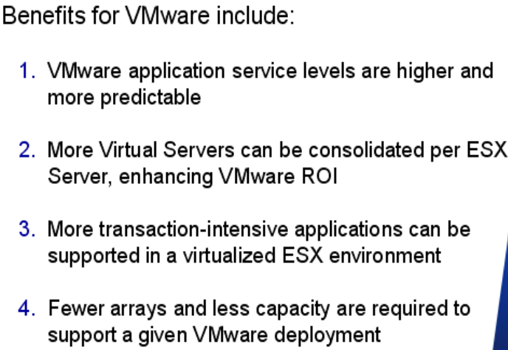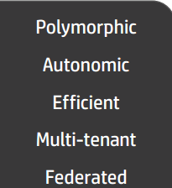

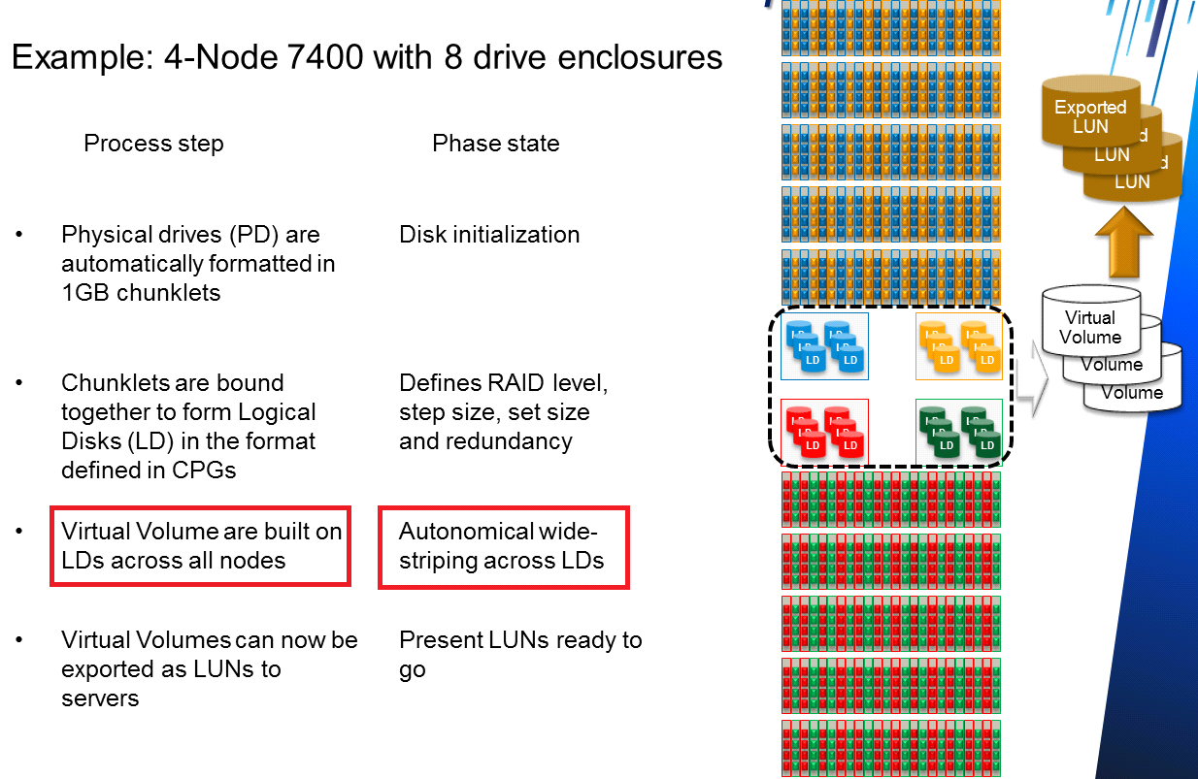
Figure 1 Autonomical wide-striping across all available logical disks

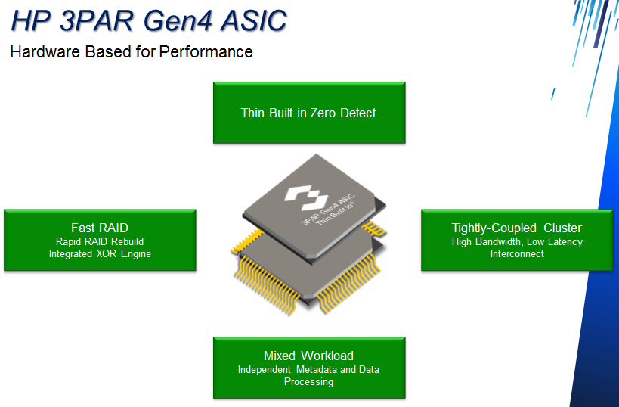
Figure 2 HP 3PAR 4th Generation ASIC

That’s why 6 to 8 out of top 10 hosting companies choose HP 3PAR.

Disk Striping and Virtual Volume

Most storage vendors use Disk Striping technique in order to boost the storage performance. However, this technique is not good enough in today’s storage.

The 3PAR MPA delivers the great storage performance and reduces a failed drive recovery time from days to hours. As of today, HP 3PAR, Dell Compellent and IBM/NetApp E-Series storage with DDP enable, are only a few vendors who can recover a failed disk from days to hours with a 3TB HDD at the 80% capacity full. The more HDDs in the HP 3PAR system, the lesser recovery time will be because 3PAR system spreads all workloads over all internal disks due to its MPA regardless whether a RAID level with 16 drives or 24 drives is configured. This is because the exported LUNs are based on a Virtual Volume that is built on Logic Disks across all nodes detailed in Figure 1 above.

The Rebuilding Time from a Failed Drive

A typical rebuilding time from a failed drive will take from 3 days to 5 days in most storage vendors’ system. IBM DCS3700 and DS3500 can reduce the rebuilding time from days to hours. Click here for details.

However, many other vendors’ rebuilding time for a failed disk drive will be much longer since they do not have the capability of either DDP or spare chunklets from HP 3PAR or Dell Compellet. Below, a screenshot illustrates a traditional RAID rebuilding method vs. a parallel rebuilds method:
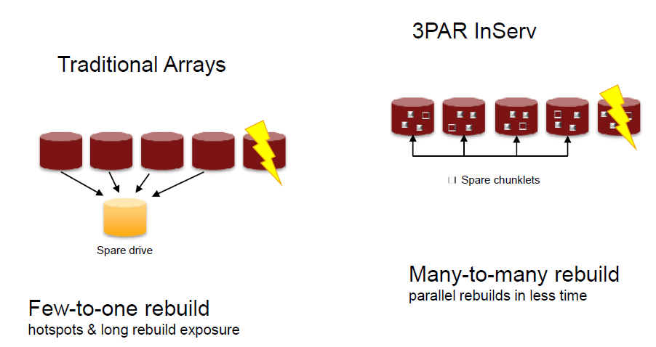
With the DDP or Chunklets method, a dedicated parity disk drive is no longer used to recover data from a failed drive. Therefore, a bottleneck due to a hot spot from a dedicated parity drive after a new drive is inserted into a storage system is eliminated.

Below are summary of HP 3PAR advantages over other Storage Vendors:

HP 3PAR from 7200 series to 10000 series can archive “Polymorphic Simplicity with One Architecture: One Operating System, One Interface and One Feature Set.

Click here and there for a comparison among HP3PAR, EMC VMAX and VNX (Source: HP). Good news: EMC is going to release ALL FLASH products based on XtremIO (XPECT MORE) to help enterprise(s) to increase the storage performance and IT resource utilization, in turn, reduce the TCO.

Big Data (Hadoop) with Scale-out Storage (NAS)

HP claims it has the best Hadoop platform in the world. However, HP may not have a good scale-out NAS EMC Isilon has claimed the title per Gartner report and IDC MarketScape Names EMC Isilon a Leader in Scale-Out File-Based Storage Market

Hadoop is pioneered by Google’s MapReduce, a programming model and framework where an application is broken down into numerous small parts, usually written in Java. Now, it is based on open-source data storage and processing API with massively scalable and automatically parallelizable capability. The core parts of a Hadoop distribution consists of HDFS storage, MapReduce API and Other Libraries.

Apache Hadoop ecosystem consists of many components, two of the important components are storage and HDFS (Hadoop Distributed File System) that provides high-throughput access and comprises of NameNode, Secondary NameNode and DataNodes.

Apache Hadoop is an open-source software framework for storing and large scale processing of data-sets on clusters of commodity hardware (Source: Wikipedia). Intel and other leading IT vendors are making Hadoop the next platform, as illustrated in Figure 1. Click here for a comparison of RDBMS and Hadoop.
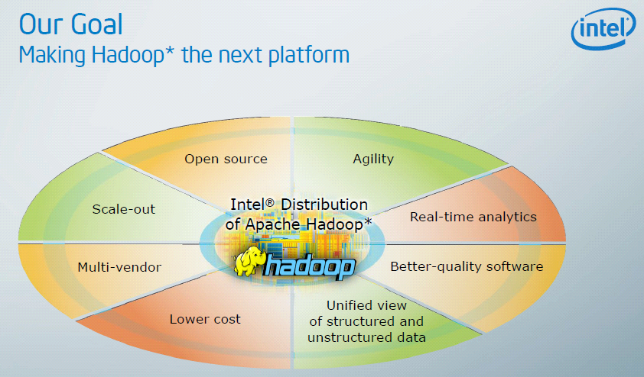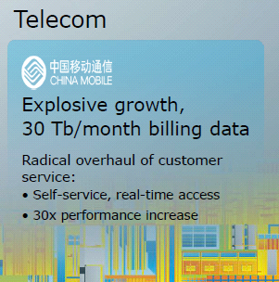
Figure 3 Intel is making Hadoop the next platform
Note: INTEL and CHINA MOBLE, the world’s largest Teleco and the No. 1 brand name in China from 2010 to 2013, are working together and have achieved the savings of $30 million every month via Hadoop technology, making Hadoop the next platform.

EMC Isilon might be a better choice for Hadoop due to its distributed computing architecture – parallel processing with rapid data transfer rates among nodes…click here to continue reading.

Note: Managing EMC VMAX storage requires a few highly skilled storage administrators

Replication

Three main replication issues are: latency, quality, and quantity.

- Latency is associated with distance and will increase (e.g., from 5 ms to 100 ms) as distance increases from Local Area Network (LAN) to Wide Area Network (WAN) or from East and West coast. Latency is static or cannot be changed and will decrease the amount of data that can be sent across the network. However, leveraging the protocols and applications behavior can put more data into the replication pipe, thus, increasing the application performance.

- Quality is associated with any issues on either the network or wide area network (WAN). When MPLS and VPNs are deployed, the quality (reliability) of the network is reduced due to dropped packets. As a result, the throughput of replication will be reduced dramatically, even though the amount of bandwidth is still available.

- Quantity is associated with network bandwidth. A larger the bandwidth (more cost), more data can be replicated.

HP claims its replication is fast flexible with both synchronous and asynchronous replication for disaster recovery protection. Since HP’s replication lacks the compression and the deduplication, a third party Wan Optimization Controller (WOC) solution such as Silver-Peak or Riverbed might be able to accelerate its replication performance by 10X or 20X.

Note: Silver-Peak or Riverbed WOC solution will not help IBM V7000 or Nimble Storage too much because both storage arrays use a real-time compression. On the other hand, Silver-peak and Riverbed solution can help NetApp or EMC VNX to achieve faster replication because both vendors’ replication is based on post-process replication and deduplication.

On the other hand, if the replication goes from a coast to coast (e.g., Los Angeles to New York), Silver-Peak or Riverbed WOC solution may also help in the IBM V7000 or Nimble Storage scenario in term of reducing packet loss and retransmission.
However, in Hadoop scenario, Isilon will take advantage of copying 100TB data from one place to another over a 10GB link (also can be considered as a different kind of replication) simply because Isilon uses a pointer to simulate a copying of data, as illustrated in the link here.

Forklift Upgrade

HP 3PAR 7400 can avoid a forklift upgrade, while EMC isn't offering a path for VNX5300 customers to be instant owners of VNX5400 (VNX2) via software download. In other words, just replacing the controller in VNX5300 will not be able to let customers to get VNX5400.

Conclusion

HP 3PAR 7400 is the best new technology in the storage market today because it was designed for today’s virtualized environments and is optimized for cloud deployments. However, ease of use, performance/throughput, availability and cost savings features are valuable to all customers. Below are a few highlight points:

- 3PAR Thin Provisioning - Industry leading technology to maximize storage utilization
- 3PAR Autonomic Storage Tiering – Automatically optimizes using multiple classes of storage
- 3PAR Virtual Domains – Multi-tenancy for service providers and private clouds
- 3PAR Dynamic Optimization – Workload management and load balancing
- 3PAR Mesh-Architecture – Advanced shared-memory architecture

The comparison of primary value to any enterprise(s) should be based on cost per terabyte (TB), IOPS, Density, Total Cost of Ownership (TCO) and Return on Investment (ROI). The comparison will provide real financial benefit to the enterprise(s) over a 3-5-year period.

IT is about providing a specific level of service at the lowest possible cost. The value to the business is the ability to improve the service while saving money.

In order to increase application performance at lower cost, today’s CIOs in any organization(s) are looking to consolidate their mission-critical applications on fewer, faster servers and to virtualize those applications to make more efficient utilization of their data center resources and often are being asked to do more with fewer resources, less time and less funding, and transform and guide an enterprise into a lean organization. Therefore, carefully examining its internal IT operations and efficiency, including using available technology in new efficient ways, often leads to trim many hidden costs and yield greater flexibility to focus on core business and pursue the innovation.
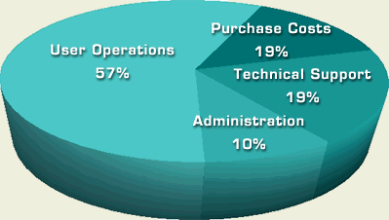
Gartner introduced the idea of "Total Cost of Ownership" (TCO) in 1986, as illustrated in the screenshot from left. The initial acquisition cost is only a part of the equation of TCO. More software purchased, more hidden cost arisen.
Therefore, any company should select a solution in accordance with its own environment needs.

Source: http://www.alligatorsql.com/solutions/tco/index.jsp

Below is an excerpt from Navigator, THE CLIPPER GROUP

“By reducing the number of physical servers populating the data center, the CIO can reduce the number of systems administrators required to drive the IT infrastructure, as well as reducing the amount of energy necessary to power the data center, and the amount of floor space required to house it. These last two points are especially critical as enterprise data centers approach maximum capacity in both of these categories. In fact, if either is exceeded, the enterprise may be forced to build out a brand new data center at a cost of millions of dollars.”

Challenge

EMC is still the No. 1 disk storage market leader with highest market share globally due to its reputation and superior technical support. Choosing EMC will not let you go wrong, as long as the capital investment is not a question. Many enterprises would like to choose the incumbent leaders in addition to traditional stereotype.

However, EMC stock is at about $24.00 for a long time and has been going down by 6.44% on a Year-to-Date basis due to the storage vendors’ thin margin competition, while HP stock is at a similar value of EMC’s for a long time.

Additional Information:

- Cloud Services

A graphic representation shows a taxonomy of cloud services (Source: Microsoft)

- Usable Capacity

Any storage system will have a different usable capacity, even though the raw storage capacity is identical.

Below is the snapshot of a few vendors’ usable capacity, snapshot usage, SATA Checksum overhead, File System Reserve and Parity.
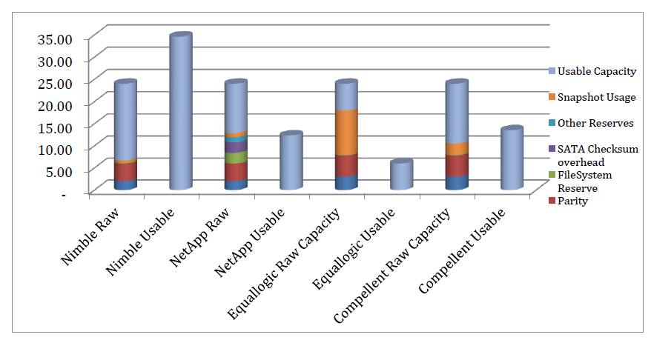
Source: Nimble

- Software-Defined Storage

Any company can get Data ONTAP that is a core building block for Software-defined storage model from NetApp private storage through Amazon services due to the partnership between NetApp and Amazon.

- Application VM runs on storage VMs
- Clustered Data ONTAP can provide Non-disruptive operations, proven efficiency and seamless scalability
- Scale-out NAS for enterprise(s) applications in a virtualized environments
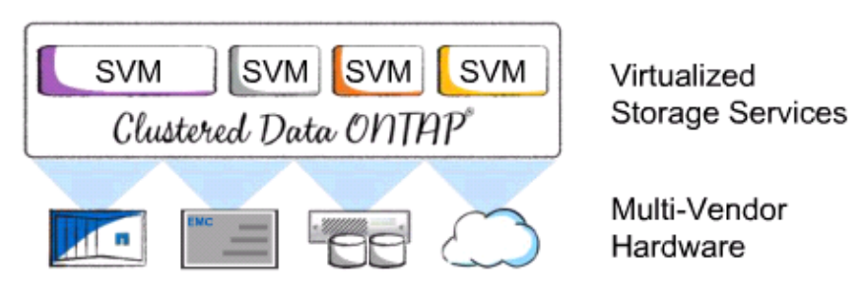
Recommended Reading

- HP Expands Midrange 3PAR Storage Portfolio with StoreServ 7000 Tier 1 Solutions (Source: www.storagereview.com)

- GARTNER MAGIC QUADRANT FOR GENERAL PURPOSE DISK ARRAYS-2013
(Source: EMC and Gartner)

- DCIG 2013 Private Cloud Storage Array Buyer's Guide.

- How New York City is going to Consolidate 50 Data Centers from 40 City Agencies into One Location (Source: InformationWeek)

- State of Texas Moves More Than 100,000 State Employees to Microsoft Cloud
The State of Texas is moving more than 100,000 employees onto Office 365 at a cost of about $3.50 per user, per month, making it the largest statewide deployment of email and collaboration services in the U.S.

Acknowledgement

Thank Tim Russ, Vice President, Enterprise Technology at Nth presented HP 3PAR Enterprise Storage (3PAR StoreServ 7000) and Steve Jung, Account Manager at the Nth to arrange this onsite presentation, respectively. Thanks Nth for allowing me to use a few graphics in my notes for clarification purpose.

