June 19, 2013
Jeremy Li

Evaluation of IBM V7000 and V7000 Unified Storage System
EXECUTIVE SUMMARY

IBM is a Fortune 500 company and has 433,362 employees in more than 150 countries and delivered the first unified storage (SAN and NAS in one box) and the second-largest vendor in the storage market.

According to GARTNER MAGIC QUADRANT FOR GENERAL PURPOSE DISK ARRAYS-2013, Storwize V7000 in-line data compression is a potential game changer, because it can shrink capacity demands by up to 80%.

IBM Storwize V7000 and V7000 Unified (NAS capability is added) leverage storage virtualization and apply a high degree of automation through Automated Easy Tier with integrated Real-time Compression technology in addition to the 4-Way Clustering capability and virtualizing existing disk systems, as illustrated in the screenshot below. Both storage systems eliminate much of the burden of managing performance and costs. Therefore, the V7000 and V7000 Unified can truly reduce the total cost of ownership (TCO) for any enterprise(s) because they can improve performance up to three times (3X), compress data up to 80% in real time and reduce its initial storage capacity size at its acquisition time.

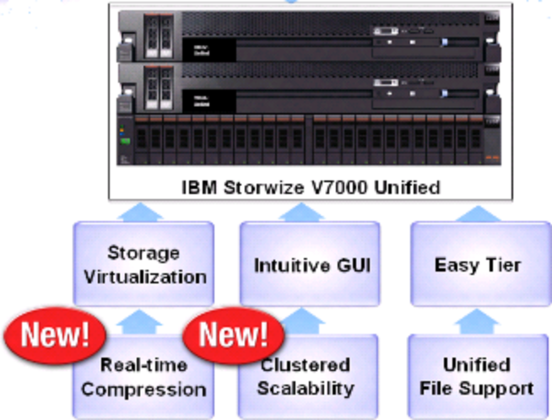

The V7000 and V7000 Unified now support 1.9PB capacity and are targeted to simplify storage for a mid-range storage market. They were the most popular storage systems in Asia Pacific Market and helped IBM gain No. 1 storage vendor in Asia Pacific in 2012. Most financial institutes in Asia Pacific such as Bank Industries rely on IBM V7000 storage technology along with IBM POWER7® computing system due to a few factors below:

- IBM Storwize V7000 and V7000 Unified provide a very similar architecture from Storage Virtualization Controller (SVC), better known as SAN Volume Controller. The SVC uses the same RAID code and same SSD code from IBM DS8000 (IBM Mainframe) to provide internal managed disks, and for tiered storage function, respectively.

- Through SVC, the V7000 can connect to any vendor’s external storage.

- With a single pane of glass, a day-to-day storage management with functions [e.g., Easy Tier, Flash Copies, Real-time Compression, Metro and Global mirrors (replication) and Thin Provisioning] and operations will play an important role since the back-end multi-vendor storage does not matter anymore due to "storage" becoming a commodity product now or sooner.

- The V7000 and V7000 Unified can connect to two platforms: IBM Power7 and x86. The performance of one physical processor from Power 7 equates to five (5) or six (6) x86 physical processors, in turn, POWER7's massive processing capabilities to meet your business needs have achieved 10 times better performance than x86 platform. The PowerVM technology on an IBM Power 750 system performs up to 131 percent better than VMware vSphere in whole core configuration with a consolidation ratio of 32 to 1 (refer to a graphic on page 8).

- Many enterprises can only use CPU utilization up to 20% on average in x86 platform, while 80% CPU utilization can be achieved under the POWER7 platform. As a result, adding additional servers (hosts) to the VMware platform that supports only x86 platform becomes normal in order to support additional workload (Scale out as a mitigation), especially in Oracle-on-Linux in VMware platform.

- The VM-to-Host ratio might be very low (e.g., 5:1 ratio to 10:1) in x86 platform under heavy computational scenario.

Note: HP claims that its 3PAR storage system guarantees 20:1 ratio in virtualization and was designed from ground zero for IT as a service in the Cloud environment due to its Massively Parallel Architecture (see “3PAR's Massively Parallel Architecture” on page 9 below for details)

- Generally speaking, one P7 processor has 4X performance than the best x86 processor after factoring the CPU utilization detailed above as well as a hypervisor (software) overhead at 15% in VMware platform vs. a built-in virtualization in firmware (hardware) at upto 5% at most in P7 series. This will help to reduce Oracle or SAP licensing.

- In x86 or VMware environment, customers must license all physical cores or sockets regardless whether only a few cores are needed to support the Oracle applications on a host (e.g., if one server has four physical CPUs installed with 8 cores per socket, 32 cores Oracle licensing must be purchased), while the Oracle licensing from IBM P series can be licensed per individual core. If an Oracle application requires only 4 cores, customers only pay for 4 cores licensing instead of paying 32 cores Oracle licensing in x86 environment. Click on the link below for details: “Understanding Oracle Certification, Support and Licensing for VMware Environments”

Watch the video to learn how POWER7 makes better information processing possible (Source: IBM)

IBM Power 7 (P750) Help in Search for Natural Gas for China's Chuanqing Drilling Engineering (Note: The storage was IBM DCS3700PM in IBM PureFlex 240 due to its massive 800,000 IOPS throughput in a burst mode)


If an EPR runs on a Linux platform (e.g., Oracle DBs on Linux platform), an enterprise might consider to select the Power7 systems in order to save money significantly because the Power7 systems can run with AIX, IBM i, and Linux together and can deliver more performance and functionality for Linux, in turn, can avoid costs of additional physical servers (Hosts), Fiber Channel and Gigabit switches, network connections (e.g., SFP and cables), data center footprint, power and cooling, operational support in addition to its acquisition and annual maintenance costs of Oracle or ISV’s enterprise licensing agreements and storage management software. That will free up IT staff to focus on more productive work.

The math is simple: if an enterprise must rely on 175 VMs (on average, a 3-VMs to 1-host ratio in many public sector enterprises due to very heavy mathematical computations required from an ERP system) to run one ERP system on the x86 platform, while the same system only needs an equivalent to 30 VMs on the Power7 systems, an enterprise will be able to save about 145 VMs that, in turn, reduce ISV’s enterprise licensing agreements and other related costs just detailed above - a few IBM P7 servers (CPU utilization can reach 90% without performance degradation) vs. about 60 x86 servers (On average, CPU utilization might be at 5%). Therefore, implementing the V7000 or other storage vendors’ product (e.g., EMC VNX or vMAX) with Power7 carefully, instead of the x86 platform, may reduce the total cost of ownership (TCO) and for a better return on investment for any enterprise(s).

With this in mind, most financial industries in Asian Pacific regions selected IBM V7000 in conjunction with IBM Power systems (P710 – P795 Unix servers running AIX) instead of x86 platform in order to save millions of dollars from Oracle software enterprise licensing agreements and other related costs for any ERP system (e.g., SAP or Oracle ERP) that usually runs on a Linux platform.
As a result, IBM offers a solution, titled “Deploy Real-time Compression and Save” - If you can't store 50% more data, IBM will make up the difference! As a matter of fact, no competitive system offers similar capability (Easy Tier and Real-time compression simultaneously) as of today.

The SVC, V7000, V3700 and V3500 that is targeted for Asia Pacific market all have the same interface and no matter what the back end storage is, they provide a consistent and simplified way with a single pane of glass to perform day to day storage operations. The V7000 also has IBM Active Cloud Engine Global Caching Support capability.

However, both V7000 and V7000 Unified Storage Systems do not support deduplication in its primary storage and will have a longer rebuilding time from a failed drive due to the lack of the IBM’s Dynamic Disk Pool (DDP) or the Chucklets capability from vendors such as HP 3PAR or Dell Compellent. Both DDP and Chucklet methods can reduce the rebuilding time from 3-5 days to a few hours from a failed drive (refer to a screenshot on page 8 for details).

Since IBM was not a storage company 10 years ago, but a computing company, it has produced a very good unified storage – V7000 Unified today.

It is worth mentioning IBM Flash can boost the ERP applications such as Oracle or SAP by 12 times faster, especially true for OLTP, which is critical for SAP and IBM DB2®. The IBM FlashSystem products (Extreme performance) that can increase application performance as much as 10x faster than other storage solutions, are designed to deliver the lowest latency and the highest IOPS in the market today at an economical price.

Note: Storage solutions often affect the entire environment. For example, if you use FlashSystem storage to meet requirements that cannot be met with scale-out storage, you might also be able to eliminate costly hardware and software licensing cost (Source: Flash or SSD: Why and When to Use IBM FlashSystem)

Finally, an investment in the cloud was not made as a justification to buy a more expensive storage system; it was made to enable IT to be delivered as a service and to make IT nimble enough to meet the demands of the business. New approaches to storage are needed to keep it from eating the cloud ROI (Source: A White Paper, titled Don't Let Cloud Storage Eat Your ROI written by Storage Switzerland, LLC)
ANALYSIS

The V7000 Unified storage has the following capabilities:

- Integrates file and block applications in a single storage system
- Single pane of glass (one administration interface) is used to manage both block and file data
- Supports for file access protocols - NFS, CIFS, FTP, HTTPS and SCP
- Supports file replication and snapshots for business continuity
- Supports 4-Way Clustering
- Supports Storage Virtualization

  - via its Intelligent Backup application (Tivoli), progressive incremental and deduplication can be supported via externally virtualized storage (e.g., HP EVA)
  - connects any third party vendors’ storage systems via Storage Virtualization Controller (SVC)

- The Real-time Compression with Auto-Tier, better known as “Easy Tier”, for the same volume simultaneously can increase the performance by 3X and achieve the compression up to 80% (Click here for details). That feature of two functions used simultaneously is a crown jewel from IBM V7000 storage system and can truly reduce the total cost of ownership (TCO) for any enterprise(s). As a matter of fact, no competitive system offers similar capability as of today.

The graphics illustrates the superior performance due to better than 1/3 response time under the IT industry standard benchmark – TPC-C Workload when the Easy Tier and Compression Used Together.

The white paper, titled “Compares IBM Real-time Compression for Storwize V7000 vs EMC and NetApp compression for Block Storage” clearly shows IBM Real-time Compression with Auto-Tier simultaneously is far more superior to its main competitors. IBM is the only vendor who can do it.

IBM Real-time Compression Advantages

According to Granter, Storwize V7000 in-line data compression is a potential game changer, because it can shrink capacity demands by up to 80%.
1. Complete transparency

2. No impact on performance (Cautions: The performance might be degraded if the CPU utilization is above 25%. Therefore, Real-time compression should be kept below 25% CPU utilization. The table referenced below shows a typical compression ratio for types of data that can be found in IBM redbooks:

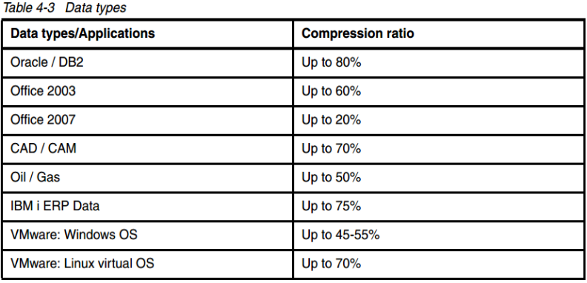

3. Minimal management requirements
4. Reduced storage capacity required

5. It might make other vendors’ products (e.g., Riberbed or SilverPeak) less attractive since their products can not perform the compression again except for performing the Dedupelication.

As a result, IBM offers a solution, titled “Deploy Real-time Compression and Save” - If you can't store 50% more data, IBM will make up the difference!

Below are excerpts from a white paper, titled “Compares IBM Real-time Compression for Storwize V7000 vs EMC and NetApp compression for Block Storage” for its Real-time Compression Technology as its crown jewel.

Executive Summary Conclusions
All EMC VNX data compression occurs post-process (after written uncompressed to the storage device), as does compression of any changes made to data with NetApp technology. Not only does this approach severely impact stored data access performance, but the data must also be stored in its uncompressed form before post-process compression can handle it. For this reason, both EMC and NetApp recommend sizing compressed devices for data at its original size. If followed, this practice eliminates the benefits of deploying compression.

Edison believes that the compression features of the EMC VNX are best utilized in environments where an entire VNX array can be dedicated to compressible low-throughput workloads, and for which considerable idle periods are available. Though there may be cases where this is a valid approach, there are other solutions on the market that would be more appropriate. NetApp compression may be practical for applications that regularly write data to storage during production operations with few or no further updates. However, the fact that it must update data post-processed makes it impractical for applications — such as databases — where frequent changes are made to stored data.

To sum up the research findings for Real-time Compression:

- Complete transparency: Real-time Compression is invisible to the server operating systems and applications, which means that no administrative overhead is required to use it. The EMC VNX Series, by contrast, is designed to compress inactive content and is entirely unsuitable for active data. While the NetApp FAS 3240 demonstrated file copy transparency with pre-processed compression on initial writes, for any subsequent changes to stored data, compression is performed after processing. Thus the NetApp FAS native compression is not practical for highly active, frequently changing data utilization in applications such as databases.

Note: NetApp claims it can also boost performance of an existing storage by 20% or more and comes with a “pays for itself in 9 months” guarantee program besides NetApp guarantees customers who will use 50% less storage for virtual environments.

Auto Tier – Easy Tier

IBM’s automated tiering is called “Easy Tier” that offers integrated no-charge thin provisioning and Easy Tier function. With Easy Tier and Compression used together, the performance can be increased by 3 times and data compression up to 80%. See three pictures illustrated above for your reference.

The EasyTier (a free application) can be created via Compellent SSD or NetApp SSD. The minute you add SSDs into a pool, the Easy Tier will be kicked in automatically in order to save the SSDs resource.

Note: NetApp started to realize the Auto-tiering is a great technology. Therefore, it started to offer this feature recently and only does Auto-tiering on SSD and does not believe the current Auto-tiering from most storage vendors is an efficient method because it took too long to move data from third tier to first tier. That’s why NetApp creates a different Auto-tiering algorithm. See NetApp Virtual Storage Tier for details.

The Power of One

IBM Storwize V7000 Unified offers:

- One system
- One management framework
- One GUI
- One unifed block and file solution

IBM Power Platform vs. Intel x86 Platform

The V7000 has two platforms: IBM POWER and Intel x86. With IBM POWER7, the performance of one physical processor is equivalent to five (5) or six (6) Intel x86 physical processors. IBM POWER7 processors usually have eight cores with four threads per core. Thus, 32 simultaneous threads or 32 virtual CPUs (vCPU) per processor socket can produce massive computer computing.

If an EPR runs on a Linux platform (e.g., Oracle on Linux platform), an enterprise might consider to select the Power platform in order to save money significantly because the Power platform can avoid costs of additional physical servers (Hosts), Fiber Channel and Gigabit switches, network connections, data center footprint, power and cooling, operational support in addition to its acquisition and annual maintenance costs of Oracle or ISV’s enterprise licensing agreements and storage management software.
The math is simple: if an enterprise must rely on 175 VMs on Intel x86 platform to run one ERP application, while the same application only needs an equivalent to 30 VMs on the Power platform, it will be able to save about 145 VMs that in turn reduce ISV’s enterprise licensing agreements and other related costs just mentioned above. Therefore, implementing the V7000 platform carefully may reduce the total cost of ownership (TCO) and for a better return on investment for any enterprise(s).

According to a white paper titled “A Comparison of PowerVM and VMware vSphere 4.1 update 1 Virtualization Performance - Edison Group (PDF, 1.21MB)” IBM POWER7 processor-based has key advantages listed below over comparable Intel-based systems regarding the performance and scalability of Power VM virtualization technologies compared to VMware vSphere1 on an x86-based platform:

• PowerVM technology on an IBM Power 750 system performs up to 131 percent better than VMware vSphere in whole core configuration with a consolidation ratio of 32 to 1.

• PowerVM on Power 750 outperforms VMware by up to 525 percent when running multiple VMs and workloads, despite the test Intel x86 system (Westmere-EX) containing a greater number of cores (40 versus 32).

• PowerVM technology on a 4-socket IBM Power 750 system demonstrated linear scaling, with 50 percent more absolute throughput performance compared to VMware vSphere.
• In terms of throughput performance, vSphere 5 demonstrated no improvement over vSphere 4.1 update 1; in fact, it demonstrated slightly lower performance overall.

Scale-Out Benchmark

The following scenario tested VMware vSphere 5 running on an HP ProLiant DL580 G7 E7-4870 server against PowerVM running on an IBM Power 750 system. AIM7 was scaled to eight VMs using 32 vCPUs per VM, configuring a total of 256 vCPUs. Running the same workloads across virtualized resources, the POWER7 processor/PowerVM -based system demonstrated a very substantial 525 percent advantage over Intel/VMware vSphere 5.

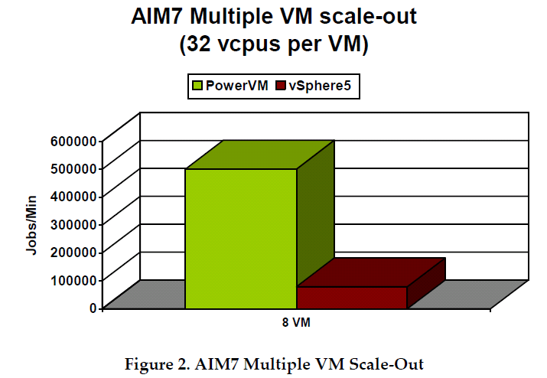
IBM V7000 Can Avoid a Forklift Upgrade

Buying IBM V7000 will let you never worry about the Forklift upgrade in the future.

Note: Per NetApp, it can change two controller headers to upgrade its existing storage in order to preserve customers’ investment. For example, after 5 years’ investment on NetApp storage, an enterprise can either upgrade or replace the old headers with more powerful headers to continue to use its existing storage or keep the old disks and purchasing newer controllers. In a common scenario, a storage array usually consists of 80% disk drives and 20% controllers. Therefore, simply replacing two controllers will preserve 80% of the original investment, instead of going through a forklift upgrade – buying a new storage enclosure or a new model.

Dell Compellent SC8000 or an earlier Model 40 is a champion for avoiding a forklift upgrade. However, when its two controllers reach a full capacity (100%), it will go through a forklift upgrade per NetApp (must buy a second array).

That’s why NetApp owns 60% Market Share in Federal Governments, and is the second largest storage vendor behind EMC.

Disk Striping Only vs. IBM Dynamic Disk Pool (DDP)

Both IBM V7000 and V7000 Unified do not support the DDP feature. Therefore, recovering a failed drive will take a long time. If recovering a failed drive is your main concerns, look for IBM DCS3700, DS5000 or HP 3PAR 7000 or 10000 series.

Most storage vendors use Disk Striping technique in order to boost the storage performance. However, this technique is not good enough in today’s storage. IBM introduced a newer and better method called “Dynamic Disk Pool” (DDP) in DS series models (e.g., DCS3700, DS5000) to enhance the storage performance and reduce a failed drive recovery time from days to hours. As of today, IBM storage with DDP enable, HP 3PAR and Dell Compellent are only vendors who can recover a failed disk from days to hours.

It is worth of mentioning that HP 3PAR has a unique Massively Parallel Architecture in addition to using a technique called “Chunklet” of a block size of 1GB with “Disk Striping” at 128KB block size across all available disks (HDDs) within a system to achieve higher performance than most comparable systems. HP claims its converged storage was born for software-defined delivery, a new style of IT, designed for cloud and optimized for big data in addition to building on converged infrastructure. Since 2010, the converged management orchestration comprises of choreograph servers, networks, and storage.
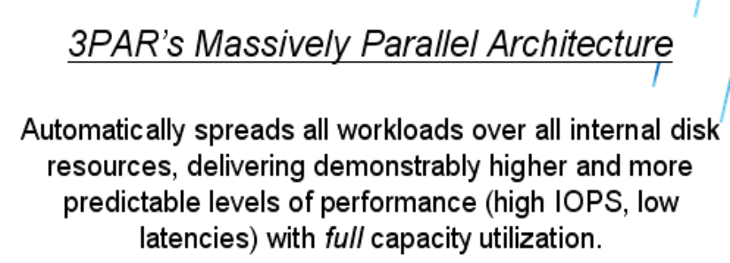
This Massively Parallel Architecture can give customers higher VMs per Host ratio. HP guarantees customers: 20:1 ratio on its HP 3PAR 7000, targeted for a mid-range storage customers with tier 1 capability usually from EMC vMAX storage. The list price from HP 3PAR 7000 is under $45,000.

That’s why 8 out of 10 top hosting companies choose HP 3PAR.

Below are summary of HP 3PAR advantages over other Storage Vendors:

Architectural Attributes
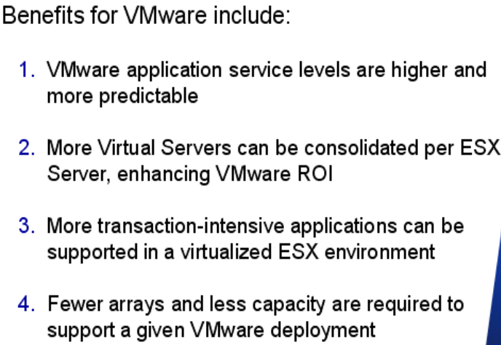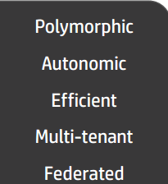

HP 3PAR from 7200 to 10800 archive “Polymorphic Simplicity with One Architecture: One Operating System, One Interface and One Feature Set.

Click here and there for a comparison among HP3PAR, EMC VMAX and VNX (Source: HP). Good news: EMC is going to release ALL FLASH products based on X-trem-IO to help enterprise(s) to increase the storage performance and IT resource utilization, in turn, reduce the TCO.

Note: NetApp’s WAFL or EMC’s VNX all rely on a fixed RAID group that contains 14+2 HDDs in most scenarios via a method called “Aggregates”. This will restrict the performance IOPs dramatically. That’s the reason NetApp and EMC customers must rely on CACHE (e.g., flash module) to address the disk bottle neck. A few storage vendors claim that the aggregates method is a 20 years old technology. NetApp can support 24 SAS HDDs and 20 SATA HDDs per RAID group.

HP 3PAR uses the RAID Group (14+2) via “Chunklet” with “Disk Striping” method to achieve far more superior performance, especially in a disk recovery scenario. With HP 3PAR, recovering a failed drive is a matter of a few hours with a 3TB SAS drive at the 80% capacity full. The more HDDs in the HP 3PAR system, the lesser recovery time will be. This also applied to IBM DCS3700 and DS5000 if the DDP is enabled.

The Rebuilding Time from a Failed Drive
A typical rebuilding time from a failed drive will take from 3 days to 5 days in most storage vendors’ system. IBM DCS3700 and DS3500 can reduce the rebuilding time from days to hours. Click here for details.

However, IBM V7000 and V7000 Unified’s rebuilding time will be much longer since they do not have the capability of either DDP or spare chunklets from HP 3PAR or Dell Compellet. Below, a screenshot illustrates a traditional RAID rebuilding method vs. a parallel rebuilds method:
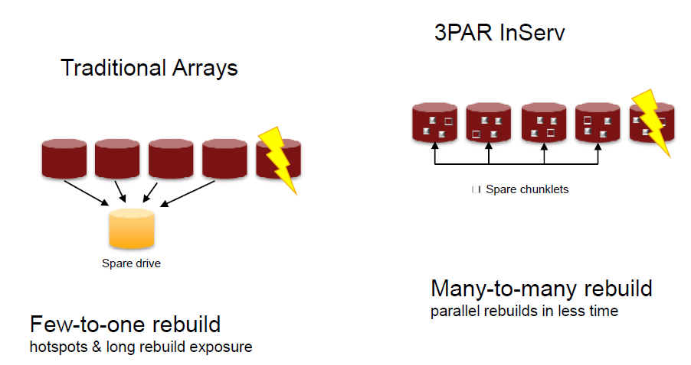
With the DDP or Chunklets method, a dedicated parity disk drive is no longer used to recover data from a failed drive. Therefore, a bottleneck due to a hot spot from a dedicated parity drive after a new drive is inserted into a storage system is eliminated.

NetApp Fabric-Attached Storage (FAS) and EMC VNX use traditional arrays method to address the data recovery, although a global spare drive is used to enhance the storage efficiency. Typically, 14 HDDs will be tied to one spare disk drive, while the rebuilding time from HP 3PAR or Dell Compellent will be greatly reduced due to a technique called “spare chunklets”, also known as “distributed sparing technique”, as illustrated in a picture below:

Note: One vendor claimed that the rebuilding time is less than 2 hours for a 3TB disk with 80% data full from SC8000 or 3PAR, while it took 7 days to rebuild a “RAID” group at the LA Sanitation Agency.
Snapshot and Replication

IBM relies on a Copy-on-Write (COW) snapshot technology, instead of a more efficient Redirect-on-Write (ROW) snapshot technology that is being used by NetApp, Dell Compellent and Nimble.

IBM FlashSystem Storage

IBM published “Flash or SSD: Why and When to Use IBM FlashSystem” in its redbook. For details, visit http://www.redbooks.ibm.com/redpapers/pdfs/redp5020.pdf

Below, key differentiators between server-side flash PCIe cards and FlashSystem storage are summarized.
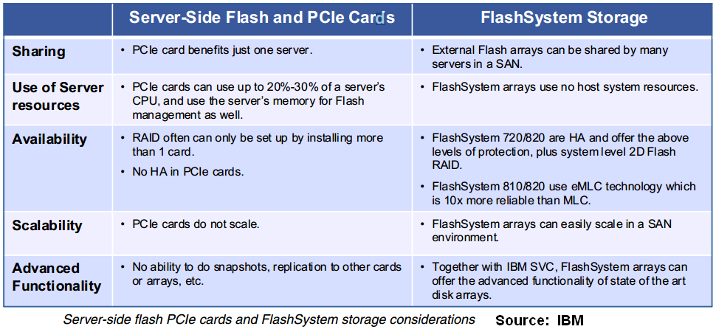

With a combination of the V7000 Power platform and FlashSystem, massive VMs and physical servers, fiber channel (SAN) switches and network connections can be reduced dramatically in turn for a better return on investment at any enterprise(s).

Conclusion

IBM Storwize V7000 and V7000 Unified (NAS capability is added) leverage storage virtualization and apply a high degree of automation through Automated Easy Tier with integrated Real-time Compression technology in addition to the 4-Way Clustering capability and virtualizing existing disk systems detailed above.

Storwize V7000 in-line data compression is a potential game changer, because it can shrink capacity demands by up to 80% (Source: GARTNER MAGIC QUADRANT FOR GENERAL PURPOSE DISK ARRAYS-2013)

Both storage systems eliminate much of the burden of managing performance and costs. Therefore, the V7000 and V7000 Unified can truly reduce the total cost of ownership (TCO) for any enterprise(s) because they can improve performance up to three times (3X), compress data up to 80% in real time and reduce its initial storage capacity size at its acquisition time.
The V7000 and V7000 Unified now support 1.9PB capacity and are targeted to simplify storage for a mid-range storage market. They were the most popular storage systems in Asia Pacific Market and helped IBM gain No. 1 storage vendor in Asia Pacific in 2012. Most financial institutes in Asia Pacific such as Bank Industries rely on IBM V7000 storage. Often, the storage is sold as a bundle along with IBM POWER7® computing system (IBM AIX Unix servers) that can reduce the costs for ISV’s enterprise licensing agreements because the Power7 platform can avoid costs of additional physical servers (Hosts), Fiber Channel and Gigabit switches, network connections, data center footprint, power and cooling, operational support in addition to its acquisition and annual maintenance costs of Oracle or ISV’s enterprise licensing agreements and storage management software because POWER7's massive processing capabilities to meet your business needs have achieved 10 times better performance than x86 platform. Again, selecting Power7 or x86 platform depends on a case-by-case basis in an enterprise.
As a matter of fact, no competitive storage system offers similar capability (Easy Tier and Real-time compression simultaneously) as of today. As a result, IBM offers a solution, titled “Deploy Real-time Compression and Save” - If you can't store 50% more data, IBM will make up the difference!

With Storage Virtualization Controller (SVC), better known as SAN Volume Controller, it can connect any vendor’s storage. Therefore, a day-to-day storage management with functions [e.g., Easy Tier, Flash Copies, Real-time Compression, Metro and Global mirrors (replication), Thin Provisioning] and operations will play an important role since the back-end multi-vendor storage does not matter anymore due to "storage" becoming a commodity product now or sooner.

The SVC, V7000, V3700 and V3500 that is targeted for Asia Pacific market, all have the same interface and no matter what the back end storage is, they provide a consistent and simplified way with a single pane of glass to perform day to day storage operations.

Also, for large enterprise(s), you may take a look at IBM Power platform vs. Intel x86 platform because the performance of one physical processor in the Power platform is equivalent to five (5) or six (6) Intel x86 physical processors. If an EPR runs on a Linux platform (e.g., Oracle on Linux platform), an enterprise might be able to save a lot of money in terms of additional servers, rack space, power and cooling, labor and management costs in addition to the acquisition and annual maintenance costs for Oracle or ISV’s enterprise licensing agreements.

In order to increase application performance at lower cost, today’s CIOs in any organization(s) are looking to consolidate their mission-critical applications on fewer, faster servers and to virtualize those applications to make more efficient utilization of their data center resources and often are being asked to do more with fewer resources, less time and less funding, and transform and guide an enterprise into a lean organization. Therefore, carefully examining its internal IT operations and efficiency, including using available technology in new efficient ways, often leads to trim many hidden costs and yield greater flexibility to focus on core business and pursue the innovation.
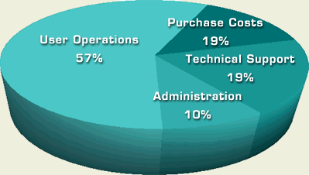
Gartner introduced the idea of "Total Cost of Ownership" (TCO) in 1986, as illustrated in the screenshot from left. The initial acquisition cost is only a part of the equation of TCO. More software purchased, more hidden cost arisen.
Therefore, any company should select a solution in accordance with its own environment needs. Source: http://www.alligatorsql.com/solutions/tco/index.jsp

Below is an excerpt from Navigator, THE CLIPPER GROUP - “By reducing the number of physical servers populating the data center, the CIO can reduce the number of systems administrators required to drive the IT infrastructure, as well as reducing the amount of energy necessary to power the data center, and the amount of floor space required to house it. These last two points are especially critical as enterprise data centers approach maximum capacity in both of these categories. In fact, if either is exceeded, the enterprise may be forced to build out a brand new data center at a cost of millions of dollars.”

Last but not least, if an enterprise needs OLAP or Big Data storage, IBM DCS3700PM storage might be considered since it can provide a burst mode at 800,000 IOPS while most comparable storage products lack of this capability in addition to Dynamic Disk Pool (DDP) capability.

Challenge

EMC is still the No. 1 disk storage market leader with highest market share globally due to its reputation and superior technical support. IBM selected EMC (VMAX family) as OEM for its System z (Mainframe). Choosing EMC will not let you go wrong, as long as the capital investment is not a question. Many enterprises would like to choose the incumbent leaders in addition to traditional stereotype – IBM is too big and has an efficiency issue with higher price.

IBM not only lost many big deals to vendors like EMC, NetApp and HP, but also lost many small or mid-range deals to vendors like Dell or Nimble because of the fact that when a final price includes the software licenses with its storage array, an enterprise often finds that the price jumps. Customers know they can get the same storage capacity and similar software features for less money elsewhere. For example, in the SMBs market, many companies are able to find an equivalent solution from Nimble at much cheaper price because Nimble offers snapshots and replication software, including Zero-copy clone free of charges.
However, EMC stock is at about $24.00 for a long time and has been going down by 6.44% on a Year-to-Date basis due to the storage vendors’ thin margin competition, while IBM has been enjoying with a high stock value at about $192.00 and gained by 0.5% on a Year-to-Date basis, even though IBM has lost storage market share in the U.S., while gaining as No. 1 storage market share in Asia Pacific in 2012.
Special Note: IBM has been targeting a few key strategic customers and willing to sell the storage to those key customers on losing money deal for a long time. As a result, any customers who are qualified as IBM’s key strategic customers should take advantage of IBM’s strategy and vision to gain the best value by doing business with IBM. For example, IBM has vision – Selling PC business to Chinese Lenovo eight years ago was a good business practice by knowing that this business might lose money in the future. Today, HP’s PC business is a losing money business, while Dell’s PC business does not make money.

Additional Information:

1. Usable Storage Capacity

Any storage system will have a different usable capacity, even though the raw storage capacity is identical.

Below is the snapshot of a few vendors’ usable capacity, snapshot usage, SATA Checksum overhead, File System Reserve and Parity.
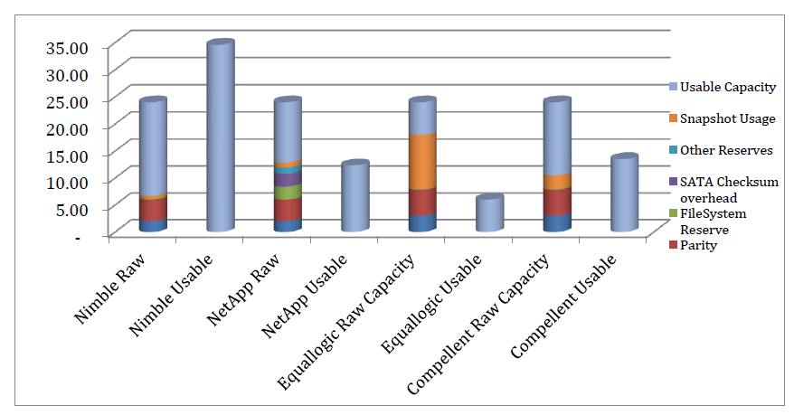
Source: Nimble

2. Cloud Services

A graphic representation shows a taxonomy of cloud services (Source: Microsoft)

3. Oracle Red Stack & Oracle Virtual Networking

Click here for a graphics illustration.

4. Software-Defined Storage

Any company can get Data ONTAP that is a core building block for Software-defined storage model from NetApp private storage through Amazon services due to the partnership between NetApp and Amazon.

- Application VM runs on storage VMs
- Clustered Data ONTAP can provide Non-desruptive operations, proven efficiency and seamless scalability
- Scale-out NAS for enterprise(s) applications in a virtualized environments
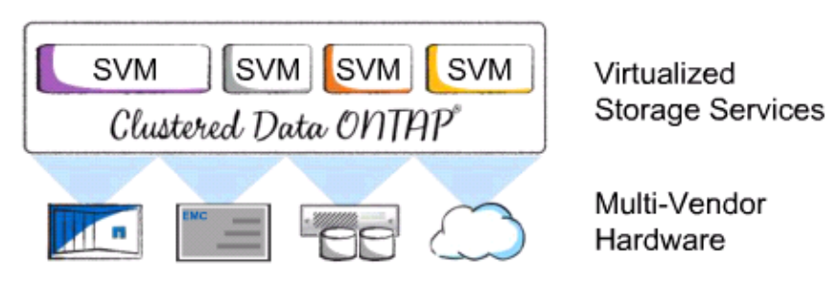
5. Cisco UCS vs. IBM PureFlex

Cisco UCS supports x86 platform only while IBM PureFlex supports both x86 and Power platform. Generally speaking, IBM PureFlex with Power7 nodes has much higher performance than Cisco UCS due to the reasons detailed above.

IBM Watson on Power uses Power 750 or 770 and can be used by the Power 795 due to its flexibility. IBM Power 795 provides extraordinary scale, capacity and bandwidth for the most demanding enterprise applications for mission-critical workloads and is the most powerful member of the IBM Power Systems™ family. It is designed for large-scale server consolidation to increase flexibility and lower operational and energy cost. The No. 1 powerful system from IBM is System z (Mainframe).

The Power systems have two operating systems: AIX and System i. Click here to see the differences Between IBM eServer iSeries and pSeries Servers Running Linux.

Recommended Reading

1. IBM Power Systems will offer us the business agility we need to continue driving business growth." - Michel Saindon, Team Leader Centralized Systems, Metro Inc.

Metro deploys a fully virtualized server landscape and a flexible storage environment for optimum SAP ERP application performance

2. State of Texas Moves More Than 100,000 State Employees to Microsoft Cloud
The State of Texas is moving more than 100,000 employees onto Office 365 at a cost of about $3.50 per user, per month, making it the largest statewide deployment of email and collaboration services in the U.S.

3. How New York City is going to Consolidate 50 Data Centers from 40 City Agencies into One Location. (Source: InformationWeek)

Acknowledgement

Thank Tanya L Davenport, Client Relationship Manager, Tony Roberts, Architect at thinkASG and Randy Johnson, IBM Storage Specialist for inviting me to attend an IBM Open House and presenting IBM V7000 Unified Solution at the Open House, respectively. Thanks thinkASG for allowing me to use a few graphics in my notes for clarification purpose.

