September 26, 2012
Jeremy Li

Credit: Afternoon Mixer and Technology Showcase, Sept. 26, 2012

ShoreTel - www.ShoreTel.com

ShoreTel and its partner Cal Net Technology Group (Best Places to Work 2012 in Los Angeles Business Journal and rated as top 5 IT consulting company in Southern California) hosted a successful Technology Showcase / Live Demonstration event, Sept. 26, 2012 at the Culver Hotel. The event was to show how ShoreTel, Cal Net, HP and Polycom can deliver Unified Communications (UC), the convergence of communications and applications via Voice over Internet Protocol (VoIP) technology, to customers with the brilliantly simple business communication. The UC software applications can provide voice, video and other streaming media applications such as desktop sharing, web conferencing, and shared whiteboard.

ShoreTel was founded in 1996 and has approximately 725 employees in 2012. Its headquarters is in Sunnyvale, California with offices in Austin, Texas, UK, Germany, Spain, Australia, Singapore and Hong Kong. It is the only vendor received a Strong Positive from the Vendor Ratings category by Gartner, while Avaya, Cisco, Interactive Intelligence and Mitel were rated as Positive (Refer to the Gartner report G00227712, published on Aug. 10, 2012 for details).

ShoreTel offers a wide range of IP phone system with UC to provide the right solution for each application – it cab be used as an executive, executive assistant, operator, ACD agent or supervisor, or general office user. The Single Image Director runs on Windows Server Operating System.

The demo equipments consist of:

- One ShortTel ShoreGear 50V, a distributed UC architecture appliance, based on flash memory (no hard disk drive, the only moving part is the fan). It can be managed and configured with a single ShoreTel Director Web application and support 50 voice mailboxes based on a very reliable Wind River VxWorks real time OS (RTOS), that powers more than 1 billion real-time systems across the globe (Nortel uses it for many years). It acts as a VoIP PBX (Private Branch Exchange), which is a telephone system designed to deliver voice or video over a data network and interoperate with the normal toll Public Switched Telephone Network (PSTN). The appliance is also integrated with a voice mail server, rather than in a separate server, which will increase not only the complexity of a VoIP design and implementation, but also the entire cost of the UC solution. According to ShoreTel, the distributed UC architecture can be scaled to support 20,000 users.
- One HP ProCurve 10/100 layer 2 switch


- One ShoreTel 655 IP phone (The MSRP is $695.00) with five (5) built-in microphones forming a 360 degree space with beam forming technology (Always searches for voices, and stop the search when a voice is detected), and one ShoreTel 265 IP phone (The MSRP is $369.00) with color screen capability.

- One Polycom IP phone with pervasive video conferencing capability. The Polycom IP phones usually consume 50% less network bandwidth and costs 20% less than Cisco’s. Polycom is in business for 15 years with 850 patents issued or pending and was born from a commitment to open standards and interoperability, and driven by a vision to make video collaboration ubiquitous, these breakthrough solutions will let customers extend access to anyone with a browser - to experience and enjoy video collaboration at the highest quality, reliability, and security.

Note: All ShoreTel phones have no video conferencing capability. It must rely on either a desktop for the video conferencing or a Polycom IP phone.

ShoreTel has reached 25,000+ customers worldwide over 40 countries as of today and 1,000+ new customers are added every quarter with 35% growth rate while an industry growth rate is at 8%.

Note: With more than 150,000 IP telephony endpoints, Cisco IT maintains one of the largest Cisco Unified Communications System deployments in the world today. Click on the link www.cisco.com/go/ciscoit for details.

The Second Quarter, 2012 Worldwide Enterprise IP Telephony Revenue Market Share per Synergy is as follows:

Cisco: 44.3%
Avaya: 29.0%
ShoreTel: 8.1%
Mitel: 6.5%

Synergy rated ShortTel as #1 Worldwide Unified Communications Desktop Solution Provider (Soft telephone and its communicators)

Communicators

A communicator is software application; a single application is for all users. It can move effortlessly between voice, video & IM as well as dialing numbers from applications or web pages etc.

There are seven (7) versions of ShoreTel communicators listed below:

- Personal - It is free of charge. 90% users will use this version.
- Workgroup Agent Access - The list price is $295.00 per user. It is the same as Personal except having one more feature login and logout.
- Professional - It can be configures as a soft phone with one-time charge of $80.00 per soft phone with unlimited free upgrade as long as a customer maintains its annual contract. A major release cycle for the upgrade is 12 months.

Note: Soft phone requires downloading software (Communicator, in this case) and then making a call from computer-to-phone or computer-to-computer. Skype, Google Voice and Yahoo Voice are commercial software of your choices for downloading.

With VoIP services such as Vonage (www.vonage.com), Ooma (http://www.ooma.com/) and Phone Power (http://www.phonepower.com), consumers can connect an adapter in order to work with the VoIP system (e.g., Ooma Telo’s jack labeled ) to their Internet router, a regular phone to the adapter (e.g., Ooma Telo’s Phone jack labeled ), as illustrated in two pictures below. They can make a phone call as usual while their computer can be off.

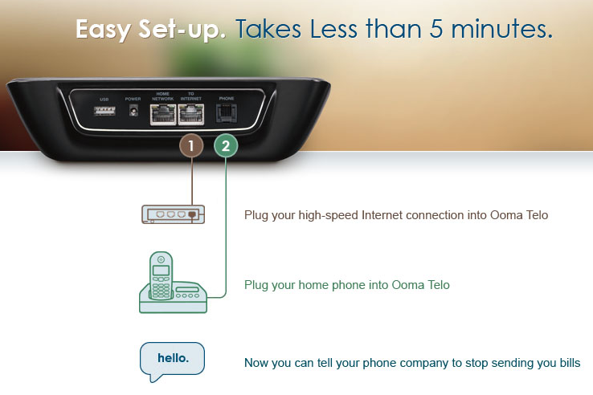


- Operator - The list price is $595.00 per user.
- Supervisor - The list price is $595.00 per user.
- Web - It is free of charge.
- Mobile - It is free of charge.

The concept of a single application for all users has dramatically reduced the ongoing maintenance cost. Each client access license is controlled by a web-based application – Director, as illustrated in the screenshot below:

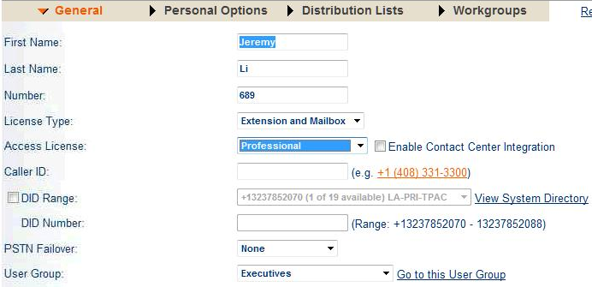

Therefore, it only takes a minute to change a client from one version to another, not like a scenario to change from Microsoft Office Standard edition into a Professional edition, which requires reloading the entire Microsoft Office Professional edition into an existing desktop.

The ShoreTel 13 release was available in July, 2012. The current client (Desktop) version of ShoreTel is 13.1, which only supports IE browser. The road map is to support both Safari and Firefox.

H.323 vs. SIP Trunking

Most ShoreTel customers are still using T1 lines (The most stable technology over the past 30 years) or Primary Rate Interface (PRI) lines via H.323, which addresses setting up and tearing down audio and call signaling and controlling, to provide audio-visual communication sessions on the toll PSTN, while few customers rely on SIP (Session Initiation Protocol) trunking, a VoIP method (a newer technology), which requires matching right applications. SIP, a text-based
Application Layer and peer-to-peer protocol, which does not depend on the Transport Layer (TCP or UDP), is primarily used in setting up and tearing down voice or video calls as well as signaling. Many SIP elements are implemented in the basic firmware functions of many IP-capable devices.
The SIP trunking technology will be very attractive and provides a cost savings if it is implemented correctly. For example, a) a big enterprise can consolidate
large amounts of PRI lines into a single large SIP trunk for all outbound calls via an existing WAN connection instead of T1 lines associates with PSTN connection. This will immediately eliminate phone bills for outbound calls; Additional technique can be used to reroute an incoming call as an outbound call. b) for an online collaboration vendor such as WebEx, deploying a SIP trunking technology at hosting site(s) via WAN connection can save millions due to the WebEx connection (application traffic) now going across a WAN, instead of ISDN PRI lines associated with PSTN. Therefore, the WAN connection is almost free of charge in this scenario. Read how Cisco’s Cloud Connected Audio application - Carrying audio conferencing on corporate network reduces costs for web conferences can save 32.4 million every year on phone bills at Cisco by clicking
http://www.cisco.com/en/US/solutions/collateral/ns340/ns1176/collaboration/Cisco_IT_Case_Study_WebEx_Cloud_Connected_Audio.html

Interoperability

ShoreTel telephony with UC and Networking solutions can work together with Cisco VoIP. Per ShortTel, there are no interoperability issues between two vendors.

Single Image Architecture and Distributed Model

The Single Image Architecture means that the Operating System and a single web-based application with its database (Director) with the entire ShoreTel system reside on single server (ST10.x and above) running on Windows Server OS at the headquarters (HQ), as illustrated on the following screenshot. This server (single image), usually called headquarters (HQ) server, includes all hardware, software licensing and all users and controls the entire system.

Distributed architecture makes it easy to deploy and scale to multiple sites and locations.

The flagship ShoreGear-220T1 can support up to 220 IP phone users without PRI line and up to 100 IP phone users with one PRI line, which contains 23 channels and 1 signaling channel. The ratio is 5 to 1. In other words, with one PRI line installed, 120 IP phone lines will be lost (24 * 5 = 120 IP lines).

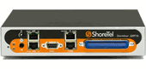
The ShoreGear-220T1A has an Amphenol socket, which can connect to the maximum 6 analog lines per appliance (e.g., analog trunks, analog devices - fax machines) and has dedicated conference ports with the same capability as ShoreGear-220T1. However, 70 IP phone lines will be available, if one PRI line and six (6) analog lines will be used.

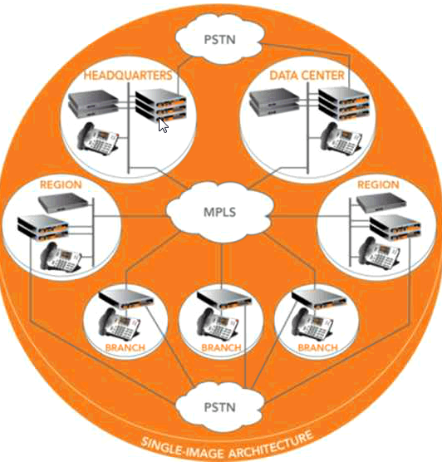

N + 1 Redundancy vs. 2N Redundancy

ShoreTel uses N + 1 method to achieve redundancy and deliver the lowest TCO.

1. With N + 1 Redundancy capability, a customer must install a second server at a remote site (Data Center, shown in the above screenshot). This server is called Distributed Voice Server (DVS), which contains everything the HQ server has except for the Director. The DVS contains its own database, voice mail storage and local Auto Attendants.

ShoreGear voicemail switches (V Switches) provide distributed and survivable voicemail and auto-attendant features at a remote site. This enables voicemail storage locally at each site to save the WAN bandwidth required for accessing voicemail messages remotely from a distributed voicemail server (DVS), and allows voicemail access even when WAN goes down. The snapshot of the difference between DVS and V Switch is shown below:

FEATURE SG-90V DVS
Number of Mailboxes 90 1000+
VM Storage - hours 56 1000+
VM Storage medium Compact Flash Hard Disk

If a remote server fails, the HQ server can provide all functions until the remote server is back in operation. Locally stored voicemail is not available at the HQ server although new voicemail can be taken.

For DR purposes, it is recommended that the HQ server be maintained in a co-location data center or other "hardened" data center environment and the main user location have a Distributed Voice Server. ShoreTel highly recommends deploying its servers on virtual servers (VMs) due to its quick recover feature.

The link http://www.bn.ca/faqs/25-shoretel-switch-faq and http://www.shoretel.com/about/newsroom/press_releases/2009-01-22.html have additional information about the V Switch.

2. One spare switch must also be installed at the HQ site (Passive).

Other vendors usually use 2N method to achieve its redundancy. This is the most expensive method because a customer must purchase multiple identical equipments.

Microsoft Active Directory (AD) Integration

ShoreTel provides professional services to import users from Microsoft Active Directory into ShoreTel database via ShoreTel Active Directory Import Application. The manufacturer's suggested retail price (MSRP) is listed below:

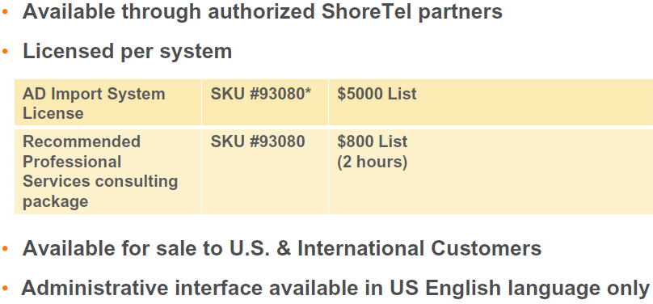

The application can automatically synchronize ShoreTel System Directory with Microsoft AD information with one way synchronization. This greatly reduces manual work and saves operational cost. It can also migrate users’ DID and extension numbers from all the legacy systems to ShoreTel Directory – Once screen for all users’ information.

Note: Cisco just made the Microsoft AD integration successfully in its latest Unity Connection 8.0 on VM on UCS first time. Therefore, the enterprise no longer needs to depend on one or more Microsoft Exchange server(s) to store voice mails, since Unity Connection 8.0 can rely on its backend storage server to support the voice mail storage. In addition, the traditional Cisco AD controllers (servers) are no longer needed because the new OS can use the existing Microsoft Active Directory for UC users (integrated).

This enhancement greatly reduces the complexity in deploying Cisco UC solutions.

Layer 2 vs. Layer 3 switches

Either a Layer 2 or a Layer 3 switch can be used in ShoreTel telephony with UC solution. Generally speaking, a customer will have more control if a Layer 2 switch is used in house, while a telephone company, or Internet telephony service provider (ITSP), will have more control if a Layer 3 switch will be used in telephony with UC solution. A Layer 3 switch is more expensive than a Layer 2 switch.

CAT 5e vs. CAT 6 Cable

The CAT5e cables will be fine for a Gigabit transmission speed in most scenarios. If the distance between the client and switch is over 50 meters and the Gigabit speed is required, it will be best to ensure that a CAT6 cable is in use. Both CAT 5e and CAT6 cables are designed for 100 meters. As a general rule of thumb, any new cable installation should be either CAT6 or even CAT6e if there is a 10Gbps potential in the near future. Click on the link below for details.

http://www.ehow.com/about_6521486_specifications-cat5_-cat6-cat6e-cables.html

Conclusion

A live demonstration of a ShoreTel system integrated with UC on Friday, Oct. 12th shows that it is very simple to create an audio user via a web-based application. The Outlook client contains only an email with a small file size of 2KB, which is a pointer of the audio file stored on the HQ server. This has demonstrated its core capability of the easy-to-use, easy-to-manage and easy-to-implement. This might be appealing to many organizations because they do not need to require having a Cisco Certified Internetwork Expert (CCIE), dedicated IT resources in house in order to successfully implement the Cisco UC architecture and a complete UC solution.

According to ShoreTel, low acquisition cost, N+1 redundancy (One spare part only) and low ongoing maintenance cost have achieved the lowest TCO in the industry. Its appliances have 12 to 15 years of mean time between failures (MTBF), five 9’s reliability and 30 watts per appliance on average.

On average, ShoreTel solution usually costs an organization from $500 to $600 per seat with UC capability (Note: Cisco Unified IP Phone 7942G’s MSRP is $595.00 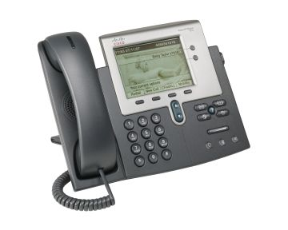.)

With SIP trunking, many calls can be free of charge by utilizing a company’s LANWAN connection. Call costs with VoIP are usually much lower, and installation and maintenance costs are less than with traditional PSTN lines. However, replacing existing PBX with analog phones will be a big challenge due to big upfront cost.

The following diagram is one of ShoreTel’s many System Designs. You can review more designs on its website WWW.BTS1981.com
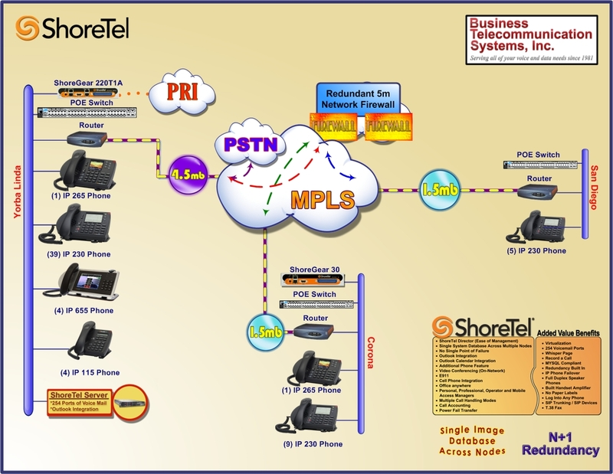
ShoreTel should consider developing a simple pricing and licensing model in order to complete with Cisco’s complex pricing and licensing model in order to win more customers who prefer to use Cisco and other vendors’ UC solutions due to vast resources available in house and fields.

Challenge:

- Since Cisco has an excellent reputation in UC solutions’ arena and a robust and complete portfolio of UC functionality and many different phone portfolios, which can offer a wide range of low-priced IP phones to any customers in order to compete in this competitive market; many customers like to adopt Cisco UC solutions, if the total cost of ownership (TCO) is not too much difference with other UC vendors’ offering, besides Cisco can take advantage of its dominant network infrastructure (switches and routers) in most Enterprises. As a result, neither HP Procure switches nor Juniper switches will be ever needed to be purchased in the implementing a total UC solutions.

- ShoreTel, like Nexsan (http://www.nexsan.com/), has fewer marketing resources than many of its UC competitors.

- ShoreTel doesn't currently offer its own multipoint video functionality and relies on Polycom’s as an alternative solution.

- ShoreTel’s flagship high-end appliance (SG220T1 or SG 220T1A) can support 220 audio users (IP phones) with Microsoft Outlook integration without PRI line. In a traditional environment with multiple PRI lines, each appliance can only support from 70 to 100 audio users due to the ratio of 5 to 1 for losing 120 IP phones once one PRI line is used (note: each SG220T1/220T1A can only support one PRI line). This big overhead means it is designed for small and up to small percentage of midsize business (SMB) market. Although it can be scaled to support 20,000 users in a distributed architecture with a single Director Web administration application to manage the multiple appliances, this will create multiple power sockets in a large enterprise environment.

- Most organizations are still relying on the existing digital PBX because it will be too expensive to replace an existing digital PBX with a VoIP PBX. By doing so, it requires to purchase (1) a new IP PBX; (2) new IP phones; (3) an expensive IP PBX with UC Infrastrure; (4) communicator clients and (5) training classes etc.

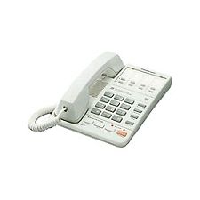
- The cheapest IP phone’s MSRP is $159.00 vs. a Panasonic Easy Phone KX-T2315 (Analog phone) at $29.95, as shown in the screenshot below:

- Using web conferencing with analog phones, most organizations can still complete the same tasks quickly to achieve the same goal.

- ShoreTel VoIP system does not support SIP trucking very well at this time.

- ShoreTel provides its proprietary IP phones as well as SIP phones.

Recommended Reading:

- How New York City is going to Consolidate 50 Data Centers from 40 City Agencies into One Location:
http://www.informationweek.com/news/government/state-local/229219575

- NASA uses Amazon's cloud computing in Mars landing mission
http://www.latimes.com/business/technology/la-fi-tn-amazon-nasa-mars-20120808,0,3551686.story

- The New York Public Library is Powered by Google Cloud
http://www.nypl.org/collections/articles-databases/google-book-search

4. Debunking the Myth of the Single-Vendor Network
http://www.dell.com/downloads/global/products/pwcnt/en/Gartner-Debunking-the-Myth-of-the-Single-Vendor-Network-20101117-published.pdf

Acknowledgement

Thank Robert Ingrum, VP IP Telephony, LANAIR Group, LLC (
http://www.lanairgroup.com) for presenting a one hour and a half webcast, titled ShoreTel System Review on Oct. 2, 2012.

Thank Wade Bowling, Area Sales Manager from ShoreTel, for presenting a live demonstration of ShoreTel system with UC at the office of the Calnet Technology Group (http://www.calnettech.com), Oct. 12, 2012 and Jessica Jae for arranging this live demonstration.

Thanks for Business Telecommunication Systems, Inc. and Lanair Group, LLC for the courtesy of one diagram, which is used in my notes, respectively.

