Aug, 02, 2012
Jeremy Li

Notes from Veeam Training Video

1. Restore an AD object - Veeam's AD AIR (Application Item Recovery) - http://dl.dropbox.com/u/61607552/AD%20Restore.mp4

- Click “Restore” button and select radio button of Application items, shown in the screenshot below and click “Next” button to continue:

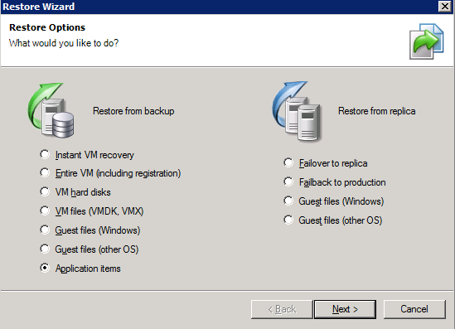

b) Check radio button of Microsoft Active Directory, as shown in the picture below:

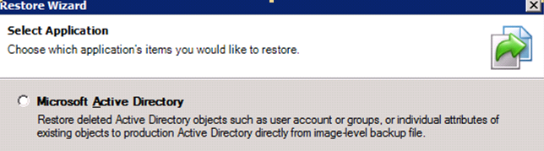

c) Download & install Veeam_B&R_AD _AIR_Setup.exe on the Veeam server by typing the IP address of the Enterprise server etc.

Note: If the AIR has been installed, just skip the above steps.

2. Restore an AD object

Let’s assume a user object (David Davis) in the AD was deleted.

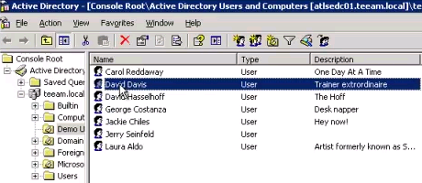
Note: David Davis should be deleted prior to the AD recovery process.

a) Under “SureBackup” section, select “Jobs” and right-click on the SureBackupJob 1 and select “Realtime statistics...”, shown in the screenshot below:

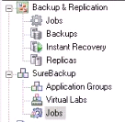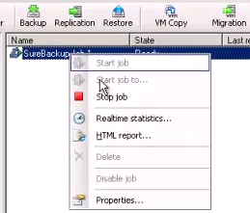

b) Right-click on the AD server (ATLSEDC) and select “Active Directory item recovery”, as shown in the screenshot below:

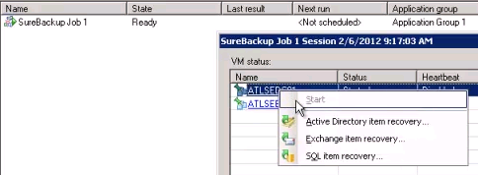

c) Follow the onscreen instructions, and type the right into in a box until the end of the wizard:

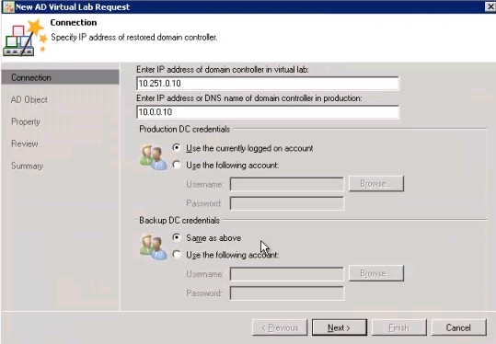

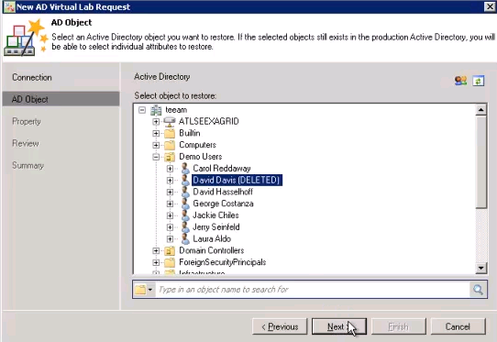
Note: David Davis (DELETED) was deleted prior to the AD recovery process.

d) Uncheck the box of “Enable users”, shown in the picture below, because a password of the user to be restored will not be restored.
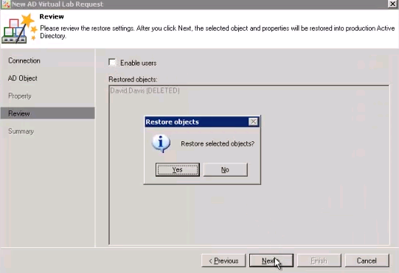

e) Click “Next” button and “Yes” button to continue.

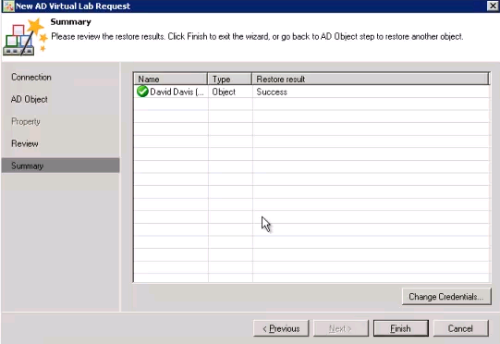

f) Click “Finish” button to continue.

3. Enable a user and reset a password for a restored user

a) With AD-snap in, reset a password, as shown below:
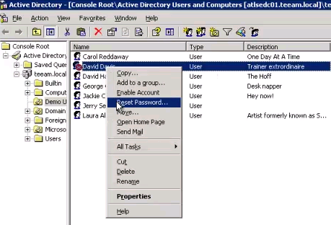
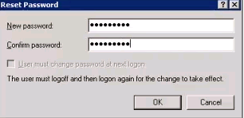

b) Enter a new password and click “OK” button to end of the restoration!

