July, 31, 2012
Jeremy Li

Notes from Veeam Training Video

Restore an Exchange Mailbox or Item - Veeam's Exchange AIR (Application Item Recovery) - http://dl.dropbox.com/u/61607552/Email%20Restore.mp4

- Click “Restore” button and select radio button of Application items, shown in the screenshot below:

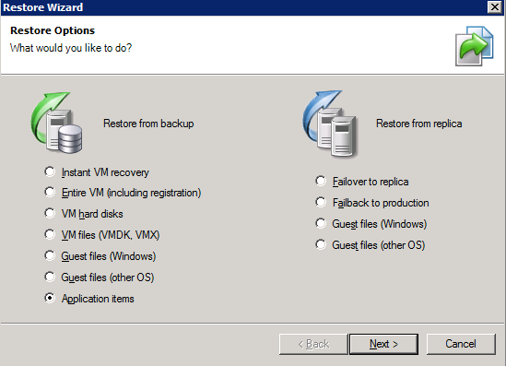

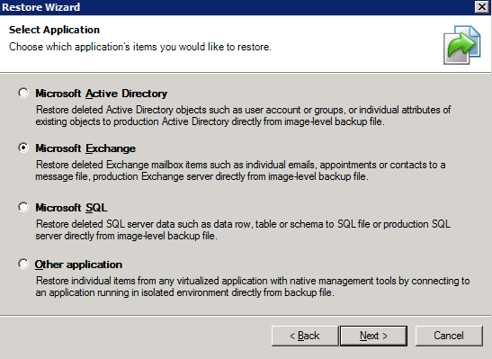
Download & install Veeam_B&R_Exchange_AIR_Setup.exe on the Veeam server by typing the IP address of the Exchange server etc.

- Under SureBackup section, select “Jobs” and right-click on the

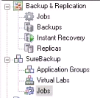 Exchange server and select “Restore Exchange Item”, as
shown in the screenshot below:

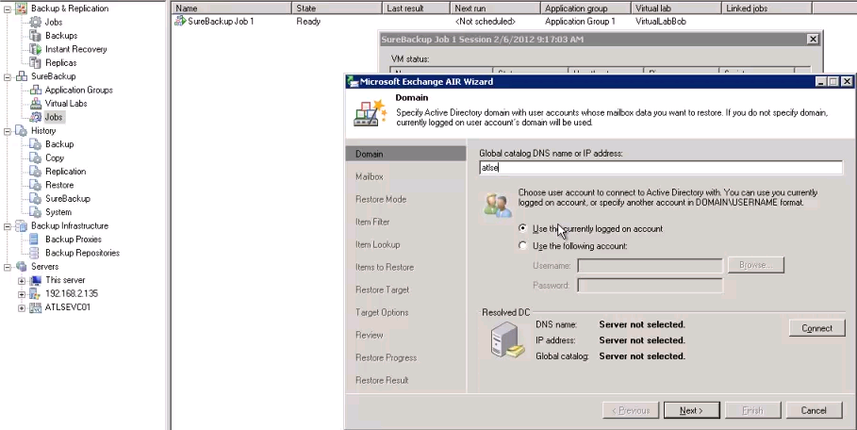

Follow the onscreen instructions, and type the right into in to a box until the end of the wizard:

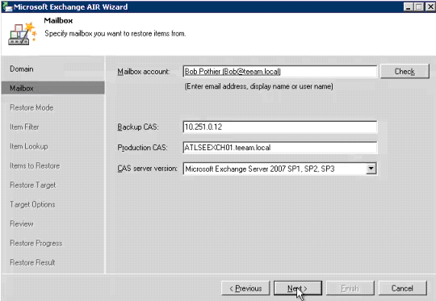
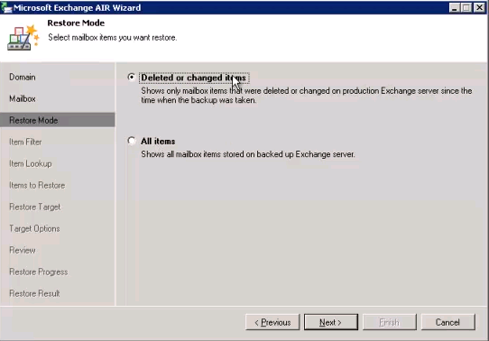

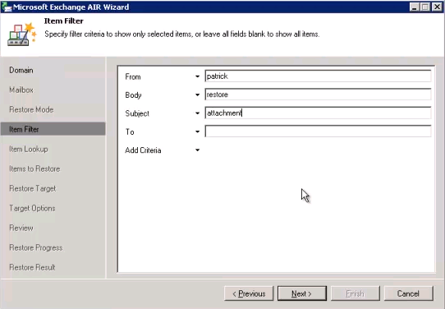

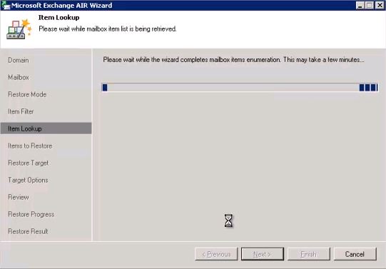

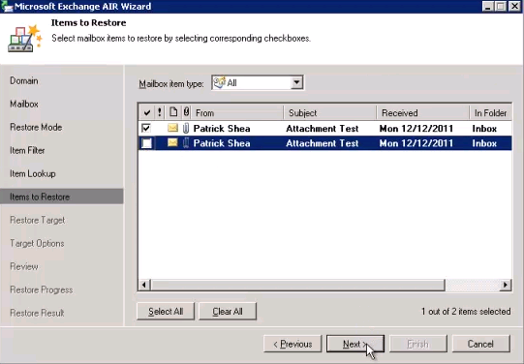

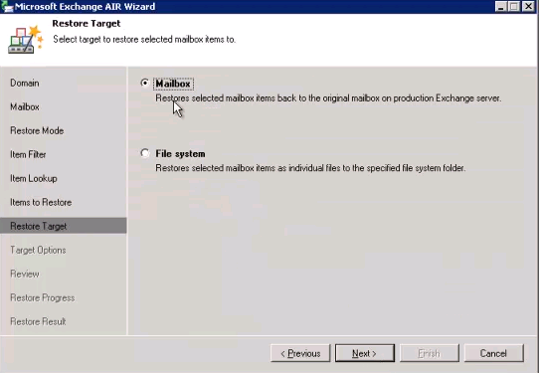

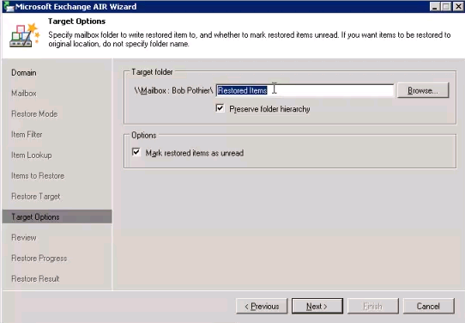
Note: This is a restored folder that will appear inside an inbox at Outlook client

Click “Next” and “Restore” button to continue.

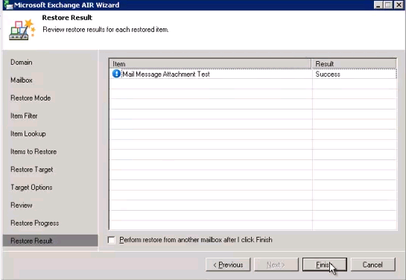

3. Now, log in to the mailbox. The “Restored Items” folder should be there, as shown in the screenshot below:

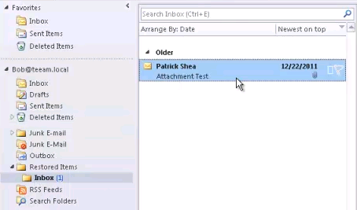

Verify the restored item – email.

The end of the restoration!

Reference: http://www.veeam.com/blog/exchange-backup-recovery.html

