Aug, 02, 2012
Jeremy Li

Notes from Veeam Training Video

1. Restore SQL - Veeam's AD AIR (Application Item Recovery) - http://dl.dropbox.com/u/61607552/SQL%20Restore.mp4

- Click “Restore” button and select radio button of Application items, shown in the screenshot below and click “Next” button to continue:

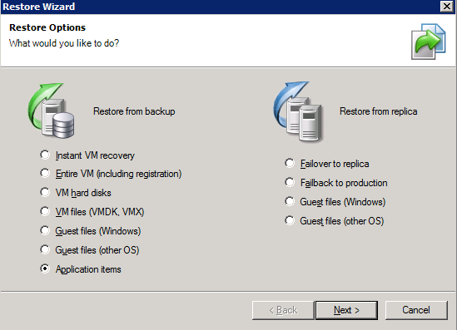

b) Check radio button of Microsoft Active Directory, as shown in the picture below:

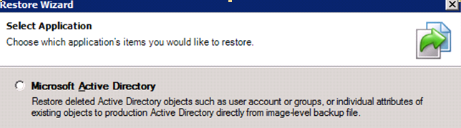

c) Download & install Veeam_B&R_SQL _AIR_Setup.exe on the Veeam server by typing the IP address of the Enterprise server etc.

Note: If the AIR has been installed, just skip the above steps.

2. Restore an AD object

Let’s assume a user object (David Davis) in the AD was deleted.

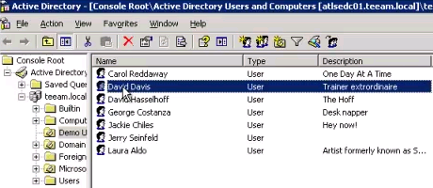
Note: David Davis should be deleted prior to the AD recovery process.

a) Under “SureBackup” section, select “Jobs” and right-click on the SureBackupJob 1 and select “Realtime statistics...”, shown in the screenshot below:

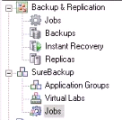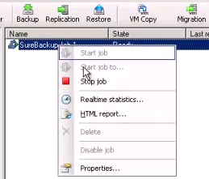

b) Right-click on the SQL server (ATLSESQL) and select “SQL item recovery”, as shown in the screenshot below:

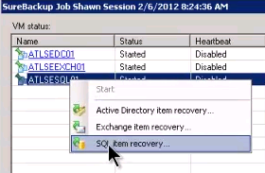

c) Follow the onscreen instructions, and type the right into in a box until the end of the wizard:

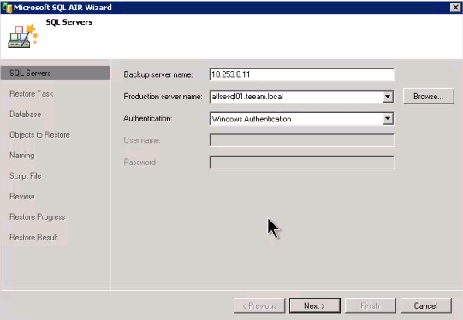

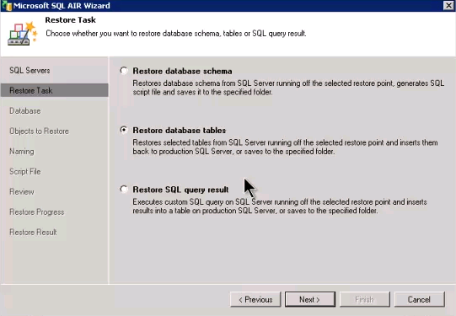

In this restore, “Restore database tables” is chosen
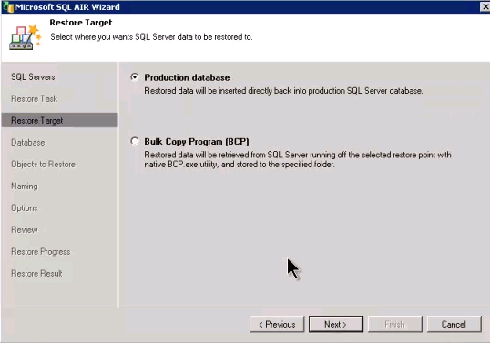

Note: If you would like to restore to a file, then, “Bulk Copy Program (BCP)” should be selected.

d) Select database table, shown in the picture below

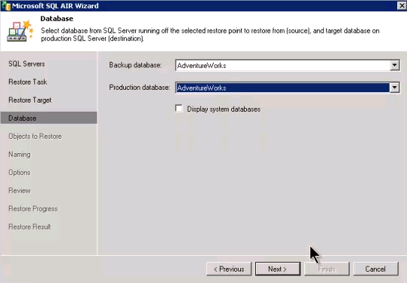

e) Select “UniMeasure” under column name, and click “Next” button to continue.

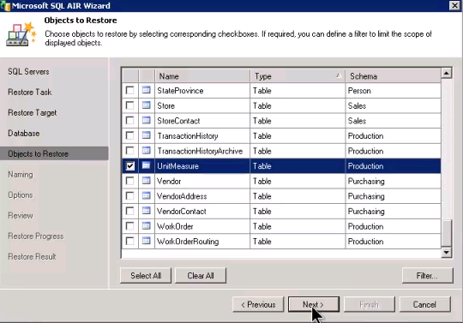

f) Click “Next” button to continue.

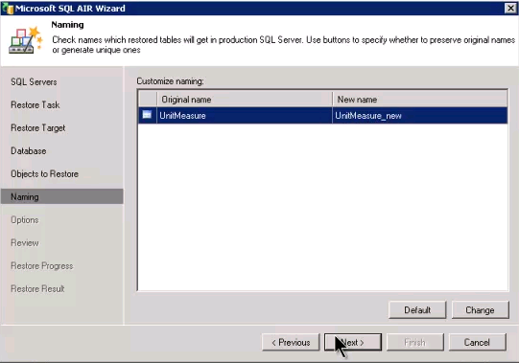

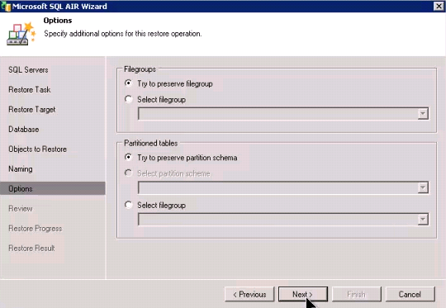

g) Click “Restore >” button to continue

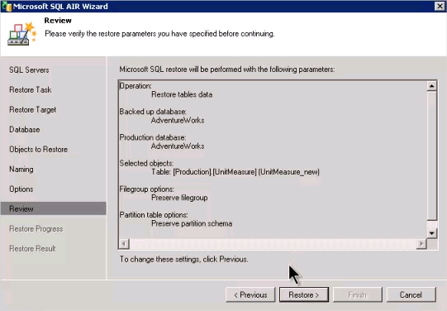

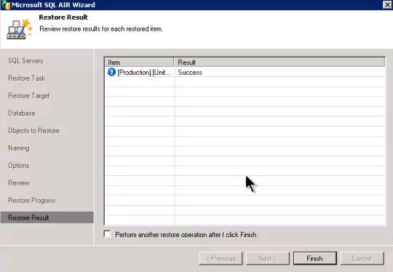

That’s the end of the restoration for a SQL table!

