July, 30, 2012
Jeremy Li

Credit: Batman Premiere at LA Live with Nimble Storage, VMware, Softchoice and Veeam - Super Powers in the Datacenter, July 27, 2012

Veeam - www.veeam.com

Veeam Version: 6.1.0.181 Setup:

I. Download a trial version by clicking on the link below:
http://www.veeam.com/vm-backup-recovery-replication-software.html?ad=home and follow the on screen instruction, as shown in some screenshots below:
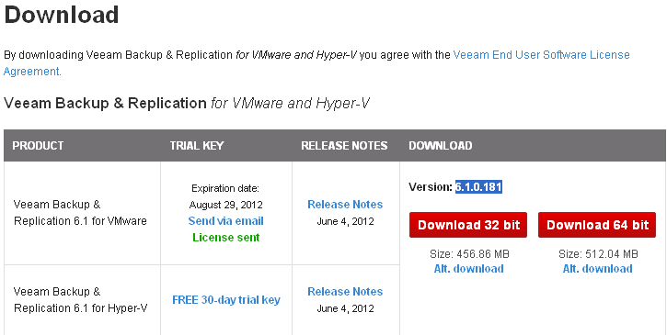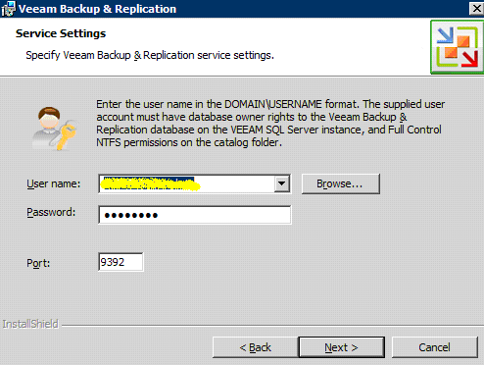

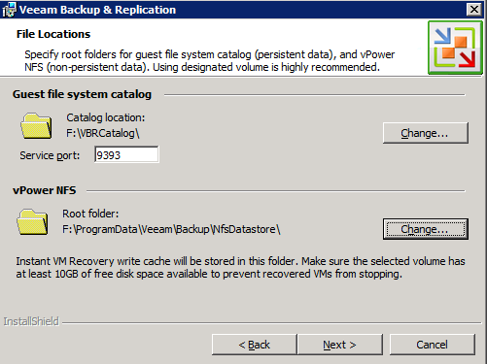

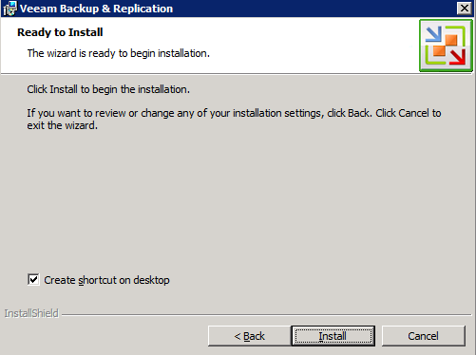

Click “Install” button to start the installation.
The end of the installation – Success!
Add a new VM server:

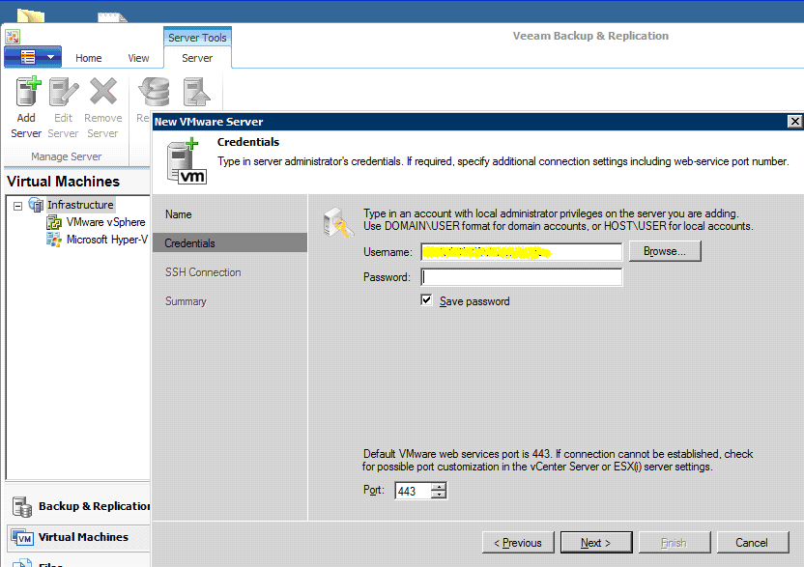

Note: Using account “Root” as a username since the VMware Host is not a part of the domain.

Veeam recommends:
- Join a VMware host into a domain so that many servers will not be required for an additional authentication
- If two VMware hosts are installed, the v-Center should be installed because the v-Center can continue to manage failed-over VMs.

That’s the end of downloading and installation, including adding a new VM into the Veeam Server for a protection!

Additional Reading:

The following notes taken from watching a Full VMware Demo - http://dl.dropbox.com/u/61607552/Full%20Demo.mp4

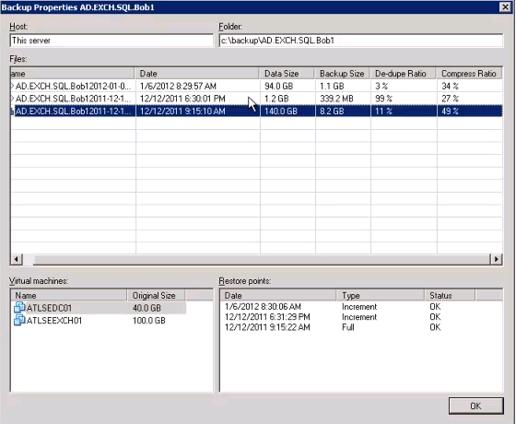
One DC + One Exchange in single backup set

- At 9:15:10AM backup: With full backup of both DC and Email server and with De-dupe ration at 11%, 89% of white space (000…000…000) with124.6GB size (89% * 140GB) has been removed since it does not make any sense to backup all zeros, 8.2GB backup size was created.

- At 6:30.01 PM backup, 1.2GB worth of changed data was backed up. Since one DC has no change, most data came from new emails. Therefore, there is almost no duplicated info to be removed. As a result, only 1% duplicated info is removed, but 27% compress occurs on this changed backup. The backup size is only 339.2MB, which is a huge disk space savings.

Note: The original 140GB data is reduced to 8.2GB as back up file size. This will greatly reduce the WAN replication bandwidth.

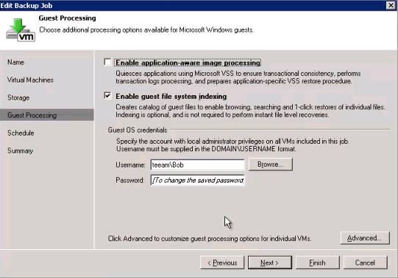

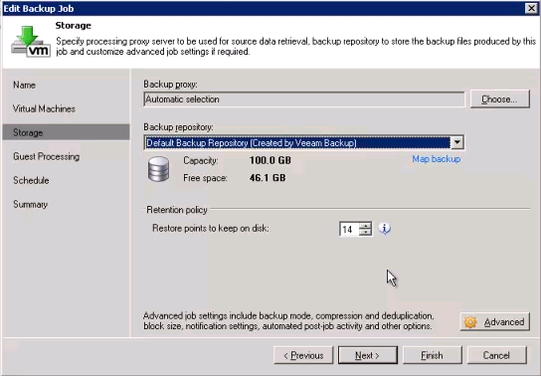

Restore points are the frequency how often I want to run a backup job multiply by retention period. For example, 30 times a month, 420 points will be created (30*14 days). For every hour backup for 30 days, 24 * 30 * 14 = 10080 restore points will be created.

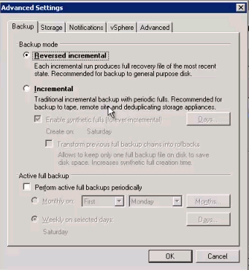

Reversed incremental:

Create one full backup, then, forever incremental backups. For example, if it is configured on August 1, 2012 for one month backup, the full backup occurs on Aug. 1, 2012, then, daily backups will be created as incremental until Sept. 1, 2012 - one full backup will be created again.

The advantage of the reversed incremental is to save disk space due to single full backup being used monthly.

Incremental:

Best scenario is for off-site backup. For example, on Monday, one full backup is created and an incremental backup is created from Tuesday to Friday. A Saturday Full backup is created by incorporating with all incremental backups from M-F to create a new full synthetic backup for an off-site archiving purpose.

The disadvantage of the Incremental backup is to consume large disk space due to multiple full backups being used weekly.

In order to reduce the disk space consumption, check the box, as shown below to keep single copy of full backup on the network or backup server:

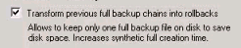

Active full backup:

If an agency requires a weekly active full backup due to an existing policy, the option can be chosen.

Advanced Settings:

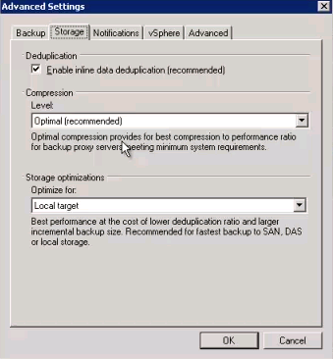

Compression ratio:

None: if a de-dupe appliance is being used
Optimal: 5:1
Low: 2:1
Best: 10:1

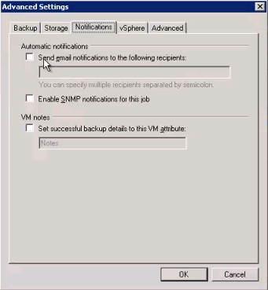

If you have a third party SNMP program listening to those notifications after the job completion, check the box of “Enable SNMP notification for this job”.

Changed block tracking:

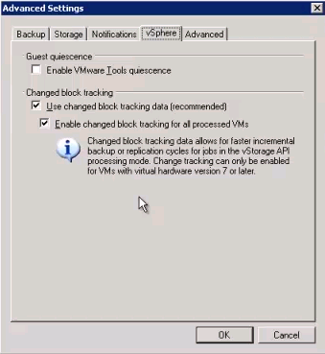

This feature comes from VMware. However, by default, it is turned off. If you have version 7 or later, turn on this feature to speed up the backup perform by up to 10 times.
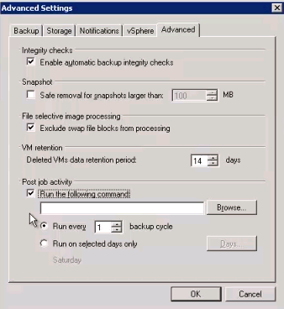

The end of the setup!

Backup:

- Network Throttling

Click “Tool” and “Traffic Throttling”

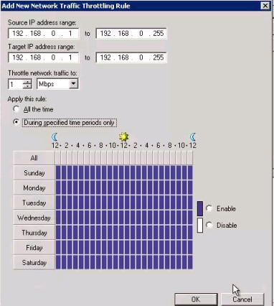
to control the network traffic.
- Re-IP Table

Primary and DR sites’ IP addresses are different. (http://www.veeam.com/KB1522 )

Watch Replication video for details: http://dl.dropbox.com/u/61607552/Replication.mp4

- More other features – to be continued…

Restore:

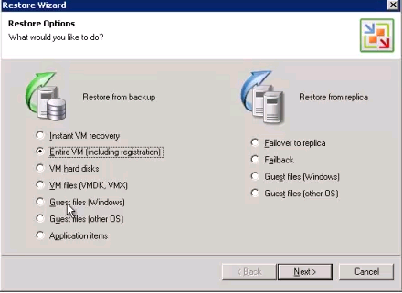
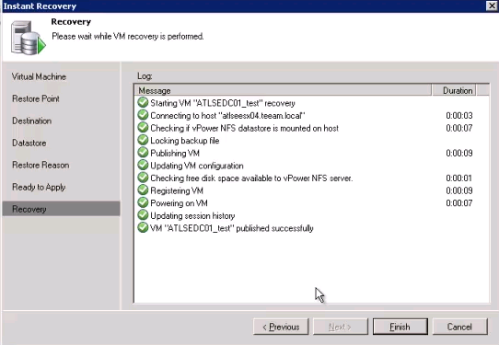

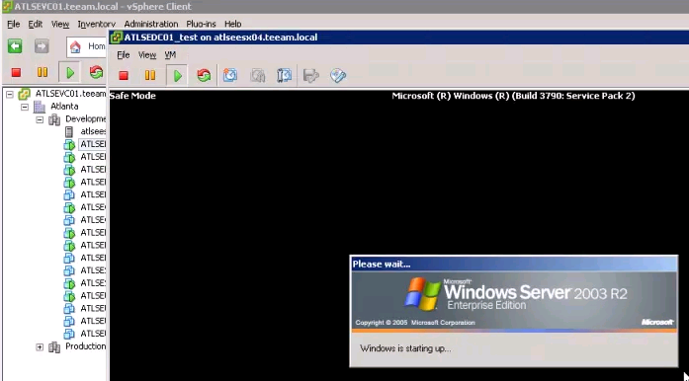

Due to a Domain Controller (DC), it will start with a safe mode first, then, shut down and restart.

Due to this DC running from a backed up file from a restored device with compressed and de-dupe turned on as a temp solution – as instant VM, the performance will be slower. It is acting like a spare tire for the time being. It gets business running and achieves “BCP” purpose.

Migration (New feature in Version 6)

1. Add the instant VM to a production DC by clicking “Add” button:

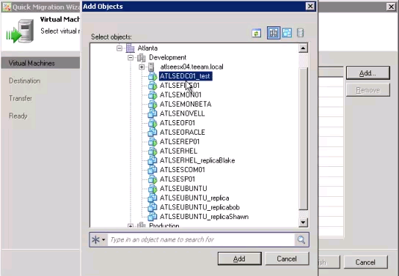

Then, move it to the production by clicking “Browse” button, as shown below:

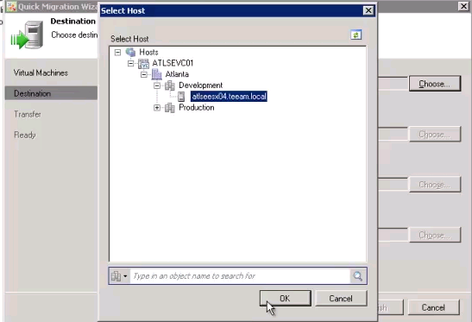

Click “OK” button to continue.
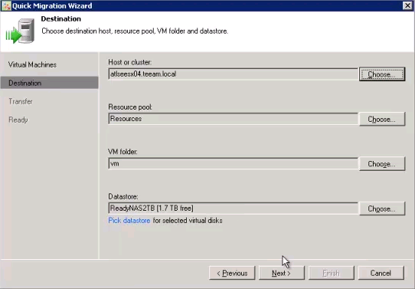
Choose where is the production Datastore

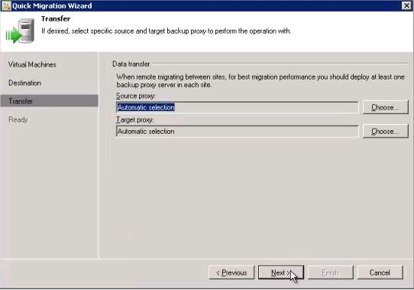

Click “Next” button to move the instant VM into a production VM (DC).

Note: While the instant VM is running, the production VM will extract this instant VM from the backup file into the production VM and merge all changes stored in the cache file located on the backup server into the production VM without touching the original backed up file serving as an instant VM for the time being. When the instant VM is turned off, the changed files will also be deleted without affecting the original backed up file.

Additional features:

- SureBackup
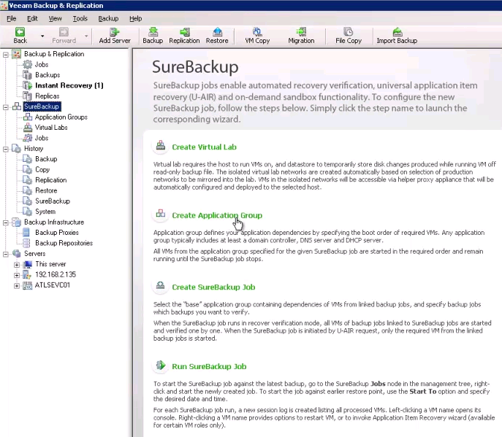

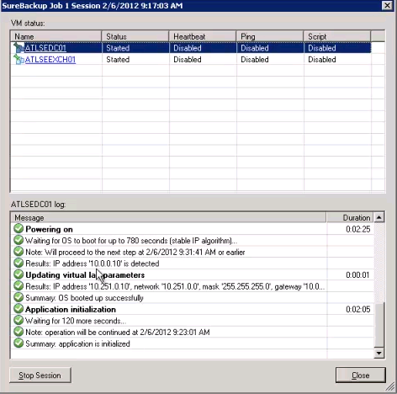
The DC IP Address 10.0.0.10 and a masqueraded IP address 10.251.0.10 are separate by a proxy (firewall).

The big advantages for testing something inside of a virtual lab:

- Testing the old backup (in this case, a DC)
- Testing for the updates and the patches
- Testing for a new installed application

Don’t risk a production VM. Testing, testing and testing.

- Application Item (Active Directory Item Recovery)

- A user David Davis has a description (attribute) as Trainer extortionate in the old backup.
- Now, change it to “Demo test”.

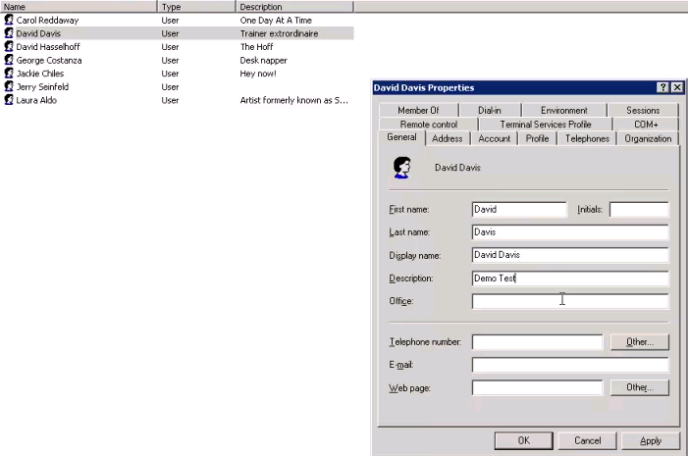

- Go to “Job”, select “DC” and choose “Active Directory item recovery…” as shown in the screenshot below:

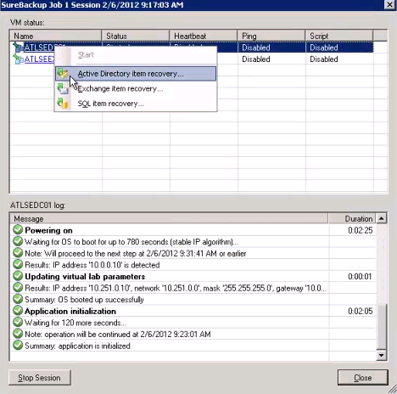

- Now, follow the on screen instructions:

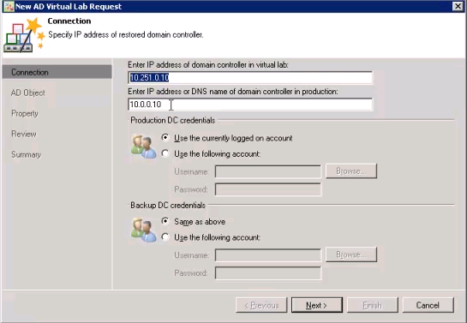
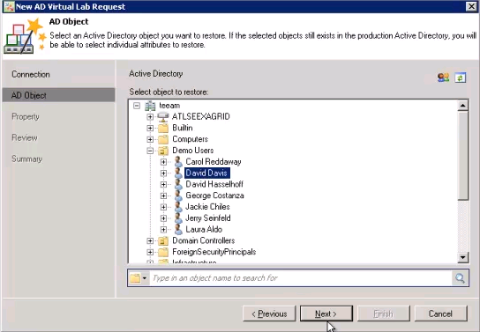

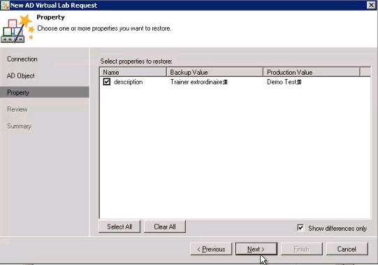
As you can see, the description from the old backup and in production is different.

- Restore the old description into the production.

Click “Next” button, as shown in above screenshot, and “Finish” button to end of the restoration!

f. Now, go back to check the restored value via AD snap-in, as shown below:

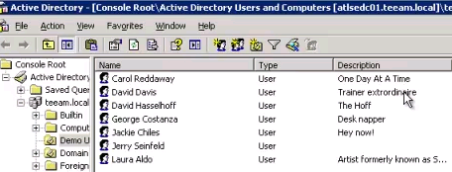

The old description was restored successfully

Note: The Application Item can restore user, group, objects and individual attribute.

- Veeam Backup & Replication (At a testing environment)

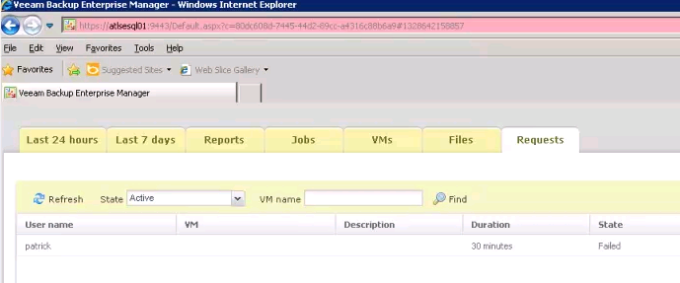

Note: The following screenshots came from a real lab environment and verified by the author.

- Add Backup Repository
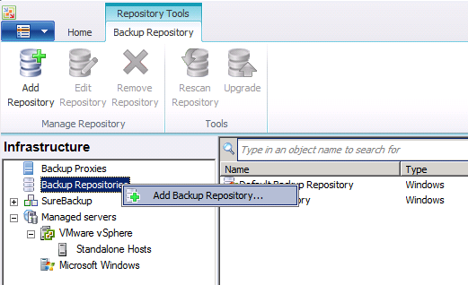
Follow on-screen instructions listed below:

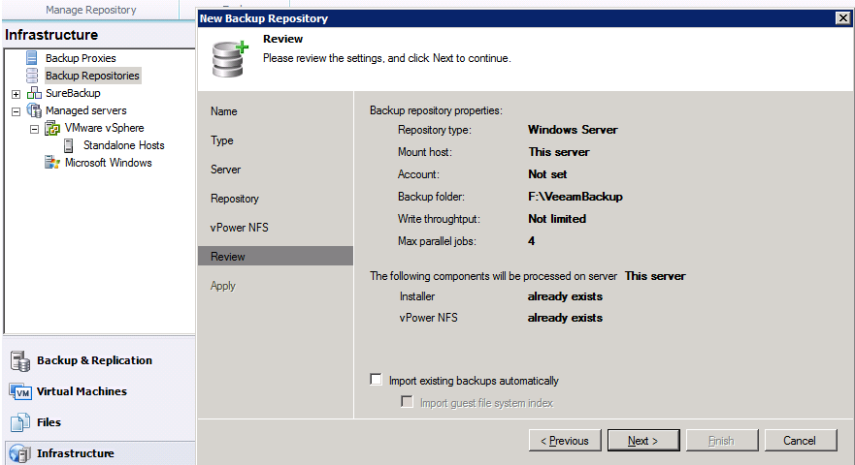

Click “Next button” to continue

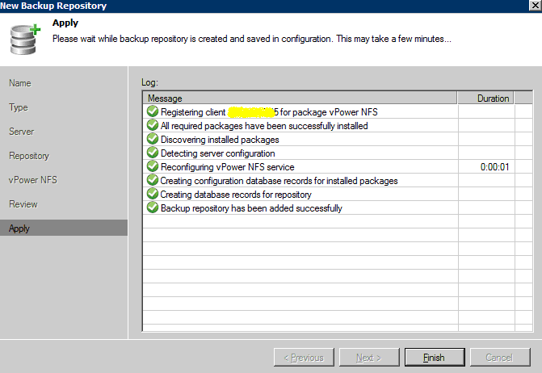

- Create a new backup job:

Enter any name under the Name box:
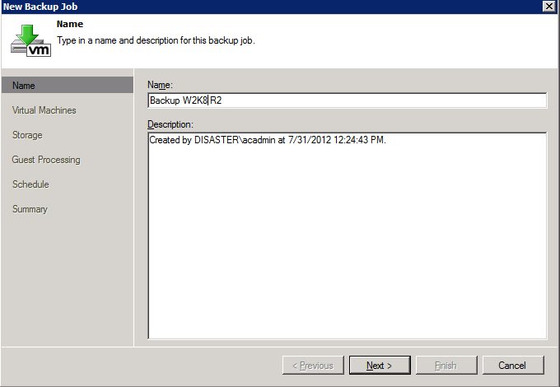

Add servers as a group (e.g., separate all Windows servers with Linux servers for a better de-dupe ratio).

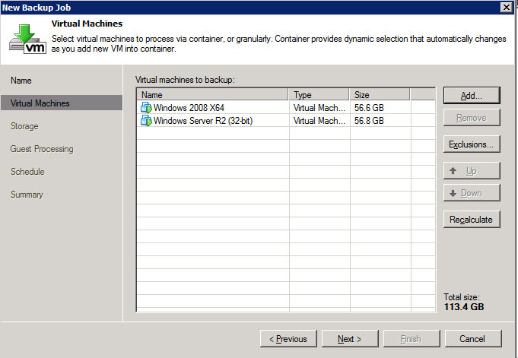

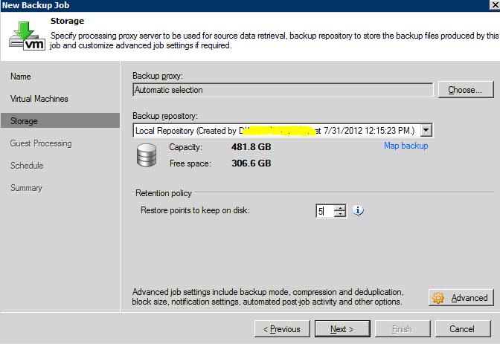
Note: Domain\Account is masked out for security reason.

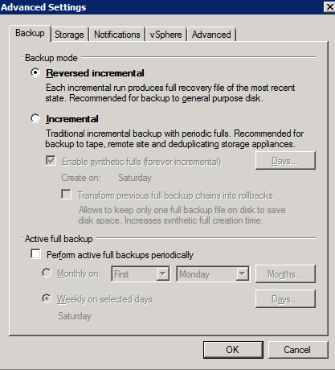

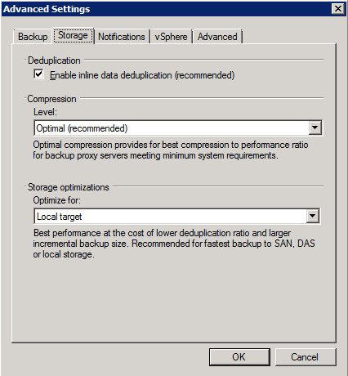

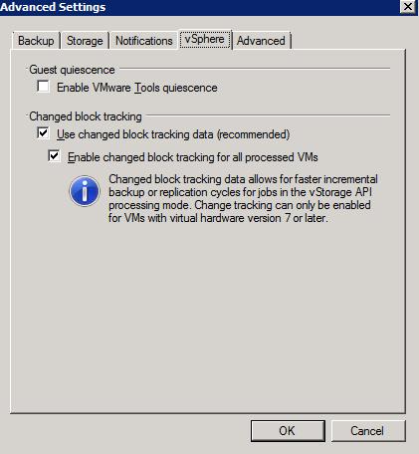
For Linux server, check the box of “Guest quiescence”; for Windows, use Microsoft VSS for better performance.

The changed block tracking (CBT) was created by VMware. Veeam just relies on the CBT to perform the changed backup. That’s the reason the backup performance is much faster when the feature CBT is turned on.

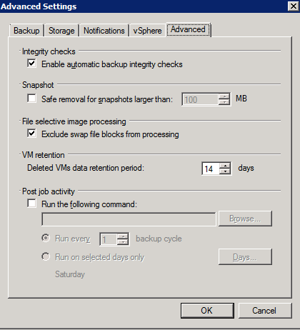

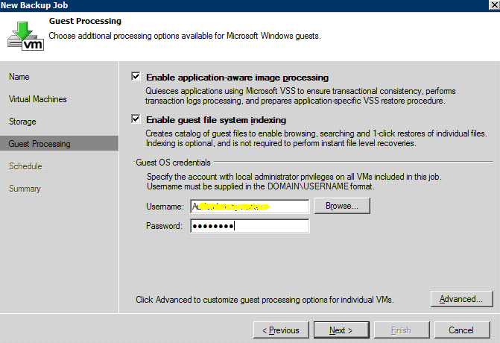
Note: Use a regular backup service account here.

Click “Next” and “Finish” button to complete the task.

