August, 02, 2012
Jeremy Li

Credit: Batman Premiere at LA Live with Nimble Storage, VMware, Softchoice and Veeam - Super Powers in the Datacenter, July 27, 2012

Veeam - www.veeam.com

Restoring one VM (Windows Server 2008 R2) at a testing environment

1. Shut the Windows Server 2008 R2 down (Simulate a VM crashed)

2. Remove the VM from Inventory and click “Yes” button to complete the task, as shown in the pictures below:

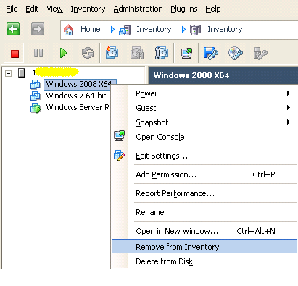
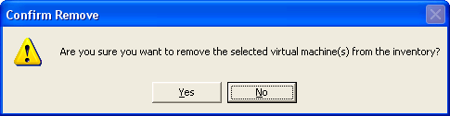

Now you will see the Windows 2008 R2 X64 is no longer in the console screen, as shown in the picture below:
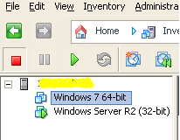

3. Rename the VM folder in Datastore (This step is not necessary)

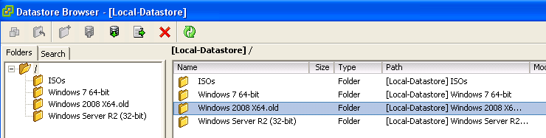

- On the Veeam server, click “Instant VM Recovery vPower” button, and select the restore point and click “Next” button, as shown in the picture below:

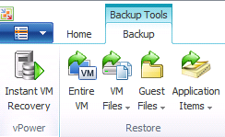
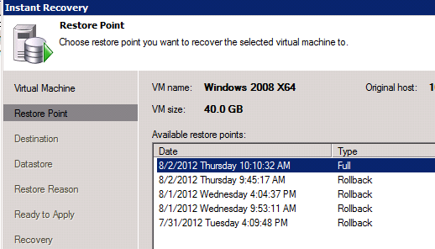
- Choose the Host (IP Address) and check two boxes, as shown below:

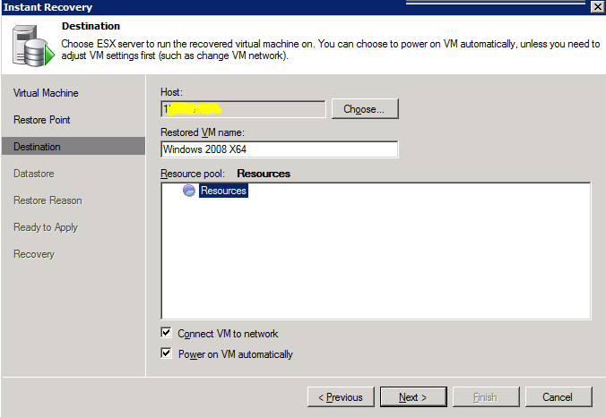

Click “Next” button to continue

- Datastore: Click “Next” button to continue

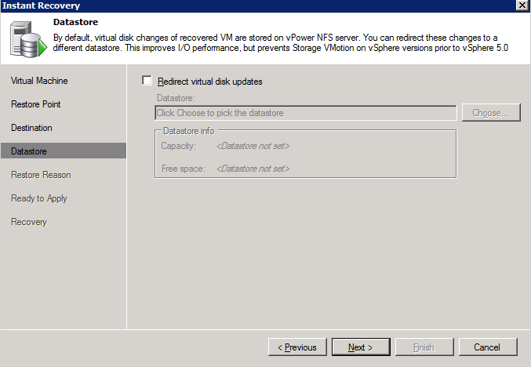

- Restore reason: Click “Next” button to continue

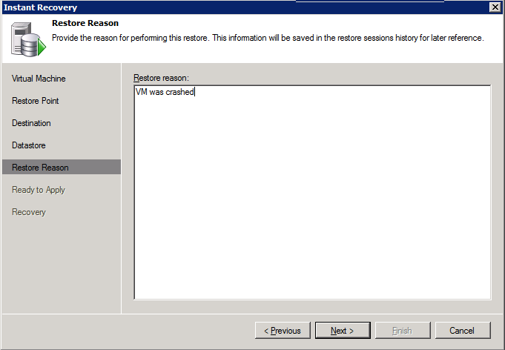

7. Ready to Apply: Click “Next” button to continue

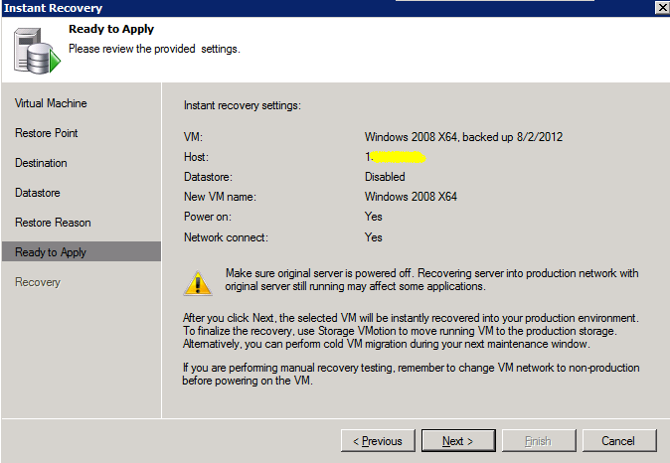

8. Instant Recovery (It only took a few seconds): Click “Finish” button
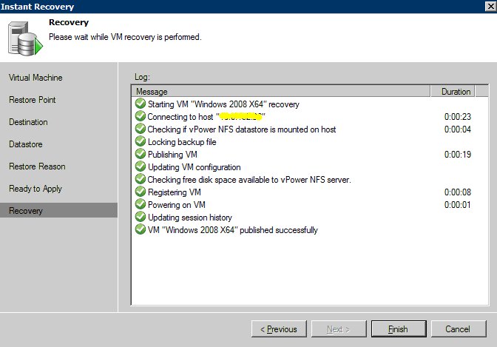

9. Go back to VMware console. The instant VM is appearing, as shown in the picture below:

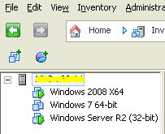

10. Log in to the Windows Server 2008 R2

Log in to the server with a success, as shown in the picture below:

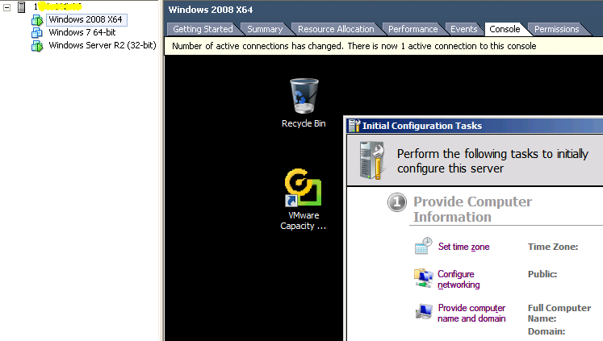

Please note that the Instant VM is running from a compressed and deduplicated backup file from a Veeam Server, as shown in the picture below:

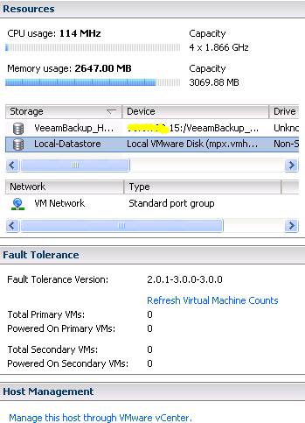

Therefore, the performance will be affected. For a best practice, move the Instant VM Recovery VM to the production ASAP.

Click http://www.veeam.com/vmware-backup/help-center/hyperv/index.html?quick_migration.htm for the quote:

“Veeam Quick Migration was designed to complement Instant VM Recovery. Instead of pulling data from vPower NFS datastore, Quick Migration registers the VM on the target host, restores the VM contents from the backup file located in the backup repository and synchronizes the VM restored from backup with the running VM.”

Check the current Datastore, it is still the same prior to the Install VM recovery process.

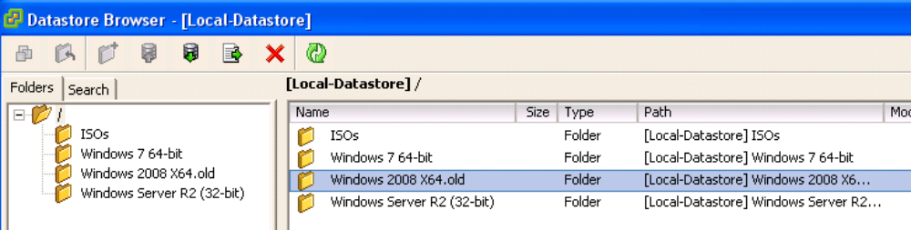

- Moving the instant VM into a production

With V-motion, it is an automatic process. But, since the current lab does not have a v-Motion installed, a manual operation is required by using “Veeam Quick Migration” method:

a) Right-click VM name, and select “Migrate to production”, as shown in the picture below:

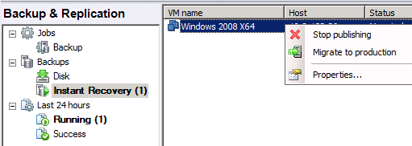

b) Select VM to migrate to a production host and click “Next” button to continue
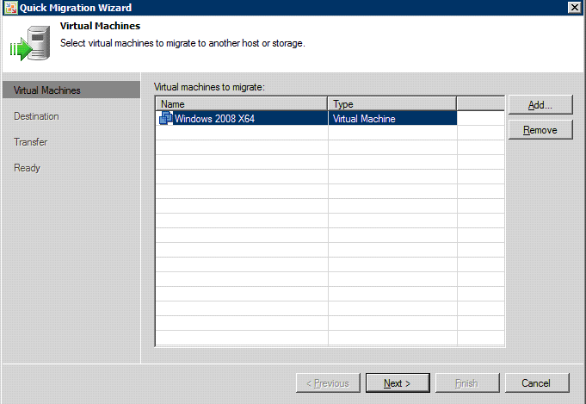

c) Choose a Host and associated Datastore from a production host and click “Next” button to continue, as shown in the picture below:

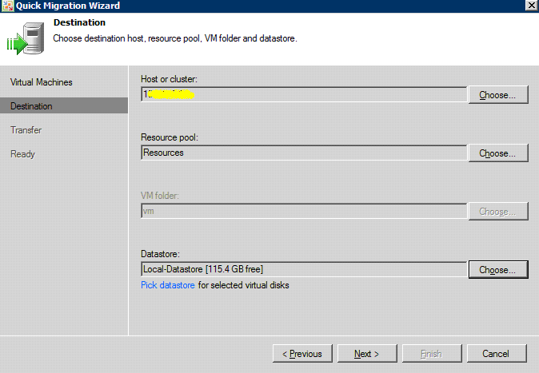
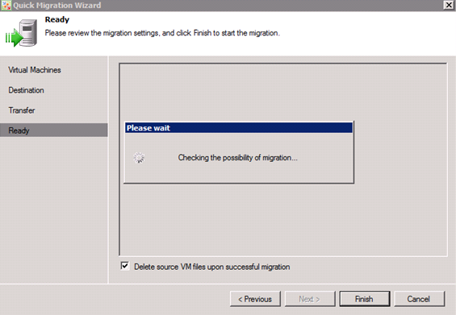

d) Leave the Source and Target proxy by default and click “Next” button to continue, as shown in the picture below:

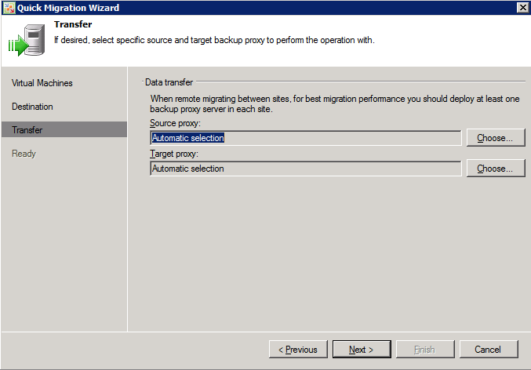

e) Click “Finish” button to start the migration, as shown in the picture below:

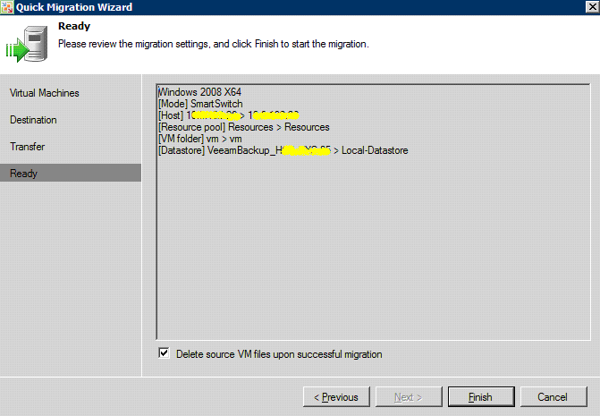

f) The job progress status window is shown in the picture below:

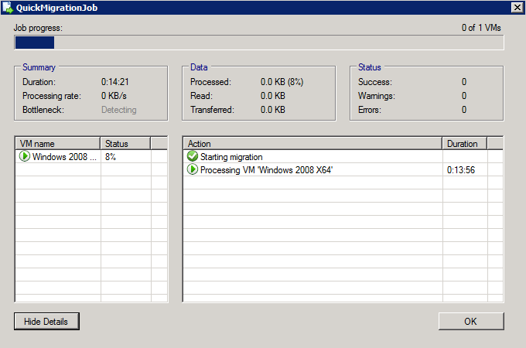

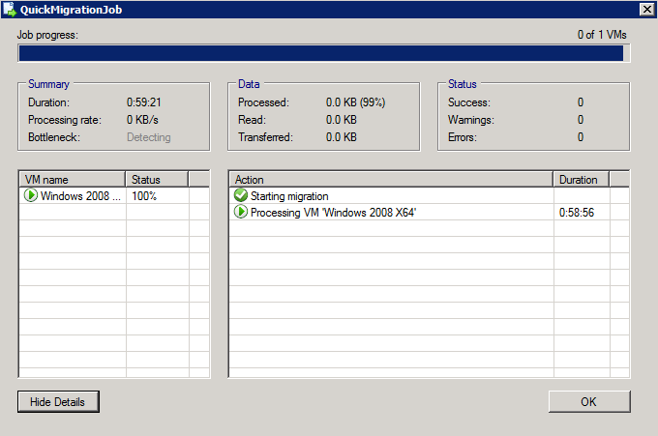

Verify that Datastore has the OS folder and vSphere Client console, as shown below:

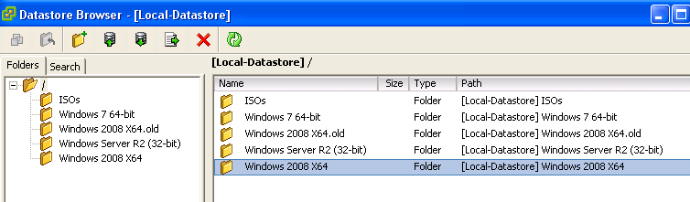

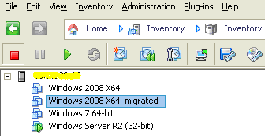

The end of the complete restoration!

