August, 02, 2012
Jeremy Li

Credit: Batman Premiere at LA Live with Nimble Storage, VMware, Softchoice and Veeam - Super Powers in the Datacenter, July 27, 2012

Veeam Software - www.veeam.com

Veeam has won 18 Biggest Awards in Virtualization Industry, including BEST OF vmworld 2011 GOLD AWARD and BEST OF vmworld 2010 GOLD AWARD in New Technology category.

Veeam has reached 42,000+ customers as of today and 1,500+ new customers are added every month, as illustrated in one of the slides listed below during the 10-minute presentation at Regal Cinemas L.A. LIVE, July 27, 2012.
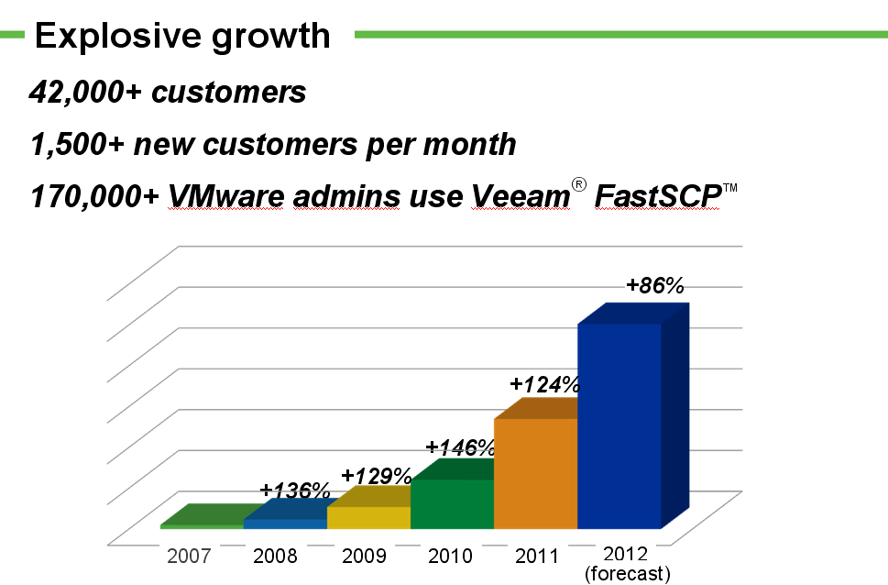

In 2011, Veeam released Backup & Replication V5 with vPower for five new features, listed below:

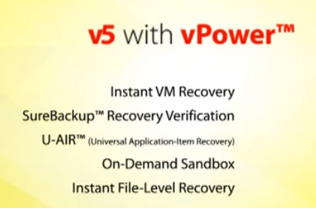

In 2012, Veeam released Backup & Replication V6 that emphasized three key areas:
- Enterprise Scalability with large deployment in mind
- Advanced Replication (10X faster than V5)
- Multi-hypervisor Support (Add Microsoft Hyper-V support)

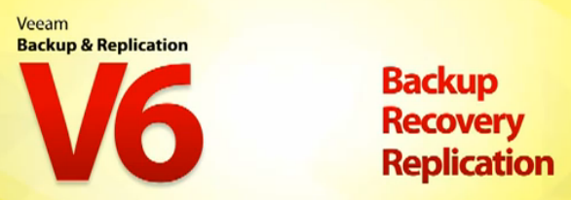

With 1 CLICK FILE RESTORE, a user can restore a file quickly.

Advance Replication has the following new features:
- Real Failback
- Delta Sync
- Improved Seeding
- Traffic throttling
- Active rollbacks
- Cluster targets

Veeam’s extremely easy and powerful backup & restore software can be categorized as one Download, one Install and one Product.

Author would like to verify the above statements and decided to download the latest V6.1, install it on a 6-year old HP DL360G5 server as a Veeam server on a testing environment with one VMware ESXi 5.0 host on a 6-year old HP DL380G5. Click on the following link below to verify the download and installation process:

http://www.lacaaea.com/vendors/Veeam-Setup-P.pdf

Restoring one VM (Windows Server 2008 R2) via Install Recovery feature

Click on the link below to verify the successful VM recovery:

http://www.lacaaea.com/vendors/Veeam-VM-Restore.pdf

Additional Reference:

Exchange Items Recovery:

http://www.lacaaea.com/vendors/Veeam-Exchange-DR.pdf

Active Directory Object Recovery:

http://www.lacaaea.com/vendors/Veeam-AD-Restore.pdf

SQL Table Recovery:

http://www.lacaaea.com/vendors/Veeam-SQL-Restore.pdf

Conclusion:

Veeam claims that its Backup & Replication software is #1 Virtual Machine Backup for any size of the organization. More than 2 million Virtual Machine (VM) are being protected by Veeam’s award winning software with more than 42,000 customers globally.

Veeam Backup & Replication software can be categorized, as shown in the following screenshot:

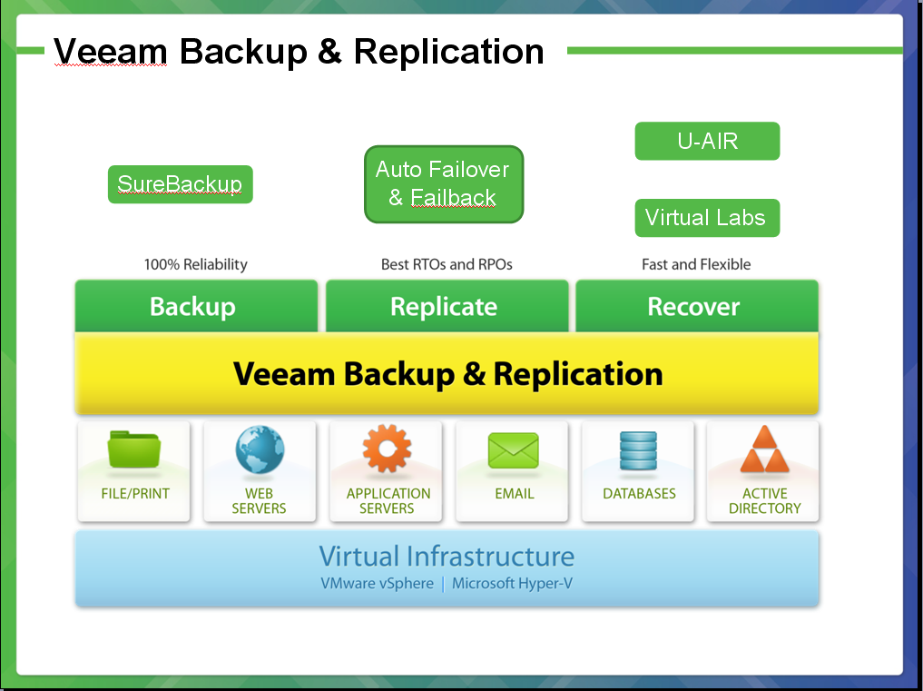

To be continued…

