August 02, 2012
Jeremy Li

Credit: Batman Premiere at LA Live with Nimble Storage, VMware, Softchoice and Veeam - Super Powers in the Datacenter, July 27, 2012

Veeam Software - www.veeam.com

Veeam has won 18 Biggest Awards in Virtualization Industry, including BEST OF vmworld 2011 GOLD AWARD and BEST OF vmworld 2010 GOLD AWARD in New Technology category.

Veeam has reached 42,000+ customers as of today and 1,500+ new customers are added every month, as illustrated in one of the slides listed below during the 10-minute presentation at Regal Cinemas L.A. LIVE, July 27, 2012.
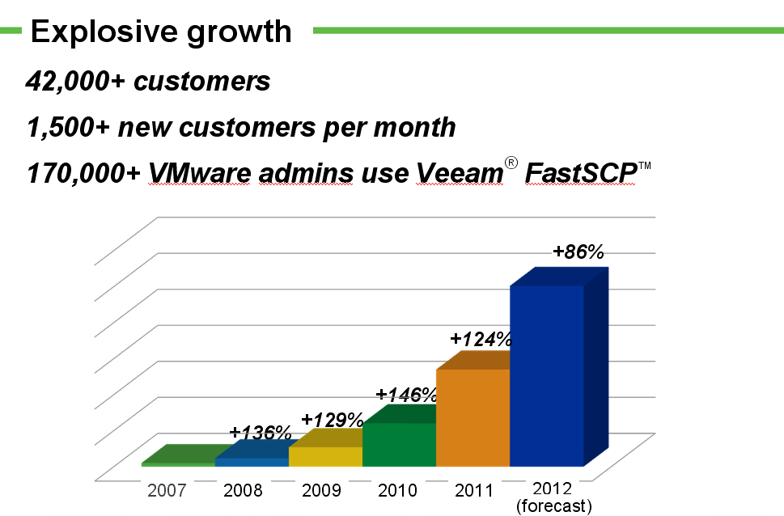

In January, 2011, Veeam released Backup & Replication V5 with vPower for five new features, listed below:

- Instant VM Recovery
- SureBackup Recovery Verification
- U-AIR (Universal Application-Item Recovery)
- On-Demand Sandbox
- Instant File-Level Recovery
In December, 2011, Veeam released Backup & Replication V6 that emphasized three key areas:

- Enterprise Scalability with large deployment in mind
- Advanced Replication (10X faster than V5)
- Multi-hypervisor Support (Add Microsoft Hyper-V support)

With 1 CLICK FILE RESTORE, a user can restore a file quickly.

In June, 2012, Veeam released Backup & Replication V6.1 for improving replication efficiencies.

Advance Replication:

Veeam replication has the following new features:

- Real Failback
- Delta Sync
- Improved Seeding
- Traffic throttling
- Active rollbacks
- Cluster targets

Sam Fawaz, Veeam Software’s Channel Systems Engineer, VMTSP, VCP, VTSP, and MCSE performed a real-time replication test to prove Veeam can perform compression and dedupe of the data to be transferred from the primary site prior to transmitting the data to the remote site. In other words, only data on the wire between proxies are compressed and dedupe. When the data arrived at the remote site, they will be uncompressed because the VMs will be published on the hosts due to VMware not be able to run VMs from a compressed and deduped state without Veeam’s vPower feature at the remote site.

The following test shows that one SQL server is being replicated for the 1st time between two sites. Notice the arrows in the screenshot below:

At the 23% of the entire replication, 8.6 GB of data are being processed (read) while only 3.7 GB of that data is being transferred to the remote site. Therefore, the data on the wire are being compressed and dedup during the process.

For Sam’s particular test, the final result was shown as below:

Processed: 36 GB
Transferred: 14.9 GB

That achieved a 58.6% reduction in the amount of data transferred.

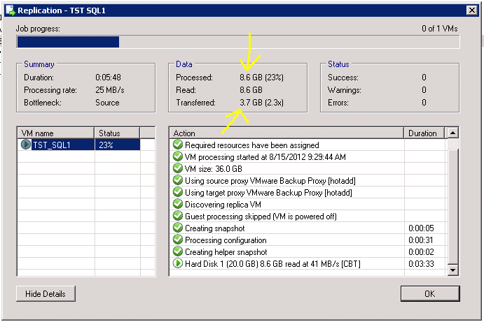

Changed Block Tracking (CBT)

Veeam V6.1 relies on a VMware feature - Changed Block Tracking (CBT) to increase an incremental backup performance by 20 times, in comparison of a traditional backup, which must scan an entire volume to look for changed file(s). The CBT is used for Backup and Replication only. The ctk is associated with a file name (e.g., vmname-ctk.vmdk or vmname-000001-ctk.vmdk). In order to use CBT, VMware hardware v7 or v8 is required.

Veeam Backup software is based on image level.

Veeam’s extremely easy and powerful backup & restore software can be categorized as one Download, one Install and one Product.

Author would like to verify the above statements and decided to download the latest V6.1, install it on a 6-year old HP DL360G5 server as a Veeam server on a testing environment with one VMware ESXi 5.0 host on a 6-year old HP DL380G5. Click on the link http://www.lacaaea.com/vendors/Veeam-Setup-P.pdf to verify the download and installation process.

Click on the link http://www.lacaaea.com/vendors/Veeam-VM-Restore.pdf to verify a successful VM (Windows Server 2008 R2) recovery via Install Recovery feature.

Additional Reference (Source: Veeam Software)

Exchange Items Recovery:
http://www.lacaaea.com/vendors/Veeam-Exchange-DR.pdf

Active Directory Object Recovery:
http://www.lacaaea.com/vendors/Veeam-AD-Restore.pdf

SQL Table Recovery:
http://www.lacaaea.com/vendors/Veeam-SQL-Restore.pdf

Veeam is going to release Veeam Explorer for Exchange2010 as a complementary add-in feature soon. For a quick overview, click on the link http://www.veeam.com/microsoft-exchange-recovery.html?ad=home for details.

Conclusion:

Veeam claims that its Backup & Replication software is #1 Virtual Machine Backup for any size of the organization. With more than 2 million Virtual Machines (VMs) being protected by Veeam’s award winning software with more than 42,000 customers globally, Veeam Backup & Replication software focuses exclusively on virtualization management and data protection for VMware and Hyper-V, and can be categorized, shown in the following screenshot:

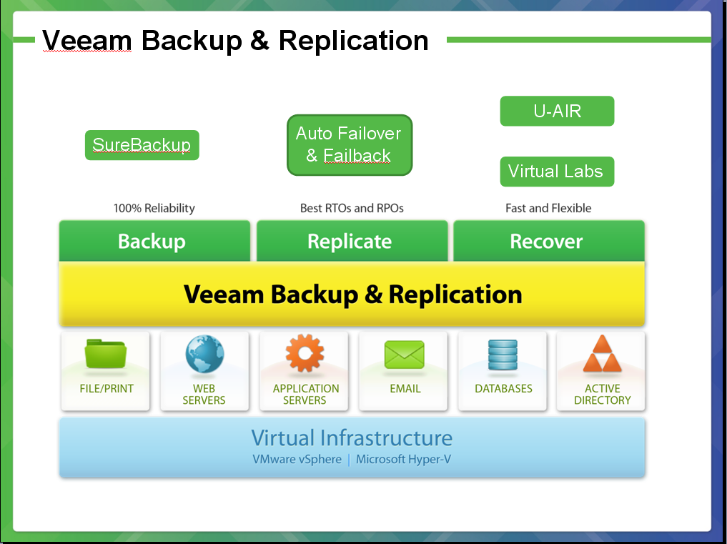

Veeam published a comparison, shown in the following table, at the request of Veeam customers and intended to help them evaluate their options for VMware backup. This publication can be obtained by visiting Veeam’s website.

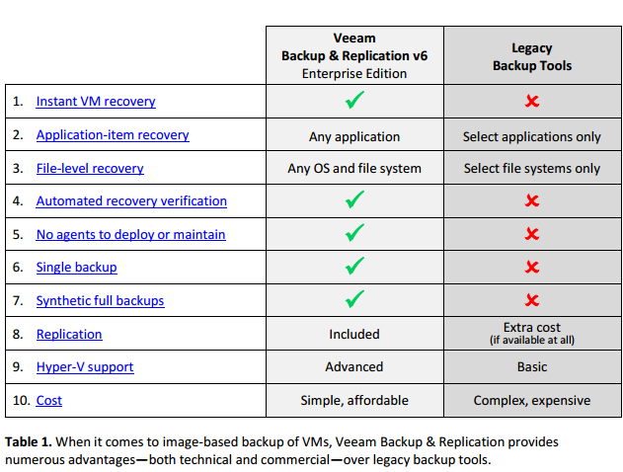

Most Veeam customers do not need to spend expensive consulting service fee in order to setup the Veeam Software correctly to protect VMs in its datacenter due to its extremely ease of installation and powerful backup & restore software. Veeam’s customers might need a phone support initially. However, other vendors’ backup and restore software might need one week to setup correctly prior to its first successful backup and restore taken place with an expensive consulting service fee needed.

Veeam leverages VMware’s snapshots for its backup, but its backups are not snapshots, and can be used for restoration and disaster recovery reliably with no agents to deploy or maintain, while a granular restore can be easily achieved.

Many vendors’ backup and restore software require deploying agent to each VM in order to retrieve granular info (e.g., NetApp cannot resort granular info, unless NetApp installs an agent on each VM).

Therefore, Veeam’s powerful backup & restore software is highly recommended for customers in a virtualized datacenter

Challenge:

Veeam replication technology is not good as NetApp or Nimble’s. Per demo, an initial replication in average must transmit 50% of the entire data from source to target after utilizing compression and dedupe. In a large data center, this might be a challenging task.

Other vendors can address this challenge better with 90% or higher dedupe and compression ratio, then, replicate a small percentage data from primary to remote site.

Snapshots on NetApp vs. Veeam Backup

With a unified or converged storage implementation (e.g., NetApp or Nimble), you can easily setup a testing or development environment quickly by utilizing the ROW snapshots, as shown in the screen shot below without consuming a lot of disk spaces. As a matter of fact, the actual disk space consumption under the “Fast cloning” is a fraction of the original disk space.

This approach not only avoids a complicated D2D secondary storage system, but also creates a powerful testing or development environment quickly to reduce the cost and achieve highest return on investment (ROI).

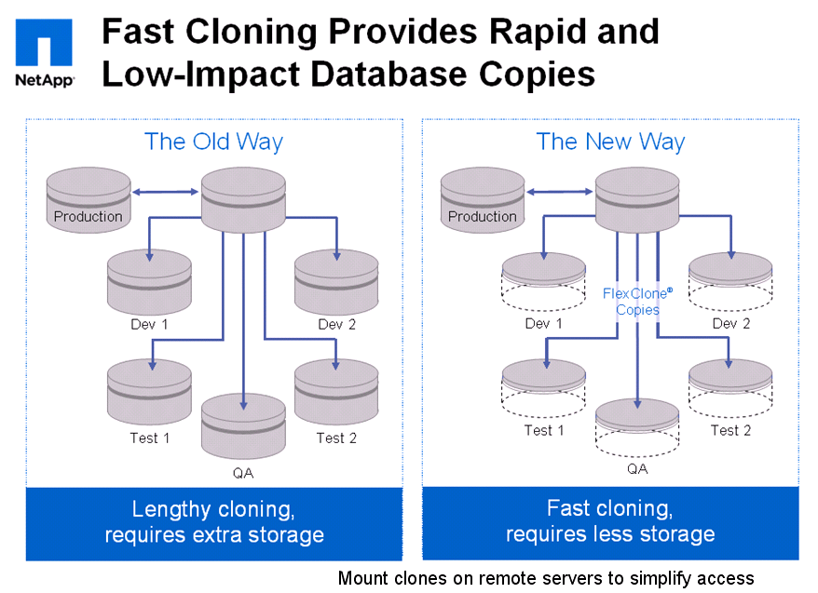

The following statements came from Sam Fawaz.

Veeam relies on VMware native snapshots, but only for the time that the VM is being backed up. The snapshot itself is Not the backup. It is used to keep the machine in production while we backup it up. The process is as follows:

Quiesce Services → Invoke Snapshot → Mount VMDK → Read VMDK and write to Target Repository → Unmount VMDK → Delete Snapshot

This way, we copy the VMDK while the machine runs on its snapshot delta file.

Also, I want you to be aware of some key points:

- A snapshot is not a backup: One of the fundamental design principles for any infrastructure professional is to introduce separation between layers of protection. Example: what if the NetApp failed?
- More portability: Veeam backup files (.VBM, .VIB, .VBK, .VRB) are much more portable than snapshots. This is used especially in cases to address off-site requirements where NetApp storage is not used.
- Storage agnostic: Chances are, many storage products are in use, and Veeam Backup & Replication is storage agnostic. Further, there is no storage vendor lock-in with Veeam for VM primary storage.
- vPower Features: The SureBackup and On-Demand Sandbox capabilities are only provided by Veeam.
- Manageability: The SnapManager series of products require agents to be installed on the VMs where a SnapManager application is available; Veeam does not require an agent to be installed on any VM.
- Cost: In terms of a place to store backups, NetApp is rather expensive disk. Veeam can leverage lesser expensive storage, yet still comes with several protocol options (CIFS, NFS, iSCSI, FC, DAS).
- Test environment: The virtual lab capability found in Veeam Backup & Replication is unmatched technology. Specifically, the network proxy appliance for VMware environments can isolate the lab from production networks.
- Depth of recovery: While both solutions can restore Active Directory users, email messages, SQL tables and provide a side-by side view of production environments vs. recent backups, Veeam has more flexibility. Example: The SQL Server DBA doesn’t know what they broke in the SQL Stored Procedure, so looking left (Production) and right (Backup) will let them see what changed.
- 1-Click File Restore (for vSphere and Hyper-V): This singular guest file restore for helpdesks isn’t available with NetApp, much less out of the hands of the storage team. The is easier with Veeam. Considering file restores are the most common restore scenario, this is a significant difference between the two solutions.

Recommended Reading:

- How New York City is going to Consolidate 50 Data Centers from 40 City Agencies into One Location:
http://www.informationweek.com/news/government/state-local/229219575

- NASA uses Amazon's cloud computing in Mars landing mission
http://www.latimes.com/business/technology/la-fi-tn-amazon-nasa-mars-20120808,0,3551686.story

- The New York Public Library is Powered by Google Cloud
http://www.nypl.org/collections/articles-databases/google-book-search

4. Debunking the Myth of the Single-Vendor Network
http://www.dell.com/downloads/global/products/pwcnt/en/Gartner-Debunking-the-Myth-of-the-Single-Vendor-Network-20101117-published.pdf

Acknowledgement

Thanks for Veeam for the courtesy of its presentation slides and other training videos, where some of them are used in my notes.

