Jeremy Li
June 12, 2012

Credit: WHIPTAIL/Cisco/DynTek- Technical Lunch Event, Downtown Los Angeles with Don Mattingly

WHIPTAIL (All-flash Array) - www.WHIPTAIL.com

New Jersey based WHIPTAIL was founded in 2008 by James Candelaria, who presented WHIPTAIL array technology at the Citrix Technology Exchange Q1 User Group Event on March 1, 2012. Click on the link below for details:

http://www.lacaaea.com/aaeapdf/san/A-Partial-Note-from-Citrix-Tech-Exchange-Q1-2012.pdf

Its specialty is to use flash-based NAND silicon storage technology – all-flash drives coupled with a unique patented operating system (OS) called “RaceRunner” to deliver 250,000 random 4K WRITE IOPS (Input/Output Operations Per Second) and 1.9 GB/s WRITE Throughput per appliance with 7-year drive wear endurance due to its intelligent wear-leveling technique in a niche market in storage arena, targeting customers who use the most demanding and costly applications. Linked below is an in-depth description of the ““RaceRunner” OS,

http://www.dcig.com/2012/01/the-ssd-garbage-collection-problem-explained.html

Its specialty product, a software-based and Linux-based appliance, is really good in a VDI environment (More “Write” than Read”), which requires high IOPS as well as in a low latency (e.g., High Frequency Trading, On Line Websites, Application Databases), High Bandwidth (e.g., Video Streaming, Batch Cycles and Database Dump/Loads) and Symmetric Read/Write (e.g., Database Batch Loads, Web Database Batch/Online) environments, as shown in a few screenshots below:

WHIPTAIL’s customers experience Return on Investment (ROI) due to reducing operational cost scientifically by reducing data processing time from days to hours or hours to minutes.

Currently, it offers two all-flash arrays:

- Accela Silicon Storage Array, single controller with RAW capacity from 1.5 to 12.0TB in a 2U appliance

- Invicta Silicon Storage Array, two active/passive software-based, Linux- based controllers with a clustered capability to share load and increase the storage RAW capacity from 6TB to 72TB.
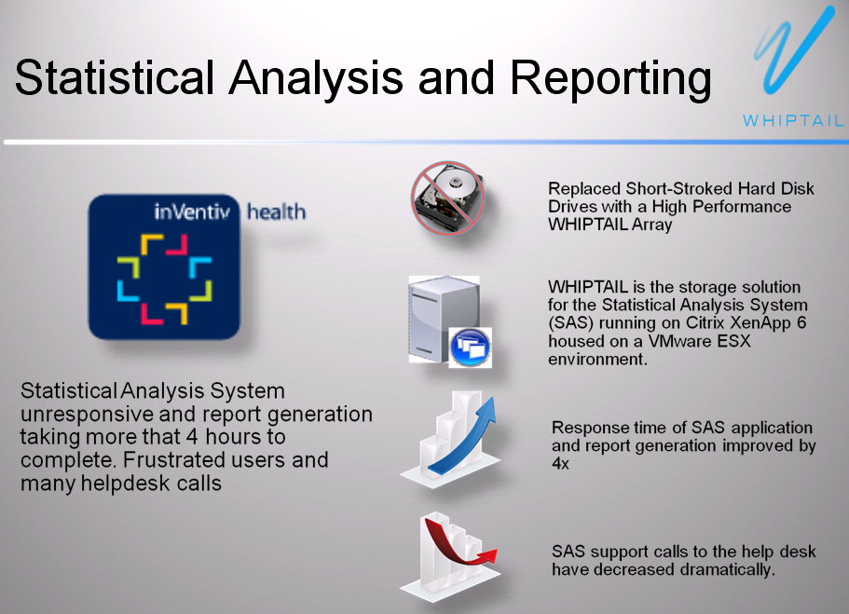

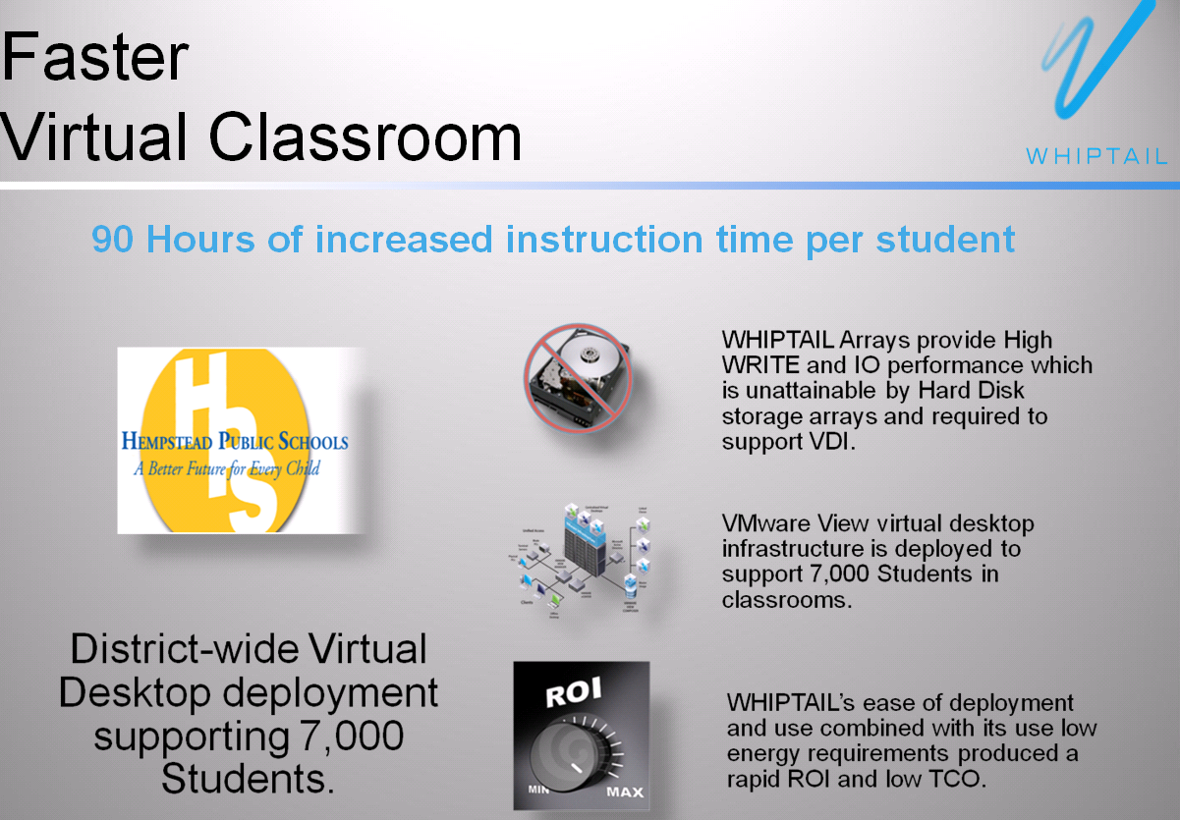
VMware View 4.5 was deployed in this scenario

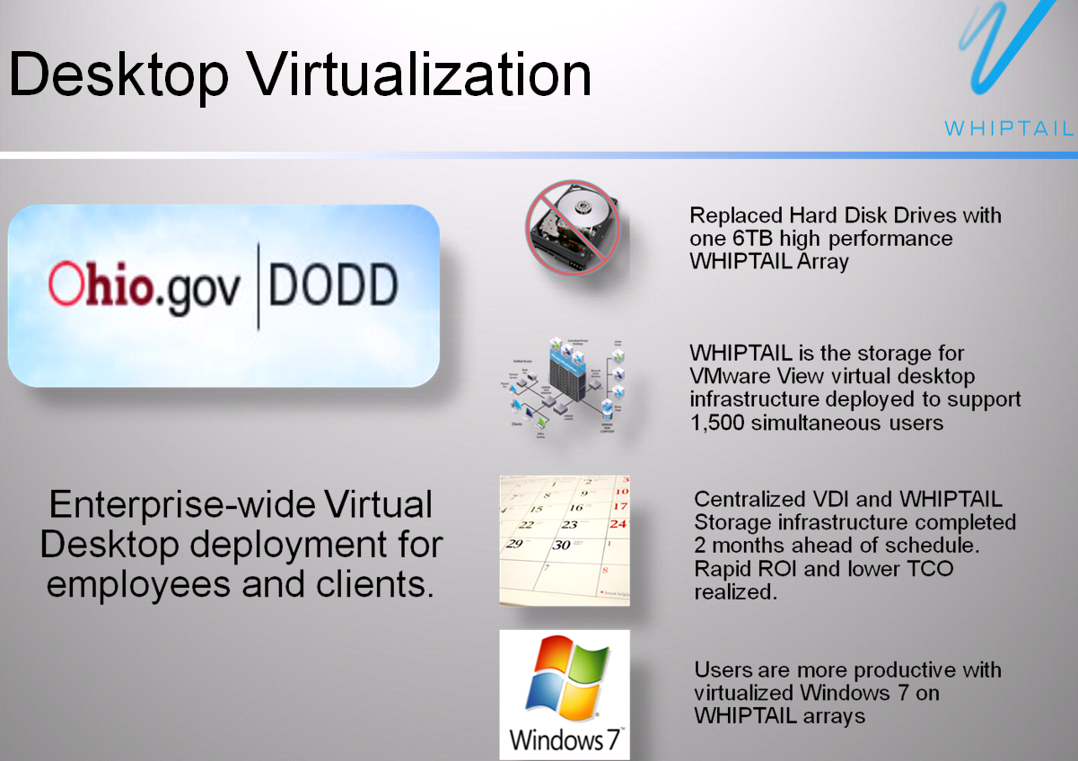
VMware View 4.5 was deployed in this scenario

Many leading IT vendors, such as AMD, bought WHIPTAIL appliances (e.g., AMD, a rival to Intel, bought WHIPTAIL appliances, even though it is based on Intel processor and chipset inside of the appliance) in a niche market in order to reduce the operation cost and enhance the return on investment (ROI), as shown below:

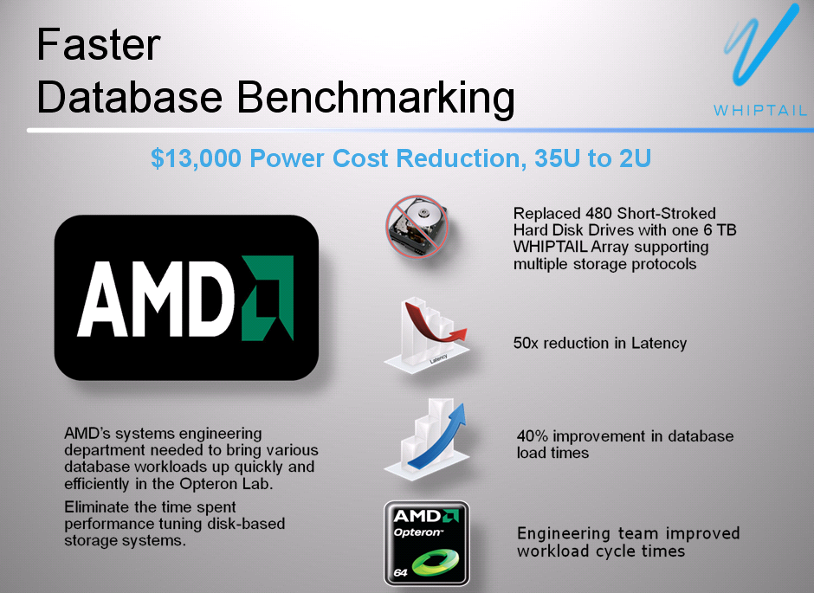

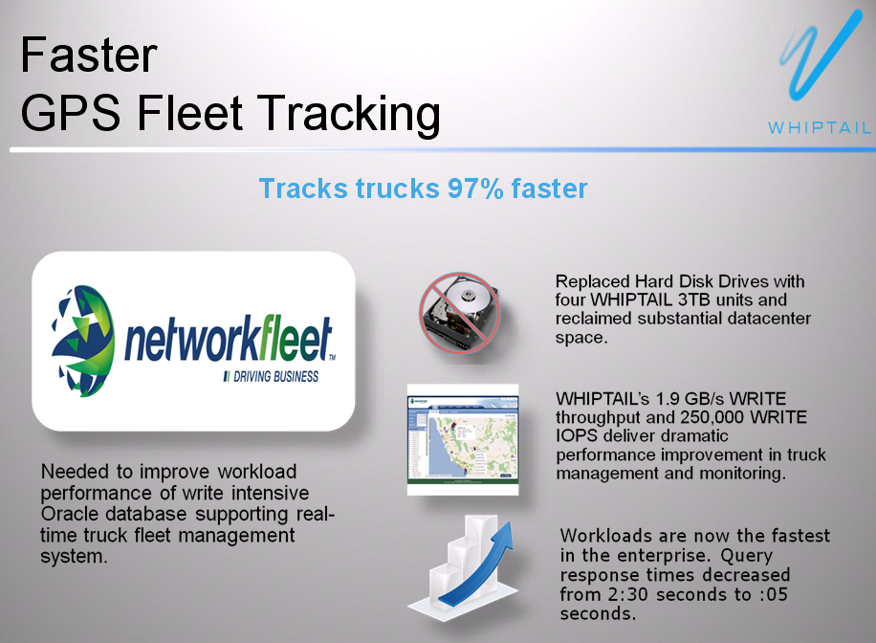

Of course, a VMware Clusters environment will also get the great benefit from WHIPTAIL all-flash enterprise storage array. The array supports interfaces of 10GbE, 1GbE, Fiber Channel 8Gb, 4Gb and Infiniband 40Gb and RAID-0, 1, 5, 6 and 10.

WHIPTAIL’s unique proprietary software with commercialization of MLC Flash drives from the RaceRunner OS can achieve “Never write data to the same cell” and optimizing high Write throughput while substantially reducing premature wear.

A testing result from WHIPTAIL's customers’ experience revealed that WHIPTAIL array can achieve the performance faster than physical desktop when a VDI implementation is successfully deployment.

A consultant from DynTek performed a live demo by using Citrix XenApp, after he turned on a hotspot via his iPhone (Not tree 4G network) to connect his laptop to DynTek’s corporate network powered by WHIPTAIL arrays. The desktop speed is amazing.

The consultant mentioned that the overall ratio from DynTek assisted VDI deployments for its customers is 10 (Citrix VDI) to 1 (VMware view) due to higher virtual desktop performance experienced during the live demo.

WHIPTAIL All-flash Array Architecture

Each array is comprised of:

- Intel Quad Core XEON processors
- 24 commercial Intel NAND-Flash Multi Layer Cell (MLC) Solid State Drives (SSDs), as shown in the screen shot below

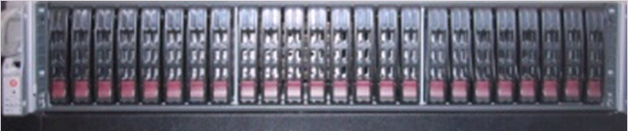

- Can be configured as Hardware RAID-0, 1, 5, 6 or 10

- Provide attractive effective cost $/GB (e.g., the SSDs have $36.00 per GB vs. HDD’s $64 per GB)

Note: Effective Cost = Nominal Cost / Utilization (e.g., in low utilization effective cost: $10GB/10% = $100/GB, while high utilization effective cost: $10GB/80% = $12.50/GB

- RACERUNNER OS Optimized for High 250,000 Write IOPS

Every storage vendor can use SSDs for fast reading, but many of them can not provide a high write Input and Output (I/O) operation. WHIPTAIL has its patented OS to eliminate three-phase (read, erase, and write) commit process by using “Alignment” at Block Translation Layer to achieve the goal: Each write to media is a complete RAID stripe – a single action (avoid read in order to do a write), as shown in a screenshot below:

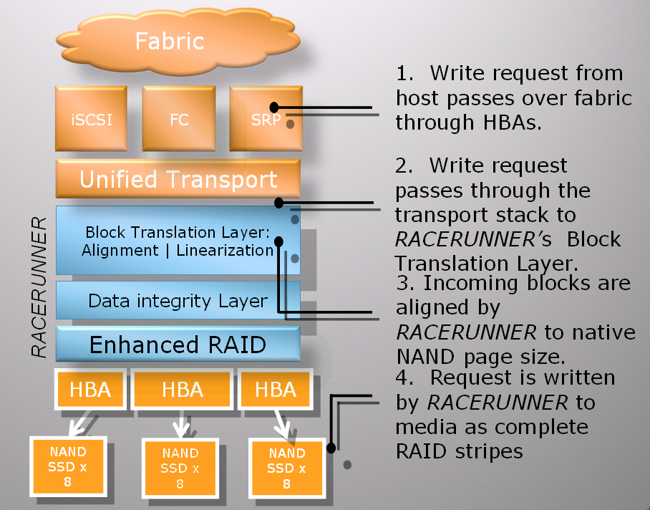
Source: WHIPTAIL

Note: Write requests are aligned in native NAND (Flash) erases block size before passed to RAID. Write requests are flushed to media as a single action of full RAID stripes.

The OS can offer linearization (wear-leveling algorithms) – every write will be striped across the entire array. This turns random writes into a sequential write all the time. Therefore, prolong the life of SSDs.

Each array can work seamlessly with the industry’s leading backup applications. WHIPTAIL software-based, Linux-based appliance typically installs in about a few hours.

Of Note:

Nimble converged storage uses patented high-efficiency Cache-Accelerated Sequential Layout (CASL) storage architecture by relying on NVRAM, DRAM and SSD cache (Read-only). Every written access to a SAS disk drive or SSD is a complete RAID stripe. Click http://www.nimblestorage.com/products/architecture for details.

Local and Remote Replication

WHIPTAILl supports both synchronous and asynchronous replication. Generally speaking, synchronous replication is used for Local Area Network (LAN) and Metro Area Network (MAN) for the best data protection (e.g., where no single transaction can be lost in case of a DR), while asynchronous replication is used for a long distance replication (e.g., Los Angeles to New York) for a highest possible performance purpose.
The asynchronous replication is mainly used for disaster recovery (DR) purpose.

Therefore, snapshots are more efficient in a DR scenario. For example, Nimble or NetApp can replicate data to a remote location for DR purpose with highly efficient redirect-on-write snapshots, and the same data is already in place and ready to be presented immediately. That’s a time savings with fewer error-prone.

The snapshots licenses, including remote replication, are optional in its appliance, while some other vendors will charge optional software licenses.

Auto-tiering

Due to all-flash array, auto-tiering is not applicable.

Software RAID vs. Hardware RAID

WHIPTAIL uses software RAID in its appliance. It believes that the software layer is the best place to manage large scale error-correction outside of Hardware (HW), and count on Intel’s forthcoming new processor, which will add additional computing power and speed the RAID performance dramatically, often at 25% range, due to its clocking speed increase in each newer processor. The software RAID approach can ultimately control over the RAID algorithm. Click on the link below for details:

http://www.dcig.com/2012/01/whiptail-gives-software-raid-the-nod.html

Single Controller vs. Dual Controllers

WHIPTAIL’s ACCELA appliance has only single controller, and its INVICTA appliance supports two active/passive controllers.

For a higher availability purpose in ACCELA appliance, a customer must purchase second ACCELA appliance and relies on synchronous replication between two units via 10GeE connection.

INVICTA appliance provides dual active/passive software-based, Linux-based RAID controllers. This approach allows performing firmware upgrades without any downtime and with almost no errors made by human being. Most storage disasters are not caused by actual HW failure, but by planned procedures gone wrong due to lack of highly skilled IT staff needed in order to perform a firmware upgrade (e.g., Virginia Repairs SAN Failure That Caused Statewide Outage). If a subject matter expert (SME) is not fully trained, a good storage product will become a bad product.

Author’s Note: Due to highly skilled IT specialists needed in data centers, especially in storage arena, the Cloud solution, in order to reduce the cost due to duplicated works, is now prevailing in most CIO’s mind simply because you just train a few highly skilled specialists for your data center, while lots of people can use it. Most big organizations can not afford to put many highly skilled specialists in many small different data centers. Often, data loss is due to lack of skilled IT professionals in your data center.

Thin Provisioning

WHIPTAIL does or does not support Thin Provisioning.

Deduplication and Compression

WHIPTAIL does not support deduplication and compression, although it will support deduplication in the future.

Quality of Service

Like most storage vendors, WHIPTAIL does not provide a feature called Quality of Service, which guarantees performance for applications.

Often, many storage vendors would like to add more spindles (HDDs) to increase the IOPS in order to increase or maintain the performance of an application (e.g., a VDI environment), but it also produces unnecessary excessive capacity because you already have too much capacity (Forces you to buy resources you don’t need).

On the other hand, an all-flash storage array often produces excessive performance (e.g., high IOPS), but lacks of a storage capacity.

Auto-tiering adds complexity and often produces some unpredictable results due to a complicated algorithm. Three scenarios mentioned above are illustrated in a screenshot below:

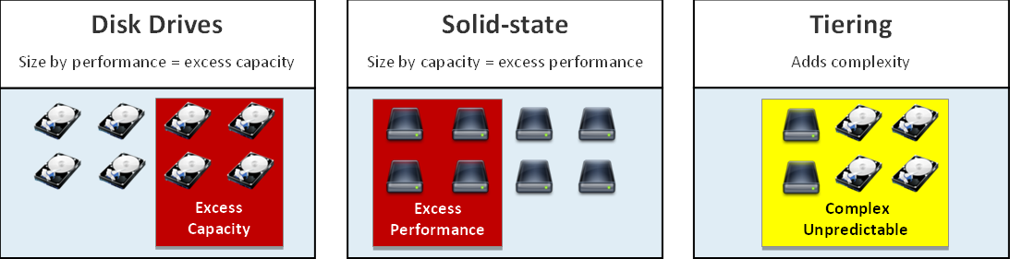

Only a few vendors (e.g., a startup company, NexGen - www.nexgen.com ) at this time offer the Quality of Service, which address three issues mentioned above.

10GbE Interface vs. Fiber Channel (FC) Interface

Per WHIPTAIL, 65% of its customers are using FC (The max speed is at 8Gb) while the remaining customers are using iSCSI or 10GbE.

A new physical network had to be implemented in FC deployment, while the ISCSI SAN and NAS can utilize on investments already made in typical networking equipment, which uses the Ethernet and IP protocols. However, with 10GbE adoption widely available, the gap for the performance of the backend between the FC and 10GbE becomes smaller and smaller. It all depends on a particular environment.

NAS or iSCSI with 1GbE or 10GbE implementation will always be slower than comparable FC deployments, because NAS deployments communicate on a higher level of the protocol stack (TCP/IP). This makes them inherently slower but has the advantages - a lower implementation cost, and the data and disks actually can be shared between targets (storage) and clients.

The savings for using economical NAS / iSCSI with 10GbE over expensive Fiber Channel is very significant due to FC’s complexity with a lot of operating expense (OpEx). Any agencies want less complexity, improved operational efficiency and ultimately, to spend less money.

Read “Top 3 Reasons Why You Can’t Build a Cloud with Fiber Channel” for additional reasons - (Source: CORAID)

http://san.coraid.com/rs/coraid/images/Coraid_Brief_Top3ReasonsWhyYou.pdf?

Read “Why FCoE and iSCSI are trumping Infiniband in today's SSD deployments - WhipTail CTO Interview Series Part V” for additional reasons:
http://www.dcig.com/2012/01/why-fcoe-and-iscsi-trump-infiniband.html

Five Guidelines as to the Best Ways to Implement Deduplication / NAS is becoming the preferred interface of deduplication targets –

http://www.dcig.com/2011/04/five-guidelines-best-implement-deduplication.html

Special note:

HP ProLiant G8 server provides two 10GeE NICs via FlexLOM (Flexible LAN on motherboard), as shown in a screen shot below. Any customer can have an option to purchase 10GeE NICs when a new server is ordered.

This is another reason the FC block protocol solution for the enterprise implement as opposed to iSCSI in NAS environment might not be necessary, in order to reduce the implementation complexity and cost.

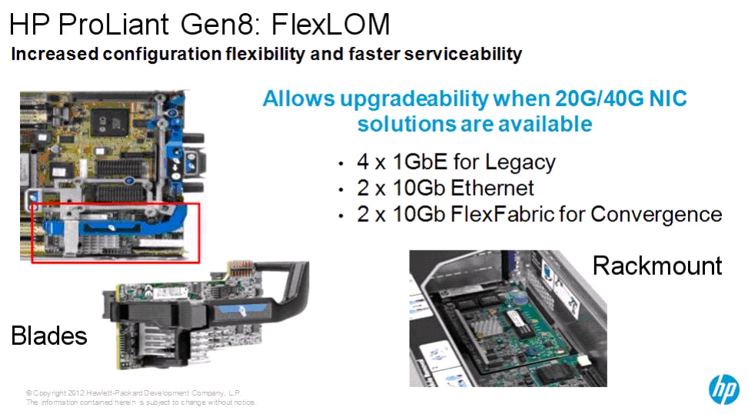
Source: HP

Caution:

The balance of high 250,000 IOPS in a 2U array with storage capacity might turn away many potential customers. For example, with 7,000 VDI users at an average 30 IOPS per user and all 15K RMS SAS HDDs (180 IPOS per drive), the VDI implementation requires 210,000 IPOS and 1,167 HDDs in order to support the VDI deployment. However, if each user requires 30GB disk space, the 210TB storage disk space is required. Then, one Accela can support IOPS up to 250,000, but short at disk capacity.

With VMware vSphere 5.0 release, it might help WHIPTAIL’s all-flash array appealing to more customers since the new feature called Linked Clones
(http://www.vmware.com/support/ws55/doc/ws_clone_overview.html#wp1028798) can reduce disk space consumption on its appliance dramatically.

Conclusion:

WHIPTAIL all-flash array can deliver 250,000 Write IPOS with 7-year drive wear endurance due to its intelligent wear-leveling technique. The SSDs has the following advantages than traditional HDDs:

- Reads and write data quickly
- Resilient to shock
- Consumes a small amount of power
- Produces a small amount of heat

Here are a few advantages by considering WHIPTAIL array:

• IO performance at 250,000 WRITE IOPS with 1.9 GB/s throughput in a 2U appliance - array
• Hundreds of HDDs will be eliminated for a VDI implementation
• Big savings on footprint, power and cooling
• Costly Over-provisioning can be avoided

Any buyer should also consider the follow factors:

- Meeting your business objectives (e.g., 10 GbE, instead of FC, might be able to meet 95 percent of all business objectives, plus 40 GbE is coming soon!)
- Vendor’s reputation
- Total cost of ownership (TCO)
- Resources, including consulting services
- Customers’ installed base
- Technical support
- Customers’ satisfaction
- Available Technical Training

Last but not least, an economical iSCSI with 10GbE is widely available, soon with 40GbE, might be able to achieve almost the same result with FC solution, but the costs of iSCSI implementation will be much less than FC deployments.
In summary, make an award in the best interests of the organization after all factors have been evaluated.

Challenge:

1. Storage Capacity

For those customers who need both high IOPS and high storage capacities, WHIPTAIL appliance might not be the best choice. They can look for other storage vendors such as NetApp (www.NetApp.com) or Nimble (www.nimblestore.com) because both vendors offer highly efficient ROW snapshots with post process or inline compression. This might avoid buying a third party vendor’s D2D backup system in order to be able to avoid a complexity and additional layer storage infrastructure, thus, greatly reducing the network traffic between the storage to a D2D system and cost of storage in the data center.

In large enterprises, adding a few SSDs might meet IOPS requirement. Per EMC, most enterprises need only 5% flash in order to achieve the balance between performance and storage needs. For example, adding 30 SSDs with 200GB capacity can achieve IOPS 74,000, while greatly reducing the number of the HDDs and power consumption, as illustrated in the screen shot below:
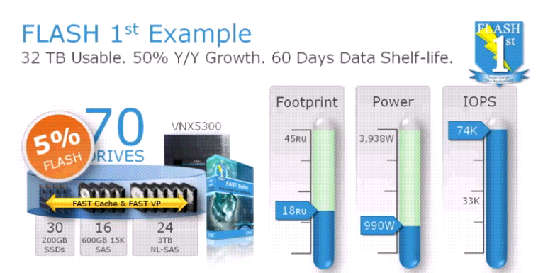

2. EMC Enters into an All-flash Array Business

EMC acquired all-flash array vendor XtremIO recently. Most CIOs will feel comfortable to buy an EMC product due to its big name. Click on the link http://www.xtremio.com/ for details.
3. Setup a Testing or Development Environment?

WHIPTAIL is currently relying on copy-on-write snapshots. This will limit the historical point-in-time copies and clone snapshots, which can be mounted as a development/testing volume.

With a unified or converged storage implementation (e.g., NetApp or Nimble), you can easily setup a testing or development environment quickly by utilizing the ROW snapshots, as shown in the screen shot below without consuming a lot of disk spaces. As a matter of fact, the actual disk space consumption under the “Fast cloning” is a fraction of the original disk space.

This approach not only avoids a complicated D2D secondary storage system, but also creates a powerful testing or development environment quickly to reduce the cost and achieve highest return on investment (ROI).

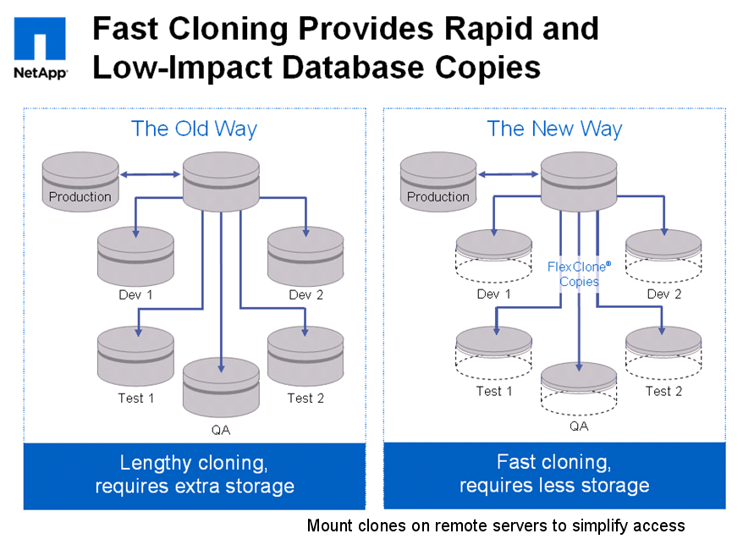
Source: NetApp

Author believes that WHIPTAIL must switch to redirect-on-write (ROW) snapshots ASAP in order to attract more potential customers.

4. WHIPTAIL does not Have Deduplication

WHIPTAIL does not support deduplication and compression at this time, although it will support deduplication in the future.

5. The Lack of Specialized Application Integration

WHIPTAIL lacks of specialized application to integrate with leading application vendors’ products. For example, NetApp’s True Unified SnapManager Application Integration can quickly restore a mailbox or a single message in minutes, instead of hours with a potential disaster happens due to an error made during a multi-step process (e.g., Microsoft Windows Server Backup for a mailbox recovery).
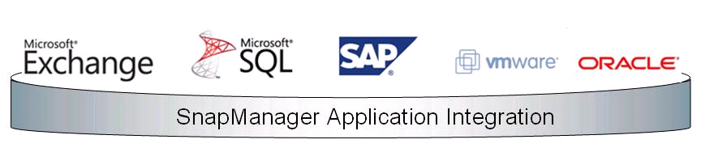

However, WHIPTAIL can work with other leading backup and restore vendors to mitigate this situation.

This is an area where NetApp and EMC have some advantages over start-up companies like WHIPTAIL and Nimble because both NetApp and EMC have been in storage business for a long time and have successfully either added the automation and scripting or partnered with 3rd party software vendor, plus even through acquisitions to achieve the integration from their storages with specialized application for the speedy recovery of data and VM’s from their snapshots.

However, it comes with the cost. Both NetApp and EMC will charge a customer an expensive license fee to use their integrated application.

6. Startup Company

Some large organizations are reluctant to do business with privately held vendors that lack financial transparency, particularly when there may be alternatives that are available from large established vendors (Source: Magic Quadrant for Midrange and High-End Modular Disk Arrays –

http://www.storagenewsletter.com/news/marketreport/gartner-magic-quadrant).

Recommended Reading:

- How New York City is going to Consolidate 50 Data Centers from 40 City Agencies into One Location:
http://www.informationweek.com/news/government/state-local/229219575

- The New York Public Library is Powered by Google Cloud
http://www.nypl.org/collections/articles-databases/google-book-search

3. Debunking the Myth of the Single-Vendor Network
http://www.dell.com/downloads/global/products/pwcnt/en/Gartner-Debunking-the-Myth-of-the-Single-Vendor-Network-20101117-published.pdf

4. Federal Cloud Computing Strategy
http://www.cio.gov/documents/Federal-Cloud-Computing-Strategy.pdf

5. CIO INSIGHT Research Exclusive - 2011 Vendor Value Study
http://circ.ziffdavisenterprise.com/pdfs/Research_CIOI11_0708.pdf

