November 16, 2012
Jeremy Li
Credit: Win8 Powered by Dell Luncheon Event, Nov. 16, 2012

Dell’s small and mid-size business (SMB) team invited about 200 IT Managers and IT Professionals to attend a lunch seminar titled Win8 Powered by Dell at Four Seasons Los Angeles in Beverly Hills, Nov. 16, 2012 from 11:00 a.m. to 1:00 p.m. to learn Dell’s latest generation of Win8 enabled products including the Latitude 10, OptiPlex 9010 All-In-One (AIO), XPS 10, XPS 12, and Latitude 6430u Ultrabook as well as in-depth conversation on migration to Windows 7/8 with Dell Custom Factory Integration (CFI) Service. Click on the link below for details:

http://www.dell.com/downloads/global/services/Hardware_Customization_Custom_Factory_Integration_(CFI)%20_Final.pdf

Dell acquired Quest in 2012 and talked about Quest Software & Step-by-Step Migration Strategy at the event. Dell packaging services are done at worldwide locations such as Da Lian, China and Bangkok, Thailand. Today, Dell is #1 Windows 7 Migration Partner for Microsoft through Dell Global Consulting Services.

Here are a few high lights:

Latitude 10

Today’s end users want the freedom to connect anytime, anywhere, to anything, on any device. A forecast projects that 96 millions tablets will be shipped worldwide in 2016. As a result, Dell is able to release some new devices, as described below:

- This tablet is built for business with Windows 8 Professional, not RT, Runtime version, which does not support legacy applications
- With Windows 8 Professional installed, it can support both Metro and Legacy applications

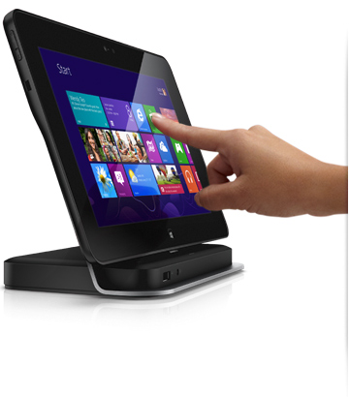
Latitude 10 tablet will be shipped in two weeks.

For more information, please visit Dell website for details.

Note: Per Dell, Microsoft just announced yesterday that the upcoming release date for Microsoft's Surface Pro will be delayed for a long time due to technical difficulties. Dell is the only vendor capable to release the tablet with Windows 8 Professional at this time.

Latitude XPS 10

- This tablet is designed for BYOD (Bring Your Own Device) with Windows 8 RT, which will not support legacy applications. Therefore, it is designed for consumers
- It is based on ARM architecture and installed with Microsoft Office 2013 RT

Latitude XPS 12

- This convertible Ultrabook, which can be easily converted to tablet with flip hinge design, is designed for business, labeled as Flexible Design for Business (Dual mode)

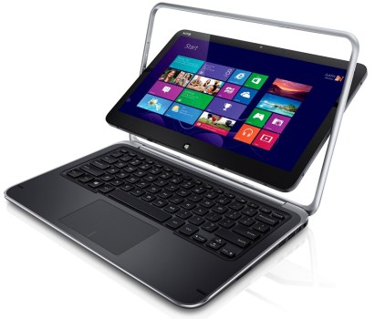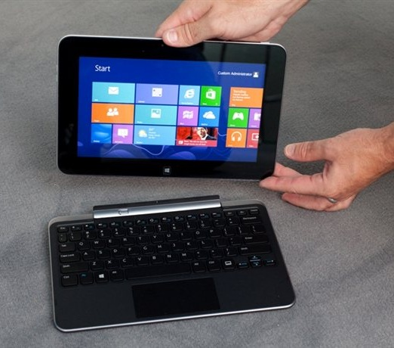

- With Windows 8 Professional installed, it can support both Metro and Legacy applications

Visit http://www.thinkdigit.com/Laptops-and-PCs/IFA-2012-Dell-unveils-three-Windows-8_10638.html for details.

OptiPlex 9010 All-in-One

- This All-in-One desktop PC, as illustrated in the picture below, can deliver excellent productivity and collaboration, plus outstanding IT control.
- It is manageable, productive and Inspired
- With Windows 8 Professional installed, it can support both Metro and Legacy applications
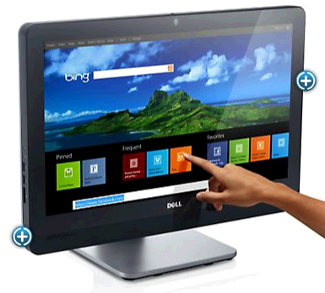

Dell B5465dnf

This mono laser multifunction printer, as illustrated in a picture below, is very attractive in price and performance.

- It delivers performance and versatility at outstanding value at $3,000.00
- Prints at 70 pages per minute with duty cycle at 300,000 pages per month
- Onsite warranty service for three years is included
- Advanced security features designed to protect data
- Boost workforce efficiency
- Print directly from Android mobile devices using Dell Mobile Print.

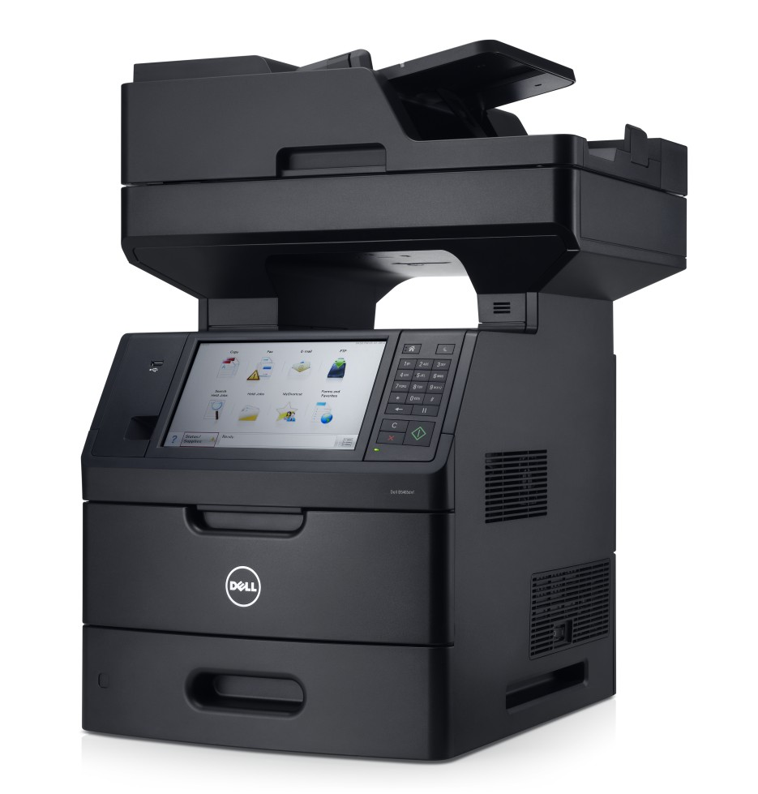

This mono laser multifunction printer is very attractive for many divisions due to lower cost and higher performance.

Conclusion:

This lunch seminar is very informative, and learns how Dell is ready to enable Windows 8 for any user computing infrastructure. It also provides an opportunity to chat with Dell SMB marketing team with some hands-on feeling about the latest generation of Dell Windows 8 systems.

Challenge:

- HP has an excellent reputation in Laser Printer Market. HP printers can last for many years without major issues.
- Many printer services vendors are only servicing HP printers due to large volumes and accessible technicians widely available
- HP provides 24x7 toll-free technical support worldwide

Recommended Reading:

- How New York City is going to Consolidate 50 Data Centers from 40 City Agencies into One Location:
http://www.informationweek.com/news/government/state-local/229219575

- NASA uses Amazon's cloud computing in Mars landing mission
http://www.latimes.com/business/technology/la-fi-tn-amazon-nasa-mars-20120808,0,3551686.story

- The New York Public Library is Powered by Google Cloud
http://www.nypl.org/collections/articles-databases/google-book-search

4. Debunking the Myth of the Single-Vendor Network
http://www.dell.com/downloads/global/products/pwcnt/en/Gartner-Debunking-the-Myth-of-the-Single-Vendor-Network-20101117-published.pdf

Acknowledgement

Thanks for David Otto, Dell Account Executive’s invitation for this event.

