May 11, 2012
Jeremy Li

Installing the VMWare vCenter

Task 1 - Installing VMware vCenter Server Appliance 5.1 to ESXi 5.1 Host 1

- Deploying VMware vCenter Server Appliance

a) Install with OVF template:

1. Downloaded VMware vCenter Server 5.1 update 1 related modules 1

While on the ESXi-01 (AMD based host) console, click "File, Deploy OVF Template...to start the "Deploying VMware vCenter Server Appliance" installation...

Deploying disk 1 of 2... Deploying disk 2 of 2 (100%)

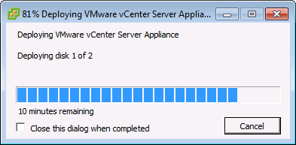
Deploying disk 1 of 2... 30 minutes remaining

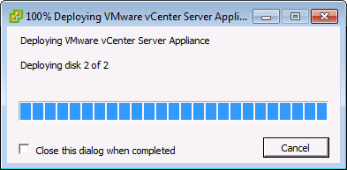

Deploying disk 2 of 2...

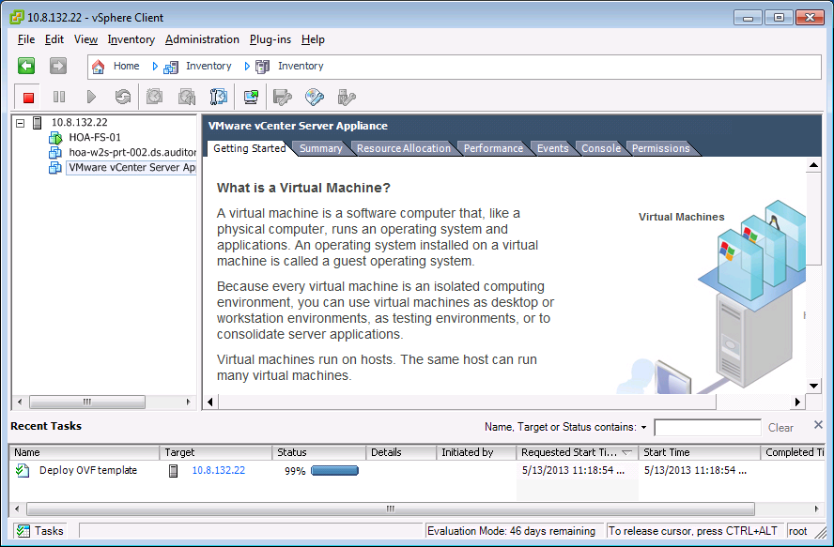

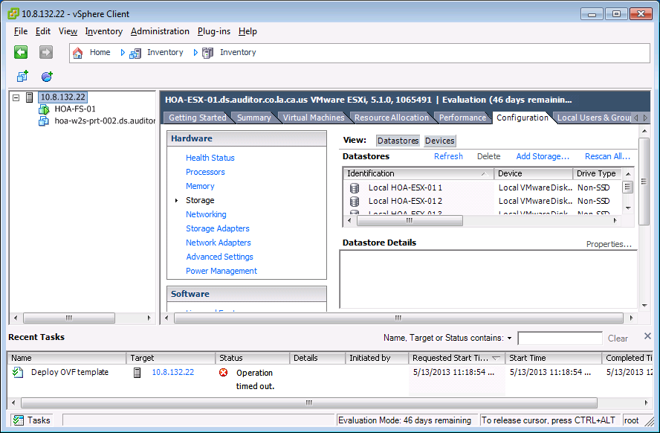
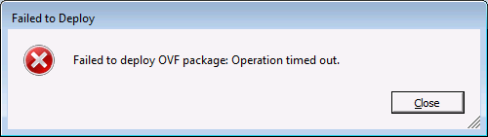

Failed installation with the OVF file (Single file installation) due to timed out.

b) Tried an alternative method (OVA)

Note: The alternative method via OVA (one configuration file and two VMDK files)

1. Downloaded VMware vCenter Server 5.1 with two filename.vmdk files and one configure file (Raw file, not OVF).

While on the ESXi-01 (AMD based host) console, click "File, Deploy OVF Template and point the files of OVA to start the "Deploying VMware vCenter Server Appliance" installation...

Deploying disk 1 of 2... Deploying disk 2 of 2 (100%)… After one hour, unfortunately, the installation failed again.

c) Installing the vCenter via the OVF Again on the Second ESXi 5.1 Host

1. While on the ESXi-02 (Intel based host) console, click "File, Deploy OVF Template...to start the "Deploying VMware vCenter Server Appliance" installation via single OVF template

1. Start the vCenter Installation via single OVF template by clicking on "File", "Deploy OVF Template and point the files of OVA" to start the installation...

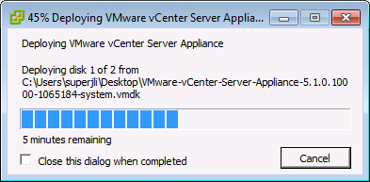

Note: The performance of the installation this time is much faster.

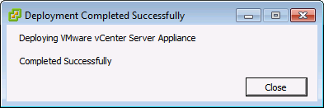

Note: Intel based host is much faster than AMD based host, even though AMD based host is more powerful than the Intel based host. There are a few possibilities on the issues:

- The downloaded OVF template might be designed for Intel based host
- Intel based host has no NIC team configured
- The NIC teaming is configured at the AMD based host

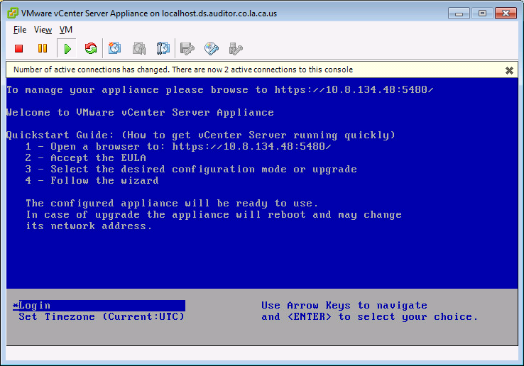

Now, https://10.8.132.5:5480 to start the vCenter Server Setup, as shown below:

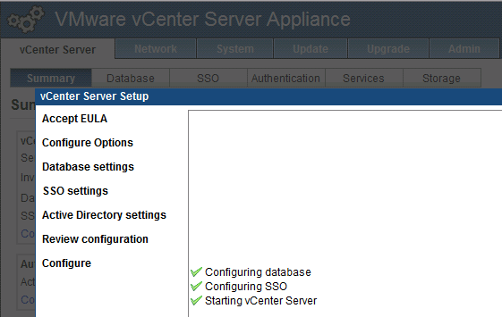

II. Start the P2V Migration on A Physical Printer Server (PRT-02)

Task 2 - P2V Migration

1. Download the vCenter converter Standalone 5.1 to the Win7 OS desktop.

2. Right-click the downloaded file, select “Run As Administrator”, to start the installation of the package into the Win 7 desktop, choose "Local"

>>> Installing VMware vCenter Converter Standalone...

Failed...

Follow the on-screen instructions referenced below:

Click "Finish" button

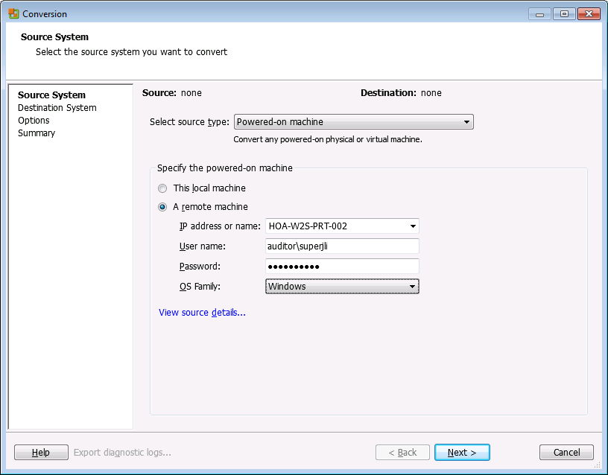

Note: There are two versions of the vCenter. The vCenter without needing a Windows OS is lacking of about 20% features in comparison of running it directly on a Windows Server 2008 R2.

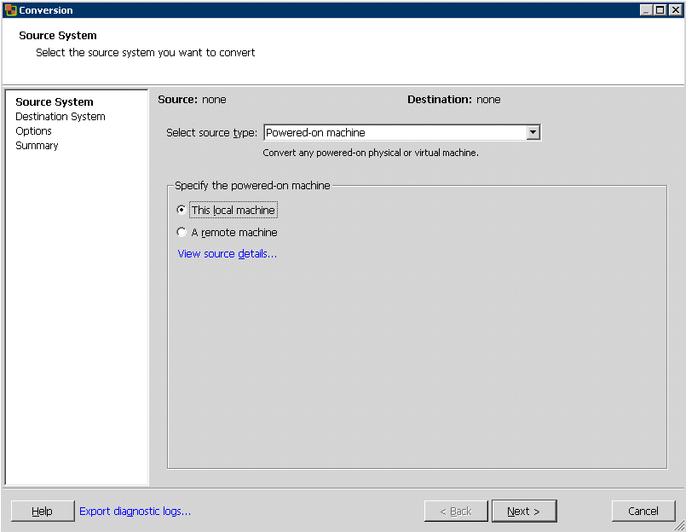

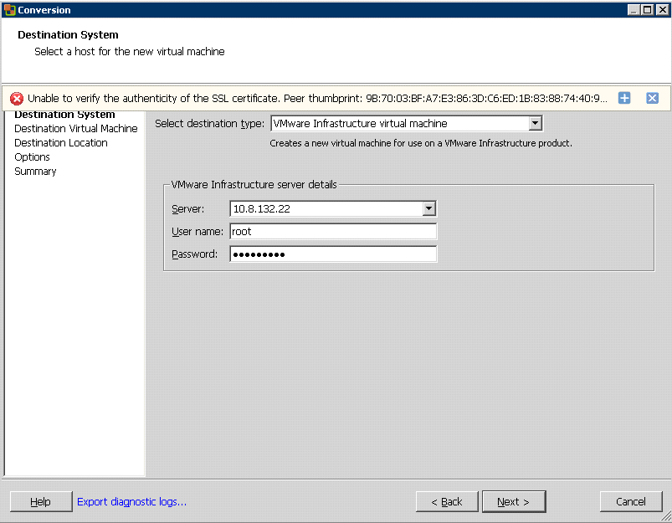

Note: Will try to install the converter again by moving the downloaded converter into the target server (Physical printer server)
Note: Always stop the printer spooler service or any application prior to the migration started (e.g., DB etc).

After the above failed installation, performed the steps below:

1. Moved the downloaded converter to the printer server (PRT-02) prior to the P2V migration, and run it locally

2. Click "Convert" on the ESXi console, and follow the onscreen instruction

>>> Installing VMware vCenter Converter Standalone...

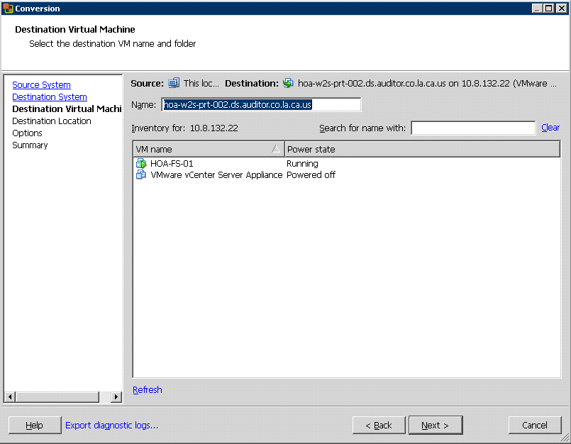

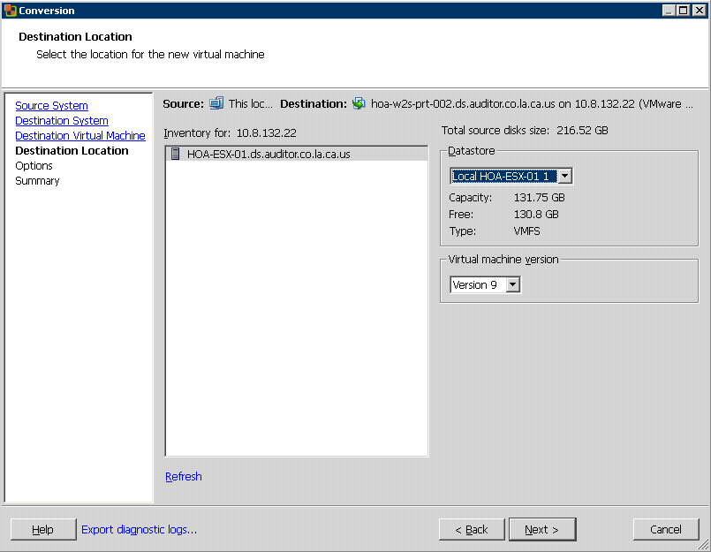

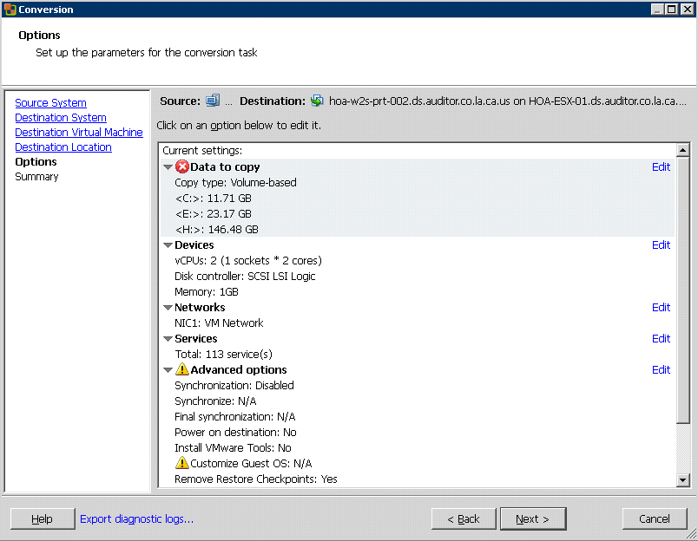

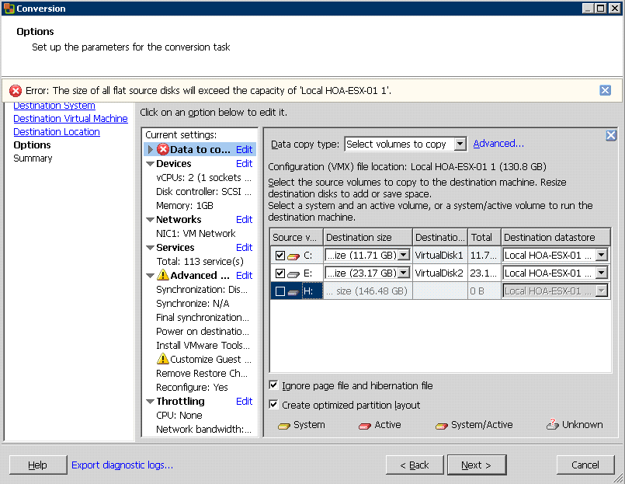
PRT-02 Configuration: Since H: drive is empty, do not migrate

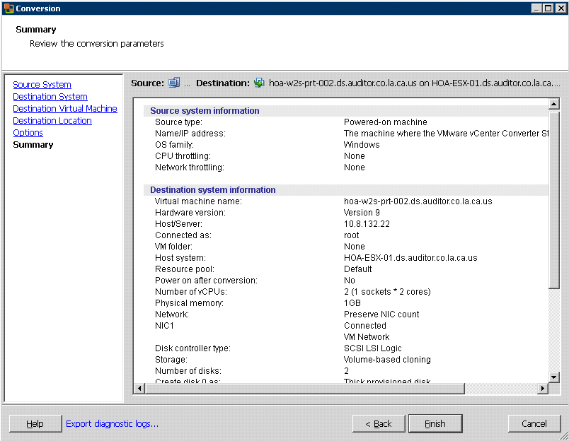

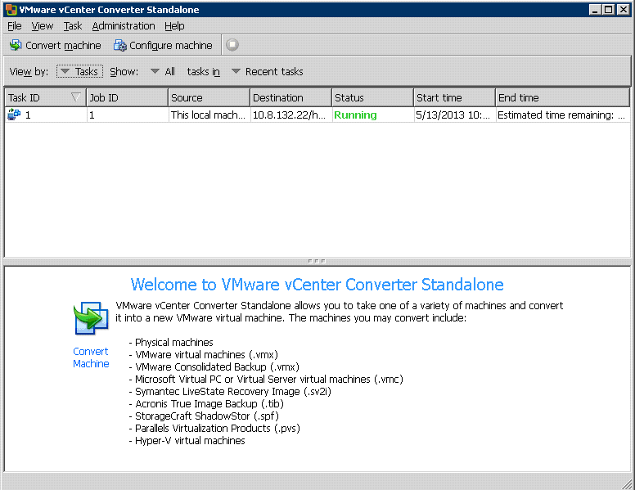

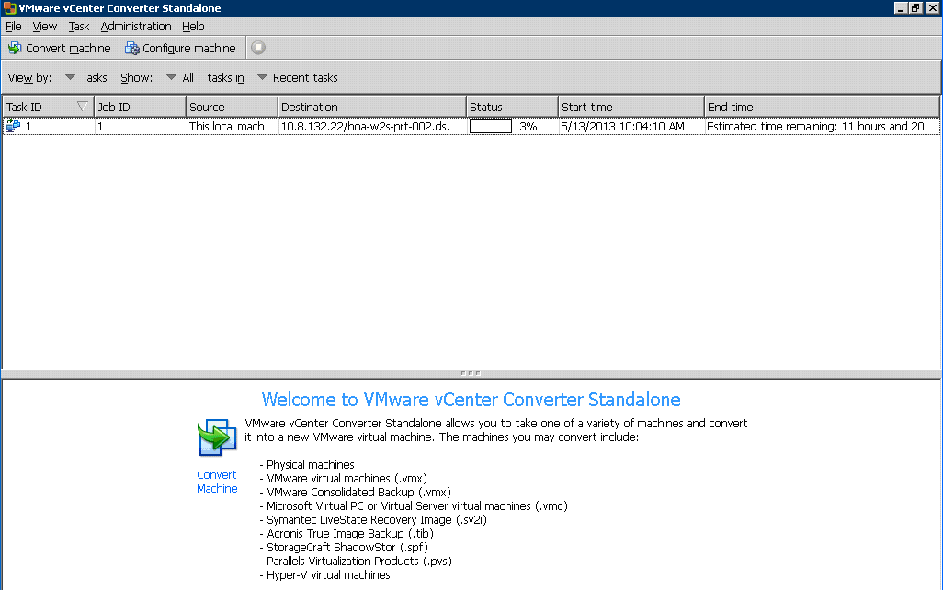
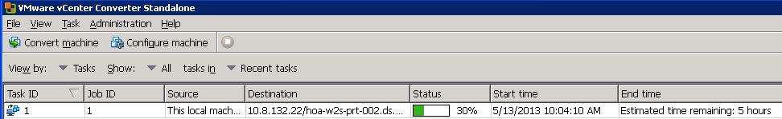
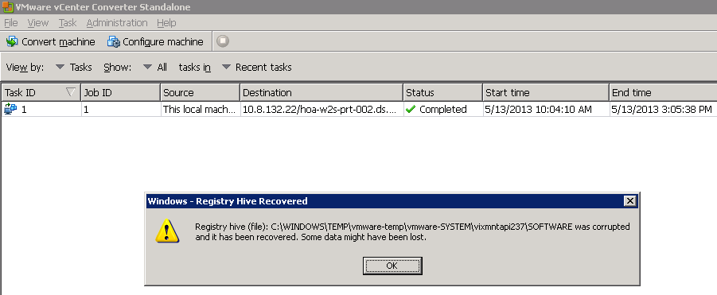

- Once the P2V is completed, you must shutdown the original physical server and start the VM on ESXi 5.1 host in order to avoid the IP# conflict.

  - Assign the original printer server’s IP# to the VM. You may click “No” button in order to continue (save the IP#)
  - Run VMware Tools by clicking VM\Guest\Install/Upgrade VMware Tools, as illustrated in the screenshot below:

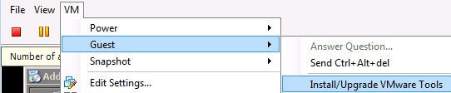
Note: This step will sync a mouse and screen in the Windows OS
environment.

  - Via Add/Remove Program, remove all HP related applet since the VM does not depend on the HW.

- End of the P2V migration

