**July 28, 2014**

**Jeremy Li**

**Aerohive Cloud-based Wi-Fi Overview**

Aerohive Networks ([www.aerohive.com](http://www.aerohive.com)) with 13,100 customers and 107.1 million revenue at the end of 2013, a cloud-enabled, controller-less Wi-Fi, routing, VPN and switching vendor, went to public (NYSE: HIVE) in March 28, 2014 and raised $75 million funding for mobile-focus wireless network. This positions Aerohive to continue innovation to lead the wireless access space.

Aerohive HiveManager has a single management interface that can be used for configuration, OS updates and monitoring with a single class of pane. It provides features:

* Secure Fast L2/L3 Roaming and actually allow firewall sessions to move around
* Seamless wire integration
* Ability for access points to talk to each other and synchronize their state
* Can dynamically reroute traffic from a failed AP into another without a single point of failure because each access point has its own internal control protocols.

The Gartner report titled “[Magic Quadrant for the Wired and Wireless LAN Access Infrastructure](http://www.gartner.com/technology/reprints.do?id=1-1WEP2NQ&ct=140630&st=sb)” dated June 26, 2014 (ID: G00261463) named Aerohive as a visionary vendor in its category two, meaning mainly focus on a specific connectivity scenario from which offering solutions for one or more vertical markets or deployment solutions that address a unique set of market requirements, due to its innovative technology.

According to Infonetics Research and broader adoption of 802.11ac:

* The world going wireless
* WiFi as a standard feature
* Applications in the network
* LAN vendors pushing WLAN
* Emergence of new, faster standards
* Mainstream enterprise adoption

It is worth mentioning that Aruba Networks, named as leaders in the Gartner [Magic Quadrant for the Wired and Wireless LAN Access Infrastructure](http://www.gartner.com/technology/reprints.do?id=1-1WEP2NQ&ct=140630&st=sb) report referenced above due to Aruba and Microsoft Lync IT showcase from which Aruba saved $2 million infrastructure and long distance call costs in a very short period of time after Aruba unplugging the last cord, as illustrated in a graphics below in its workplace.  Click on the links below for details:

[Learn how Arube Wi-Fi deployed on Microsoft HQ with 25,000 employees working there](https://www.youtube.com/watch?v=Hn2-UKZuxmQ) (A must-see video) and <http://www.arubanetworks.com/solutions/lync/>

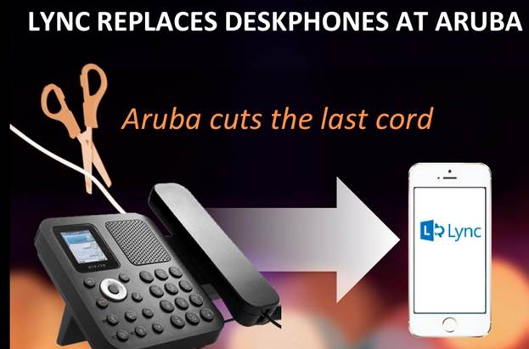

**Figure 1**

Below are from a Q & A session during the Aerohive Technology Overview via E-mail

Q1: **Can you please give me a comparison chart between Aerohive and Cisco Meraki Cloud-based Wi-Fi?**

A1: Some of the characteristics of Aerohive architecture and software can provide the following benefits:

* **Linear scalability and cost** because no wireless controllers are required. Scale one access point at a time.
* **High uptime and network throughput** due to distributed control in each access point.
* **Enterprise grade functionality and high security** features (TPM chip, stateful firewall) included out of the box.

**In comparison to Cisco Meraki we have a few advantages:**

1. **Guarantee of service. Aerohive provides wireless connectivity regardless of license status.**

**Meraki:** If you do not renew your support license with Meraki, they will turn off your access points, rendering your network gone. Here is the explanation from Meraki:

**Q: What happens when my license runs out?**

A: You can purchase a renewal through an authorized Meraki partner. If you chose not to renew, your will no longer be able to manage your devices via the Meraki cloud, and your Meraki network devices will cease to function. This means that you will no longer be able to configure or make changes to your Meraki network equipment, and your Meraki network products will no longer allow traffic to pass to the Internet. See here: <https://docs.meraki.com/display/kb/Meraki+Licensing+FAQ>

**Aerohive:** If you do not renew your support license with us, your network will continue to function normally. You will not have the ability to login to Hive Manager and change configuration settings until your support is renewed. However, you can still manage all the access points through CLI on the console port.

1. **High uptime. Aerohive wireless will function without the reliance on a controller.**

**Meraki:** If you lose connection to the “Cloud Controller”, your network will not fully function. Here is the explanation from Meraki:

i. Connectivity loss can occur for several reasons: your WAN connection goes down, a Meraki data center experiences an outage, or there is an Internet routing issue between your site and Meraki.  This note describes the behavior of your network under this "connectivity loss" state. The Meraki Cloud Controller is an out of band architecture, meaning that no client data flows through the cloud controller.  The system is also designed to handle connectivity failures gracefully. In general, wireless clients will continue to be able to use the WLAN during a connectivity loss.  Clients will continue to be able to access local LAN resources (e.g., printers and file shares) and, if an internet connection is available, the Internet as well. When your network is in the "connectivity loss" state, you will notice the following changes:

1. Network configuration changes will not take effect
2. Usage statistics will become out of date
3. Channel spreading and other optimizations will not run
4. The Rogue AP list will not update
5. If you are using Meraki-hosted RADIUS for authentication and Controller Disconnection Behavior is set to "Retricted", new clients will not be able to authenticate.  By default, all new clients are denied.  You can also select for all new clients to be allowed (Open).  Clients who have already authenticated continue to function normally.
6. Newly associated clients will not see Meraki-hosted splash pages.  Clients will be given access without seeing the splash page. (depends on settings on Configure -> Access Control -> Controller Disconnection Behavior)
7. If you have Meraki Billing enabled, new clients will not be able to purchase network access.

ii. These services will automatically resume functioning once connectivity between the wireless network and the Meraki network is restored. If a Meraki data center experiences an outage, your network will automatically fail over to another Meraki data center. During the fail-over time your network will experience connectivity loss as described above. Assuming you have setup email alerts, you will receive an email when a Meraki node loses connectivity to the Cloud Controller, allowing you to take corrective action if necessary.

iii. See this detail here: <https://kb.meraki.com/knowledge_base/connection-loss-to-cisco-meraki-cloud-controller>

**Aerohive:** Does not rely on any controller to function. Each access point has its own internal control protocols. This distributed model provides an industry leading network uptime.

1. **High security**

**Meraki:**  Access points can be stolen and sensitive data can be accessed.

**Aerohive:** Integrated TPM chip provides hardware based key storage and encryption. Even if an access point is stolen, no data can be accessed.

1. **Application Control, Application Firewall, and Bonjour Gateway all included at no additional cost.**

**Meraki:** Requires a separate device to manage application visibility/control, application firewall, and bonjour gateway. This device starts at $495 plus a $500 license (MX60) up to $31,995 and a $32,000 license (MX600) depending on the needs of your network. If you have multiple locations, you need to purchase multiple devices to cover these locations.

**Aerohive:** All application visibility/control, application firewall, and bonjour gateway functionality is included with each access point. This allows you to scale these services to multiple sites at no additional cost.

**Q2: Can you compare Aerohive’s Wi-Fi solution (Controller-less) with Aruba’s Wi-Fi solution (Controller-based) in regard to Microsoft Lync integration? See the link below for details:**

[Learn how Arube Wi-Fi deployed on Microsoft HQ with 25,000 employees working there](https://www.youtube.com/watch?v=Hn2-UKZuxmQ) (A must-see video) and <http://www.arubanetworks.com/solutions/lync/>

A2: Aruba facilitates Microsoft Lync by using QoS to prioritize traffic for that application. We also have full integration with Microsoft Lync! Aerohive also has application based QoS to prioritize Microsoft Lync traffic. To make it even easier, we have **Microsoft Lync traffic tagged in our database**. View the attached screenshot, “microsoft-lync-integration.jpg” to see that Microsoft Lync is integrated in our HiveManager software.

Here are some more details about our Application Visibility and Control including QoS:

Aerohive Application Visibility and Control

* **Application visibility and control now available on APs and HiveManager**
  + Granular Dashboard Reporting
  + QoS marking over the air and on the wire
  + Rate limiting
  + Firewall
  + Over 700 built in applications
    - Google/YouTube, Skype, P2P downloads, Apple/iTunes, MS Lync, HTTP video apps, and more
  + Up to 100 Custom Applications
* **Provides contextual visibility and policy enforcement**
  + Leverage existing Aerohive network for visibility and control
  + Provide differing levels of access and performance for applications, based on user identity, device type, location – **all on the same SSID**
* **A scalable solution, replicable for one site or entire organization**
  + Inspection and enforcement done at the network edge.  No additional hardware or licenses required

**Aerohive Application Visibility provides:**

* Learn about what is really going on your network
* Deep packet inspection provides per flow analysis of traffic, analyzing traffic behavior, not just destination and IP address.
* High level application usage statistics with drill-down information to quickly find how bandwidth is consumed, who is using it and where, and what role those users have.
* Provides Contextual Awareness, automatically leveraging topology structure, attribute tags, network policies, SSIDs, and user profiles as built-in filters
* Current and historical data
* Customizable, per-admin views allow customer to organize content to fit needs

**Aerohive Application Control provides:**

* QoS
  + Provide role-specific, identity-aware policies on the same SSID
  + Prioritize mission critical traffic
  + Rate limit unimportant, bandwidth/airtime-hogging applications
  + Provide QoS over the air, and pass markings to the rest of the network
* Firewall
  + Provide role-specific, identity-aware behavior on the same SSID
  + Block unwanted traffic outright at the edge of the network

I put together three images showing how QoS can be applied to the Microsoft Lync application on your network to guarantee bandwidth.

1. Shows Microsoft Lync as an integrated application.
2. Shows an example of a Rate Control and Queuing setup. Notice how class, “4 – Controlled Load” is allocated a certain amount of bandwidth. The number “4” here does not necessarily indicate priority; it is how much bandwidth that is allocated to this class that matters. This is only an example, and these variables can be changed.
3. Shows the QoS classifier map where I added the Microsoft Link application to the class “4 – Controlled” to guarantee that level of service.

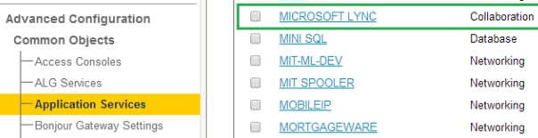

**Figure 2**

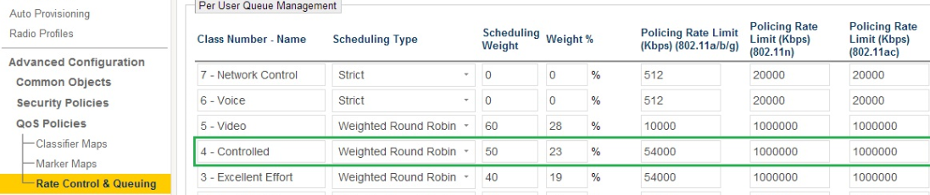

**Figure 3**

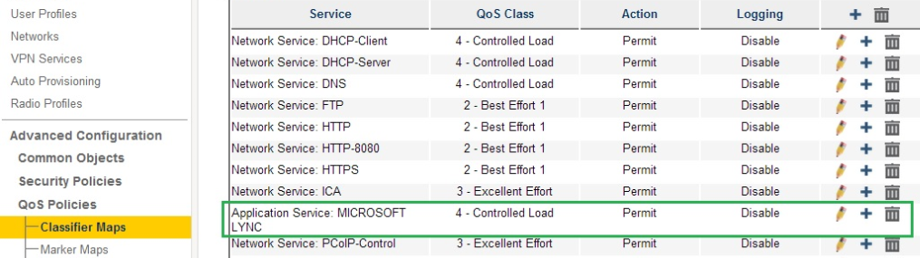

**Figure 4**

**Q3: According to the Gartner report dated June 26, 2014 (ID: G00261463), it implies that Cisco ISE and Prime cannot enforce policy to the Aerohive cloud-based solutions and manage Aerohive assets, respectively, in addition, Cisco has at least four separate access layer connectivity architectures that developed by separate development teams, and does not have a consistent user interface between solutions that often have different functionality for security, guest, network management and policy enforcement.**

A3: Regarding the great divide in functionality and compatibility for the different Cisco platforms, this is a problem for Cisco.

Aerohive has a single unified architecture and management interface. This means we are consistent in our development team, management interface, with the consistent functionality for security, guest, network management, and policy enforcement for all products. Our HiveManager is compatible with all Aerohive products. So, you can have different types of access points all under the same management.

**Q4:  When do you think Aerohive will support Mobileiron’s API since both Aruba Networks and Cisco Systems, Inc. joined the group that supports the MobileIron for a MDM, MAM and MCM solution? Below is one of the MobileIron Solutions:**

[http://www.mobileiron.com/en/customers/case-studies/st-joseph-health](http://www.mobileiron.com/en/customers/case-studies/st-joseph-health#_blank)

A4: We have an unofficial date to integrate with MobileIron sometime in 2015. Aerohive currently integrates with AirWatch and JAMF mobile management solutions. These vendors will provide a similar level of control as MobileIron. Keep in mind that to accomplish the integration between MobileIron and Aruba, you need Clearpass which is a per user licensed software suite that is sold as a virtual or hardware appliance. In addition, you need to buy an annual license to manage those users as well. See those costs here: <http://www.securewirelessworks.com/ClearPass-Access-MGMT.asp>. With Aerohive, our integration with AirWatch and JAMF are included at no extra cost. When available, MobileIron integration with Aerohive will be included for no extra cost as well.

**Q5:      Do you think Aerohive QoS is based on per user, instead of per Application, as illustrated in the screenshot in Figure 3?**

According to a must-see-video via [Learn how Arube Wi-Fi deployed on Microsoft HQ with 25,000 employees working there](https://www.youtube.com/watch?v=Hn2-UKZuxmQ#_blank), Microsoft evangelist said that Aruba is the only WiFi vendor knows how to use QoS per application, implying “not per user”.  If per user, that will be a different story, meaning it will increase the management dramatically.

A5: **Aruba is NOT the only vendor with per application QoS. Aerohive has per application QoS!** In your case, it is Microsoft Lync. The verbiage above, “Per User…” is related to how rate limits are applied. The rate limits in the table above are on a per user basis rather than an entire network basis. This means that if Microsoft Lync is set to a rate limit of let’s say 100Mbps, each user on the network will be allowed to use 100Mbps for that application. If Aerohive had a network wide QoS policy for Microsoft Lync set for 100Mbps, then the rate limit for Microsoft Lync on the entire network would be limited to 100Mbps. In this scenario, if 50 users were using Microsoft Lync, they would only be allowed 2Mbps per user. This network wide method does not scale. That is why Aerohive uses a per user rate limit. Please note, that this per user rate limiting for **QoS can be applied globally to all users under a user profile,** meaning you do not have to configure each user individually. For instance, you could have different network user profiles for employees, contractors, guests, etc. under the same SSID. This simplifies the process and saves time.

**Q6.  How many Aerohive APs are deployed at** [PNC Financial Services](http://en.wikipedia.org/wiki/PNC_Financial_Services#_blank)?  **That figure might boost our confidence since it had approximately $271.2 billion in 12/2011.**

A6. I am not at liberty to provide the exact number of access points, but I can tell you that it is a very large deployment across 1500+ locations. As you can imagine, each location will have more than one access point.

**Q7:  How does Aerohive address location-based services?  Please refer to the Cisco location-based services for your reference:**

“Cisco location-based services, a part of its Connected Mobile Experiences (CMX) can meet enterprises needs for submeter accuracy for Wi-Fi, without the supplemental beaconing or a separate overlay for the Location-aware Solution.”

A7: When Aerohive is configured for location density, we can provide accuracy to the meter. The more Aerohive access points you have, the better the accuracy, since Aerohive uses triangulation to identify device locations. The Cisco CMX location based services are part of the Cisco controller based infrastructure (Not Meraki) which has a much higher TCO and CAPEX than Aerohive. I can provide a TCO comparison of Aerohive and Cisco once I have the variables for your deployment. Furthermore, this sub-meter specification sounds impressive, but what is the practicality of sub-meter accuracy? Aerohive is able to provide accuracy to the meter which is more than sufficient to locate devices.

**Q8: Again, thank you for sharing the Gartner’s report with me via** <http://www.gartner.com/technology/reprints.do?id=1-1WEP2NQ&ct=140630&st=sb>

I noticed the following trend from the Gartner report referenced in the above link:

*“As vendors increasingly focused on the midmarket and small or midsize businesses (SMBs) for wireless deployments, we saw them shift from large, one-size-fits-all network service application suites to line-item applications that provided specific business value, such as guest access, policy management, onboarding and network management (see "Network Access for Guests or Contractors Requires More than an Open Network, Coffee Shop Strategy"). “*

What does it mean?

For my understanding, it means that if a solution from Microsoft Lync and Aruba’s patented and unique App QoS (a line item application), is best for most Microsoft entrenched customers, many mid-market enterprises might consider to use it in order to reduce the TCO dramatically, meaning configuring the APP QoS once, it will be for all users regardless they are on one of 2,000 VLANs or 3,000 different groups.  This is “**Set up once, and forget it**”.

A8: This is the trend of vendors providing services to customers as feature licenses, rather than including all features in one offering. This feature licensing structure sounds nice, but it ends up costing you more in the end. Aerohive simplifies this by providing a feature rich product from the beginning.

You mention, “Aruba’s patented and unique App QoS.” However, this is not patented or unique to Aruba. **Aerohive has per application QoS!**

Aerohive is designed to simplify network management with the “Set up once, and forget it” philosophy. You can apply QoS and other policies globally, regardless of VLANs or groups, under one pane of glass to simplify the process, save time, and reduce TCO dramatically.

**Challenges**

1. Leading incumbent Cisco is still the largest Enterprise wired and wireless vendor and largest market share in the unified market.
2. Aerohive lacks the Quality of Service (QoS) per application, meaning, it cannot prioritize one application with another. For example, it cannot give Microsoft Lync with VoIP highest priority. As a result, the performance for Lync will not be good as Aruba’s Wi-Fi solution because Aruba can prioritize QoS per application.

**Note:** Cisco also lacks QoS per application and can only provide QoS per VLAN. As a result, Cisco Wi-Fi or Wired network will have a performance issue for Lync in comparison to Aruba’s solution. See a must-view video via [Learn how Arube Wi-Fi deployed on Microsoft HQ with 25,000 employees working there](https://www.youtube.com/watch?v=Hn2-UKZuxmQ) for details.

1. Cisco ISE and Prime cannot be used to enforce policy to the Aerohive cloud-based solution and managing Aerohive assets, respectively.

**Conclusion**

Today’s access layer market is moving towards from two separate wired and wireless network into a single unified access layer.

Aerohive can provide distributed (Controller-less) Wi-Fi architecture and delivering simplicity, reliability and affordability Wi-Fi network for mobile-focus wireless network. It provides no single point of failure and eliminates data bottlenecks due to all functions built in its Access Point (AP), meaning just add one AP when additional performance is needed.

Aerohive HiveManager has a single management interface that can be used for configuration, OS updates and monitoring with a single class of pane. It provides a feature of Secure Fast L2/L3 Roaming and seamless wire integration. It can dynamically reroute traffic from a failed AP into another without a single point of failure.

Gartner assessed Aerohive as a Visionary in Gartner’s Magic Quadrant for the Wired and Wireless LAN Access Infrastructure” dated June 26, 2014 (ID: G00261463).

**Recommended Reading**

1. [Magic Quadrant for the Wired and Wireless LAN Access Infrastructure](http://www.gartner.com/technology/reprints.do?id=1-1WEP2NQ&ct=140630&st=sb) dated June 26, 2014 (ID: G00261463)
2. [Magic Quadrant for Network Access Control](http://www.gartner.com/technology/reprints.do?id=1-1O50YI3&ct=131213&st=sb) dated 12 December 2013 ID:G00249599

**Acknowledgement**

Thanks Ryan Rodriguez, Territory Manager – SoCal North SLED for providing me a Q&A session via E-mail.