**Nov. 19, 2013**

**Jeremy Li**

[**Silver Peak**](http://www.silver-peak.com) **- Easily Meet Your RPO with Replication Acceleration Software**

In 2004, Silver Peak was founded by a former Cisco Chief Technology Officer, David Hughes, PhD, who owns 35 patents in [WAN optimization](http://en.wikipedia.org/wiki/WAN_optimization) products. Its headquarters is located in Santa Clara, California.

Silver Peak has more than 2,000 customers globally with growth rate at 50% year over year in 2013, generated product revenue run-rate at $XXXXXX and shipped YYYY units in the 4th quarter, 2012. Silver Peak WAN optimization solution has earned Editor’s Choice award for software-based WAN optimization by InfoWorld. Click [here](http://mkto-i0190.com/534DKC0180001Gc000h8L01) to download the article. EMA Awards Silver Peak "[Best WOC for Storage](http://www.silver-peak.com/news/press-releases/analyst-firm-recognizes-silver-peak-complete-application-support)"

Silver Peak’s Replication Acceleration software, known as “Velocity Replication Acceleration (VRX)”, which is deployed as a virtual machine (VM), is used to enhance or optimize storage vendors’ replication software (e.g., snapshot replication, Continues Asynchronous Replication, Asynchronous Replication and continuous data protection – CDP replication) and many other applications from a site to a site - across Wide Area Network (WAN).

The installation is very simple and can be completed in 15 minutes with 6-clicks. Often, it can enable customers to protect more data, use bandwidth efficiently, replicate over longer distance, and meet or shrink their RPO (Recovery Point Objective - how much data can you afford to lose) and RTO (Recovery Time Objective - how much time until you are up and running again) for many storage vendors who do not have a capability of IBM’s [real-time compression](http://lacaaea.com/vendors/EasyTier-Compression-Together80.JPG) or other vendors’ [inline deduplication](http://lacaaea.com/vendors/Inline-Dedupe.jpg).

Generally speaking, Downtime equates to Event+RTO, and Data Loss equates to Event+RPO+RTO.

RPO is typically managed by either replicating data (e.g., Silver Peak’s Replication Acceleration Software) from source to target or backing up data from the source to disk storage or tape. In order to protect data lost or downtime, customers replicate data for backup or BCP purpose,

Three main replication issues are: latency, quality, and quantity.

1. Latency is associated with distance and will increase (e.g., from 5 ms to 100 ms) as distance increases from Local Area Network (LAN) to Wide Area Network (WAN) or from East and West coast. Latency is static or cannot be changed and will decrease the amount of data that can be sent across the network. However, leveraging the protocols and applications behavior can put more data into the replication pipe, thus, increasing the application performance.
2. Quality is associated with any issues on either the network or wide area network (WAN). When MPLS and VPNs are deployed, the quality (reliability) of the network is reduced due to dropped packets. As a result, the throughput of replication will be reduced dramatically, even though the amount of bandwidth is still available.
3. Quantity is associated with network bandwidth. A larger the bandwidth (more cost), more data can be replicated.

The Velocity Replication Acceleration has either VX, full featured software or VRX (Replication only) that enables its customers to leverage their existing storage vendors’ replication technology (e.g., NetApp SnapMirror) by dramatically reducing replication costs and increase the performance from 10X to 20X on average through its patented techniques: 1) **Network Acceleration** that addresses the latency, which is caused by the distance between sites; 2) **Network Integrity** that address quality issues by repairing lost or and out-of-order packets in real-time and 3) **Network Memory** that provides real-time deduplication and compression for replication.

Silver Peak provides three models of VRX family, as illustrated in the table below:

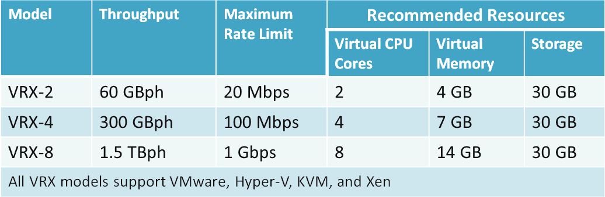

Enterprises can rely on Velocity Replication Acceleration to achieve:

* Protect more data
* Use bandwidth more efficiently
* Replicate over longer distance
* All of these things help customer meet or shrink their RPO

**Layer 3 vs. Layer 7**

Silver Peak uses Layer 3, instead of Layer 7 Riverbed is relying on to replicate data. The advantage of layer 3 is that it will not depend on any plug-in available for any customized application. It is independent from an application or OS. With constant updates or changes from many OS or applications, Apple and Google decided to use Silver Peak replication technology in house without needing to depend on a patch or update from each ISV’s update.

**Does Any Organization Need Silver-Peak VRX?**

It all depends.

In NetApp scenario, Silver-Peak VRX or VX will definitely help to increase the performance dramatically by relying on its real-time compression and deduplication with a byte-level granularity in addition to its technique of mitigating the packet(s) loss that is caused by 1) carrier congestion and service level agreement (SLA); 2) TCP window size reduction by half when packets are lost and 3) retransmission of the lost packets.

Many NetApp customers have been experiencing a big performance increase from 10X to 20X after turning off the dedupe feature that consumes high CPU as well as memory resources, which cause a slow storage performance. The VRX software can accelerate NetApp SnapMirror without using NetApp internal resources by using its real-time compression and deduplication NetApp lacks.

Silver Peak VRX software can truly complement NetApp SnapMirror and SnapVault to further optimize performance to overcome distance and congestion by efficiently conducting offsite replication, transferring only changed blocks for up to 70% of bandwidth savings by leveraging. Watch how to configure Silver Peak VRX with a NetApp storage in [video](http://www.youtube.com/watch?v=p2YcqKL88qw) for details.

With VX or VRX, customers can:

• Easily meet or shrink its RPO while reducing disaster recovery costs

• Accelerate data replication and remote backup without spending an expensive bandwidth upgrades that are often useless or are not effective due to latency fixed or poor quality links from Teleco.

**Note:** The throughput is independent to the network bandwidth because it is equal to or less than the Receive Window Size divided by Round Trip Time.

• Protect more data in less time with no changes to your existing infrastructure

Another advantage for deploying the VX or VRX is to have a chance to explore your organization’s options and determine how easy replication acceleration can be deployed and managed. For example,

1. Increase the distance between your sites
2. Hurricane Sandy was another good example to illustrate why an organization should back up their data to a site far away from its primary site

**Challenges**

1. Silver Peak VRX may not be able to help customers who rely on the real-time compression (e.g., IBM V7000 or inline deduplication) since the VRX cannot compress or dedupe the data that is already compressed or deduped again.

However, it can offload the real-time or inline dudepe process from the storage. That may still achieve the performance gain.

2. Adding VRX is also introducing additional layer of dependency or complexity, although the VRX is simple to install in just 15 or 20 minutes.

**Conclusion**

Silver Peak VRX is a very good replication accelerator application that can help many organizations to achieve…

Trying to download the VRX software and install it to any virtual machine with a 30-day trial license is a good idea. By using the trial, any organizations can see the benefits of Velocity Replication Acceleration with their own data and on their own network.

It is worth of mentioning that always try to keep your system simple that can be easily manageable. Albert Einstein said “Simpler is better, but not simple.” A graphics below illustrates how a system is associated with technology and requirements.



**Recommended Reading**

1. [State of Texas Moves More Than 100,000 State Employees to Microsoft Cloud](http://www.microsoft.com/en-us/news/Press/2013/Feb13/02-15TexasO365PR.aspx)

The State of Texas is moving more than 100,000 employees onto Office 365 at a cost of about $3.50 per user, per month, making it the largest statewide deployment of email and collaboration services in the U.S.

1. [How New York City is going to Consolidate 50 Data Centers from 40 City Agencies into One Location](http://www.informationweek.com/government/state-local/nyc-opens-consolidated-data-center/229219575)(Source: InformationWeek)

**Acknowledgement**

Thank Jeff Buttemer, Silver Peak Systems, Inc., for presenting the Easily Meet Your RPO with Replication Acceleration Software at the Huntley Hotel, in Santa Monica, Nov. 19, 2013.

Thanks Silver Peakfor allowing meto use a few graphics in my notes for clarification purpose!