**July 15, 2014**

**Jeremy Li**

**VMware Disaster Recovery Overview - Protect Your Applications and Data with VMware Business Continuity/Disaster Recovery Solutions**

VMware ([www.VMware.com](http://www.VMware.com)) is a public company and named as a Magic Quadrant for x86 Server Virtualization Infrastructure Leader in 2014 for fifth straight year from Gartner.

In September 2013, VMware released vSphere 5.5 that includes Site Recovery Manager (SRM) 5.5 to further enhance Disaster Recovery for virtualization environments.

In a physical environment, an array-based replication, snapshots and mirroring can reduce a workload from a server, meaning reducing IOs loads (data movement) from a server.

In a virtual environment, things are changed because a hypervisor maintains its own allocated storage resources that will be shared among all VMs on a host (also known as I/O blender), while arrays have no idea how many VMs on a single LUN or VOLUME are sharing the storage resources via the I/O bender. Therefore, the VMware VAAI was born in version 4.1 and the vSphere replication (VM-to-VM) was born in SRM 5.5 to address the issues, as illustrated in a screenshot below:

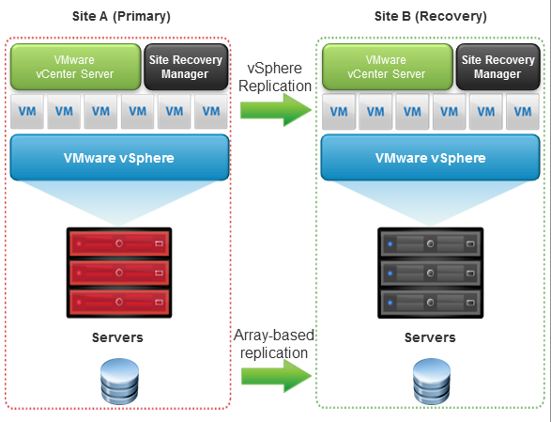

**Note:** One of the VAAI features resolved the locking and unlocking of small portion of storage resources, also known as region, thus, dramatically increase the storage array performance.

A SSD technology is very good for handling random IOs while the VMs are difficult to deal with random IOs because of an IO Blender issue.

A few highlights are listed below:

* The vSphere Replication provides asynchronous replication with flexible Recovery Point Objectives (RPO) that range from 15min to 24 hours
* The vSphere Replication enables simpler replication that is managed directly from vCenter Server with virtual machine granularity.  Users can now replicate individual virtual machines (VM-to-VM) that in turn essentially has eliminated a third party VM-to-VM replication technology advantage in a tier-2 application environment
* Because it operates at the individual virtual machine disk (VMDK) level, it enables replication that is storage agnostic. Customers can save not only on replication software, but also on storage infrastructure by using lower end, heterogeneous arrays across sites, including Direct Attached Storage

**What the new three features from SRM 5.5 do?**

* SRM 5.5 simplifies the setup and on-going management of recovery and migration plans.  Customers can replace traditional, manual runbooks with centralized recovery plans, which reduces the time required for set up from weeks to minutes
* SRM automates the orchestration of the failover process to the secondary site, as well as the failback to the production environment. Failover and failback automation can eliminate errors with manual processes and eliminates complexity. This level of automation also enables users to test their recovery plans with non-disruptively, thus can predict the Recovery Time Objectives (RTOs) and increase the confidence level in a recovery plan
* SRM 5.5 can increase the support flexibility via different replication solutions and either leverage vSphere Replication or a wide range of storage vendors’ array-based replication software

In addition, SRM 5.5 can now:

* Recover from multiple point-in-time snapshots using vSphere Replication. This features enables customers to recover from a previous known “good state” if the last restore point is corrupted
* Supports storage vMotion and storage DRS (Distributed Resource Scheduler™) for workloads moving within a consistency group at the primary site
* Adds interoperability with Virtual SAN for workloads replicated with vSphere Replication

See [VMware vCenter Site Recovery Manager 5.5 Release Notes](https://www.vmware.com/support/srm/srm-releasenotes-5-5-0.html) dated March, 2014 for details.

However, SRM 5.5 cannot protect first-tier applications because it relies on the vSphere Replication technology that is based on asynchronous replication. As a result, there will be data loss from a range of 15 minutes to 24 hours, depending on flexible Recovery Point Objectives (RPO) in your environment.

Therefore, VMware always tells its customers to rely on a storage vendor’s array-based replication technology (e.g., implemented SRM with EMC Recover Point between sites) to address any first-tier application to protect data since VMware provides API to use a storage vendor’s SRA (Storage Replication Adapter) that often increases complexity with additional layer component, as illustrated in a screenshot below. Often, it limits a choice because each storage vendor writes its own SRA.

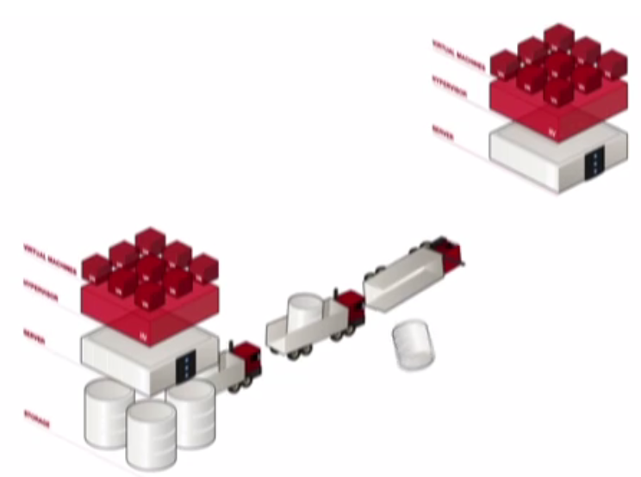

**Figure 1 A Storage Vendor Array-based Replication Technology**

An alternative solution is to consider relying on a third party solution to protect first-tier applications. For example, [Zerto Disaster Recovery as a Service (DRaaS)](http://www.zerto.com/bcdr-for-cloud-providers/dr-as-a-service-draas/) can be considered because Zerto Virtual Replication is based on a continuing replication that can provide a point-in-time for recovery. See <http://www.zerto.com/zerto-virtual-replication-video/> for details.

Another solution for protecting data and first-tier applications is to seek an expensive hardware-based solution such as EMC [VPLEX](http://www.emc.com/collateral/hardware/white-papers/h8232-vplex-architecture-wp.pdf) to protect its data and applications. The VPLEX replication method is active/active, while the vSphere replication or an array-based replication is active/passive.

Below are from a Q & A session during the Nutanix Technology Overview via Web Conferencing:

**Q1: Can you please tell me whether** [Zerto Virtual Replication 3.5](http://www.zerto.com/news-events/press-releases/zerto-adds-offsite-backup/) **is able to replace a storage vendor’s array-based replication?**

A1:

**Q2:       Can SRM 5.5 replicate between different versions of vSphere or from vCloud to vSphere?**

A2:

**Q3:       Can SRM 5.5 support vCloud?**

A3:

**Q4:       Will SRM 5.5 support vApps, or consistency across more than one VM?**

Please tell me the followings if SRM 5.5 does not support vApps:

1. What I will lose?
2. What’s the advantage of vApps that contains many VMs?

A4:

**Conclusion**

Although VMware SRM 5.5 introduced a VM-to-VM replication above hypervisor to reduce the array-based replication complexity, it still cannot protect data or prevent data loss from first-tier applications in a virtual environment because it relies on vSphere Replication that is based asynchronous replication technology.

As a result, a flexible Recovery Point Objectives (RPO) can be achieved from 15 minutes to 24 hours depending on a Disaster Recovery plan.

**Summary:**

If first-tier applications must be protected fully, either 1) consider to use a storage vendor’s array-based replication software that is expensive and complexity, always requiring a professional service and annual contract for a support call or 2) consider a third party replication technology such as Zerto Virtual Replication technology. See a 90-second video at <http://www.zerto.com/zerto-virtual-replication-video/> for details.

Last but not least, if any enterprise uses EMC [VPLEX](http://www.emc.com/collateral/hardware/white-papers/h8232-vplex-architecture-wp.pdf) to protect its data (Active/Active), any above replication technology should not be considered. However, most enterprises cannot afford to have two VPLEX appliances as a minimum due to high costs, professional services and etc.

It all depends on your environment.

**Recommended Reading**

1. [Gartner has once again named VMware a leader in 2014 Magic Quadrant for x86 Server Virtualization Infrastructure](http://www.gartner.com/technology/reprints.do?id=1-1WR7CAC&ct=140703&st=sb) 2 July 2014 ID:G00262673
2. [Magic Quadrant for Integrated Systems](http://go.nutanix.com/GartnerMQ2014.html?utm_source=homepage&utm_campaign=gartner%20mq&utm_medium=banner) 16 June 2014 ID:G00252466
3. **Critical Capabilities for General-Purpose, High-End Storage Arrays –** 7 March 2014 ID:G00248908
4. **Critical Capabilities for General-Purpose, Midrange Storage Arrays -** 7 March 2014 ID:G00248904
5. [Dell Fluid Cache for SAN Frequently Asked Questions](http://www.dell.com/learn/us/en/555/shared-content~data-sheets~en/documents~dell-fluid-cache-for-san-faq.pdf) – 4/1/2014

**Acknowledgement**

Thanks Tony Okwechime, System Engineer from VMware for presenting “Protect Your Applications and Data with VMware Business Continuity/Disaster Recovery Solutions”

with follow-up Q&As via email.

Thanks VMware for allowing meto use one graphics in my notes for clarification purpose.