Vaccination Center

Following are instructions for running the frontend and backend of the application.

We have to unzip the file for running the application.

Prerequisites
NodeJS v14.17.0

Backend

1) Open the backend folder in terminal and execute
npm install

2) For seeding the database, execute

npm run initDB

3) To start the application, execute

npm start

Then the backend api docs would be available at

http://localhost:8080/api-docs

Frontend

1) Open the frontend folder in terminal and execute
npm install

2) To start the application, execute

npm start

Then the frontend would be accessible at:

http://localhost:3000/

Database Design

Following are the tables used for the application:

1) appointments

For keeping the appointments with resident & community center details.
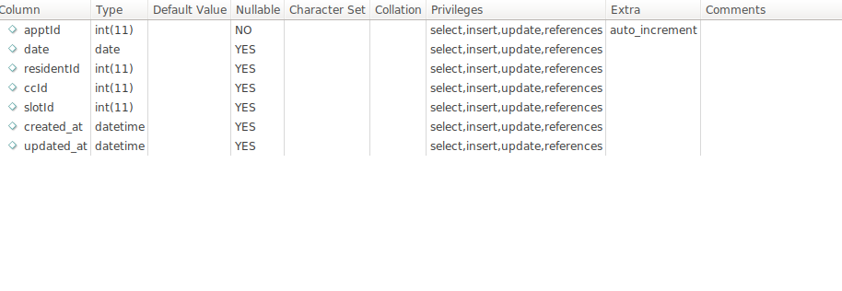

2) community_centers

For keeping the community centers list.

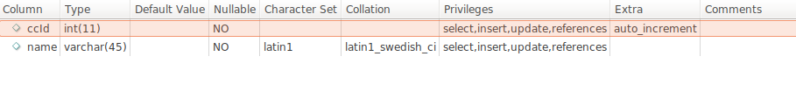

3) nurses

For keeping the nurse data with their allocated community center
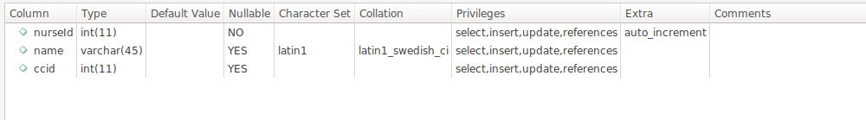

4) shifts
For maintaining the duty schedule in a day

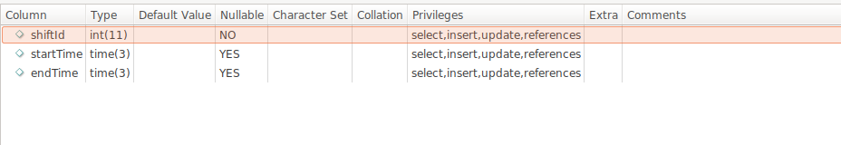
5) slots

To store the slots to be displayed in the frontend

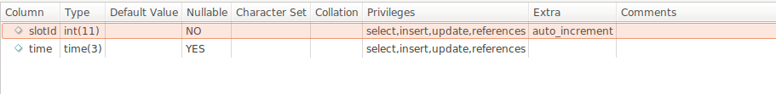
6) workdays

To store the workdayId which is to track the day-wise schedule of the nurses
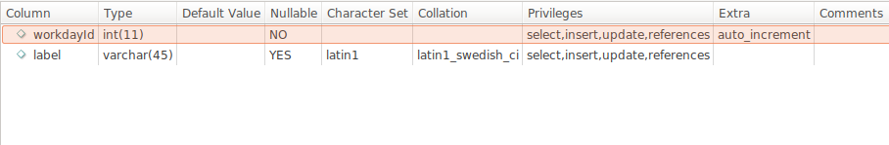
7) workday_schedules

To keep the nurses day-wise schedule

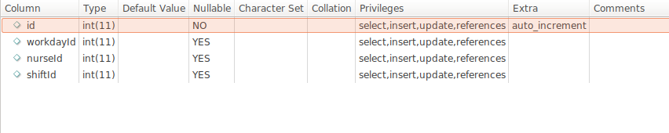

Assumptions

The capacity of a vaccination center is purely depend on the number of resources (Nurses) and their work schedule.

Nurses have fixed week day schedules which are kept in the workday_schedules table.

By default, it is assumed that a nurse can vaccinate 1 patient per slot (15min). But this assumption can be changed by updating the PERSON_PER_NURSE_PER_SLOT variable in the backend/.env file. If a nurse can vaccinate n patients per slot, then we can use PERSON_PER_NURSE_PER_SLOT=n.

Two work shifts (08:00-14:00, 14:30-20:30) are scheduled to manage nursing staffs.
No workday schedules are scheduled for Sunday. So no slots would be shown on the system if the selected date falls on a Sundy.

For testing the application behavior, lets consider some test cases using the seeded database.

1) Consider vaccine center as Bukit Batok CC (ccId=1),

There are 4 nurses (with nurseIds 1,2,3 & 4) working at this cc with different work day schedules.

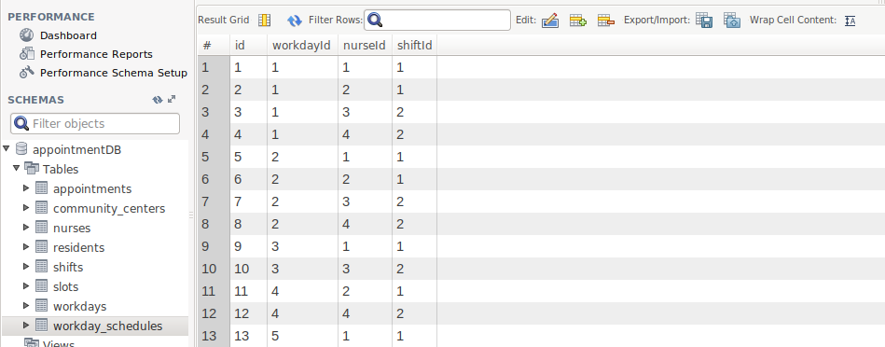
If we try to book appointment on “Tuesday” (workdayId 2) at any time slot (say 8am), the system should allow booking for 2 patients as there are 2 nurses at working for morning shift and afternoon schedules with PERSON_PER_NURSE_PER_SLOT=1.
When we try to select the same date and center, the system won’t show 8 am slot as all the slots are fully booked.

2) Consider vaccine center as Bukit Batok CC ,

If we try to book appointment on Wednesday at 8am, only one patient should be able to book as only one nurse is assigned in the morning shift.
Similarly for afternoon slot, only one patient can book at the same slot as only one nurse is allocated to the CC .

3) Consider vaccine center as Bukit Panjang CC.

According to Tuesday work schedule,
Two nurses (NurseIds 5 & 6) are assigned in the morning shift and no nurses are assigned in the afternoon shift.

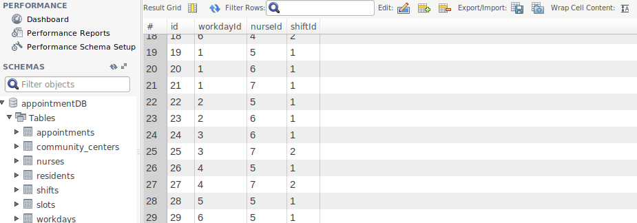
Then 2 patients can book the same slot (say 8am) in the morning shift.

If another patient tries to book the same time slot, then the 8am slot won’t be shown in the system.

None of the afternoon slots won’t be shown in the system as no nurses are assigned in the afternoon shift.

