Q.1 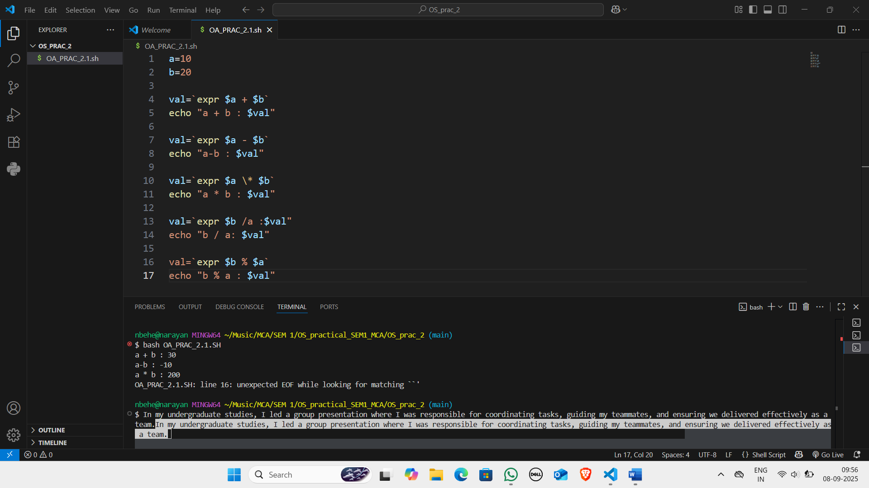

Q.2

Q.3

Q.4

