**行星对宇宙线的遮挡作用分析**

李军

*江苏省南京市栖霞区元化路6-10中国科学院紫金山天文台*

***Abstract***

In addition to Einstein’s famous cosmological constants, a large number of dark energy theoretical models have been proposed to try to explain this mystery. In these dark energy models, only a single scalar field cannot make the state equation parameters . So we must consider the dark energy model with multiple scalar fields. From standard cosmology, we can see that the smaller the of an ideal fluid substance, the slower its energy density decreases with the expansion of the universe.

Recently, cosmologists have made a lot of efforts in constructing models that enable  in the phantom field. Obviously, only a single-field phantom model () or quintessence model () can not make the state equation parameter of dark energy w cross phantom potential well . The No-go theorem shows that the following conditions make it impossible for w cross phantom potential well w=-1:(1)Classical physics; (2)General relativity is reasonable; (3)Single real scalar field; (4)Arbitrary Lagrangian density . Among them, the  is the kinetic energy term.(5)is a continuous and sufficiently differentiable function. Therefore, to achieve the transition from  to  (or from  to ), at least one of the conditions in the No-go theorem above must be abandoned. Obviously, the simplest method is to consider the model containing multiple scalar fields to destroy the condition (3).

This paper studies the evolution of the dark energy model with double scalar fields. In addition to several common evolutionary endings, this model can give the result of the accelerated expansion of the universe and achieve the goal of the state equation cross  in the process.

I 引言

宇宙线是天体过程的一种直观的表现，对宇宙线的研究工作可以追溯到1929年. 每秒钟每平方米的面积上约有1000个宇宙线粒子轰击到地球大气层上[1].但是宇宙线并不是总能顺利地到达地球并被人类观测到，影响宇宙线到达人类可观测区域内的诸多因素中，天体的遮挡作用占其中很大的比重.

$f=\sum{∆tr^{2}ε\left(θ\right)}$

日影通常是指宇宙线被太阳遮挡，最早由George W. Clark在1957年提出的.

月影和日影已经经过了天文学家的多次讨论。本文的目的是仿照月影作用的分析和计算，对太阳系中的行星进行分析，通过将分析结果和月影作用进行对比，指出相对于月影，太阳系中的行星对宇宙线的能否被忽略.

在一些工作开始之前，我们先介绍一些概念性的知识.

**A 天体视半径的变化规律**

天体的视半径是指观测者的眼睛到天体中心的连线与观测者的眼睛到天体切线所形成的夹角度数（本文统一使用弧度制）.但是由于天体运动产生影响，天体的视半径往往是一个动态的值，在以下分析中，本文认为在100s的时间内，天体的视半径是保持不变的（具体原因由以下分析得到）.

**B 遮挡率**

**定义某个天体对宇宙线的遮挡率**

**其中，r为天体的视半径， $∆t$**为测量时间隔（本文认为在此时间间隔内的天体视半径是定值）， $ε\left(θ\right)$ 为探测阵列的探测效率. （为了简化计算，本文对于探测率的计算并没有考虑阵列的探测面积）

$ε\left(θ\right)$ 的值，由以下拟合过程得到：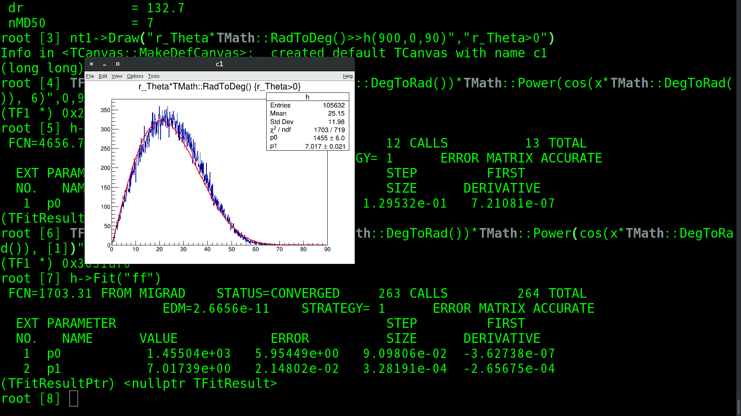

可以看到拟合给出的指数为 $7.017±0.021$.为了简化之后的计算过程，这里取指数值为7，可以得到探测效率的解析式为

$$ε\left(θ\right)=\cos^{7}θ$$

因此，我们可以得到遮挡率为：

$f=\sum{∆tr^{2}\cos^{7}θ}$

II 月球对宇宙线的遮挡作用

**A 月影基本参数的变化**

以下是我们所能用到的参数随着时间的变化规律。

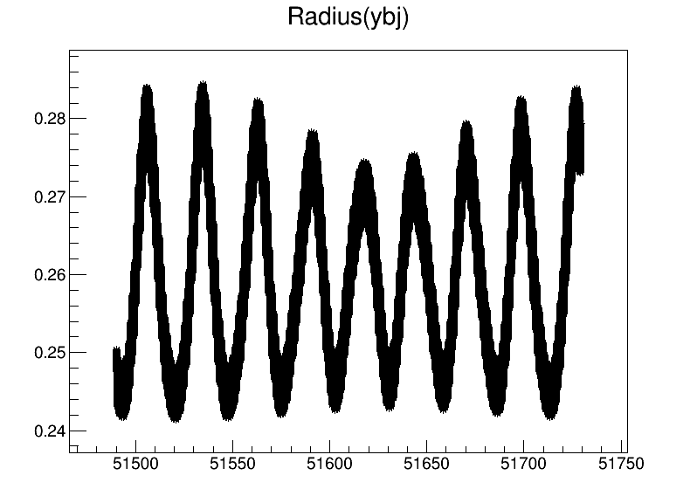

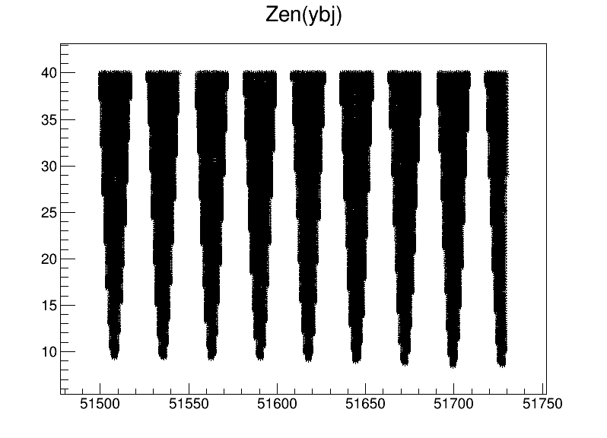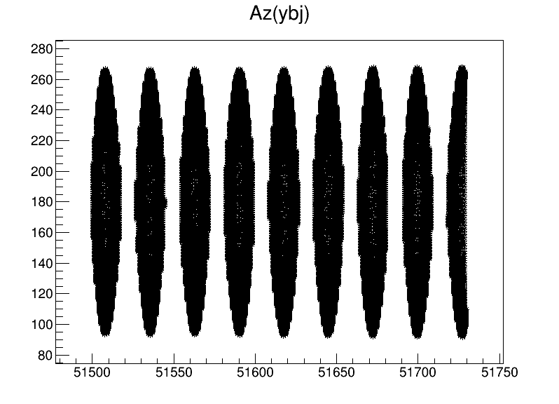

从以上图表我们可以看出，月球的视半径、天顶角和方位角都是根据时间变化而变的动态值。

**B 遮挡率分析**

根据I 中的分析，我们可以得到一个衡量天体遮挡宇宙线程度的标准 $f$, 那么本章节就利用这一参数对月影进行分析.

经过计算，我们可以得到，月球对宇宙线的遮挡率为207.120064025.

**C 仿真分析**

**由于本文要对分析过程给出验证，这里可以给出一个仿真分析，以验证结果是否可信。**

III 行星对宇宙线的遮挡作用

根据以上分析，我们可以知道月亮对宇宙线的遮挡情况。用同样的方法，我们可以得到太阳系其他行星的视半径、天顶角、以及其他参数的变化情况。

properties, this model is able to achieve equations of state exceeding -1 and may avoid "big tear".

Dark energy initially showed the evolutionary behavior of the Phantom field. In the end, this situation needs to select a special potential energy to make the Phantom field finally withdraw from the evolution. The Quintessence field oscillates because it obtains a large mass, so that the dark energy finally evolves according to the behavior of matter, which avoids the failure caused by the Phantom field. Stability and the emergence of "big tear" in the future.

If early Quintessence dominates, then . Whether it is the Quintessence field or the Phantom field, as long as they evolve independently, according to the law of conservation of energy, they all satisfy:

,which is .

Therefore, as the energy density of the phantom field increases with time, the quintessence energy density decreases at any time, and the phantom field always plays a leading role at the end. At this time, . That is to say, regardless of the initial training and the energy density of the two scalar fields, the energy density of the quintessence field is always smaller than the energy density of the phantom field to a certain stage of evolution. If the initial conditions are set to make the density of the quintessence field larger. That is, in the early stage of evolution, , the dual-field model can make w exceed -1. The ultimate fate of the universe is deSitter space-time or "big tear".

In this case, we need to choose the appropriate interaction items. Of course, this type of interacting dual-field dark energy model, the final result also includes "large tear" because the state equation W has always been less than -1, or the universe evolved into DeSitter because the state equation  eventually tended to -1 . If the scalar fields of these two momentum terms have opposite signs, and the potential energy satisfies a certain condition, the kinetic energy terms of the Phantom field will rapidly decay in evolution, with the following form: . In this way, the evolution of the Phantom field is "frozen".

To achieve this goal, a negative kinetic energy field with only nonindependent potential energy terms can be selected. This kind of field is coupled with a scalar field with positive kinetic energy terms. This situation will be discussed in detail below. Here is a special case. Let the Lagrangian of the dual-field model be[7]:



(3.1)

At the beginning, we can choose that the derivative of the potential energy to the field is close to 0, which means that the potential energy is almost constant in this stage, and the two fields are close to decoupling. We call this phase the "weak coupling" period, at which time they can be regarded as mutually independent. On the contrary, when the derivative of the potential energy with respect to the field is not 0, the two scalar fields are in the "strong coupling" period. At this time, they have a clear interaction.

In the weakly coupled period, the phantom field appears as a massless scalar field, and its energy density is attenuated rapidly according to the rules of a. The mouth here is the scale factor of the universe. The corresponding quintessence field has a qualitative term, and its evolutionary behavior is determined by the ratio . If is much smaller than 1, it will show a "slow roll" behavior, similar to a cosmological constant. However, when is far greater than 1, its kinetic energy and potential energy terms will oscillate together, and will attenuate according to the law of n, showing the material behavior in the oscillation.

During the strong coupling phase, the two scalar fields will quickly evolve towards their equilibrium point, as shown in Figure 1[7].

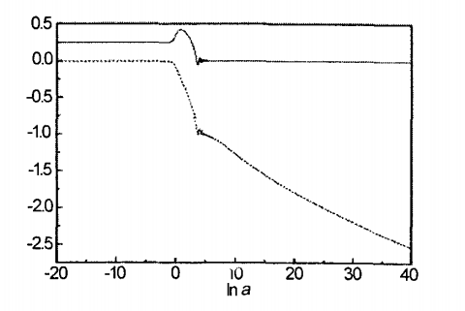

Fig.1 The scalar field as a function of 

Because the equilibrium point determines the evolution trend of cosmos at a certain degree, it is necessary to analyze the equilibrium point of these two scalar fields in detail. The partial derivative of the effective potential for the two scalar fields can be obtained by simple calculation, and the equilibrium point is reached when the partial derivative is equal to zero. We find that the equilibrium point of  is infinity, while the equilibrium point of  is 0.

During the evolution of , the zero point is the smallest value. In the initial state, if is not nearly equal to 0, the evolutionary behavior is a Phantom-like scalar field, and will drive the potential energy to increase. This direction of evolution tends to be negative infinity along . In this process, the evolutionary line is a scalar field similar to quintessence, and f gradually evolves toward the zero point. In summary, the entire system will evolve towards the weak coupling stage, and  will gain a large quality.

In this example, the initial condition selected is the dark energy state equation . Because in the early stages of evolution, radiation first dominates, and then matter dominates. The evolution of both fields is frozen, and the equation of state is always . After dark energy begins to evolve, the energy density of the phantom field increases with time, and the energy density of the quintessence field decreases with time. The state equation of the system will evolve from greater than  to less than . As shown in Figure 1, the quintessence field is drawn with solid lines, and the dashed line represents the phantom field. When the potential energy increases to a certain extent, the contribution of the phantom field to the evolution of potential energy becomes negligible, and both fields have entered the stage of independent evolution. At this time, phantom exits the evolution, and the universe re-enters the dominant phase of the quintessence field, and the quintessence field begins to oscillate due to the acquisition of a mass much larger than , which causes the state equation w to oscillate around zero. In this way, the phenomenon of "big tear" is avoided. The evolution of the equation of state w is shown in Figure 2[7].

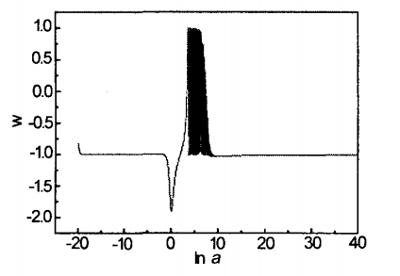

Fig.2 The equation of state  as a function of 

The special feature of this model is that it is first directed by quintessence to be directed by phantom, but it ends with quintessence. The last evolutionary behavior is similar to the evolution of matter, so that the universe stops accelerating expansion.

**IV 其他天体对宇宙线的遮挡作用**

**A Quintom model**

Recently, cosmologists have made a lot of efforts in constructing models that enable  in the phantom field. Obviously, only a single-field phantom model () or quintessence model () can not make the state equation parameter of dark energy w cross phantom potential well . The No-go theorem shows that the following conditions make it impossible for w cross phantom potential well w=-1:(1)Classical physics; (2)General relativity is reasonable; (3)Single real scalar field; (4)Arbitrary Lagrangian density . Among them, the  is the kinetic energy term.(5)is a continuous and sufficiently differentiable function. Therefore, to achieve the transition from  to  (or from  to ), at least one of the conditions in the No-go theorem above must be abandoned. Obviously, the simplest method is to consider the model containing multiple scalar fields to destroy the condition (3).

The paper [8] considers a double real scalar field model and discusses the possibility of w cross phantom potential well . Feng Wang and Zhang proposed a quintom model in [7] (quintom is named after combining the word prefix of quintessence and the word suffix of phantom). Naturally, its Lagrangian density has the following form[7]:

 (4.1)

Among them,  and  play the roles of quintessence field and phantom field respectively. Consider the RIV metric for flat spacetime and assume that both and are uniformly isotropressure and energy density of the quintom field are:

 (4.2)

 (4.3)

Thus, the state equation parameter is:

 (4.4)

Obviously, when ,  and when , . So the quintom model achieve the transition from  to  (or from  to ).

**B Model with three real scalar fields**

We consider the following model with three real scalar fields to break the third condition of No-go theorem. Its Lagrangian density has the following form:



(4.5)

Consider the RW metric in flat space:

 (4.6)

It is obtained by the Euler-Lagrange equation:

 (4.7)

 (4.8)

 (4.9)

Let

 (4.10)

We can calculate that

 (4.11)

So

 (4.12)

Combining (4.11) and (4.12), we can get the following formula￥：

(4.13)

Lagrangian density has the following form:

 (4.13)

Then the energy density and pressure are:

 (4.13)

 (4.14)

State equation parameters:



(4.15)

Obviously, We can draw that when ,  and when , .So the dark energy mode with three scalar fields achieves the transition from  to  (or from  to ).

V 结论

This paper first analyzes the development status of various scalar field dark energy models and dark energy models, and focuses on three types of models: dark energy models with a single scalar field, dark energy models with dual scalar fields, and three scalar fields Dark energy model. We also introduced the characteristics and limitations of these three types of models.

Through our discussion, we can know that with the development of astronomical observation technology in recent years, when domestic and foreign cosmologists use experimental data to fit the dark energy model, they find that the state equation of dark energy has a tendency to cross -1 . So since then, many scholars have begun to try to establish a new dark energy model to solve this problem.

This paper reviews the standard cosmological model and the LCDM dark energy model. This scalar field model can easily obtain the oscillating H and w<1 equations of state. Obviously, only a single-field phantom model () or quintessence model () can not make the state equation parameter of dark energy w cross phantom potential well .

We know that the following conditions make it impossible for w cross phantom potential well w=-1:(1)Classical physics; (2)General relativity is reasonable; (3)Single real scalar field; (4)Arbitrary Lagrangian density . Among them, the  is the kinetic energy term.(5)is a continuous and sufficiently differentiable function.

In order to destroy the condition (3), we introduced a dark energy model with two scalar fields. In this part of the discussion,the quintom model can achieve the transition from  to  (or from  to ). For the dark energy model with three scalar fields, it can also achieve the transition from  to  (or from  to ).

According to [3], we know that the dark energy model with multiple scalar fields can obtain different fate of the universe's evolution: DeSitter space-time (the universe will continue to expand, and the later evolutionary behavior is similar to the cosmological constant); 2) "Great tear" (In a limited time, the scale factor of the universe, the energy density of dark energy, and the pressure all reach infinity); 3) Dark energy evolves in a behavior similar to matter, and the universe stops accelerating its expansion. The construction of dark matter models with different number of scalar fields is much helpful for humans to understand the universe and predict the fate of the universe.

**References**

1. 托马斯·K.盖瑟，宇宙线和粒子物理.
2. A．R．Liddle and D．H．Lyth，Cosmological inflation and large。scale structure, Cambridge University Press(2000)．
3. S．Weinberg, Gravitation and Cosmology，John Wiley and Sons，Inc·(1972)·
4. E．J．Copeland，M．Sami and S．Tsujikawa，“Dynamics of dark energy，"Int·J．Mod．Phys．D 15，1753(2006)
5. w．L．FYeedman et a1．’I‘Final Results from the Hubble Space Telescope Key Project to Measure the Hubble Constant，”Astrophys．J．553，47(2001)．
6. 张晓菲 ，刘汇慧 “双场暗能量模型的研究”.
7. Bo Feng，Xiulian Wang，and Xinmin Zhang．Dark Energy Constraints from the Cosmic Age and Supernova[J]．Modern Physics Letters A，2004．3(12)t23．
8. Wayne Hu．Crossing the Phantom Dividel Dark Energy Internal Degrees of Freedom．Modern Physics Letters A．2005．2(1)：27．
9. 苏奇平 “暗能量中的标量场模型” . 20080601
10. 李微 “含三个实标量场的暗能量模型” . 1673—0569(2009)01—0063—04
11. Alexander Vikman．Can dark energy evolve to the phantom．Modern Physics Letters A．2005，4(1)120．