## Chapter 2

import sys import re

WORD_RE = re.compile('\w+')

index = {}

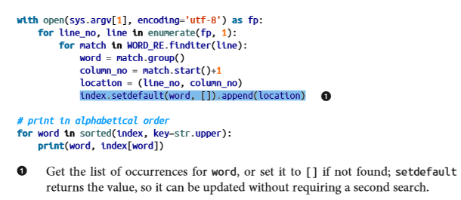

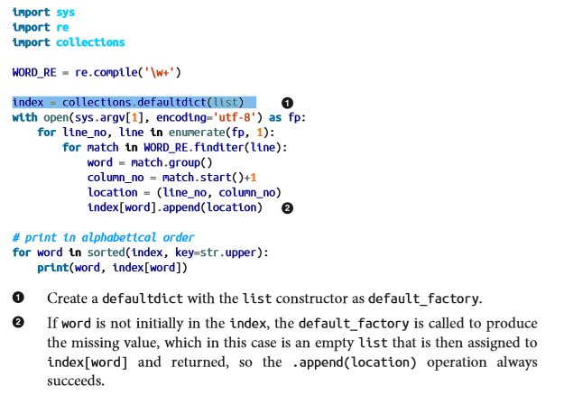

collections.OrderedDict

collections.ChainMap

collections.Counter

collections.UserDict

**Immutable Mappings**

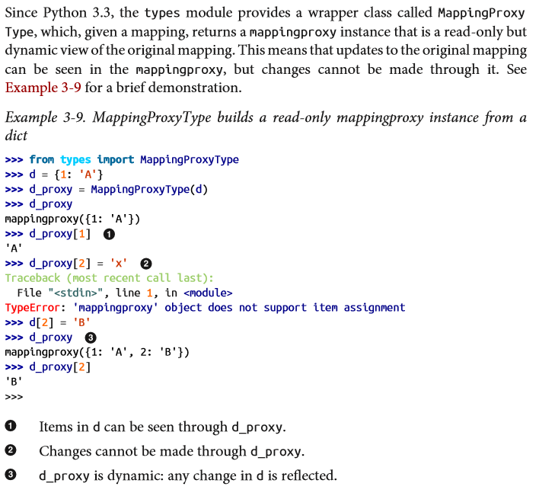

**Set Theory**

Set elements must be hashable. The set type is not hashable, but frozenset is, so you can have frozenset elements inside a set.

In addition to guaranteeing uniqueness, the set types implement the essential set operations as infix operators, so, given two sets a and **b, a | b returns their union, a & b computes the intersection**, and a - b the difference

