**LAB 3**

Tên: Hà Chí Hân

Lớp: 11_DH_CNPM1

MSSV: 1150080014

**Thực hành 1**

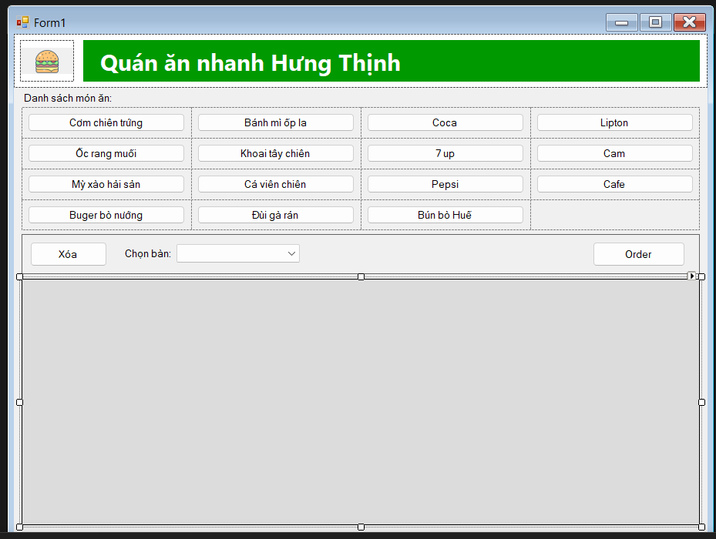

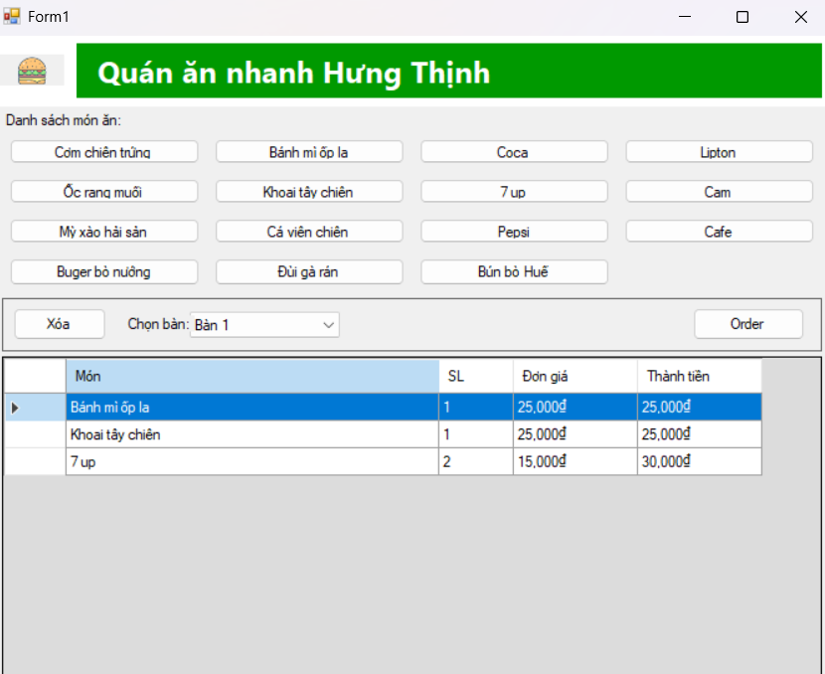

* Form1.cs

using System;

using System.Data;

using System.IO;

using System.Linq;

using System.Windows.Forms;

using System.Collections.Generic;

namespace ChiHan_1150080014_BTTuan6

{

public partial class Form1 : Form

{

private DataTable orderTable;

private readonly Dictionary<string, decimal> priceList = new Dictionary<string, decimal>

{

["Cơm chiên trứng"] = 35000m,

["Bánh mì ốp la"] = 25000m,

["Coca"] = 15000m,

["Lipton"] = 12000m,

["Ốc rang muối"] = 60000m,

["Khoai tây chiên"] = 25000m,

["7 up"] = 15000m,

["Cam"] = 12000m,

["Mỳ xào hải sản"] = 55000m,

["Cá viên chiên"] = 20000m,

["Pepsi"] = 15000m,

["Cafe"] = 18000m,

["Buger bò nướng"] = 45000m,

["Đùi gà rán"] = 40000m,

["Bún bò Huế"] = 48000m

};

public Form1()

{

InitializeComponent();

for (int i = 1; i <= 20; i++) cboTable.Items.Add("Bàn " + i);

cboTable.SelectedIndex = 0;

orderTable = new DataTable();

orderTable.Columns.Add("Món", typeof(string));

orderTable.Columns.Add("SL", typeof(int));

orderTable.Columns.Add("Đơn giá", typeof(decimal));

orderTable.Columns.Add("Thành tiền", typeof(decimal), "SL * [Đơn giá]");

dgv.DataSource = orderTable;

dgv.Columns["Món"].Width = 300;

dgv.Columns["SL"].Width = 60;

dgv.Columns["Đơn giá"].DefaultCellStyle.Format = "#,0₫";

dgv.Columns["Thành tiền"].DefaultCellStyle.Format = "#,0₫";

dgv.CellEndEdit += (s, e) =>

{

if (dgv.Columns[e.ColumnIndex].Name == "SL")

{

int sl;

if (!int.TryParse(Convert.ToString(dgv.Rows[e.RowIndex].Cells["SL"].Value), out sl) || sl <= 0)

{

if (!dgv.Rows[e.RowIndex].IsNewRow) dgv.Rows.RemoveAt(e.RowIndex);

}

orderTable.AcceptChanges();

}

};

}

private void menuButton_Click(object sender, EventArgs e)

{

var b = sender as Button;

if (b == null) return;

string name = b.Text;

if (!priceList.ContainsKey(name))

{

MessageBox.Show("Chưa có giá cho món: " + name);

return;

}

var rows = orderTable.AsEnumerable().Where(r => r.Field<string>("Món") == name);

if (rows.Any())

rows.First()["SL"] = rows.First().Field<int>("SL") + 1;

else

orderTable.Rows.Add(name, 1, priceList[name]);

orderTable.AcceptChanges();

}

private void btnRemove_Click(object sender, EventArgs e)

{

if (dgv.SelectedRows.Count == 0)

{

MessageBox.Show("Hãy chọn 1 dòng để xóa.", "Thông báo",

MessageBoxButtons.OK, MessageBoxIcon.Information);

return;

}

foreach (DataGridViewRow row in dgv.SelectedRows)

if (!row.IsNewRow) dgv.Rows.Remove(row);

orderTable.AcceptChanges();

}

private void btnOrder_Click(object sender, EventArgs e)

{

if (orderTable.Rows.Count == 0)

{

MessageBox.Show("Chưa có món nào để Order.", "Thông báo",

MessageBoxButtons.OK, MessageBoxIcon.Information);

return;

}

string tableName = cboTable.SelectedItem != null ? cboTable.SelectedItem.ToString() : "Bàn ?";

decimal total = orderTable.AsEnumerable().Sum(r => r.Field<int>("SL") * r.Field<decimal>("Đơn giá"));

var lines = new List<string>();

lines.Add("BÀN: " + tableName);

lines.Add("THỜI GIAN: " + DateTime.Now.ToString("yyyy-MM-dd HH:mm:ss"));

lines.Add(new string('-', 40));

foreach (DataRow r in orderTable.Rows)

{

string n = r.Field<string>("Món");

int q = r.Field<int>("SL");

decimal p = r.Field<decimal>("Đơn giá");

lines.Add(string.Format("{0} x {1} @ {2:#,0}₫ = {3:#,0}₫", n, q, p, q * p));

}

lines.Add(new string('-', 40));

lines.Add(string.Format("TỔNG: {0:#,0}₫", total));

string outDir = Path.Combine(Environment.GetFolderPath(Environment.SpecialFolder.MyDocuments), "Orders");

Directory.CreateDirectory(outDir);

string fileName = string.Format("Order_{0}_{1}.txt", tableName.Replace(' ', '_'), DateTime.Now.ToString("yyyyMMdd_HHmmss"));

File.WriteAllLines(Path.Combine(outDir, fileName), lines.ToArray());

MessageBox.Show("Đã ghi Order vào thư mục Documents/Orders.", "Thành công",

MessageBoxButtons.OK, MessageBoxIcon.Information);

}

private void picLogo_Click(object sender, EventArgs e)

{

}

}

}

* Form1.Designer.cs

namespace ChiHan_1150080014_BTTuan6

{

partial class Form1

{

private System.ComponentModel.IContainer components = null;

private System.Windows.Forms.Panel headerPanel;

private System.Windows.Forms.PictureBox picLogo;

private System.Windows.Forms.Panel bannerPanel;

private System.Windows.Forms.Label lblTitle;

private System.Windows.Forms.Label lblDanhSach;

private System.Windows.Forms.TableLayoutPanel tlpMenu;

private System.Windows.Forms.Panel stripPanel;

private System.Windows.Forms.Button btnRemove;

private System.Windows.Forms.Label lblChonBan;

private System.Windows.Forms.ComboBox cboTable;

private System.Windows.Forms.Button btnOrder;

private System.Windows.Forms.DataGridView dgv;

private System.Windows.Forms.Button btn1;

private System.Windows.Forms.Button btn2;

private System.Windows.Forms.Button btn3;

private System.Windows.Forms.Button btn4;

private System.Windows.Forms.Button btn5;

private System.Windows.Forms.Button btn6;

private System.Windows.Forms.Button btn7;

private System.Windows.Forms.Button btn8;

private System.Windows.Forms.Button btn9;

private System.Windows.Forms.Button btn10;

private System.Windows.Forms.Button btn11;

private System.Windows.Forms.Button btn12;

private System.Windows.Forms.Button btn13;

private System.Windows.Forms.Button btn14;

private System.Windows.Forms.Button btn15;

protected override void Dispose(bool disposing)

{

if (disposing && (components != null)) components.Dispose();

base.Dispose(disposing);

}

#region Windows Form Designer generated code

private void InitializeComponent()

{

this.headerPanel = new System.Windows.Forms.Panel();

this.picLogo = new System.Windows.Forms.PictureBox();

this.bannerPanel = new System.Windows.Forms.Panel();

this.lblTitle = new System.Windows.Forms.Label();

this.lblDanhSach = new System.Windows.Forms.Label();

this.tlpMenu = new System.Windows.Forms.TableLayoutPanel();

this.btn1 = new System.Windows.Forms.Button();

this.btn2 = new System.Windows.Forms.Button();

this.btn3 = new System.Windows.Forms.Button();

this.btn4 = new System.Windows.Forms.Button();

this.btn5 = new System.Windows.Forms.Button();

this.btn6 = new System.Windows.Forms.Button();

this.btn7 = new System.Windows.Forms.Button();

this.btn8 = new System.Windows.Forms.Button();

this.btn9 = new System.Windows.Forms.Button();

this.btn10 = new System.Windows.Forms.Button();

this.btn11 = new System.Windows.Forms.Button();

this.btn12 = new System.Windows.Forms.Button();

this.btn13 = new System.Windows.Forms.Button();

this.btn14 = new System.Windows.Forms.Button();

this.btn15 = new System.Windows.Forms.Button();

this.stripPanel = new System.Windows.Forms.Panel();

this.btnRemove = new System.Windows.Forms.Button();

this.lblChonBan = new System.Windows.Forms.Label();

this.cboTable = new System.Windows.Forms.ComboBox();

this.btnOrder = new System.Windows.Forms.Button();

this.dgv = new System.Windows.Forms.DataGridView();

this.headerPanel.SuspendLayout();

((System.ComponentModel.ISupportInitialize)(this.picLogo)).BeginInit();

this.bannerPanel.SuspendLayout();

this.tlpMenu.SuspendLayout();

this.stripPanel.SuspendLayout();

((System.ComponentModel.ISupportInitialize)(this.dgv)).BeginInit();

this.SuspendLayout();

this.headerPanel.Anchor = ((System.Windows.Forms.AnchorStyles)(((System.Windows.Forms.AnchorStyles.Top | System.Windows.Forms.AnchorStyles.Left)

| System.Windows.Forms.AnchorStyles.Right)));

this.headerPanel.BackColor = System.Drawing.Color.White;

this.headerPanel.Controls.Add(this.picLogo);

this.headerPanel.Controls.Add(this.bannerPanel);

this.headerPanel.Location = new System.Drawing.Point(0, 0);

this.headerPanel.Name = "headerPanel";

this.headerPanel.Size = new System.Drawing.Size(900, 70);

this.headerPanel.TabIndex = 0;

this.picLogo.Image = global::ChiHan_1150080014_BTTuan6.Properties.Resources.Hamberger;

this.picLogo.Location = new System.Drawing.Point(8, 8);

this.picLogo.Name = "picLogo";

this.picLogo.Size = new System.Drawing.Size(70, 54);

this.picLogo.SizeMode = System.Windows.Forms.PictureBoxSizeMode.Zoom;

this.picLogo.TabIndex = 0;

this.picLogo.TabStop = false;

this.picLogo.Click += new System.EventHandler(this.picLogo_Click);

this.bannerPanel.Anchor = ((System.Windows.Forms.AnchorStyles)(((System.Windows.Forms.AnchorStyles.Top | System.Windows.Forms.AnchorStyles.Left)

| System.Windows.Forms.AnchorStyles.Right)));

this.bannerPanel.BackColor = System.Drawing.Color.FromArgb(((int)(((byte)(0)))), ((int)(((byte)(153)))), ((int)(((byte)(0)))));

this.bannerPanel.Controls.Add(this.lblTitle);

this.bannerPanel.Location = new System.Drawing.Point(90, 8);

this.bannerPanel.Name = "bannerPanel";

this.bannerPanel.Size = new System.Drawing.Size(800, 54);

this.bannerPanel.TabIndex = 1;

this.lblTitle.Dock = System.Windows.Forms.DockStyle.Fill;

this.lblTitle.Font = new System.Drawing.Font("Segoe UI", 18F, System.Drawing.FontStyle.Bold);

this.lblTitle.ForeColor = System.Drawing.Color.White;

this.lblTitle.Location = new System.Drawing.Point(0, 0);

this.lblTitle.Name = "lblTitle";

this.lblTitle.Padding = new System.Windows.Forms.Padding(15, 0, 0, 0);

this.lblTitle.Size = new System.Drawing.Size(800, 54);

this.lblTitle.TabIndex = 0;

this.lblTitle.Text = "Quán ăn nhanh Hưng Thịnh";

this.lblTitle.TextAlign = System.Drawing.ContentAlignment.MiddleLeft;

this.lblDanhSach.AutoSize = true;

this.lblDanhSach.Location = new System.Drawing.Point(10, 75);

this.lblDanhSach.Name = "lblDanhSach";

this.lblDanhSach.Size = new System.Drawing.Size(121, 16);

this.lblDanhSach.TabIndex = 1;

this.lblDanhSach.Text = "Danh sách món ăn:";

this.tlpMenu.Anchor = ((System.Windows.Forms.AnchorStyles)(((System.Windows.Forms.AnchorStyles.Top | System.Windows.Forms.AnchorStyles.Left)

| System.Windows.Forms.AnchorStyles.Right)));

this.tlpMenu.ColumnCount = 4;

this.tlpMenu.ColumnStyles.Add(new System.Windows.Forms.ColumnStyle(System.Windows.Forms.SizeType.Percent, 25F));

this.tlpMenu.ColumnStyles.Add(new System.Windows.Forms.ColumnStyle(System.Windows.Forms.SizeType.Percent, 25F));

this.tlpMenu.ColumnStyles.Add(new System.Windows.Forms.ColumnStyle(System.Windows.Forms.SizeType.Percent, 25F));

this.tlpMenu.ColumnStyles.Add(new System.Windows.Forms.ColumnStyle(System.Windows.Forms.SizeType.Percent, 25F));

this.tlpMenu.Controls.Add(this.btn1, 0, 0);

this.tlpMenu.Controls.Add(this.btn2, 1, 0);

this.tlpMenu.Controls.Add(this.btn3, 2, 0);

this.tlpMenu.Controls.Add(this.btn4, 3, 0);

this.tlpMenu.Controls.Add(this.btn5, 0, 1);

this.tlpMenu.Controls.Add(this.btn6, 1, 1);

this.tlpMenu.Controls.Add(this.btn7, 2, 1);

this.tlpMenu.Controls.Add(this.btn8, 3, 1);

this.tlpMenu.Controls.Add(this.btn9, 0, 2);

this.tlpMenu.Controls.Add(this.btn10, 1, 2);

this.tlpMenu.Controls.Add(this.btn11, 2, 2);

this.tlpMenu.Controls.Add(this.btn12, 3, 2);

this.tlpMenu.Controls.Add(this.btn13, 0, 3);

this.tlpMenu.Controls.Add(this.btn14, 1, 3);

this.tlpMenu.Controls.Add(this.btn15, 2, 3);

this.tlpMenu.Location = new System.Drawing.Point(10, 95);

this.tlpMenu.Name = "tlpMenu";

this.tlpMenu.RowCount = 4;

this.tlpMenu.RowStyles.Add(new System.Windows.Forms.RowStyle(System.Windows.Forms.SizeType.Percent, 25F));

this.tlpMenu.RowStyles.Add(new System.Windows.Forms.RowStyle(System.Windows.Forms.SizeType.Percent, 25F));

this.tlpMenu.RowStyles.Add(new System.Windows.Forms.RowStyle(System.Windows.Forms.SizeType.Percent, 25F));

this.tlpMenu.RowStyles.Add(new System.Windows.Forms.RowStyle(System.Windows.Forms.SizeType.Percent, 25F));

this.tlpMenu.Size = new System.Drawing.Size(880, 160);

this.tlpMenu.TabIndex = 2;

this.btn1.Dock = System.Windows.Forms.DockStyle.Fill;

this.btn1.Location = new System.Drawing.Point(8, 8);

this.btn1.Margin = new System.Windows.Forms.Padding(8);

this.btn1.Name = "btn1";

this.btn1.Size = new System.Drawing.Size(204, 24);

this.btn1.TabIndex = 0;

this.btn1.Text = "Cơm chiên trứng";

this.btn1.Click += new System.EventHandler(this.menuButton_Click);

this.btn2.Dock = System.Windows.Forms.DockStyle.Fill;

this.btn2.Location = new System.Drawing.Point(228, 8);

this.btn2.Margin = new System.Windows.Forms.Padding(8);

this.btn2.Name = "btn2";

this.btn2.Size = new System.Drawing.Size(204, 24);

this.btn2.TabIndex = 1;

this.btn2.Text = "Bánh mì ốp la";

this.btn2.Click += new System.EventHandler(this.menuButton_Click);

this.btn3.Dock = System.Windows.Forms.DockStyle.Fill;

this.btn3.Location = new System.Drawing.Point(448, 8);

this.btn3.Margin = new System.Windows.Forms.Padding(8);

this.btn3.Name = "btn3";

this.btn3.Size = new System.Drawing.Size(204, 24);

this.btn3.TabIndex = 2;

this.btn3.Text = "Coca";

this.btn3.Click += new System.EventHandler(this.menuButton_Click);

this.btn4.Dock = System.Windows.Forms.DockStyle.Fill;

this.btn4.Location = new System.Drawing.Point(668, 8);

this.btn4.Margin = new System.Windows.Forms.Padding(8);

this.btn4.Name = "btn4";

this.btn4.Size = new System.Drawing.Size(204, 24);

this.btn4.TabIndex = 3;

this.btn4.Text = "Lipton";

this.btn4.Click += new System.EventHandler(this.menuButton_Click);

this.btn5.Dock = System.Windows.Forms.DockStyle.Fill;

this.btn5.Location = new System.Drawing.Point(8, 48);

this.btn5.Margin = new System.Windows.Forms.Padding(8);

this.btn5.Name = "btn5";

this.btn5.Size = new System.Drawing.Size(204, 24);

this.btn5.TabIndex = 4;

this.btn5.Text = "Ốc rang muối";

this.btn5.Click += new System.EventHandler(this.menuButton_Click);

this.btn6.Dock = System.Windows.Forms.DockStyle.Fill;

this.btn6.Location = new System.Drawing.Point(228, 48);

this.btn6.Margin = new System.Windows.Forms.Padding(8);

this.btn6.Name = "btn6";

this.btn6.Size = new System.Drawing.Size(204, 24);

this.btn6.TabIndex = 5;

this.btn6.Text = "Khoai tây chiên";

this.btn6.Click += new System.EventHandler(this.menuButton_Click);

this.btn7.Dock = System.Windows.Forms.DockStyle.Fill;

this.btn7.Location = new System.Drawing.Point(448, 48);

this.btn7.Margin = new System.Windows.Forms.Padding(8);

this.btn7.Name = "btn7";

this.btn7.Size = new System.Drawing.Size(204, 24);

this.btn7.TabIndex = 6;

this.btn7.Text = "7 up";

this.btn7.Click += new System.EventHandler(this.menuButton_Click);

this.btn8.Dock = System.Windows.Forms.DockStyle.Fill;

this.btn8.Location = new System.Drawing.Point(668, 48);

this.btn8.Margin = new System.Windows.Forms.Padding(8);

this.btn8.Name = "btn8";

this.btn8.Size = new System.Drawing.Size(204, 24);

this.btn8.TabIndex = 7;

this.btn8.Text = "Cam";

this.btn8.Click += new System.EventHandler(this.menuButton_Click);

this.btn9.Dock = System.Windows.Forms.DockStyle.Fill;

this.btn9.Location = new System.Drawing.Point(8, 88);

this.btn9.Margin = new System.Windows.Forms.Padding(8);

this.btn9.Name = "btn9";

this.btn9.Size = new System.Drawing.Size(204, 24);

this.btn9.TabIndex = 8;

this.btn9.Text = "Mỳ xào hải sản";

this.btn9.Click += new System.EventHandler(this.menuButton_Click);

this.btn10.Dock = System.Windows.Forms.DockStyle.Fill;

this.btn10.Location = new System.Drawing.Point(228, 88);

this.btn10.Margin = new System.Windows.Forms.Padding(8);

this.btn10.Name = "btn10";

this.btn10.Size = new System.Drawing.Size(204, 24);

this.btn10.TabIndex = 9;

this.btn10.Text = "Cá viên chiên";

this.btn10.Click += new System.EventHandler(this.menuButton_Click);

this.btn11.Dock = System.Windows.Forms.DockStyle.Fill;

this.btn11.Location = new System.Drawing.Point(448, 88);

this.btn11.Margin = new System.Windows.Forms.Padding(8);

this.btn11.Name = "btn11";

this.btn11.Size = new System.Drawing.Size(204, 24);

this.btn11.TabIndex = 10;

this.btn11.Text = "Pepsi";

this.btn11.Click += new System.EventHandler(this.menuButton_Click);

this.btn12.Dock = System.Windows.Forms.DockStyle.Fill;

this.btn12.Location = new System.Drawing.Point(668, 88);

this.btn12.Margin = new System.Windows.Forms.Padding(8);

this.btn12.Name = "btn12";

this.btn12.Size = new System.Drawing.Size(204, 24);

this.btn12.TabIndex = 11;

this.btn12.Text = "Cafe";

this.btn12.Click += new System.EventHandler(this.menuButton_Click);

this.btn13.Dock = System.Windows.Forms.DockStyle.Fill;

this.btn13.Location = new System.Drawing.Point(8, 128);

this.btn13.Margin = new System.Windows.Forms.Padding(8);

this.btn13.Name = "btn13";

this.btn13.Size = new System.Drawing.Size(204, 24);

this.btn13.TabIndex = 12;

this.btn13.Text = "Buger bò nướng";

this.btn13.Click += new System.EventHandler(this.menuButton_Click);

this.btn14.Dock = System.Windows.Forms.DockStyle.Fill;

this.btn14.Location = new System.Drawing.Point(228, 128);

this.btn14.Margin = new System.Windows.Forms.Padding(8);

this.btn14.Name = "btn14";

this.btn14.Size = new System.Drawing.Size(204, 24);

this.btn14.TabIndex = 13;

this.btn14.Text = "Đùi gà rán";

this.btn14.Click += new System.EventHandler(this.menuButton_Click);

this.btn15.Dock = System.Windows.Forms.DockStyle.Fill;

this.btn15.Location = new System.Drawing.Point(448, 128);

this.btn15.Margin = new System.Windows.Forms.Padding(8);

this.btn15.Name = "btn15";

this.btn15.Size = new System.Drawing.Size(204, 24);

this.btn15.TabIndex = 14;

this.btn15.Text = "Bún bò Huế";

this.btn15.Click += new System.EventHandler(this.menuButton_Click);

this.stripPanel.Anchor = ((System.Windows.Forms.AnchorStyles)(((System.Windows.Forms.AnchorStyles.Top | System.Windows.Forms.AnchorStyles.Left)

| System.Windows.Forms.AnchorStyles.Right)));

this.stripPanel.BorderStyle = System.Windows.Forms.BorderStyle.FixedSingle;

this.stripPanel.Controls.Add(this.btnRemove);

this.stripPanel.Controls.Add(this.lblChonBan);

this.stripPanel.Controls.Add(this.cboTable);

this.stripPanel.Controls.Add(this.btnOrder);

this.stripPanel.Location = new System.Drawing.Point(10, 260);

this.stripPanel.Name = "stripPanel";

this.stripPanel.Size = new System.Drawing.Size(880, 52);

this.stripPanel.TabIndex = 3;

this.btnRemove.Location = new System.Drawing.Point(10, 9);

this.btnRemove.Name = "btnRemove";

this.btnRemove.Size = new System.Drawing.Size(100, 32);

this.btnRemove.TabIndex = 0;

this.btnRemove.Text = "Xóa";

this.btnRemove.Click += new System.EventHandler(this.btnRemove_Click);

this.lblChonBan.AutoSize = true;

this.lblChonBan.Location = new System.Drawing.Point(130, 16);

this.lblChonBan.Name = "lblChonBan";

this.lblChonBan.Size = new System.Drawing.Size(67, 16);

this.lblChonBan.TabIndex = 1;

this.lblChonBan.Text = "Chọn bàn:";

this.cboTable.DropDownStyle = System.Windows.Forms.ComboBoxStyle.DropDownList;

this.cboTable.Location = new System.Drawing.Point(200, 12);

this.cboTable.Name = "cboTable";

this.cboTable.Size = new System.Drawing.Size(160, 24);

this.cboTable.TabIndex = 2;

this.btnOrder.Anchor = ((System.Windows.Forms.AnchorStyles)((System.Windows.Forms.AnchorStyles.Top | System.Windows.Forms.AnchorStyles.Right)));

this.btnOrder.Location = new System.Drawing.Point(740, 9);

this.btnOrder.Name = "btnOrder";

this.btnOrder.Size = new System.Drawing.Size(120, 32);

this.btnOrder.TabIndex = 3;

this.btnOrder.Text = "Order";

this.btnOrder.Click += new System.EventHandler(this.btnOrder_Click);

this.dgv.AllowUserToAddRows = false;

this.dgv.Anchor = ((System.Windows.Forms.AnchorStyles)((((System.Windows.Forms.AnchorStyles.Top | System.Windows.Forms.AnchorStyles.Bottom)

| System.Windows.Forms.AnchorStyles.Left)

| System.Windows.Forms.AnchorStyles.Right)));

this.dgv.BackgroundColor = System.Drawing.Color.Gainsboro;

this.dgv.ColumnHeadersHeight = 29;

this.dgv.Location = new System.Drawing.Point(10, 318);

this.dgv.Name = "dgv";

this.dgv.RowHeadersWidth = 51;

this.dgv.SelectionMode = System.Windows.Forms.DataGridViewSelectionMode.FullRowSelect;

this.dgv.Size = new System.Drawing.Size(880, 320);

this.dgv.TabIndex = 4;

this.AutoScaleDimensions = new System.Drawing.SizeF(8F, 16F);

this.AutoScaleMode = System.Windows.Forms.AutoScaleMode.Font;

this.ClientSize = new System.Drawing.Size(900, 650);

this.Controls.Add(this.headerPanel);

this.Controls.Add(this.lblDanhSach);

this.Controls.Add(this.tlpMenu);

this.Controls.Add(this.stripPanel);

this.Controls.Add(this.dgv);

this.Name = "Form1";

this.StartPosition = System.Windows.Forms.FormStartPosition.CenterScreen;

this.Text = "Form1";

this.headerPanel.ResumeLayout(false);

((System.ComponentModel.ISupportInitialize)(this.picLogo)).EndInit();

this.bannerPanel.ResumeLayout(false);

this.tlpMenu.ResumeLayout(false);

this.stripPanel.ResumeLayout(false);

this.stripPanel.PerformLayout();

((System.ComponentModel.ISupportInitialize)(this.dgv)).EndInit();

this.ResumeLayout(false);

this.PerformLayout();

}

#endregion

}

}

**Thực hành 2:**

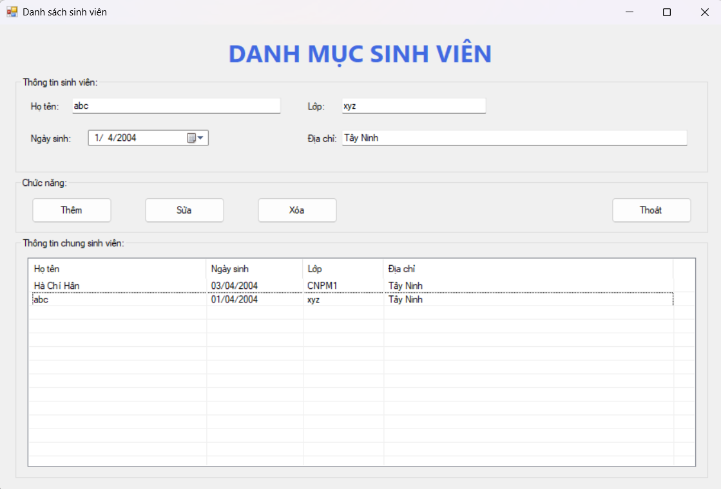

* Form1.cs

using System;

using System.Globalization;

using System.Windows.Forms;

namespace ChiHan_1150080014_BTTuan6_TH2

{

public partial class Form1 : Form

{

public Form1()

{

InitializeComponent();

dtpNgaySinh.Value = DateTime.Today;

}

private void btnThem_Click(object sender, EventArgs e)

{

if (string.IsNullOrWhiteSpace(txtHoTen.Text))

{

MessageBox.Show("Họ tên không được rỗng.", "Thiếu thông tin",

MessageBoxButtons.OK, MessageBoxIcon.Warning);

txtHoTen.Focus();

return;

}

var item = new ListViewItem(txtHoTen.Text.Trim());

item.SubItems.Add(dtpNgaySinh.Value.ToString("dd/MM/yyyy", CultureInfo.InvariantCulture));

item.SubItems.Add(txtLop.Text.Trim());

item.SubItems.Add(txtDiaChi.Text.Trim());

lvSinhVien.Items.Add(item);

ClearInputs();

}

private void btnSua_Click(object sender, EventArgs e)

{

if (lvSinhVien.SelectedItems.Count == 0)

{

MessageBox.Show("Hãy chọn 1 dòng để sửa.", "Thông báo",

MessageBoxButtons.OK, MessageBoxIcon.Information);

return;

}

if (string.IsNullOrWhiteSpace(txtHoTen.Text))

{

MessageBox.Show("Họ tên không được rỗng.", "Thiếu thông tin",

MessageBoxButtons.OK, MessageBoxIcon.Warning);

txtHoTen.Focus();

return;

}

var sel = lvSinhVien.SelectedItems[0];

sel.Text = txtHoTen.Text.Trim();

sel.SubItems[1].Text = dtpNgaySinh.Value.ToString("dd/MM/yyyy", CultureInfo.InvariantCulture);

sel.SubItems[2].Text = txtLop.Text.Trim();

sel.SubItems[3].Text = txtDiaChi.Text.Trim();

}

private void btnXoa_Click(object sender, EventArgs e)

{

if (lvSinhVien.SelectedItems.Count == 0)

{

MessageBox.Show("Hãy chọn 1 dòng để xóa.", "Thông báo",

MessageBoxButtons.OK, MessageBoxIcon.Information);

return;

}

lvSinhVien.Items.Remove(lvSinhVien.SelectedItems[0]);

ClearInputs();

}

private void btnThoat_Click(object sender, EventArgs e)

{

Close();

}

private void lvSinhVien_SelectedIndexChanged(object sender, EventArgs e)

{

if (lvSinhVien.SelectedItems.Count == 0) return;

var sel = lvSinhVien.SelectedItems[0];

txtHoTen.Text = sel.Text;

DateTime d;

if (DateTime.TryParse(sel.SubItems[1].Text, out d))

dtpNgaySinh.Value = d;

else

dtpNgaySinh.Value = DateTime.Today;

txtLop.Text = sel.SubItems[2].Text;

txtDiaChi.Text = sel.SubItems[3].Text;

}

private void ClearInputs()

{

txtHoTen.Clear();

txtLop.Clear();

txtDiaChi.Clear();

dtpNgaySinh.Value = DateTime.Today;

txtHoTen.Focus();

}

}

}

* Form1.Designer.cs

namespace ChiHan_1150080014_BTTuan6_TH2

{

partial class Form1

{

private System.ComponentModel.IContainer components = null;

private System.Windows.Forms.Label lblTitle;

private System.Windows.Forms.GroupBox grpInfo;

private System.Windows.Forms.Label lblHoTen;

private System.Windows.Forms.Label lblLop;

private System.Windows.Forms.Label lblNgaySinh;

private System.Windows.Forms.Label lblDiaChi;

private System.Windows.Forms.TextBox txtHoTen;

private System.Windows.Forms.TextBox txtLop;

private System.Windows.Forms.DateTimePicker dtpNgaySinh;

private System.Windows.Forms.TextBox txtDiaChi;

private System.Windows.Forms.GroupBox grpActions;

private System.Windows.Forms.Button btnThem;

private System.Windows.Forms.Button btnSua;

private System.Windows.Forms.Button btnXoa;

private System.Windows.Forms.Button btnThoat;

private System.Windows.Forms.GroupBox grpList;

private System.Windows.Forms.ListView lvSinhVien;

private System.Windows.Forms.ColumnHeader colHoTen;

private System.Windows.Forms.ColumnHeader colNgaySinh;

private System.Windows.Forms.ColumnHeader colLop;

private System.Windows.Forms.ColumnHeader colDiaChi;

protected override void Dispose(bool disposing)

{

if (disposing && (components != null)) components.Dispose();

base.Dispose(disposing);

}

#region Windows Form Designer generated code

private void InitializeComponent()

{

this.components = new System.ComponentModel.Container();

this.lblTitle = new System.Windows.Forms.Label();

this.grpInfo = new System.Windows.Forms.GroupBox();

this.lblHoTen = new System.Windows.Forms.Label();

this.lblLop = new System.Windows.Forms.Label();

this.lblNgaySinh = new System.Windows.Forms.Label();

this.lblDiaChi = new System.Windows.Forms.Label();

this.txtHoTen = new System.Windows.Forms.TextBox();

this.txtLop = new System.Windows.Forms.TextBox();

this.dtpNgaySinh = new System.Windows.Forms.DateTimePicker();

this.txtDiaChi = new System.Windows.Forms.TextBox();

this.grpActions = new System.Windows.Forms.GroupBox();

this.btnThem = new System.Windows.Forms.Button();

this.btnSua = new System.Windows.Forms.Button();

this.btnXoa = new System.Windows.Forms.Button();

this.btnThoat = new System.Windows.Forms.Button();

this.grpList = new System.Windows.Forms.GroupBox();

this.lvSinhVien = new System.Windows.Forms.ListView();

this.colHoTen = new System.Windows.Forms.ColumnHeader();

this.colNgaySinh = new System.Windows.Forms.ColumnHeader();

this.colLop = new System.Windows.Forms.ColumnHeader();

this.colDiaChi = new System.Windows.Forms.ColumnHeader();

this.AutoScaleMode = System.Windows.Forms.AutoScaleMode.Font;

this.ClientSize = new System.Drawing.Size(900, 580);

this.Text = "Danh sách sinh viên";

this.StartPosition = System.Windows.Forms.FormStartPosition.CenterScreen;

this.lblTitle.Text = "DANH MỤC SINH VIÊN";

this.lblTitle.Font = new System.Drawing.Font("Segoe UI", 22F, System.Drawing.FontStyle.Bold);

this.lblTitle.ForeColor = System.Drawing.Color.RoyalBlue;

this.lblTitle.AutoSize = false;

this.lblTitle.TextAlign = System.Drawing.ContentAlignment.MiddleCenter;

this.lblTitle.Location = new System.Drawing.Point(10, 10);

this.lblTitle.Size = new System.Drawing.Size(880, 48);

this.Controls.Add(this.lblTitle);

this.grpInfo.Text = "Thông tin sinh viên:";

this.grpInfo.Location = new System.Drawing.Point(20, 65);

this.grpInfo.Size = new System.Drawing.Size(860, 120);

this.Controls.Add(this.grpInfo);

this.lblHoTen.Text = "Họ tên:";

this.lblHoTen.Location = new System.Drawing.Point(16, 30);

this.lblHoTen.AutoSize = true;

this.grpInfo.Controls.Add(this.lblHoTen);

this.txtHoTen.Location = new System.Drawing.Point(70, 26);

this.txtHoTen.Size = new System.Drawing.Size(260, 22);

this.grpInfo.Controls.Add(this.txtHoTen);

this.lblLop.Text = "Lớp:";

this.lblLop.Location = new System.Drawing.Point(360, 30);

this.lblLop.AutoSize = true;

this.grpInfo.Controls.Add(this.lblLop);

this.txtLop.Location = new System.Drawing.Point(405, 26);

this.txtLop.Size = new System.Drawing.Size(180, 22);

this.grpInfo.Controls.Add(this.txtLop);

this.lblNgaySinh.Text = "Ngày sinh:";

this.lblNgaySinh.Location = new System.Drawing.Point(16, 70);

this.lblNgaySinh.AutoSize = true;

this.grpInfo.Controls.Add(this.lblNgaySinh);

this.dtpNgaySinh.Format = System.Windows.Forms.DateTimePickerFormat.Short;

this.dtpNgaySinh.Location = new System.Drawing.Point(90, 66);

this.dtpNgaySinh.Size = new System.Drawing.Size(150, 22);

this.grpInfo.Controls.Add(this.dtpNgaySinh);

this.lblDiaChi.Text = "Địa chỉ:";

this.lblDiaChi.Location = new System.Drawing.Point(360, 70);

this.lblDiaChi.AutoSize = true;

this.grpInfo.Controls.Add(this.lblDiaChi);

this.txtDiaChi.Location = new System.Drawing.Point(405, 66);

this.txtDiaChi.Size = new System.Drawing.Size(430, 22);

this.grpInfo.Controls.Add(this.txtDiaChi);

this.grpActions.Text = "Chức năng:";

this.grpActions.Location = new System.Drawing.Point(20, 190);

this.grpActions.Size = new System.Drawing.Size(860, 70);

this.Controls.Add(this.grpActions);

this.btnThem.Text = "Thêm";

this.btnThem.Location = new System.Drawing.Point(20, 25);

this.btnThem.Size = new System.Drawing.Size(100, 32);

this.btnThem.Click += new System.EventHandler(this.btnThem_Click);

this.grpActions.Controls.Add(this.btnThem);

this.btnSua.Text = "Sửa";

this.btnSua.Location = new System.Drawing.Point(160, 25);

this.btnSua.Size = new System.Drawing.Size(100, 32);

this.btnSua.Click += new System.EventHandler(this.btnSua_Click);

this.grpActions.Controls.Add(this.btnSua);

this.btnXoa.Text = "Xóa";

this.btnXoa.Location = new System.Drawing.Point(300, 25);

this.btnXoa.Size = new System.Drawing.Size(100, 32);

this.btnXoa.Click += new System.EventHandler(this.btnXoa_Click);

this.grpActions.Controls.Add(this.btnXoa);

this.btnThoat.Text = "Thoát";

this.btnThoat.Location = new System.Drawing.Point(740, 25);

this.btnThoat.Size = new System.Drawing.Size(100, 32);

this.btnThoat.Anchor = (System.Windows.Forms.AnchorStyles.Top | System.Windows.Forms.AnchorStyles.Right);

this.btnThoat.Click += new System.EventHandler(this.btnThoat_Click);

this.grpActions.Controls.Add(this.btnThoat);

this.grpList.Text = "Thông tin chung sinh viên:";

this.grpList.Location = new System.Drawing.Point(20, 265);

this.grpList.Size = new System.Drawing.Size(860, 300);

this.Controls.Add(this.grpList);

this.lvSinhVien.Location = new System.Drawing.Point(15, 25);

this.lvSinhVien.Size = new System.Drawing.Size(830, 260);

this.lvSinhVien.View = System.Windows.Forms.View.Details;

this.lvSinhVien.FullRowSelect = true;

this.lvSinhVien.GridLines = true;

this.lvSinhVien.MultiSelect = false;

this.lvSinhVien.HideSelection = false;

this.lvSinhVien.SelectedIndexChanged += new System.EventHandler(this.lvSinhVien_SelectedIndexChanged);

this.colHoTen.Text = "Họ tên"; this.colHoTen.Width = 220;

this.colNgaySinh.Text = "Ngày sinh"; this.colNgaySinh.Width = 120;

this.colLop.Text = "Lớp"; this.colLop.Width = 100;

this.colDiaChi.Text = "Địa chỉ"; this.colDiaChi.Width = 360;

this.lvSinhVien.Columns.AddRange(new System.Windows.Forms.ColumnHeader[] {

this.colHoTen, this.colNgaySinh, this.colLop, this.colDiaChi

});

this.grpList.Controls.Add(this.lvSinhVien);

}

#endregion

}

}