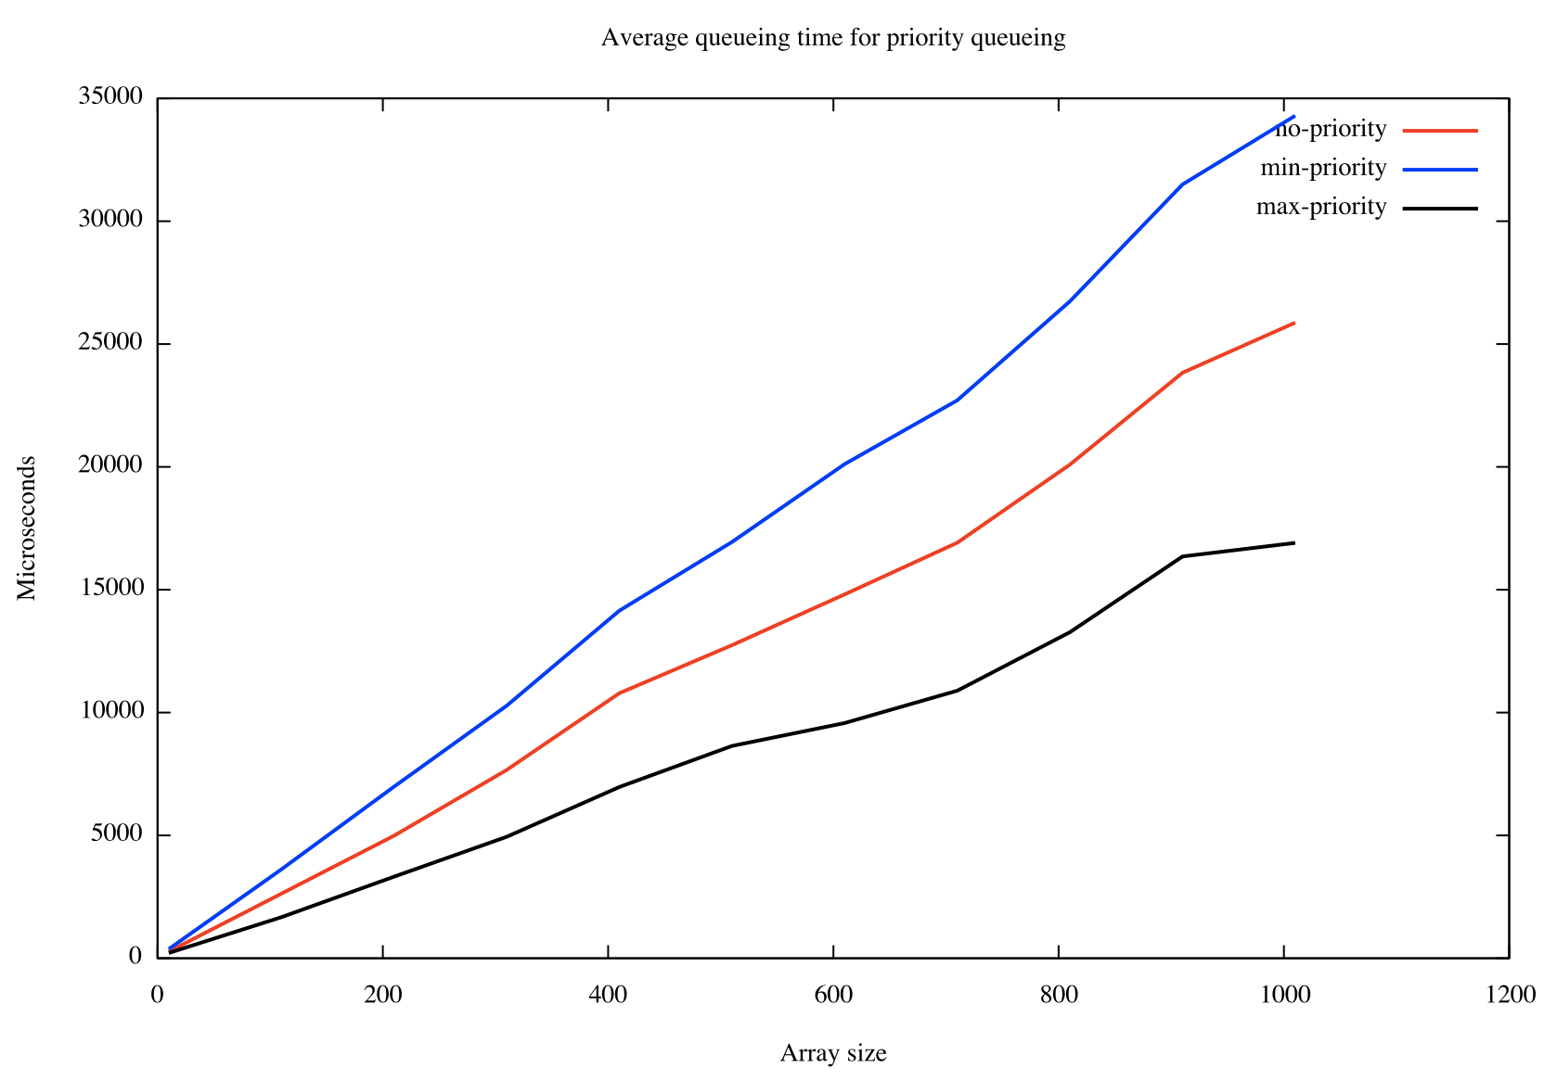

A: normal random array. B: sorted array. C: reversed of B

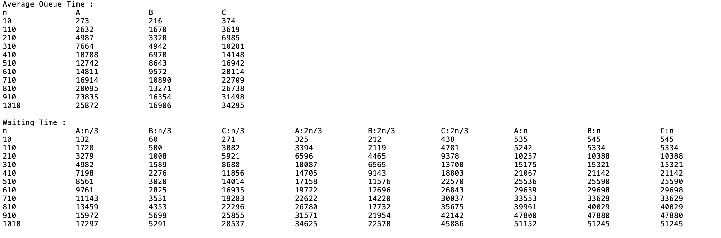

Although the total times spent in these three cases are very close. When we look at waiting times of three jobs for all the three cases for element numbers n/3, 2n/3, it’s easy to know that sorted array spent the less and the reversed of it spent the most.

(The text of these dates in the next page.)

Average Queue Time :

n A B C

10 273 216 374

110 2632 1670 3619

210 4987 3320 6985

310 7664 4942 10281

410 10788 6970 14148

510 12742 8643 16942

610 14811 9572 20114

710 16914 10890 22709

810 20095 13271 26738

910 23835 16354 31498

1010 25872 16906 34295

Waiting Time :

n A:n/3 B:n/3 C:n/3 A:2n/3 B:2n/3 C:2n/3 A:n B:n C:n

10 132 60 271 325 212 438 535 545 545

110 1728 500 3082 3394 2119 4781 5242 5334 5334

210 3279 1008 5921 6596 4465 9378 10257 10388 10388

310 4982 1589 8688 10087 6565 13700 15175 15321 15321

410 7198 2276 11856 14705 9143 18803 21067 21142 21142

510 8561 3020 14014 17158 11576 22570 25536 25590 25590

610 9761 2825 16935 19722 12696 26843 29639 29698 29698

710 11143 3531 19283 22622 14220 30037 33553 33629 33629

810 13459 4353 22296 26780 17732 35675 39961 40029 40029

910 15972 5699 25855 31571 21954 42142 47800 47880 47880

1010 17297 5291 28537 34625 22570 45886 51152 51245 51245