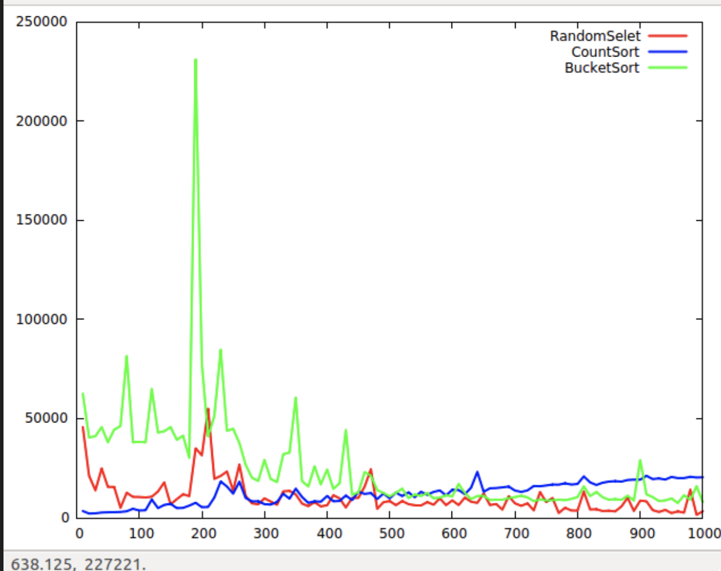

When n is small, the process of program running affects the algorithm running time. But as n increase, the impact is getting smaller and smaller. Obviously, the time complexity of these three algorithms is O(n). So, the running time of these three algorithms are closer for higher values of n.

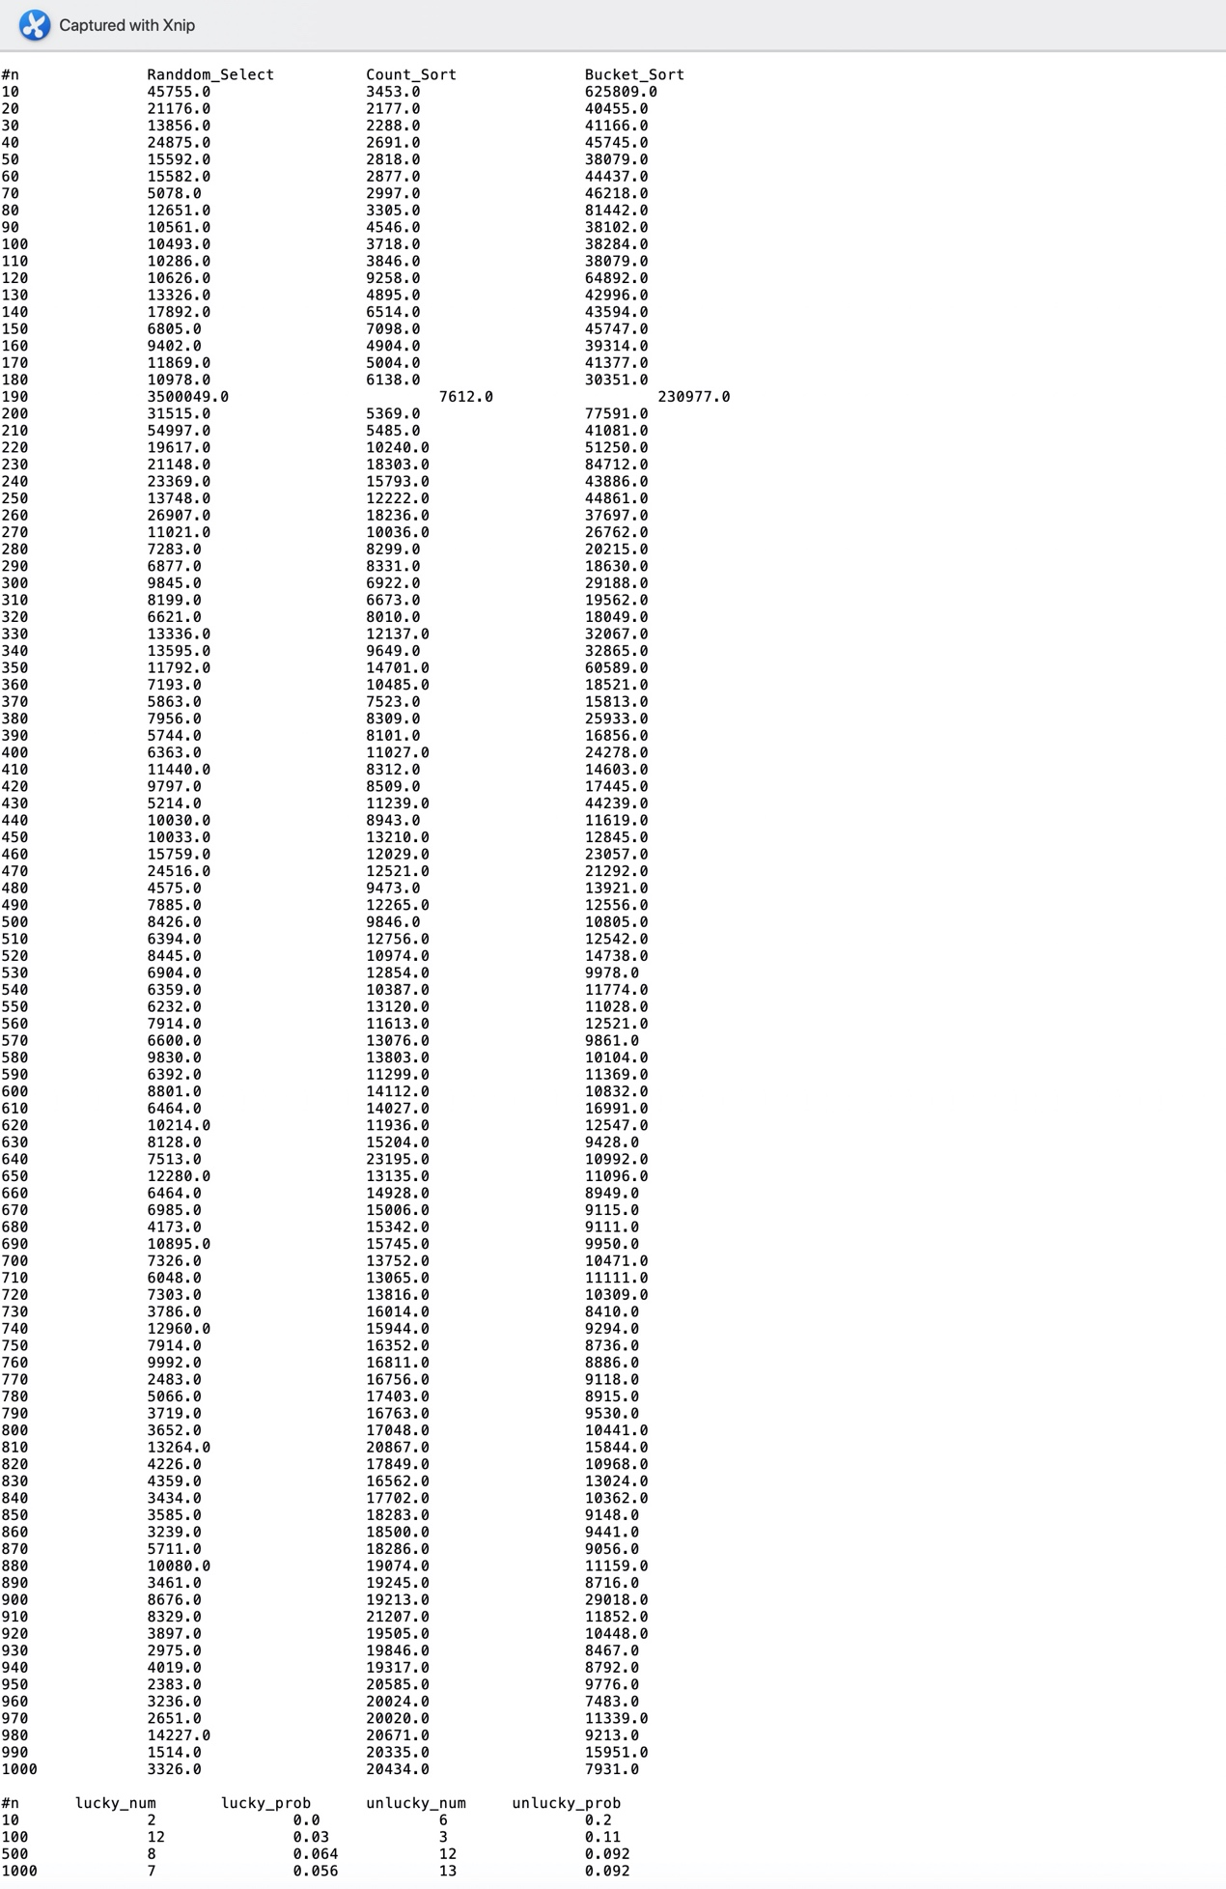

#n Randdom_Select Count_Sort Bucket_Sort

10 45755.0 3453.0 625809.0

20 21176.0 2177.0 40455.0

30 13856.0 2288.0 41166.0

40 24875.0 2691.0 45745.0

50 15592.0 2818.0 38079.0

60 15582.0 2877.0 44437.0

70 5078.0 2997.0 46218.0

80 12651.0 3305.0 81442.0

90 10561.0 4546.0 38102.0

100 10493.0 3718.0 38284.0

110 10286.0 3846.0 38079.0

120 10626.0 9258.0 64892.0

130 13326.0 4895.0 42996.0

140 17892.0 6514.0 43594.0

150 6805.0 7098.0 45747.0

160 9402.0 4904.0 39314.0

170 11869.0 5004.0 41377.0

180 10978.0 6138.0 30351.0

190 3500049.0 7612.0 230977.0

200 31515.0 5369.0 77591.0

210 54997.0 5485.0 41081.0

220 19617.0 10240.0 51250.0

230 21148.0 18303.0 84712.0

240 23369.0 15793.0 43886.0

250 13748.0 12222.0 44861.0

260 26907.0 18236.0 37697.0

270 11021.0 10036.0 26762.0

280 7283.0 8299.0 20215.0

290 6877.0 8331.0 18630.0

300 9845.0 6922.0 29188.0

310 8199.0 6673.0 19562.0

320 6621.0 8010.0 18049.0

330 13336.0 12137.0 32067.0

340 13595.0 9649.0 32865.0

350 11792.0 14701.0 60589.0

360 7193.0 10485.0 18521.0

370 5863.0 7523.0 15813.0

380 7956.0 8309.0 25933.0

390 5744.0 8101.0 16856.0

400 6363.0 11027.0 24278.0

410 11440.0 8312.0 14603.0

420 9797.0 8509.0 17445.0

430 5214.0 11239.0 44239.0

440 10030.0 8943.0 11619.0

450 10033.0 13210.0 12845.0

460 15759.0 12029.0 23057.0

470 24516.0 12521.0 21292.0

480 4575.0 9473.0 13921.0

490 7885.0 12265.0 12556.0

500 8426.0 9846.0 10805.0

510 6394.0 12756.0 12542.0

520 8445.0 10974.0 14738.0

530 6904.0 12854.0 9978.0

540 6359.0 10387.0 11774.0

550 6232.0 13120.0 11028.0

560 7914.0 11613.0 12521.0

570 6600.0 13076.0 9861.0

580 9830.0 13803.0 10104.0

590 6392.0 11299.0 11369.0

600 8801.0 14112.0 10832.0

610 6464.0 14027.0 16991.0

620 10214.0 11936.0 12547.0

630 8128.0 15204.0 9428.0

640 7513.0 23195.0 10992.0

650 12280.0 13135.0 11096.0

660 6464.0 14928.0 8949.0

670 6985.0 15006.0 9115.0

680 4173.0 15342.0 9111.0

690 10895.0 15745.0 9950.0

700 7326.0 13752.0 10471.0

710 6048.0 13065.0 11111.0

720 7303.0 13816.0 10309.0

730 3786.0 16014.0 8410.0

740 12960.0 15944.0 9294.0

750 7914.0 16352.0 8736.0

760 9992.0 16811.0 8886.0

770 2483.0 16756.0 9118.0

780 5066.0 17403.0 8915.0

790 3719.0 16763.0 9530.0

800 3652.0 17048.0 10441.0

810 13264.0 20867.0 15844.0

820 4226.0 17849.0 10968.0

830 4359.0 16562.0 13024.0

840 3434.0 17702.0 10362.0

850 3585.0 18283.0 9148.0

860 3239.0 18500.0 9441.0

870 5711.0 18286.0 9056.0

880 10080.0 19074.0 11159.0

890 3461.0 19245.0 8716.0

900 8676.0 19213.0 29018.0

910 8329.0 21207.0 11852.0

920 3897.0 19505.0 10448.0

930 2975.0 19846.0 8467.0

940 4019.0 19317.0 8792.0

950 2383.0 20585.0 9776.0

960 3236.0 20024.0 7483.0

970 2651.0 20020.0 11339.0

980 14227.0 20671.0 9213.0

990 1514.0 20335.0 15951.0

1000 3326.0 20434.0 7931.0

#n lucky_num lucky_prob unlucky_num unlucky_prob

10 2 0.0 6 0.2

100 12 0.03 3 0.11

500 8 0.064 12 0.092

1000 7 0.056 13 0.092