**Transaction**

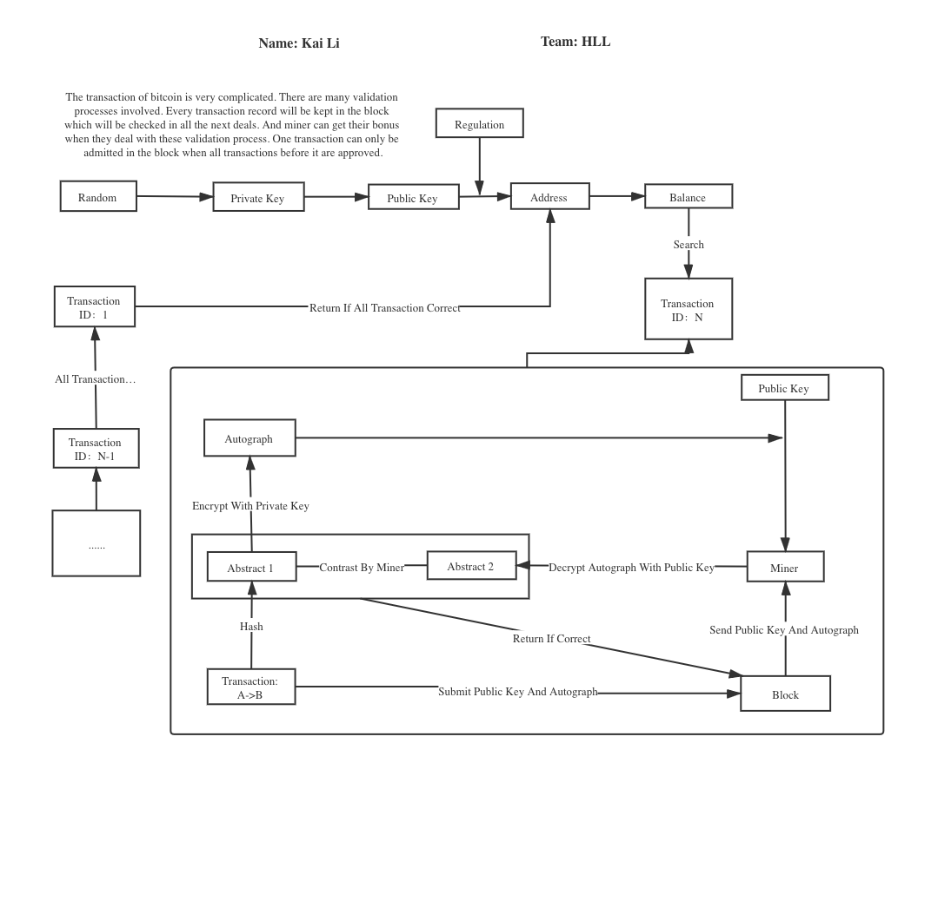

In my opinion, if we want to make the system of Bitcoin run under regulation like Libra but keep its non-centralization. The best way is to find an algorithm that can transform the public key of those who voluntarily accept regulation to a new one. In order to get the new under-regulation key, you have to submit an application attached with your personal information to the agency and wait for approval and your new key. Those who get a new under-regulation key can do everything with their bitcoin and others may get some restriction.