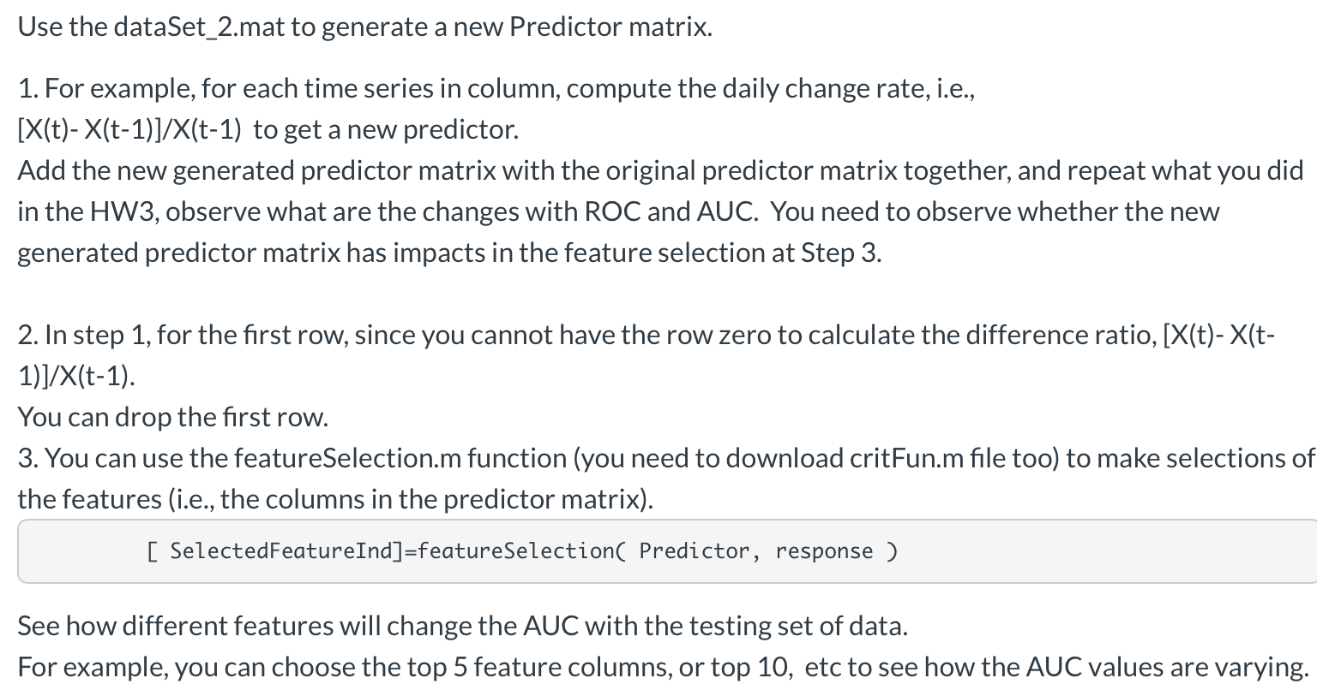

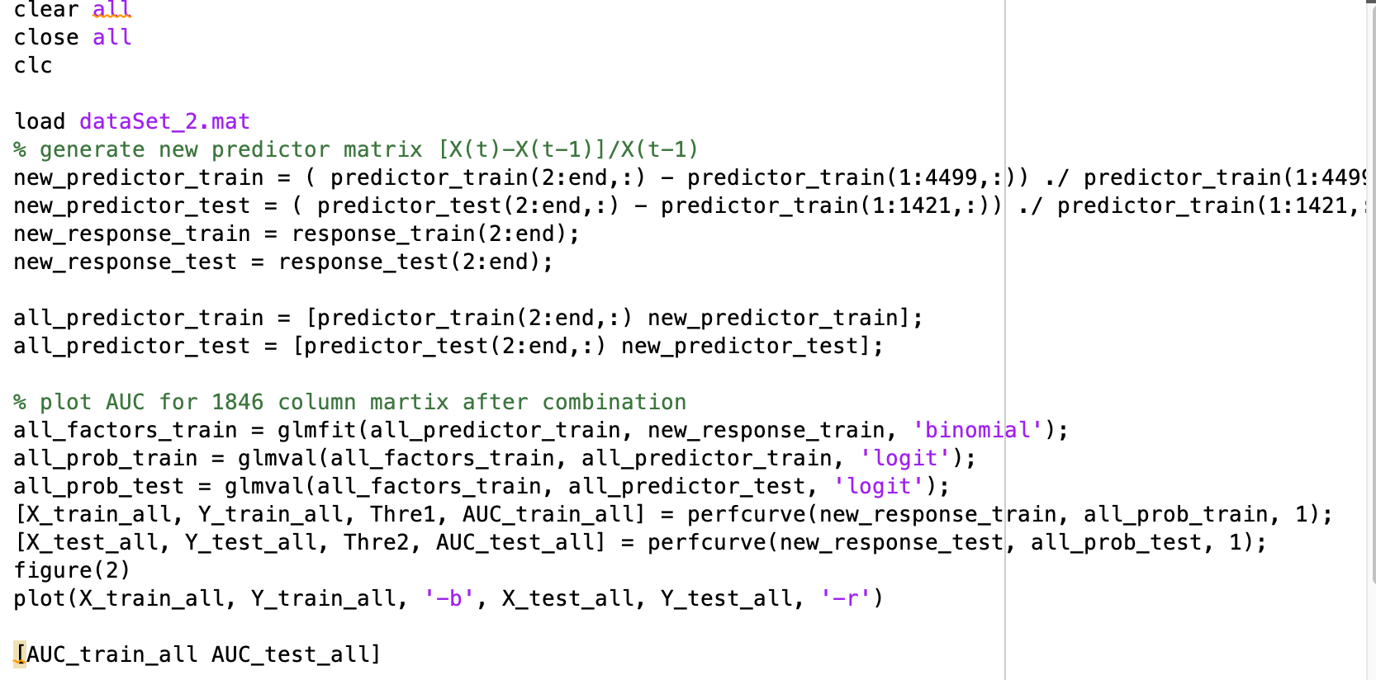

In the first step, we add the new generated predictor matrix with the original one and get ROC & AUC as below.

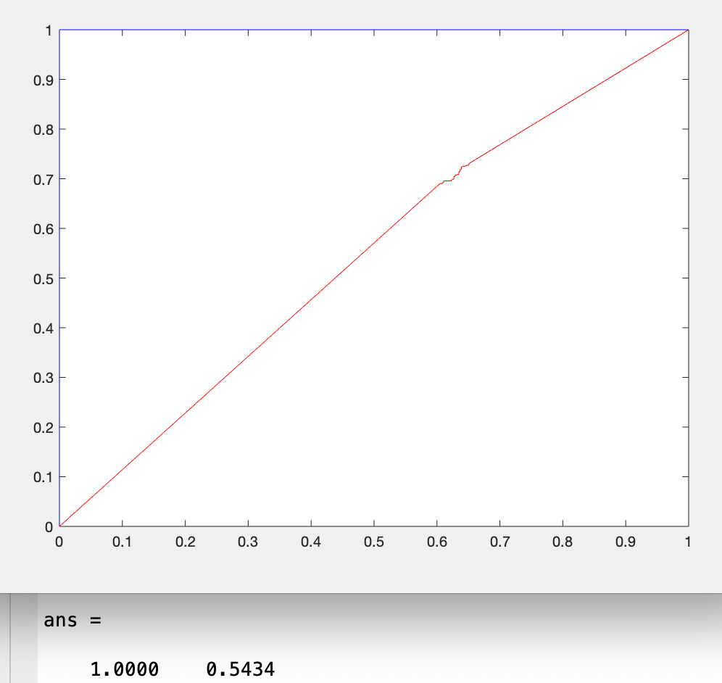

Then let’s start featureselect.

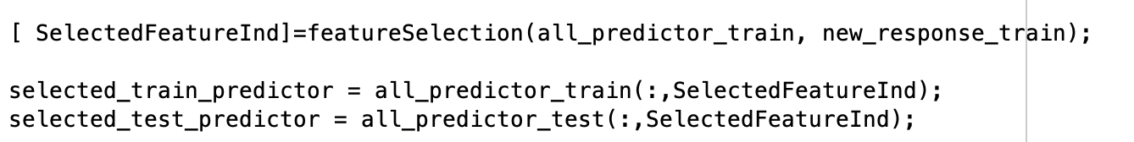

And get result as below.

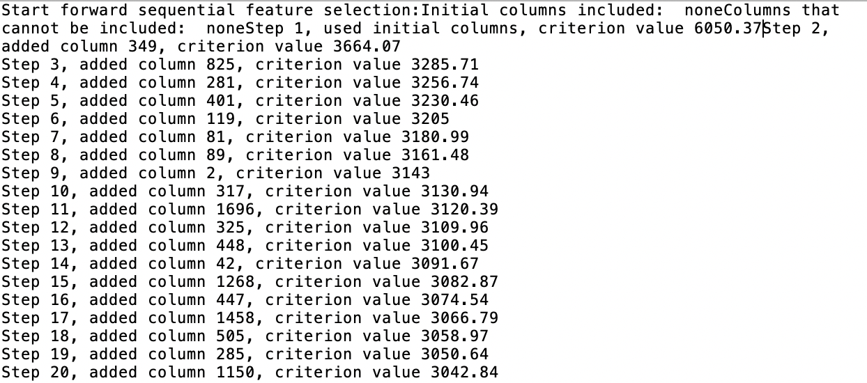

Try the top 5 at first and get the AUC = 0.9289 for train and AUC =0.9096 for test. It seems pretty good for this generation and selection.

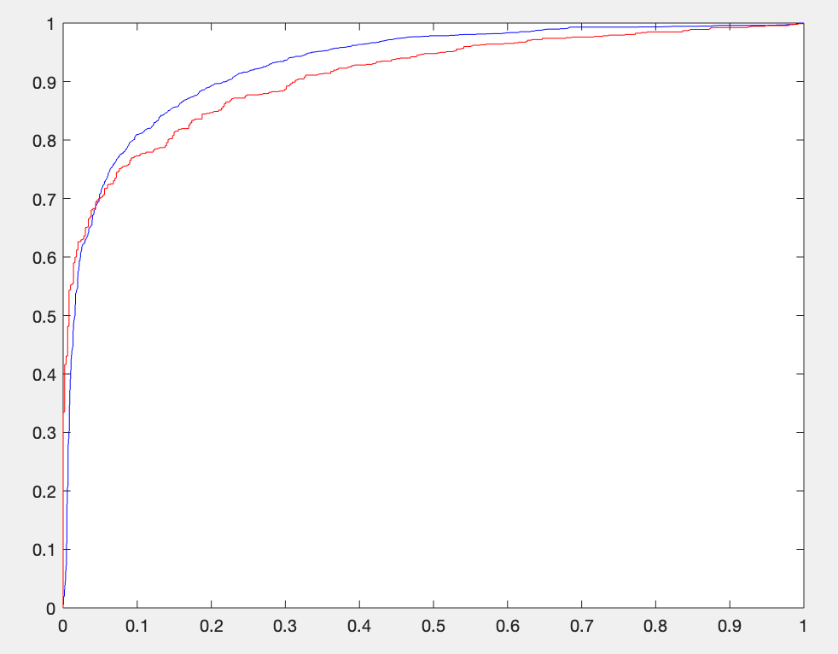

Try top 10 feature columns. Then AUC = 0.9306 for train and AUC =0.9064for test.

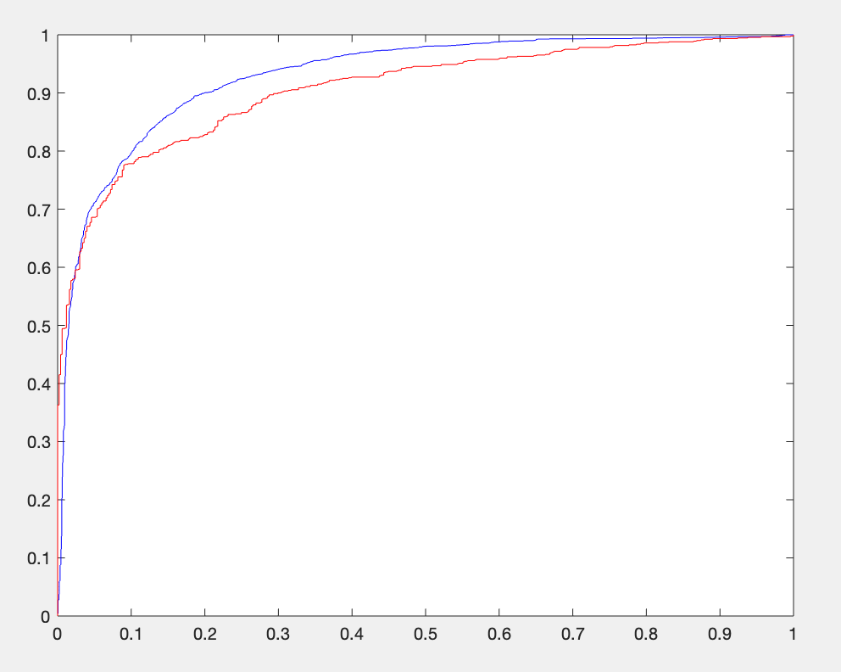

And top 20 feature columns. Then AUC = 0.9344 for train and AUC =0.8916 for test.

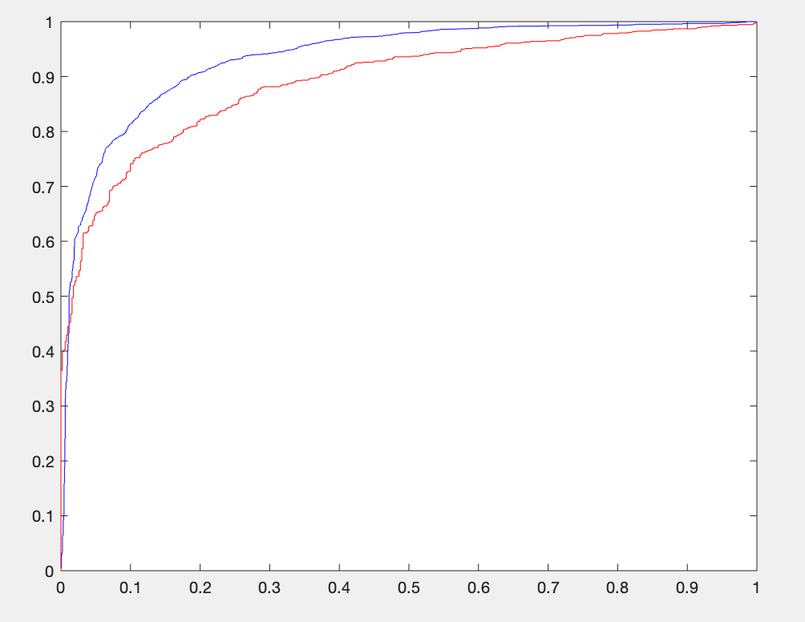

So maybe top 5 or top 10 feature columns are best for this selection.