1.

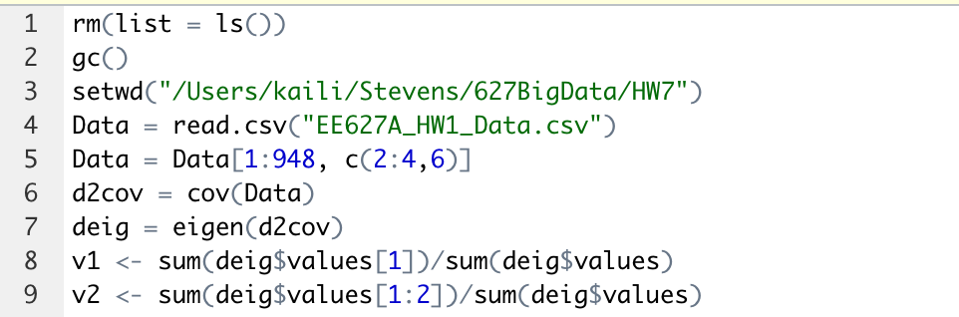

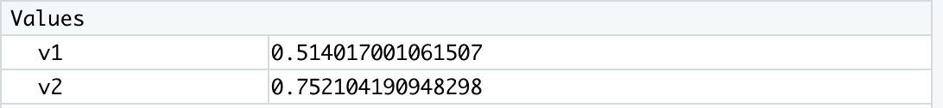

Obviously, v2 is more than 75%. So, it needs 2 principal components account for 75% of the covariance matrix trace.

2.

