1. Test the MSE values with rank=5, 10, 20, 30

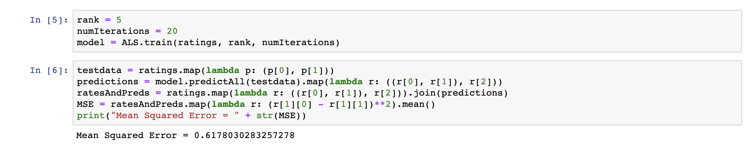

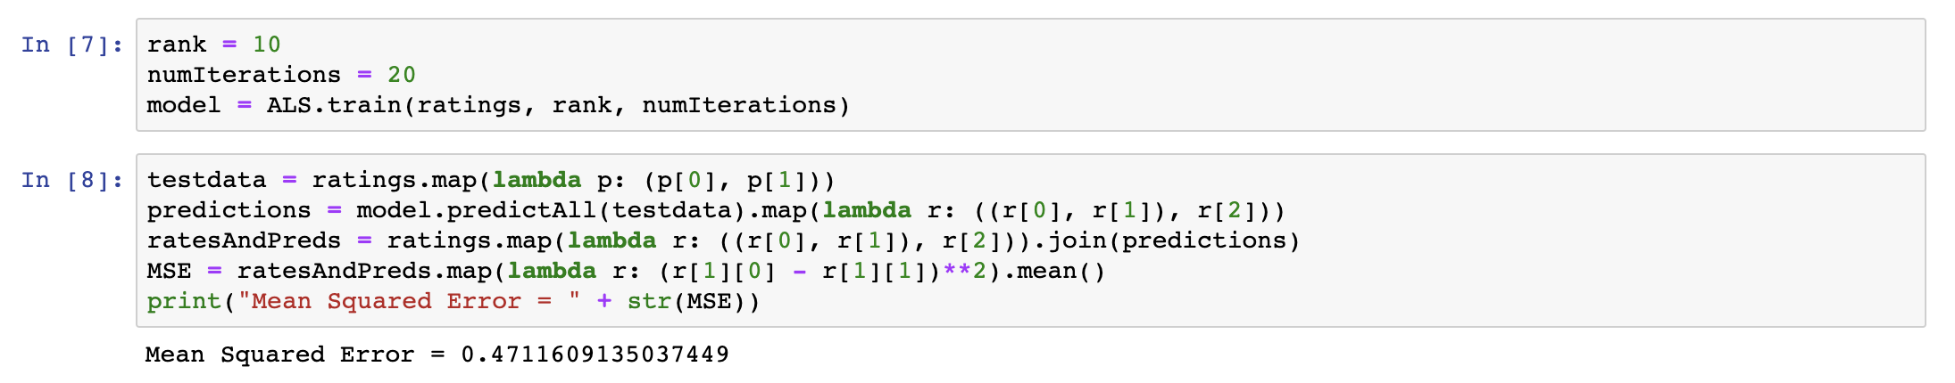

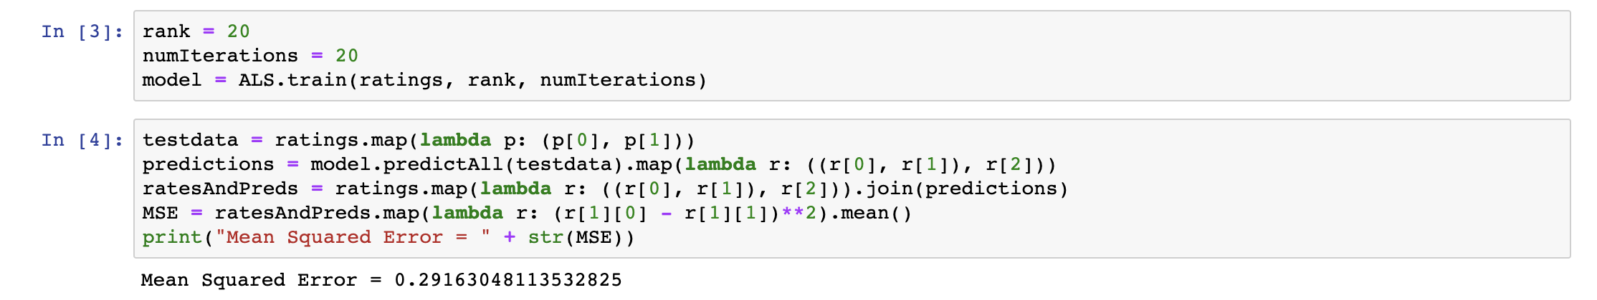

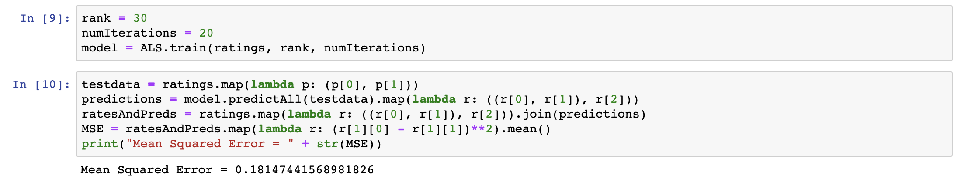

Rank

5 0.6178030283257278

10 0.4711609135037449

20 0.29163048113532825

30 0.18147441568981826

As it shows above, the MSE decreased as rank increased.

1. Fixed "rank=20", with different numIterations=2, 5,10, 20

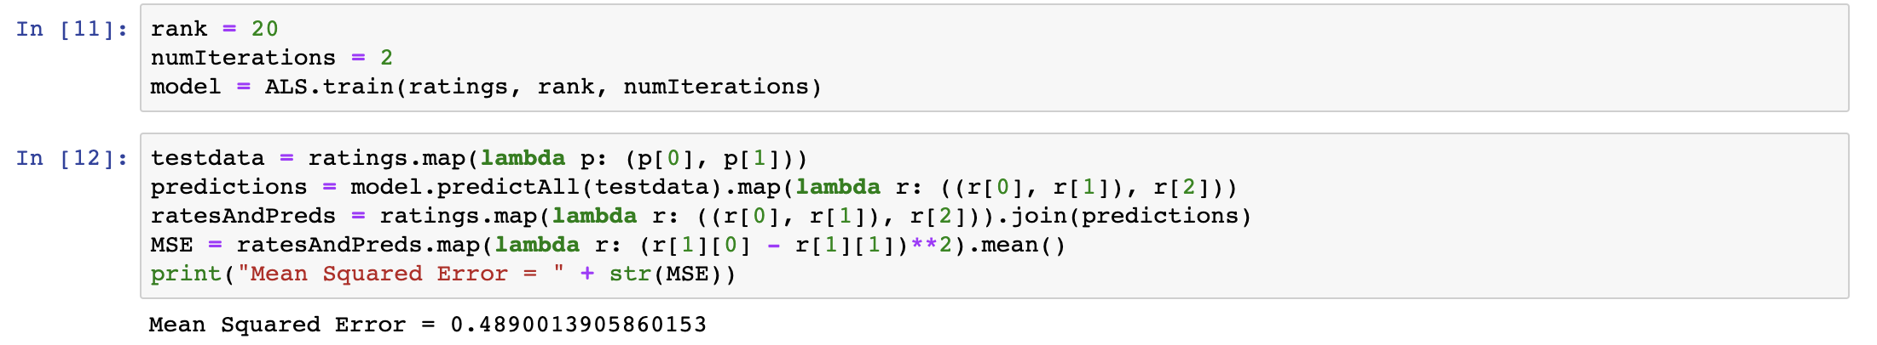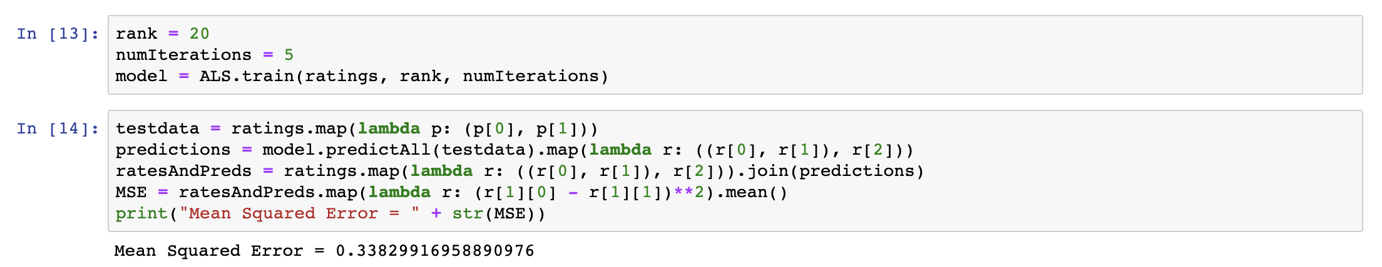

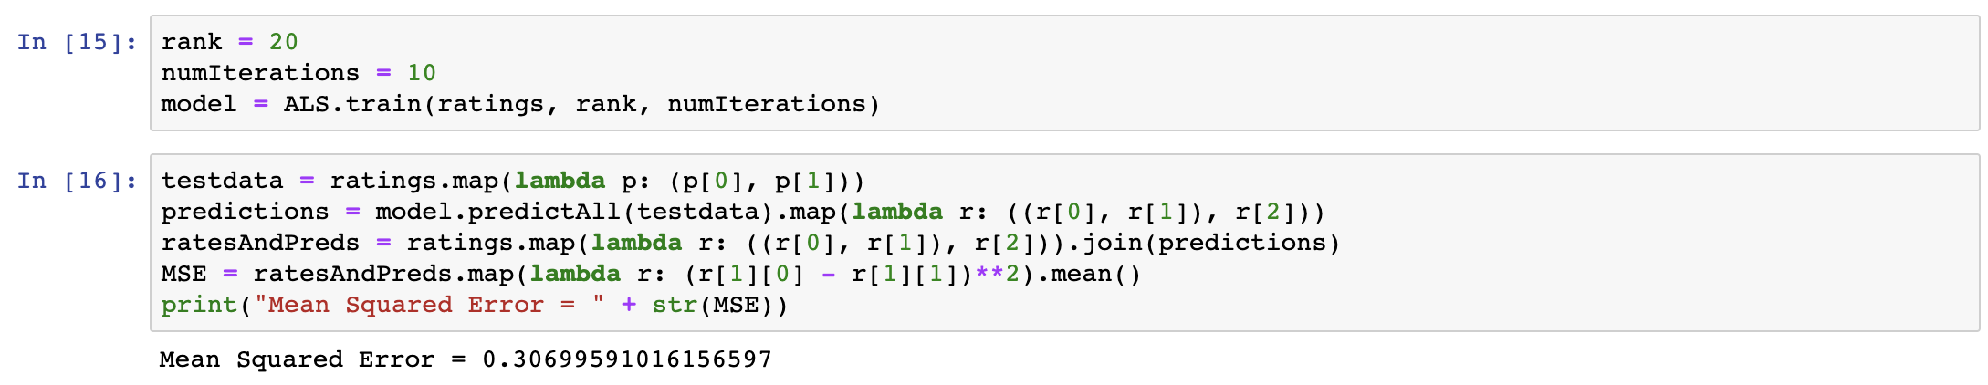

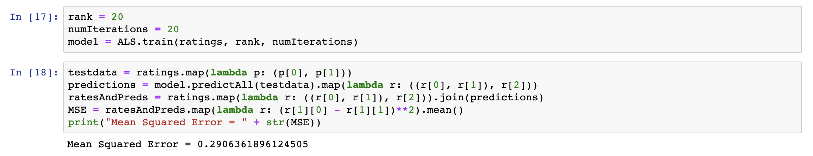

Rank = 20

Numiterations MSE

2 0.4890013905860153

5 0.33829916958890976

10 0.3069959101615697

20 0.2906361896124505

As it shows above, the MSE decreased as numIteration increased.

1. Fixed "rank=20" and "numIterations=20",  with = 2000, 5000, 10000, 20000, 50000, 100000

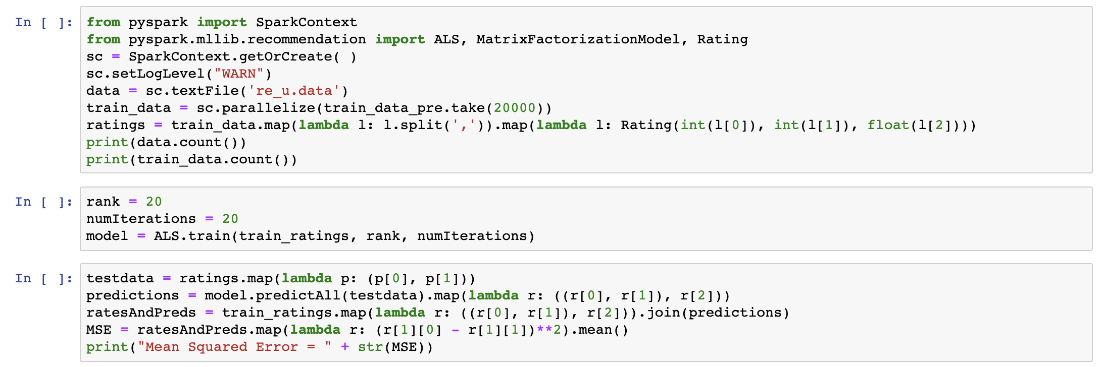

rank=20" and "numIterations=20

size MSE

2000 9.9191004400280498 e-05

5000 0.000659682781938134

10000 0.002988928947876204

20000 0.025387303979932457

50000 0.151221837001804823

100000 0.291294923919096340

As the data shows, MSE increase with data-size increase.