Q1:

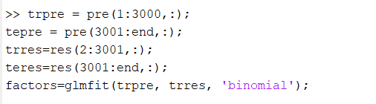

For training data:

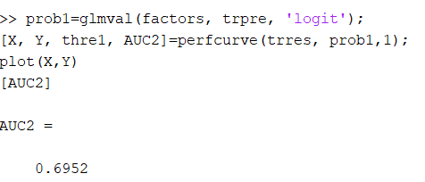



AUC = 0.6952

For testing data:

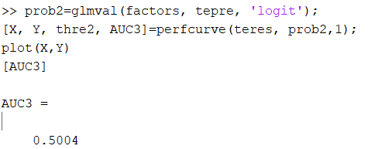



AUC = 0.5004

Q2:

After applied x(isinf(x)) = 0, the data and AUCdidn’t change. Hence, there is no infinity number in the data.

Q3:

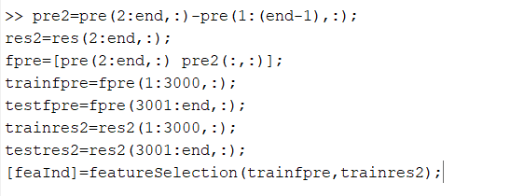

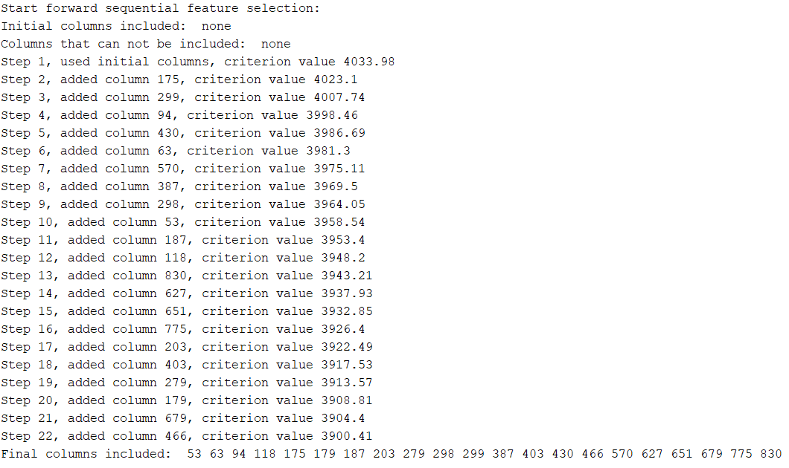

Applying all the features chosen:

Training data:

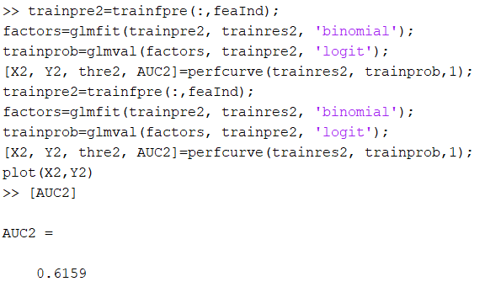



AUC = 0.6159

Testing data:

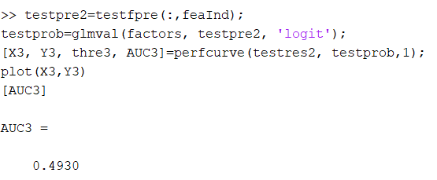



AUC = 0.493

Using top 5:

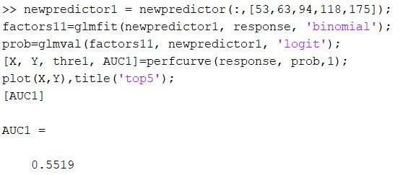



AUC = 0.5519

Using top 10:

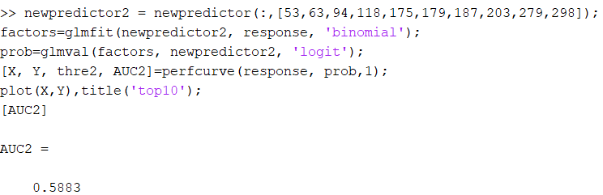



AUC = 0.5883