Part 1:

Part 2:

1. fixed numIterations = 20
2. rank = 5

1. rank = 10

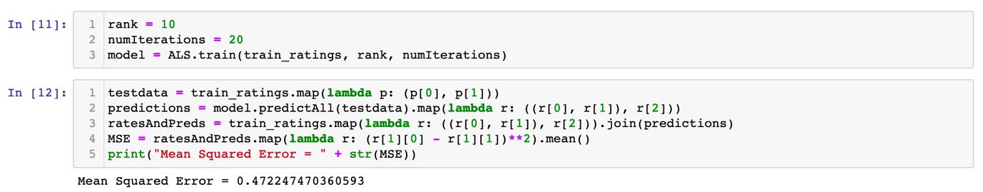

1. rank = 20

1. rank = 30

As it shows, as rank increased, the MSE decreased.

1. fixed rank = 20
2. numIterations = 2

1. numIterations = 5

1. numIterations = 10

1. numIterations = 20

1. numIterations = 30

because numlteration is too large, the function cannot run properly.

As we see, as numIteration increased, the MSE decreased.

1. With fixed rank = 20, numIterations = 30

Size of data Mean Squared Error

2000  0.291120758082147923

5000 0.291259682781938134

10000 0.29208892894787620

20000 0.291487303979932457

50000 0.291021837001804823

100000 0.291294923919096340

As data shows, the size of data won’t affect MSE.