https://blog.csdn.net/fengchao2016/article/details/78664708

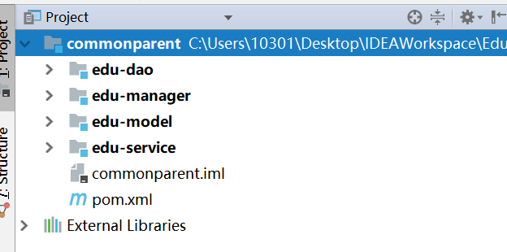
edu-manager - 公司员工
edu-student - 学生员工
edu-customer - 客户员工
edu-api

项目构造
Jdk1.8
Tomcat8.5
Mysql5.7
SSM
Spring 4.x 版本
MyBatis 3.x 版本

1》更改IDEA-Maven的用户配置文件
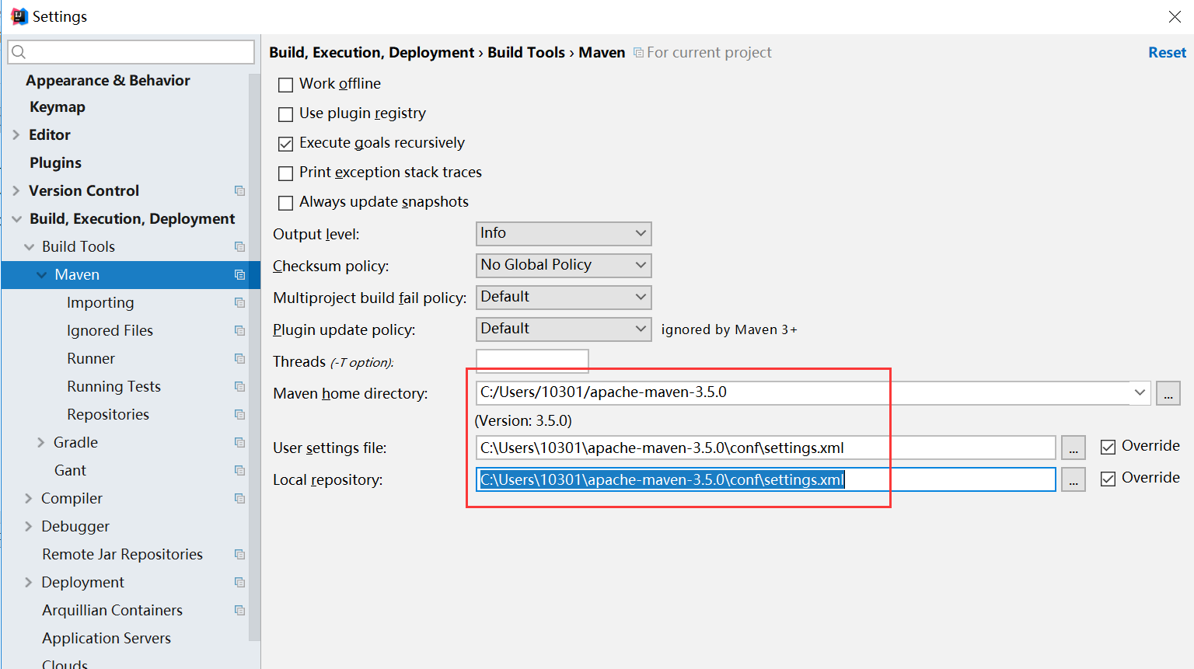

2》创建一个空白项目
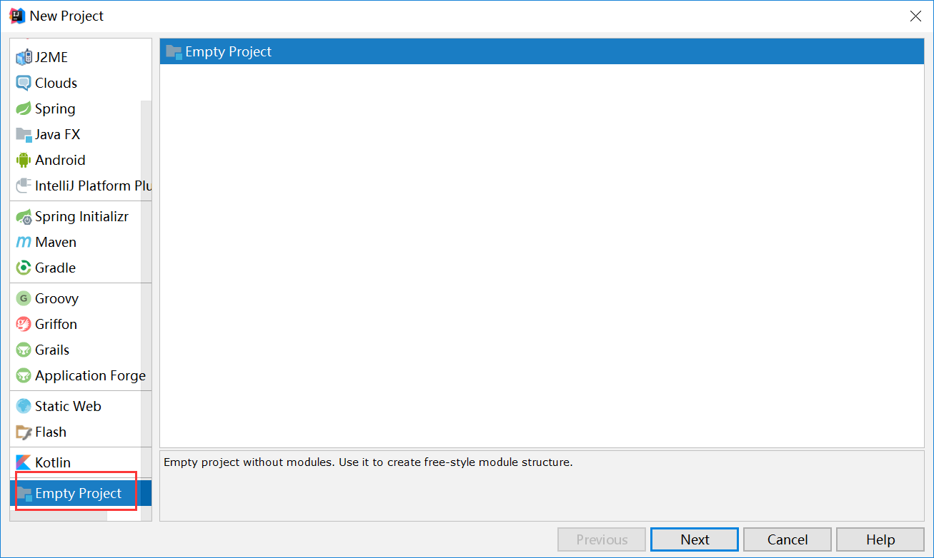

项目名就叫 【教育培训项目】
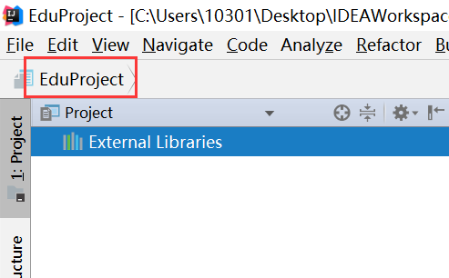

3》创建父工程
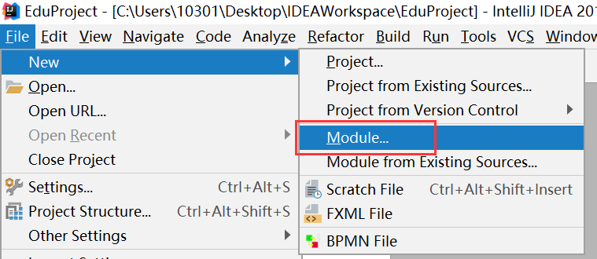

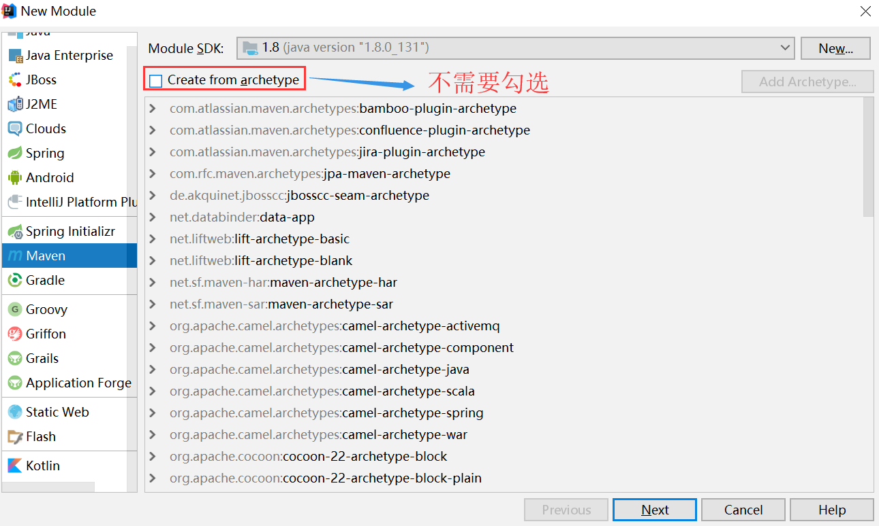
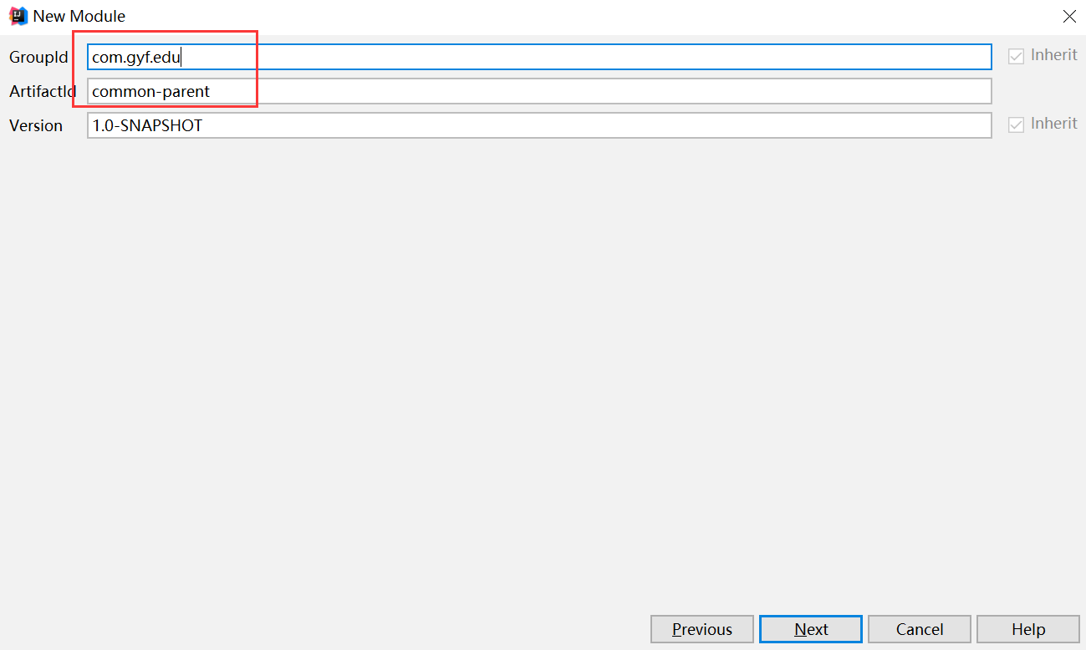

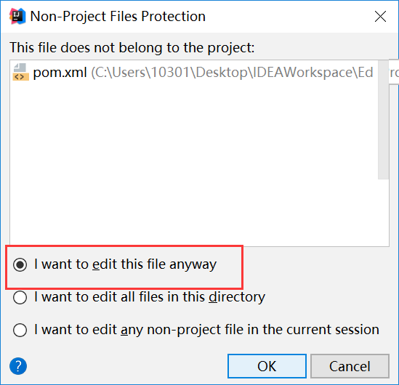

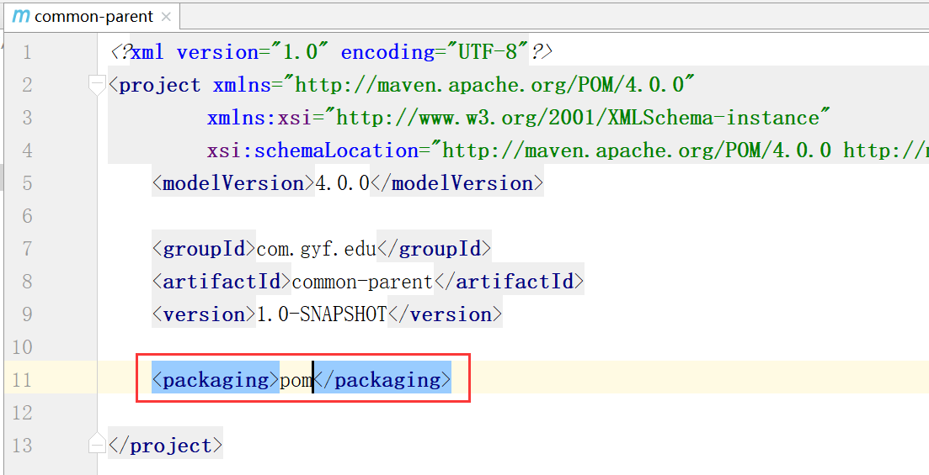
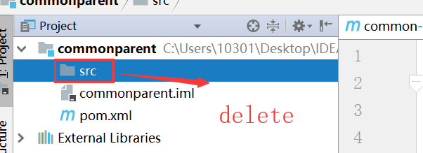

4》创建model子工程
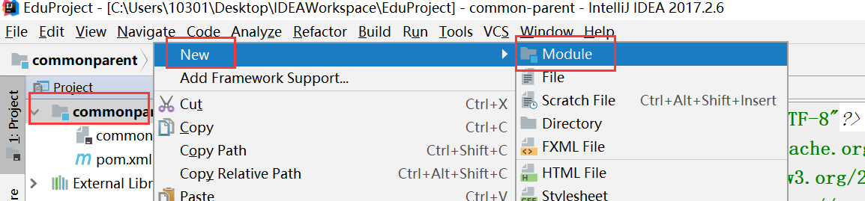
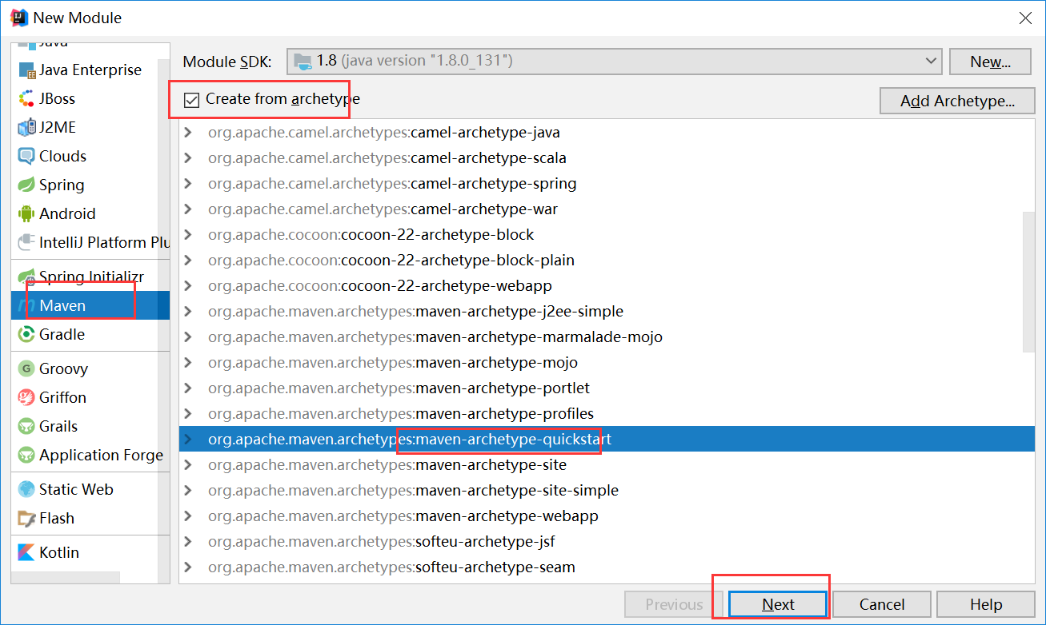

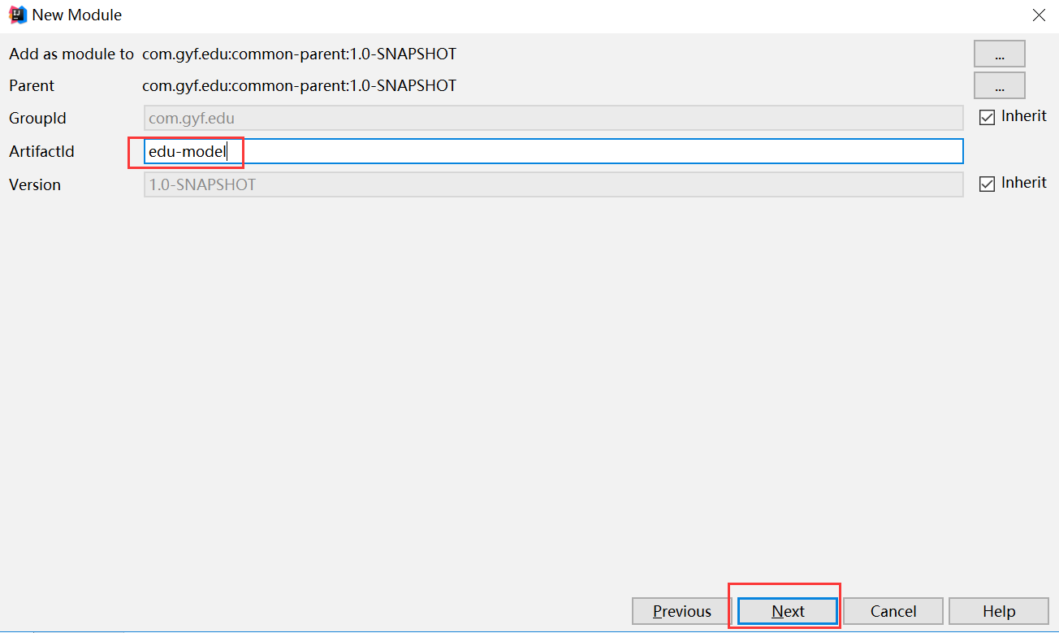

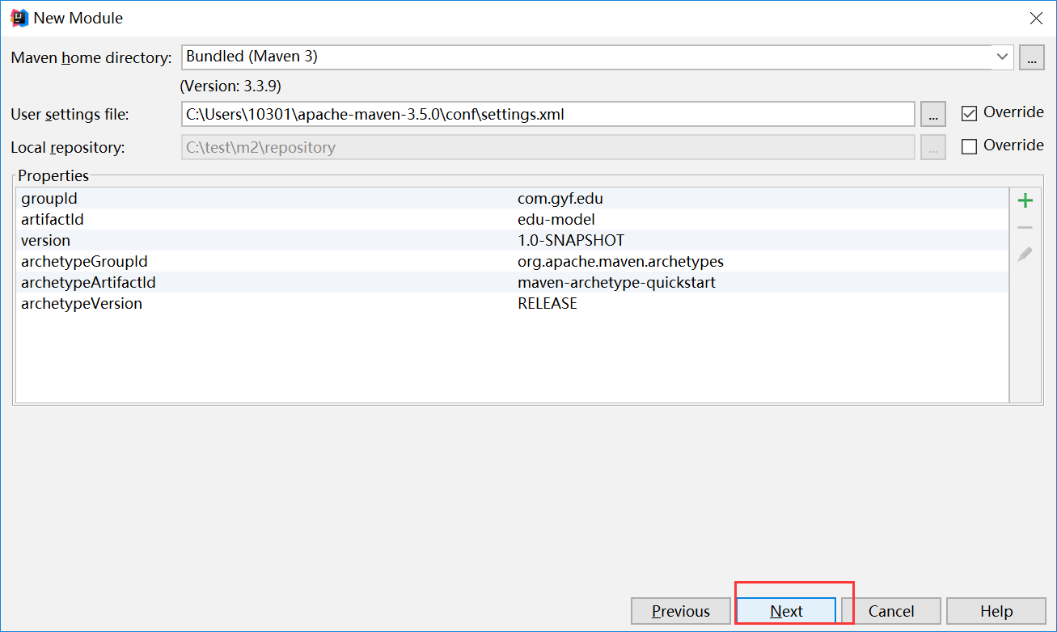

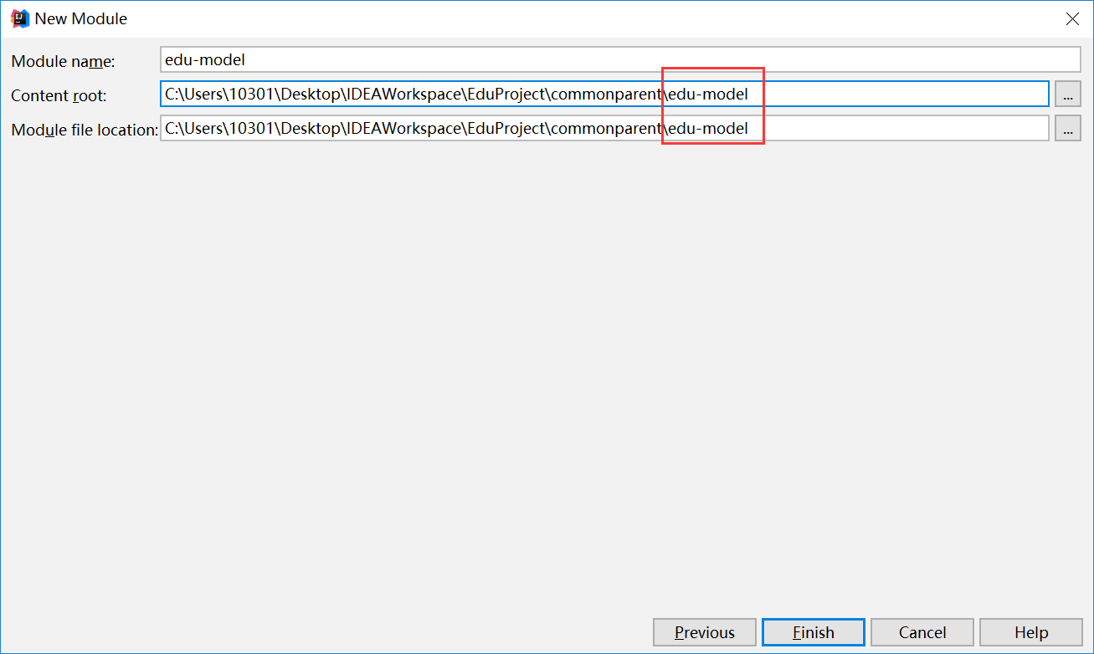

5》创建dao子工程

6》创建service子工程

7》创建Manager后台管理
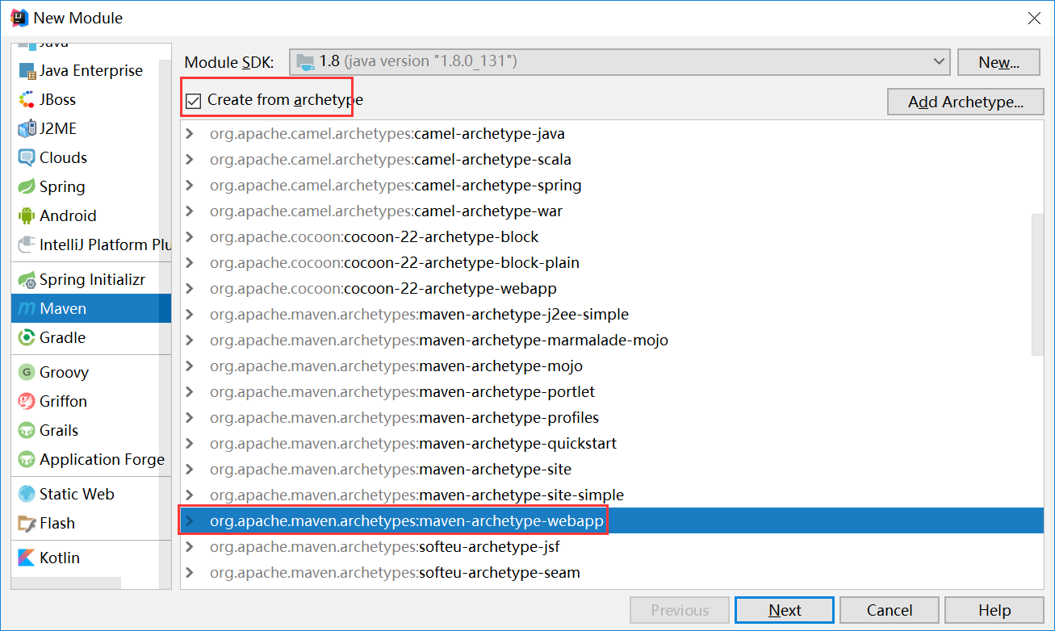

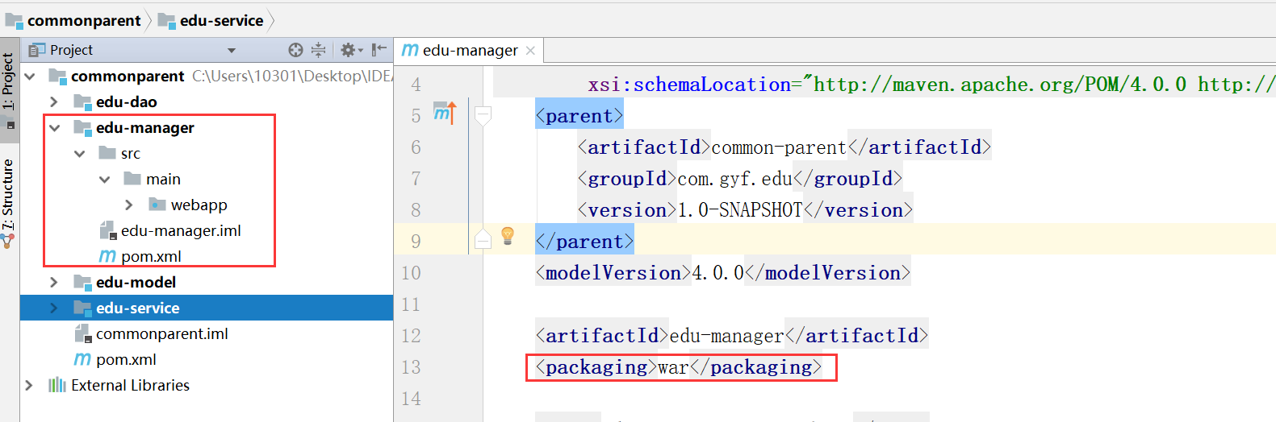

8》在parent中抽取公共的依赖
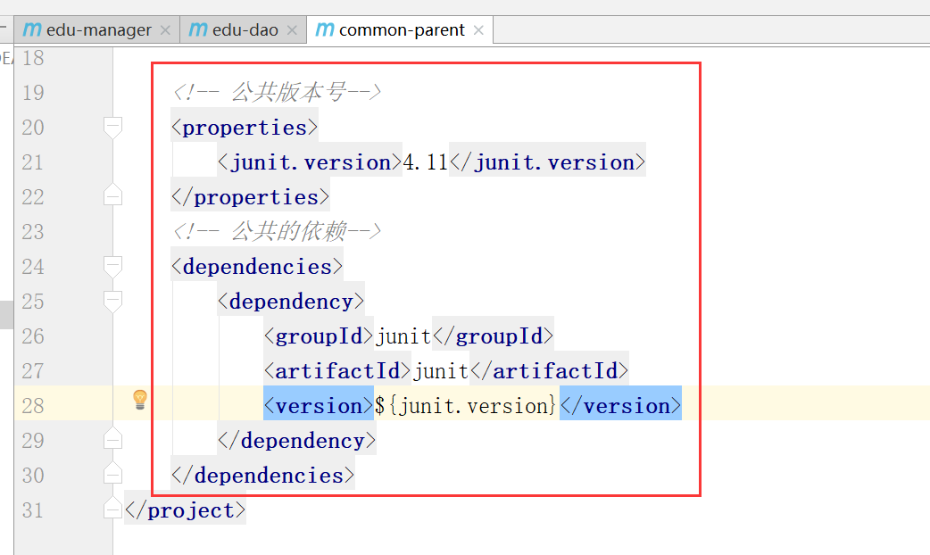

9》Manager中先集成SpringMVC
<dependency>
<groupId>org.springframework</groupId>
<artifactId>spring-test</artifactId>
<version>${spring.version}</version>
</dependency>
<dependency>
<groupId>org.springframework</groupId>
<artifactId>spring-core</artifactId>
<version>${spring.version}</version>
</dependency>
<dependency>
<groupId>org.springframework</groupId>
<artifactId>spring-oxm</artifactId>
<version>${spring.version}</version>
</dependency>
<dependency>
<groupId>org.springframework</groupId>
<artifactId>spring-tx</artifactId>
<version>${spring.version}</version>
</dependency>
<dependency>
<groupId>org.springframework</groupId>
<artifactId>spring-jdbc</artifactId>
<version>${spring.version}</version>
</dependency>
<dependency>
<groupId>org.springframework</groupId>
<artifactId>spring-aop</artifactId>
<version>${spring.version}</version>
</dependency>
<dependency>
<groupId>org.springframework</groupId>
<artifactId>spring-context</artifactId>
<version>${spring.version}</version>
</dependency>
<dependency>
<groupId>org.springframework</groupId>
<artifactId>spring-context-support</artifactId>
<version>${spring.version}</version>
</dependency>
<dependency>
<groupId>org.springframework</groupId>
<artifactId>spring-expression</artifactId>
<version>${spring.version}</version>
</dependency>
<dependency>
<groupId>org.springframework</groupId>
<artifactId>spring-orm</artifactId>
<version>${spring.version}</version>
</dependency>
<dependency>
<groupId>org.springframework</groupId>
<artifactId>spring-web</artifactId>
<version>${spring.version}</version>
</dependency>
<dependency>
<groupId>org.springframework</groupId>
<artifactId>spring-webmvc</artifactId>
<version>${spring.version}</version>
</dependency>
<dependency>
<groupId>org.springframework</groupId>
<artifactId>spring-aspects</artifactId>
<version>${spring.version}</version>
</dependency>

把版本信息放在父工程中
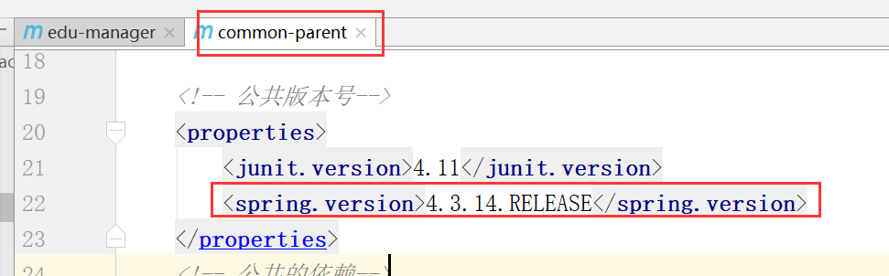

10》Tomcat跑工程
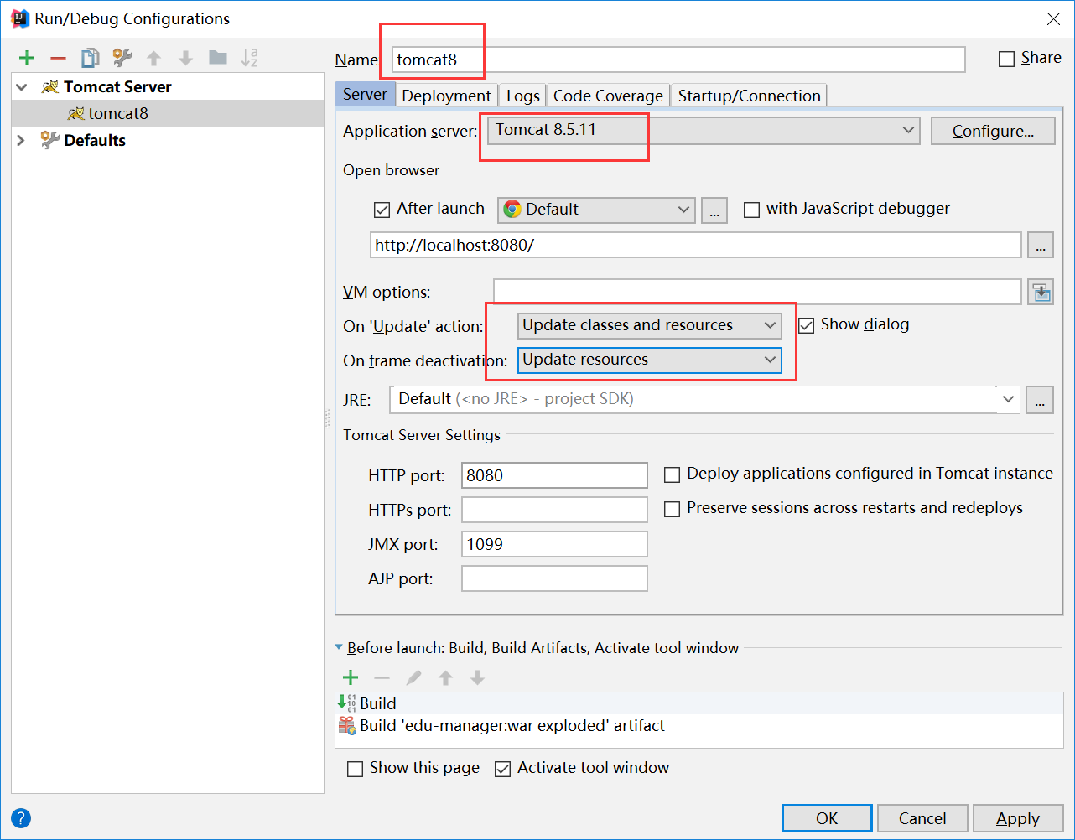

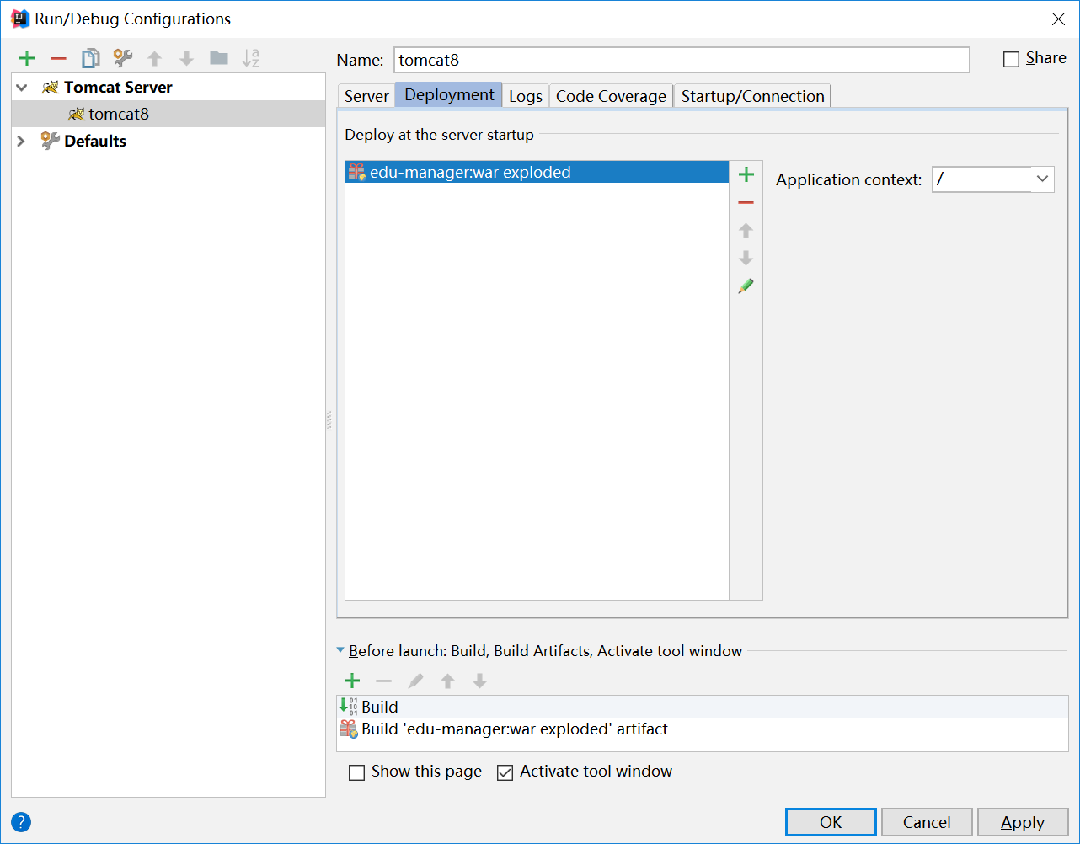

11》添加SpringMVC配置文件
Springmvc
<?xml version="1.0" encoding="UTF-8"?>
<beans xmlns="http://www.springframework.org/schema/beans"
xmlns:xsi="http://www.w3.org/2001/XMLSchema-instance"
xmlns:mvc="http://www.springframework.org/schema/mvc"
xmlns:context="http://www.springframework.org/schema/context"
xmlns:aop="http://www.springframework.org/schema/aop" xmlns:tx="http://www.springframework.org/schema/tx"
xsi:schemaLocation="http://www.springframework.org/schema/beans
http://www.springframework.org/schema/beans/spring-beans-3.2.xsd
http://www.springframework.org/schema/mvc
http://www.springframework.org/schema/mvc/spring-mvc-3.2.xsd
http://www.springframework.org/schema/context
http://www.springframework.org/schema/context/spring-context-3.2.xsd
http://www.springframework.org/schema/aop
http://www.springframework.org/schema/aop/spring-aop-3.2.xsd
http://www.springframework.org/schema/tx
http://www.springframework.org/schema/tx/spring-tx-3.2.xsd">
<!-- 1.注解扫描位置-->
<context:component-scan base-package="com.gyf.edu.web.controller" />
<!-- 2.配置映射处理和适配器-->
<bean class="org.springframework.web.servlet.mvc.method.annotation.RequestMappingHandlerMapping"/>
<bean class="org.springframework.web.servlet.mvc.method.annotation.RequestMappingHandlerAdapter"/>
<!-- 3.视图的解析器-->
<bean
class="org.springframework.web.servlet.view.InternalResourceViewResolver">
<property name="prefix" value="/WEB-INF/views/" />
<property name="suffix" value=".jsp" />
</bean>
</beans>

12》在web.xml中加载SpringMVC配置文件
<!-- 配置springmvc-->
<servlet>
<servlet-name>DispatcherServlet</servlet-name>
<servlet-class>org.springframework.web.servlet.DispatcherServlet</servlet-class>
<init-param>
<param-name>contextConfigLocation</param-name>
<param-value>classpath:springmvc.xml</param-value>
</init-param>
<load-on-startup>1</load-on-startup>
</servlet>
<servlet-mapping>
<servlet-name>DispatcherServlet</servlet-name>
<url-pattern>*.do</url-pattern>
</servlet-mapping>

随便使用一个控制器，看是否springmvc配置成功

13》更改web.xml为3.0
<?xml version="1.0" encoding="UTF-8"?>
<web-app
version="3.0"
xmlns="http://java.sun.com/xml/ns/javaee"
xmlns:xsi="http://www.w3.org/2001/XMLSchema-instance"
xsi:schemaLocation="http://java.sun.com/xml/ns/javaee http://java.sun.com/xml/ns/javaee/web-app_3_0.xsd">

14》dao-整合mybatis
<dependency>
<groupId>org.mybatis</groupId>
<artifactId>mybatis</artifactId>
<version>${mybatis.version}</version>
</dependency>

<mybatis.version>3.4.1</mybatis.version>

添加mybatis依赖

添加Mapper公共接口
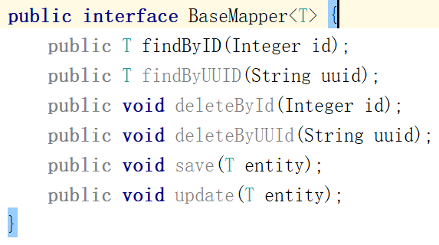

添加UserMapper.java和xml
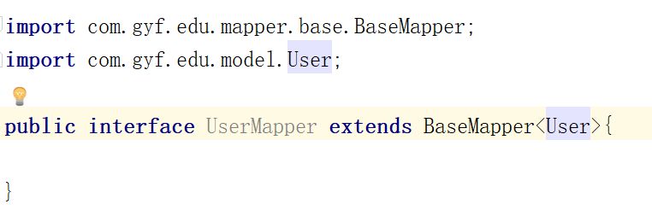

<?xml version="1.0" encoding="UTF-8" ?>
<!DOCTYPE mapper PUBLIC "-//mybatis.org//DTD Mapper 3.0//EN" "http://mybatis.org/dtd/mybatis-3-mapper.dtd" >
<mapper namespace="com.gyf.edu.mapper.UserMapper" >
<select id="findByID" resultType="user" parameterType="int">
SELECT * FROM t_user WHERE id = #{id}
</select>
</mapper>

15》service依赖dao
service里添加spring的一些依赖
<dependency>
<groupId>org.springframework</groupId>
<artifactId>spring-beans</artifactId>
<version>${spring.version}</version>
</dependency>
<dependency>
<groupId>org.springframework</groupId>
<artifactId>spring-context</artifactId>
<version>${spring.version}</version>
</dependency>
<dependency>
<groupId>org.springframework</groupId>
<artifactId>spring-tx</artifactId>
<version>${spring.version}</version>
</dependency>

然后写个UserService，抽取基类
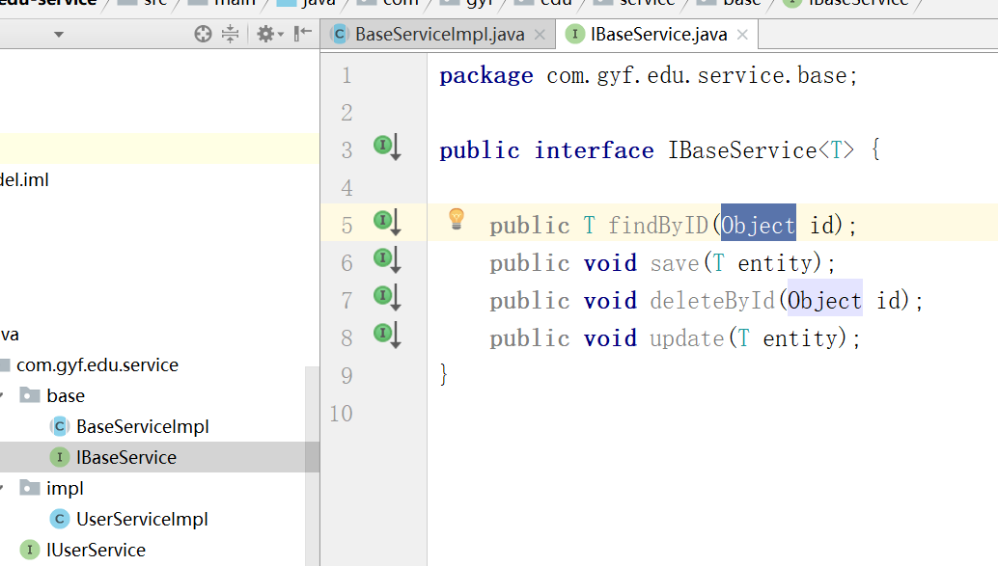
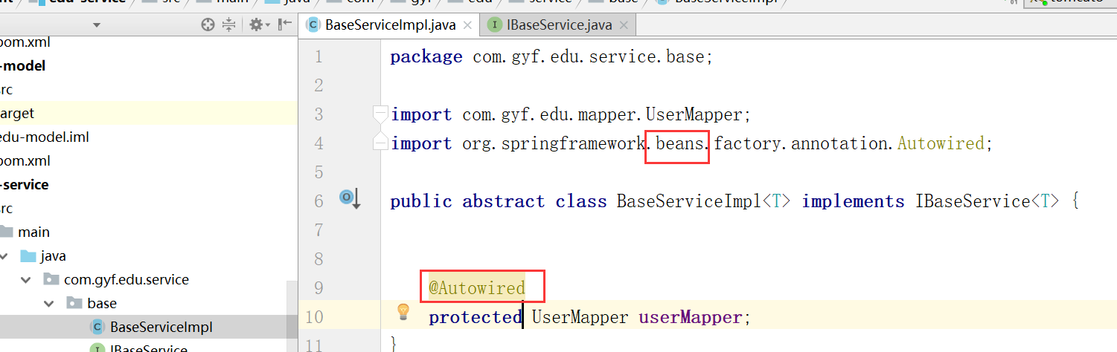
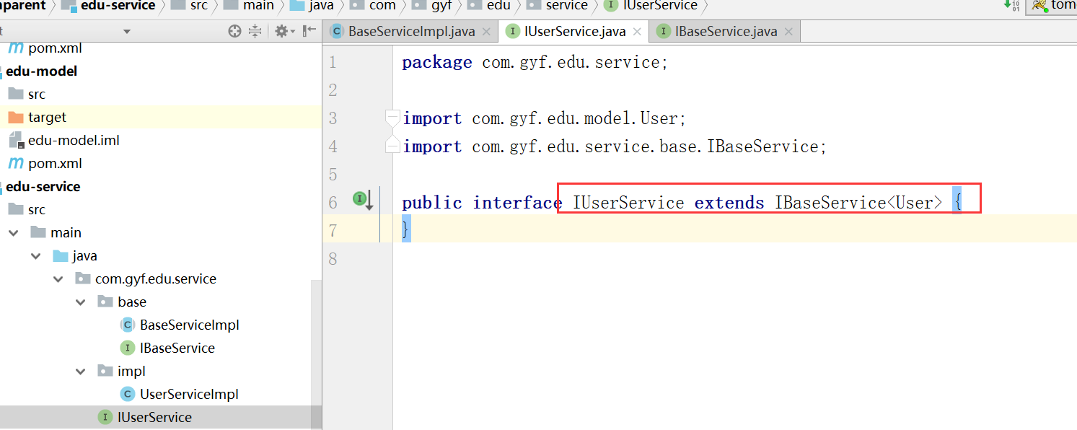
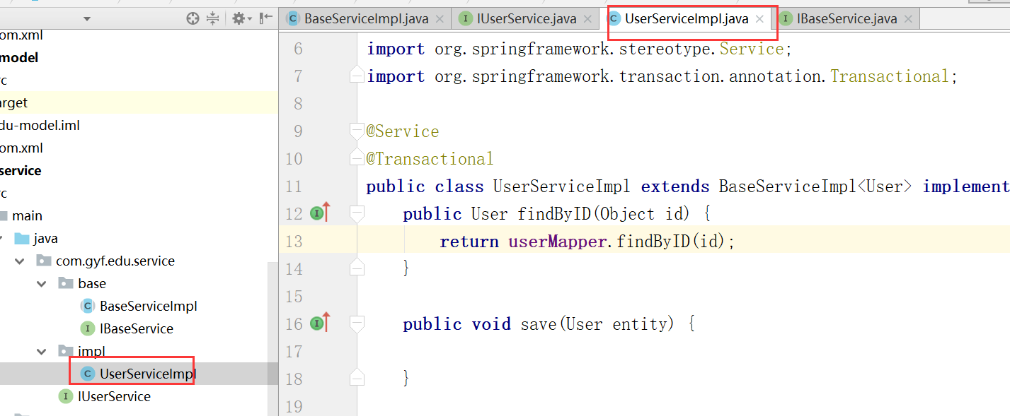

16》manager依赖 service
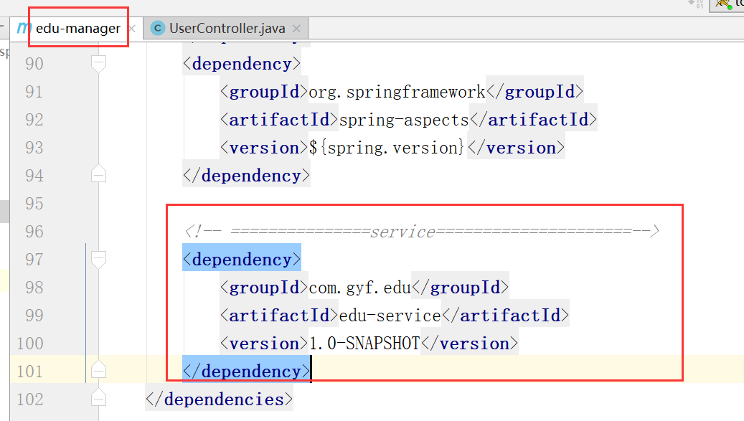
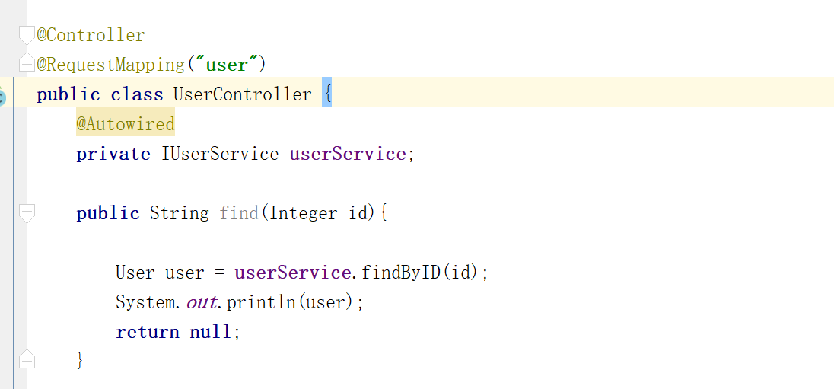

去除自动检测bean是否存在
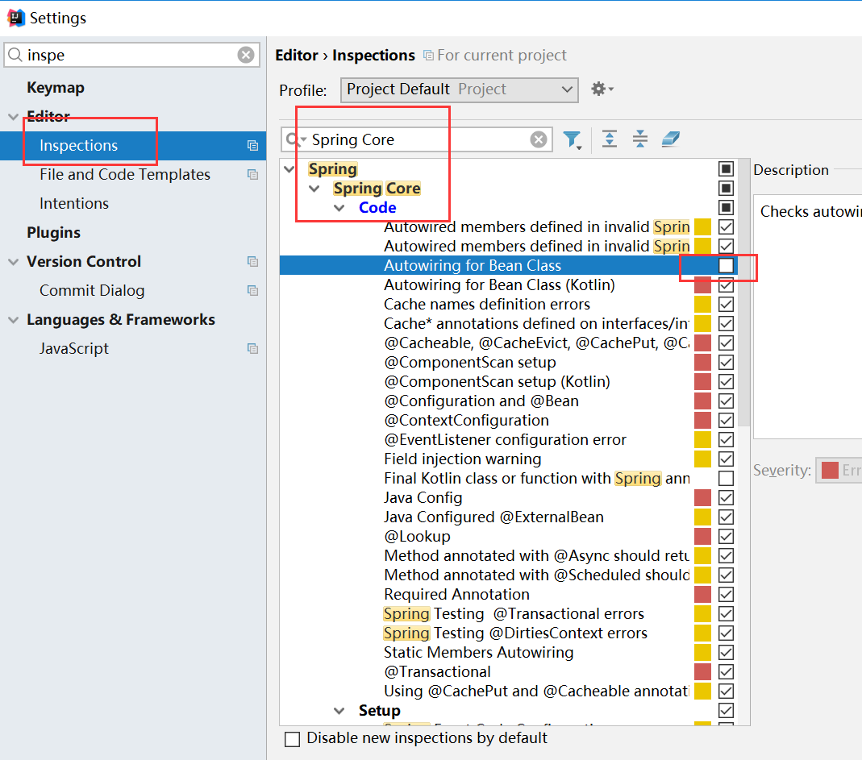

17》Manager 添加其它依赖
Spring+ SpringMVC
MyBatis
Mybatis-spring整合包
AOP联盟+织入
c3p0 数据库连接池
MySQL连接驱动 + jstl
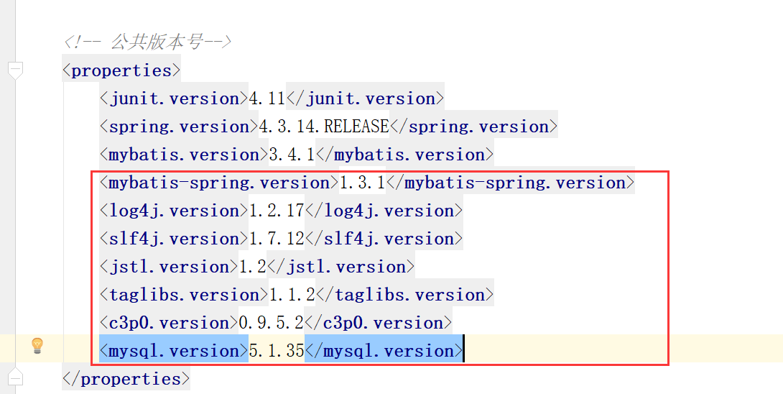
<properties>
<junit.version>4.11</junit.version>
<spring.version>4.3.14.RELEASE</spring.version>
<mybatis.version>3.4.1</mybatis.version>
<mybatis-spring.version>1.3.1</mybatis-spring.version>
<log4j.version>1.2.17</log4j.version>
<slf4j.version>1.7.12</slf4j.version>
<jstl.version>1.2</jstl.version>
<taglibs.version>1.1.2</taglibs.version>
<c3p0.version>0.9.5.2</c3p0.version>
<mysql.version>5.1.35</mysql.version>
</properties>

<!-- 数据库驱动 -->
<dependency>
<groupId>mysql</groupId>
<artifactId>mysql-connector-java</artifactId>
<version>${mysql.version}</version>
</dependency>
<!-- 数据连接池 -->
<dependency>
<groupId>com.mchange</groupId>
<artifactId>c3p0</artifactId>
<version>${c3p0.version}</version>
</dependency>
<!-- jstl标签类 -->
<dependency>
<groupId>jstl</groupId>
<artifactId>jstl</artifactId>
<version>${jstl.version}</version>
</dependency>
<dependency>
<groupId>taglibs</groupId>
<artifactId>standard</artifactId>
<version>${taglibs.version}</version>
</dependency>
<!-- log start -->
<dependency>
<groupId>log4j</groupId>
<artifactId>log4j</artifactId>
<version>${log4j.version}</version>
</dependency>
<dependency>
<groupId>org.slf4j</groupId>
<artifactId>slf4j-api</artifactId>
<version>${slf4j.version}</version>
</dependency>
<dependency>
<groupId>org.slf4j</groupId>
<artifactId>slf4j-log4j12</artifactId>
<version>${slf4j.version}</version>
</dependency>

18》Manager的其它配置文件
applicationContext,mybatis,log4j,db.properties

19》web.xml加载applicationContext.xml配置文件
<context-param>
<param-name>contextConfigLocation</param-name>
<param-value>classpath:applicationContext.xml</param-value>
</context-param>
<listener>
<listener-class>org.springframework.web.context.ContextLoaderListener</listener-class>
</listener>

20》在dao打包时要在pom中配置
<plugin>
<artifactId>maven-resources-plugin</artifactId>
<version>3.0.2</version>
<executions>
<execution>
<id>copy-xmls</id>
<phase>process-sources</phase>
<goals>
<goal>copy-resources</goal>
</goals>
<configuration>
<outputDirectory>${basedir}/target/classes</outputDirectory>
<resources>
<resource>
<directory>${basedir}/src/main/java</directory>
<includes>
<include>**/*.xml</include>
</includes>
</resource>
</resources>
</configuration>
</execution>
</executions>
</plugin>

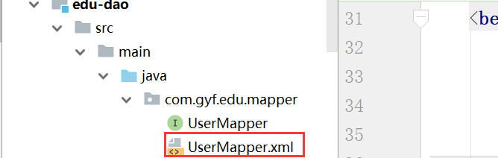
因为默认情况下.xml不会打包到jar包中

21》去除mybatis的配置文件
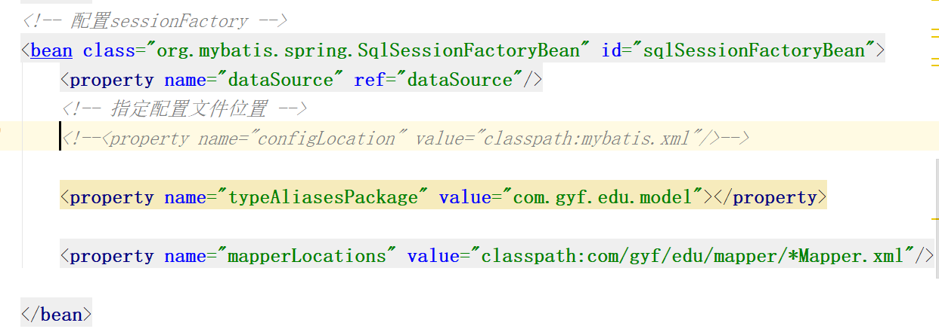

- 整合页面

