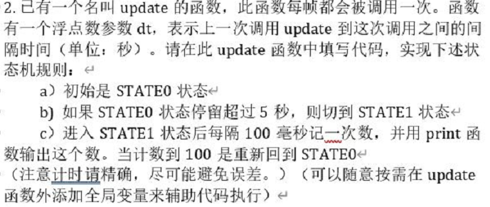
float dt = 0;
float time = 0;
int times = 0;
bool state = false;
// Update is called once per frame
void Update()
{
if (!state)
{
if (time >= 5)
{
state = true;

}
else
{
time += Time.deltaTime;//计时5秒,fixedDeltaTime误差大？

}
//Debug.Log(time);
}
else
{

dt += Time.deltaTime;
if(dt > 0.1)
{
dt = 0;
print(times);
times++;
}
if (times > 100)
{
state = false;
time = 0;
times = 0;
}
}
if (state)
{
print("STATE1");
}
else
{
print("STATE0");
}

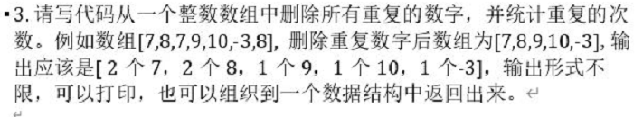
static void Main(string[] args)
{
int[]t = { 7, 8, 7, 9, 10, -3, 8 };
find(t);
}
static int[] find(int []nums)
{
int size = nums.Length;
int[] m = new int[size];//存放删除数字后的数组
int[] count = new int[size];//存放重复数字个数
int indexM = 0;
int indexCount = 0;
for(int i = 0; i < size; i++)
{
if (exist(nums[i], m))
{
count[indexCount]++;
indexCount++;

}
else//第一次出现
{
count[indexM]++;
m[indexM] = nums[i];
indexM++;

}
}

for(int n =0;n<indexM;n++)
{
Console.WriteLine(count[n]+"个" + m[n]);
}

return m;
}
static bool exist(int n, int[]m)
{
bool exist = false;
for(int i = 0; i < m.Length; i++)
{
if (m[i] == m[i + 1])
{
break;
}
if (n == m[i])
{
exist = true;
}
}
return exist;
}

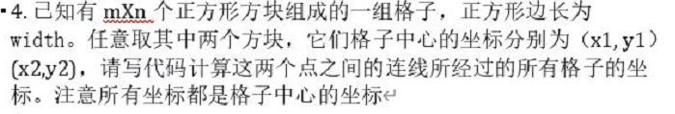
void cubeLocal(int x1,int y1,int x2,int y2,int width)//默认输入合法且x1<x2,y1>y2
{
int m = (x2 - x1) / width;
int n = (y1 - y2) / width;
if (m == n)
{
for(int i = 0; i < m; i++)
{
Console.WriteLine("x坐标" +( x1 + i * width) + " " + "y坐标" +( y1 - i * width));
}
}
if (m > n)
{
for (int i = 0; i <=m; i++)//横向的第i格在纵向上，y的坐标下降(width*i*n)/m
{
int down = (i * n) / m;//下降了j格
if (down % (width/2) != 0)
{
Console.WriteLine("x坐标" + (x1 + i * width) + " " + "y坐标" + (y1 - down * width));
}
else//线压在正方形边上，取两个中心坐标
{
Console.WriteLine("x坐标" + (x1 + i * width) + " " + "y坐标" + (y1 - down * width));
Console.WriteLine("x坐标" + (x1 + i * width) + " " + "y坐标" + (y1 - (down +1) * width));
}
}

}
//其他类似
}

