**SUMMER 2019 INTERNSHIP, COPART**

SOFTWARE ENGINEER INTERN

**COPART**

Project 1:

Activity Description

Overview:

I worked on the development of a company-bank integration framework for payments systems. The objective was to create a system through which vendors can be paid and the data can be synced and replicated with the associated banks. Further, the system had to facilitate CRUD operations on vendor and debtor bank details, allow the calculation of the commission based on the pricing system, recognize that a party needs to be paid, and initiate the payment for the same.

Responsibilities:

My responsibility was to develop web RESTful APIs for all the functionalities required involving fetch, add, update, and delete vendor and debtor i.e. the company bank accounts, and bank branches for UK and Ireland regions. Essentially, I had to develop the backend services for CRUD operation and passing the same information to the existing mainframe system for replication.

Problems associated:

IBAN (International Bank Account Number) is used for international wire transfers or remittances. It consists of maximum 34 characters comprising of country code, bank code, account number, check digits and sort code. The numbers begin with a two-digit country code, two check digits and a long number representing the unique number assigned to the account. It is used for facilitating remittances to the European nations, and some Middle East countries.

In UK, bank transactions can be done based on Account Number and Sort code, but for Ireland, IBAN number is required.

As a result, two different API’s had to be designed for UK and Ireland, and functionality to accept the IBAN and replicate it to the necessary systems was needed to be done.

Solution:

The task was divided into multiple sub tasks.

1. A batch job was created to retrieve the data from an external payments table for all the subhauler payouts.
2. The information retrieved gets saved to my system’s (back office) database.
3. As the data got pulled, all the transactions are updated to ‘INPROGRESS’ in both the external and my system databases.
4. The payment request structure is prepared and enriched using user data obtained from another external user database.
5. Another batch job was created that sends the required enriched payment request data to the bank file generation service for further processing.
6. The file writer service writes the data to a file, encrypts the same and digitally signs it.
7. Another service pushes the file to a queue that eventually sends it to the Bank through SFTP.
8. If there is any error the same is retried and finally marked as accepted after getting a successful acknowledgement from the bank.
9. Following this, a remittance advice is created and sent to all the vendors.
10. A service is created to pull the data from payout transaction table and show on the UI.
11. To view, add, edit, and delete the debtor bank information separate REST APIs are created.

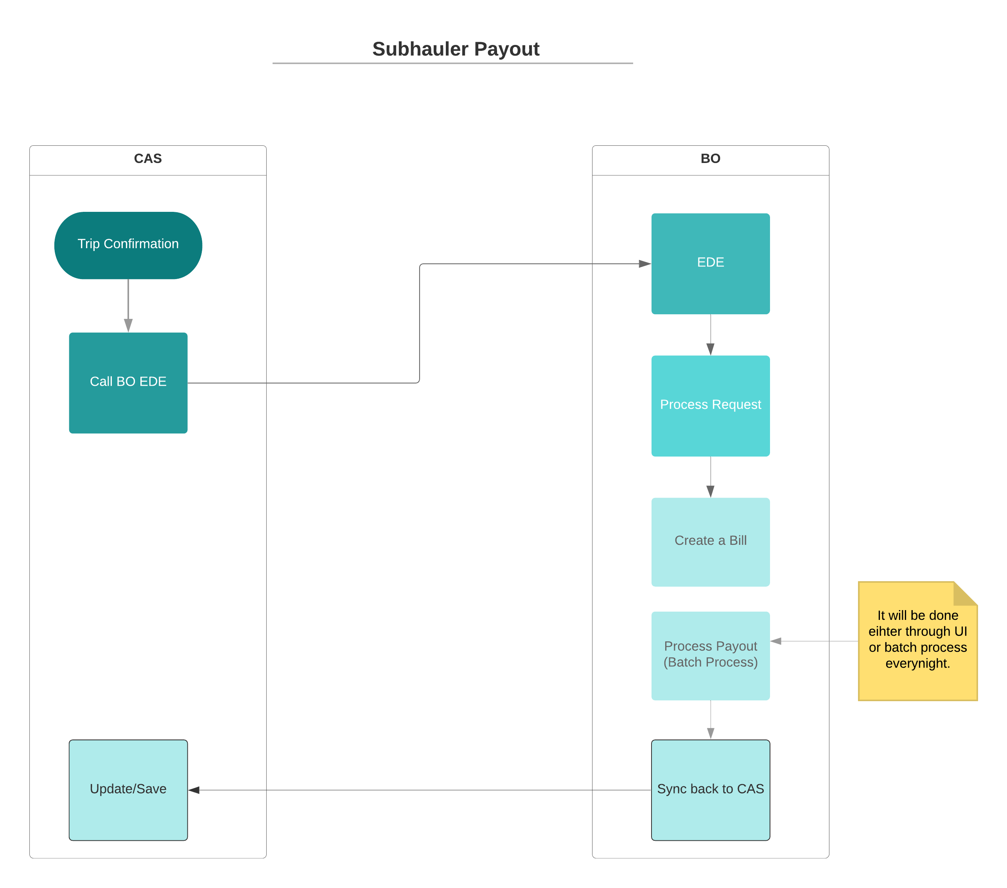

Analysis and learning

This project helped me gain subject matter expertise on what all information is required to perform transactions in different countries across Europe and North America. It also helped me learn and get hands on experience on developing a web application using Spring Boot. I also got to interact with different teams and external vendors to work on a project collaboratively.

Relation to theory learned in the classroom:

The course on Database Design provided me the theory and exposure to how a relational database is designed and optimize. I had to creation SQLs for the different REST APIs for the multiple modules that I developed.

The knowledge gained by completing course work on Data structures and algorithms also helped me develop the repository and data access and storage layer of the web application modules that I developed. Particularly Hash Tables, Hash Maps, Queues were of high importance in my coding pattern.

The experience obtained in my project is going to help to on my next assignment as I now know the flow of data within a complete web application starting from the controller layer, through the service layer, to the repository or data access layer. It has also augmented my debugging skills.

Further, the experience of working with multiple teams – namely, Quality Assurance, DevOps, and the business was very useful and gave me a knowhow of what could be the different bottlenecks between the development and deployment processes and how could the same be resolved. I would now be able to work independently for most part of a project that is assigned to me. I will also be able to collaborate more effectively with my teammates, other teams and offshore teams.

After I graduate and start working as a professional these skills are going to help me. These skills of working with multiple teams and learning about the different problems that may come across and the ways to work around them cannot be taught only through books. A firsthand experience is always helpful.

To improve the performance on the assignment, it would have been immensely helpful if I got to shadow an experienced developer on a project for a few weeks. But understanding the tight deadlines for delivery, it has also given me an experience to work under pressure and how the work can be broken into sub tasks and accomplished in a pipeline. Scaling up the team would also have been useful. In my next project, if I were to manage or lead the same, I would like to have the basic knowledge on multiple projects, so that I can chip in to some other project when my current project heads into a bottleneck or wait time due to dependency on progress made by some other team involved.

Project 2:

Activity Description

Overview:

I participated in the creation of a high-level design for an application that is used to make payments through User Interface

Responsibilities:

My responsibility was to understand the business requirement from the client and research about the technologies and techniques that can be used to develop submodules of the project.

Solution:

1. Once a business confirmation is received from the associated external vendor, a payout record is created and saved in a staging area with NOT_PROCESSED status.
2. A batch process picks the records which are not yet processed and calls a service to initiate the payout.
3. The same transactions are the updated in the database as IN_PROGRESS.
4. The batch job calls the payout service which eventually save the data to payout tables.
5. Based on the approval configuration for vendors, records either go through the payout approval process or are processed for payout.
6. Payout batch job picks the records which needs to be paid out and calls the bank file generation service to generate the bank file.
7. Required tax is calculated through pricing service.
8. Once the acknowledgement is received, the records are updated as PROCESSED in the database.
9. For payment reversal, the external system handling the user input sends an event to our system and the payout is reversed if it is in the initiation phase.

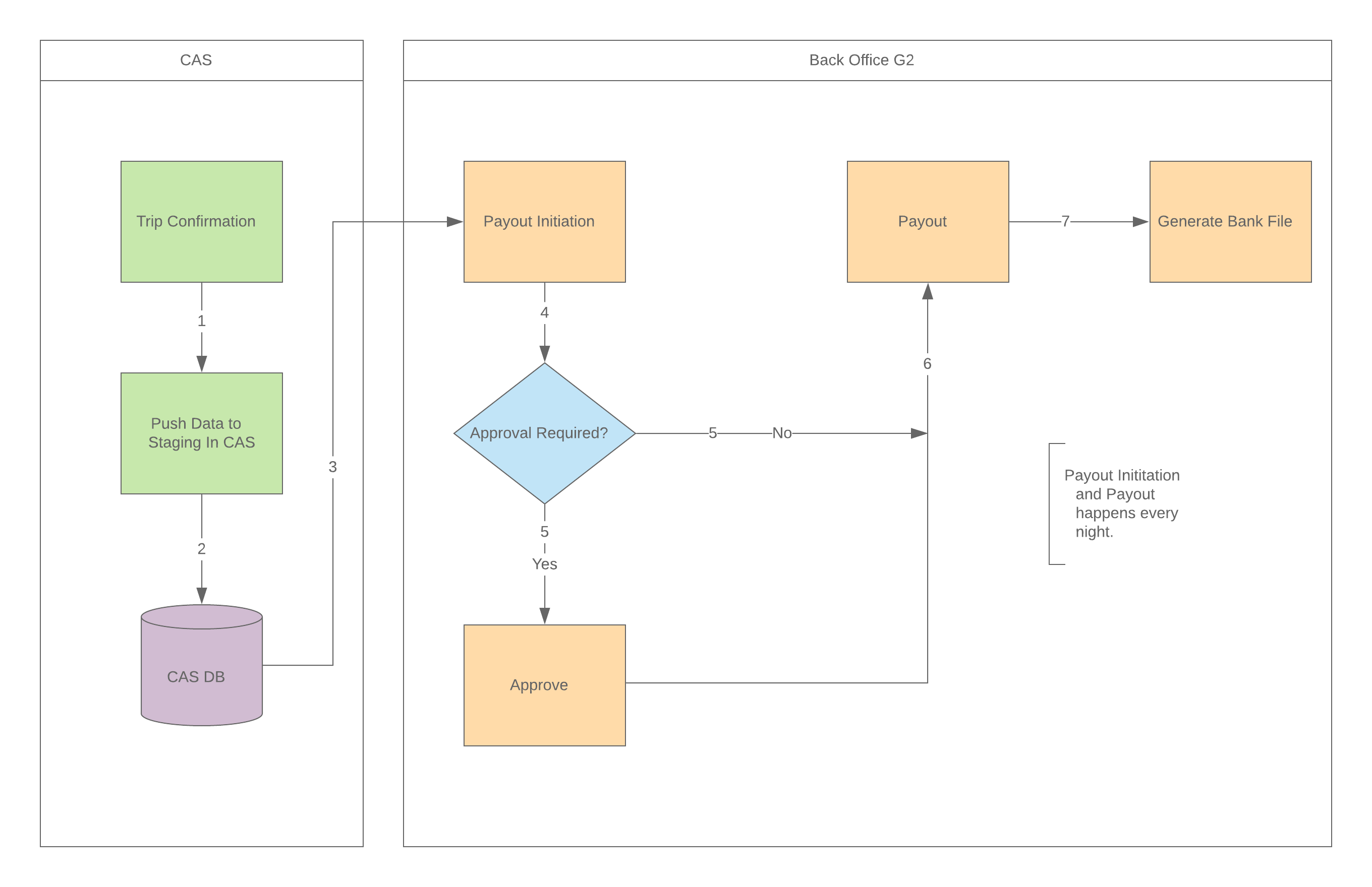

Analysis and learning

This project helped me learn and get hands on experience on system designing and an exposure to work with business personnel, designers and architects. The effective collaboration with different teams was also valuable.

Relation to theory learned in the classroom:

The course on Database Design provided me the theory and exposure to how a relational database is designed and optimize. I had to creation SQLs for the different REST APIs for the multiple modules that I developed.

The system design knowledge gained from completing course work on Big Data Management an Analytics helped me to have the fundamental knowledge of what are the different components and new technologies involved in handling data while keeping the system Consistent, Available. Partitionable and Scalable.

The experience obtained in my project is going to help me on my next assignment as I now know the flow of data within a complete web application starting from the controller layer, through the service layer, to the repository or data access layer. It has also augmented my debugging skills. The experience gained along with the coursework has motivated me to learn more on System designing so that I can take up similar role in my future endeavors.

Further, the experience of working with multiple teams – namely, Quality Assurance, DevOps, and the business was very useful and gave me a knowhow of what could be the different bottlenecks between the development and deployment processes and how could the same be resolved. I would now be able to work independently for most part of a project that is assigned to me. I will also be able to collaborate more effectively with my teammates, other teams and offshore teams.

After I graduate and start working as a professional these skills are going to help me. These skills of working with multiple teams and learning about the different problems that may come across and the ways to work around them cannot be taught only through books. A firsthand experience is always helpful.

To improve the performance on the assignment, it would have been immensely helpful if I got to shadow an experienced developer on a project for a few weeks. But understanding the tight deadlines for delivery, it has also given me an experience to work under pressure and how the work can be broken into sub tasks and accomplished in a pipeline. Scaling up the team would also have been useful. In my next project, if I were to manage or lead the same, I would like to have the basic knowledge on multiple projects, so that I can chip in to some other project when my current project heads into a bottleneck or wait time due to dependency on progress made by some other team involved.